**Major Project Report**

On

## HUMAN RESOURCE MANAGEMENT SOFTWARE

## Submitted by

**Yashaswi Palandure, 33**

## Guided by

Prof. Kiran Gavhale



## Department of Information Technology

**Yeshwantrao Chavan College of Engineering, Nagpur**

*(An Autonomous Institute, Affiliated to RTM Nagpur Universiy, Nagpur. )*

**Session: 2021-2022**

Yeshwantrao Chavan College of Engineering, Nagpur

## Department of Information Technology

**Session: 2021-22**



**Certificate**

This is to certify that Mr./Ms. **Yashaswi Palandure ,** has completed a **Major Project** course titled “***HUMAN RESOURCE MANAGEMENT SOFTWARE****”* towards the partial fulfillment of requirements for the B.E. eighth semester of Information Technology.

## Submitted by

**Yashaswi Palandure**

**Prof. Kiran Gavhale**

Project Guide

## Prof. B. U. Bawankar Dr. R. C. Dharmik

Project Co-ordinator(IT) HOD (IT)

### DECLARATION

We certify that

1. The work contained in this project has been done by us under the guidance of our supervisor(s).
2. The work has not been submitted to any other Institute for any degree or diploma.
3. We have followed the guidelines provided by the Institute in preparing the project report.
4. We have conformed to the norms and guidelines given in the Ethical Code of Conduct of the Institute.
5. Whenever we have used materials (data, theoretical analysis, figures, and text) from other sources, we have given due credit to them by citing them in the text of the report and giving their details in the references. Further, we have taken permission from the copyright owners of the sources, whenever necessary.

### Yashaswi Palandure

### ACKNOWLEDGEMENT

We are extremely thankful to our guide **Prof. Kiran Gavhale** under whom our project took the shape of reality from mere idea. We are thankful to our guide for enlightening us with his precious guidance and constant encouragement. We thank our guide for providing us with ample support and valuable time. We are indebted to our guide who constantly provided a stimulus to reach our goals.

We are grateful to **Dr.R.C.Dharmik**, HOD Information Technology, YCCE , for his kind co- operation and timely help.

We express our gratitude towards **Dr.U.P.Waghe**, Principal YCCE, for his never-ending support and motivation.

Lastly, we would like to thank all those who were directly or indirectly related to our project and extended their support to make the project successful.

### Yashaswi Palandure (33)

**Final Year IT.**

### Table of Content

**CONTENTS Page No.**

Title Page I

Certificate of Approval II

Declaration III

Acknowledgement IV

Table of Content V

List of Figure VI

Abstract

Chapter 1: - Introduction 1

* 1. Overview 2
  2. Problem Statement 3

Chapter 2: - Review of Literature 4

2.1 Literature Review 5

Chapter 3: - Work Done 8

* 1. Proposed Work 9
  2. Flow Chart 10
  3. Tools used 11

Chapter 4: - Results and Discussions 12

Chapter 5: - Future Scope and Conclusions 16

5.1 Future Scope and Conclusion 17

Chapter 6: Literature Cited / References 18

6.1 References 19

## List of Figures

|  |  |  |
| --- | --- | --- |
| **Fig no.** | **Figure Name** | **Page No.** |
| Fig 1: | Flow chart of application | 16 |
| Fig 2: | Login Page | 19 |
| Fig 3 : | Admin Dashboard | 19 |
| Fig 4: | Organisation Page | 20 |
| Fig 5 : | Employees Management | 20 |
| Fig 6 : | Attendance Management | 21 |
| Fig 7 : | Leave Application | 21 |
| Fig 8 : | Project management | 22 |
| Fig 9 : | Task Management | 23 |

### ABSTRACT

We are developing an web based application in which we aim to to build the human resource management system to increase the efficiency of the performance and the safety of the decisions taken and the advancement of the institution. To maintain the data of all active and inactive employees requires a significant amount of time if we do it without software.

Among the total human resource activities, managing the human capital i.e. employees is the significant task to

any HR. The main function of HR is to recruit, manage and store the employee data which includes their personal

information including their job roles, job streams, projects allotted, salaries and many more which allows them to

face huge workload. In order to support the HR’s there are some electronic based HR systems called HRMS

human resource management system. This application is cost effective one that allow the HR’s to manage the

timings of employee works, employee information systems and performance appraisal, employee service and

employee attendance. This project belongs to a category of web application that can be accessed through PC with

internet connection. The application makes sure that the proper user interface is provided to the communicating

parties to work easily on the application.

# CHAPTER 1 INTRODUCTION

### CHAPTER 1: INTRODUCTION

### OVERVIEW

For more than a century now, human resource management, as a discipline and practice in the management of people in an organization, has evolved and developed into different areas. These disciplines and practices have gone through a process of trial and error, theory building and testing of various concepts by practicing managers and academics.

The changing organizational environment in the marketplace pushed managers to improve efficiency in the production and service delivery processes by increasing their ability to use the best practices of people management at the time. That is, employee management techniques or methods that would improve production, reduce service delivery costs, and at the same time ensure sustained availability of competent staff in the organization. This study is devoted to providing organizations with a human resource management system of the evolution and development of human resource management and the way it works and influences people management in contemporary organizations.

**System description:**

Human resources management system (HRMS) was created to include the best practices for service human resources departments within the company and is the work of all employees department. The target group of the system that serves the human resource procedures is special for the employees and managers. This system of work area makes it easy to enter movements daily work , also organizes holidays, whether in the day or hours , Emission a monthly report full and detailed and accurate for all staff movements within a specified period (work required -work actual ). The proposed system will allow improve perform the job functions of the employees department and faculty by provide system allows:

1.Tasks are dispensed paper charged for the time and effort.

2.Keep electronic records of employee's information, benefits, education, adjustments, evaluations and requests instead of paper files that need extra space.

3.Electronic working will be easy to completion tasks.

4.The system flexible to add, delete, edit for employee record and all information belong to human resources management.

### PROBLEM STATEMENT

We have to develop an web application which aims to build the human resources management system to increase the efficiency of the performance and the safety of the decisions taken and the advancement of the institution.

# CHAPTER 2

**REVIEW OF LITERATURE**

### CHAPTER 2: REVIEW OF LITERATURE

### LITERATURE REVIEW

### 

### Technology

### Frontend: React.js

### Backend: Node.js

### Database: MongoDB

**ReactJs :**

React is an open source JavaScript library that is used to create user-linked links for single-page applications. Used for managing web viewing layers and mobile applications. React also allows us to create reusable UI components. The main goal of React JS is to improve User Interfaces (UI) which improve the speed of applications. It uses a virtual DOM (JavaScript object), which improves application performance. The visual JavaScript DOM is faster than the standard DOM. We can apply React JS to client and server side and other components. It uses component and data patterns that improve readability and help maintain large applications.

**NodeJs:**

Node.js is an open source, cross-platform runtime environment for developing server-side and networking applications. Node.js applications are written in JavaScript, and can be run within the Node.js runtime on OS X, Microsoft Windows, and Linux. Node.js also provides a rich library of various JavaScript modules which simplifies the development of web applications using Node.js to a great extent. A Node.js app runs in a single process, without creating a new thread for every request. Node.js provides a set of asynchronous I/O primitives in its standard library that prevent JavaScript code from blocking and generally, libraries in Node.js are written using non-blocking paradigms, making blocking behavior the exception rather than the norm.

**MongoDB :**

MongoDB is an object-oriented, simple, dynamic, and scalable NoSQL database. It

is based on the NoSQL document store model. The data objects are stored as separate

document inside a collection — instead of storing the data into the columns and rows

of a traditional relational database. MongoDB makes use of records which are made

up of documents that contain a data structure composed of field and value pairs.

Documents are the basic unit of data in MongoDB. Sets of documents are

called collections, which function as the equivalent of relational database tables.

Collections can contain any type of data, but the restriction is the data in a collection

cannot be spread across different databases.

The feasibility of software can be tested in four dimensions:

**1.Technical Feasibility*:***

Since the project uses reliable tools like open source technology like

react, node.js, and MongoDB, the system can be implemented efficiently

without any issues. The trio of this technology can efficiently handle data, requests and also

create user friendly applications. Hence this project has a good technical feasibility.

***2. Time Schedule Feasibility:***

The project involved to be developed consists of total four different modules

hence it is quite tedious to manage but considering that there are sufficient human

resources available, it is feasible to develop the application in the allotted duration.And if the

requirement changes, according to it duration will be changed.

***3. Operational Feasibility:***

How the project will work and who will use it, all such concerns arise in this phase. We have to

study the existing system’s problem, and is it worth solving or not. This Project will save a lot of

time and effort of a user to analyze the employee information and also provide additional

functionality. Hence it is operationally feasible.

***4. Implementation Feasibility:***

The requirements mentioned above can be fulfilled using various technologies

available. React-.js, and MongoDB, the implementation of the project is

feasible.

# CHAPTER 3 WORK DONE

### CHAPTER 3: WORK DONE

### PROPOSED WORK

* + 1. **Login using AD credentials :** As an application user, One should be able to login to the application with the AD credentials.

**Input**: Enter username and password.

**Output**: One should be able to login to HRMS using AD credentials else failed.

* + 1. **View/Edit the employee’s information** : As an application admin, One should be able to view and edit any employee’s General information.

**Inpu**t: select employee whom you want to edit info on the employee page**.**

**Output**: Update employee information or error.

**3. Download employee attachments** : As an application admin, One should be able to view,

upload, delete and download my own as well as other employees’ attachments.

**Input** : click on the download attachment button.

**Output:** get csv file of employee details.

**4. LogOut** :

**Input**: click on logout button.

**Output**: employee logged out from HRMS.

### FLOW CHART

### 

### 

### TOOLS USED

1. **VS Code** :

Visual Studio Code (famously known as VS Code) is a free open source text editor by Microsoft. VS Code is available for Windows, Linux, and macOS. Although the editor is relatively lightweight, it includes some powerful features that have made VS Code one of the most popular development environment tools in recent times.

**2)** **MongoDB** : **The MongoDB Database Tools are a collection of command-line utilities for working with a MongoDB deployment**. MongoDB stores data in flexible, JSON-like documents, meaning fields can vary from document to document and data structure can be changed over time

**3) Postman :** Postmanis an application used for API testing. It is an HTTP client that tests HTTP requests,

utilizing a graphical user interface, through which we obtain different types of responses that need to be

subsequently validated. Postman offers many endpoint interaction methods. The following are some of the

most used, including their functions :

* GET: Obtain information
* POST: Add information
* PUT: Replace information
* PATCH: Update certain information
* DELETE: Delete information

# CHAPTER 4

**RESULTS AND DISCUSSIONS**

### CHAPTER 4: RESULTS AND DISCUSSIONS

1. Login Page :

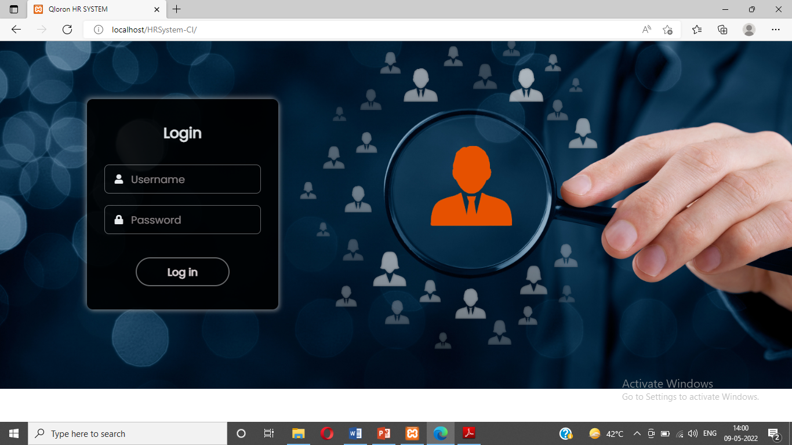

2) Admin Dashboard:

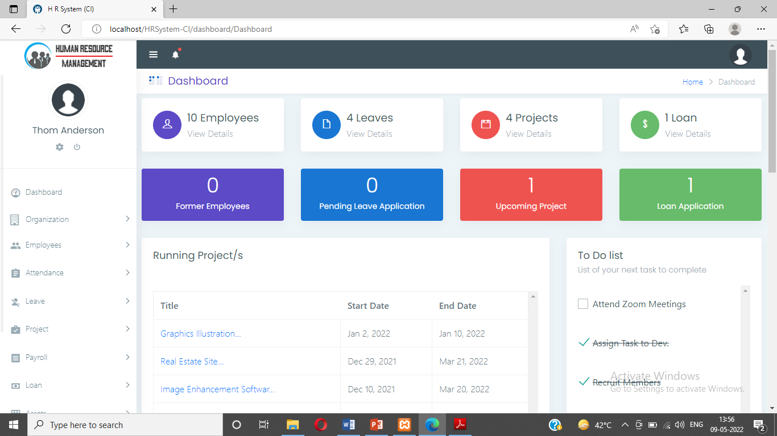

1. Organisation :

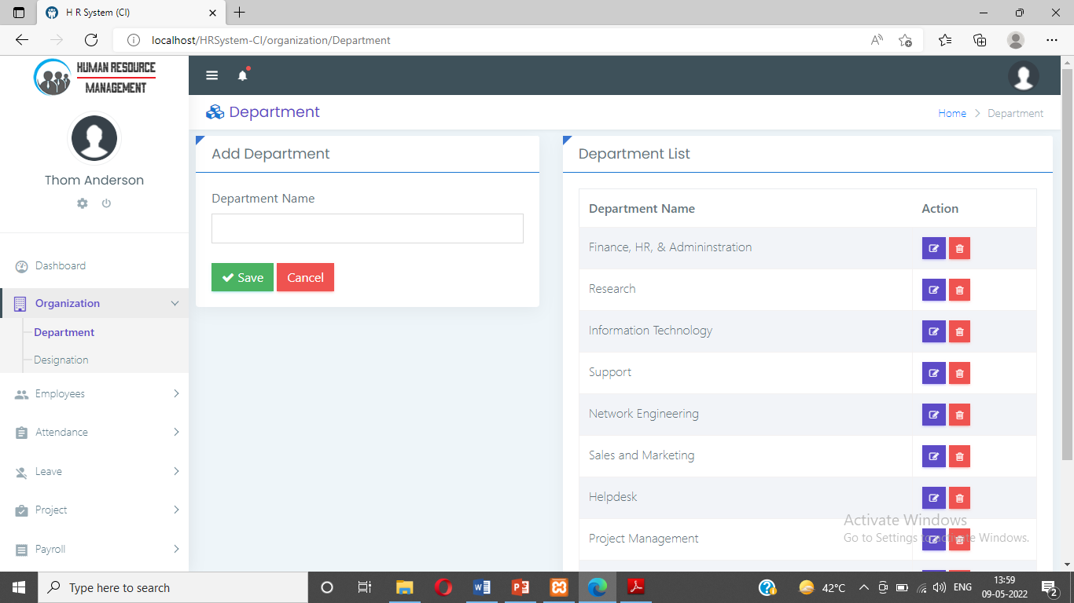

3) Employees :

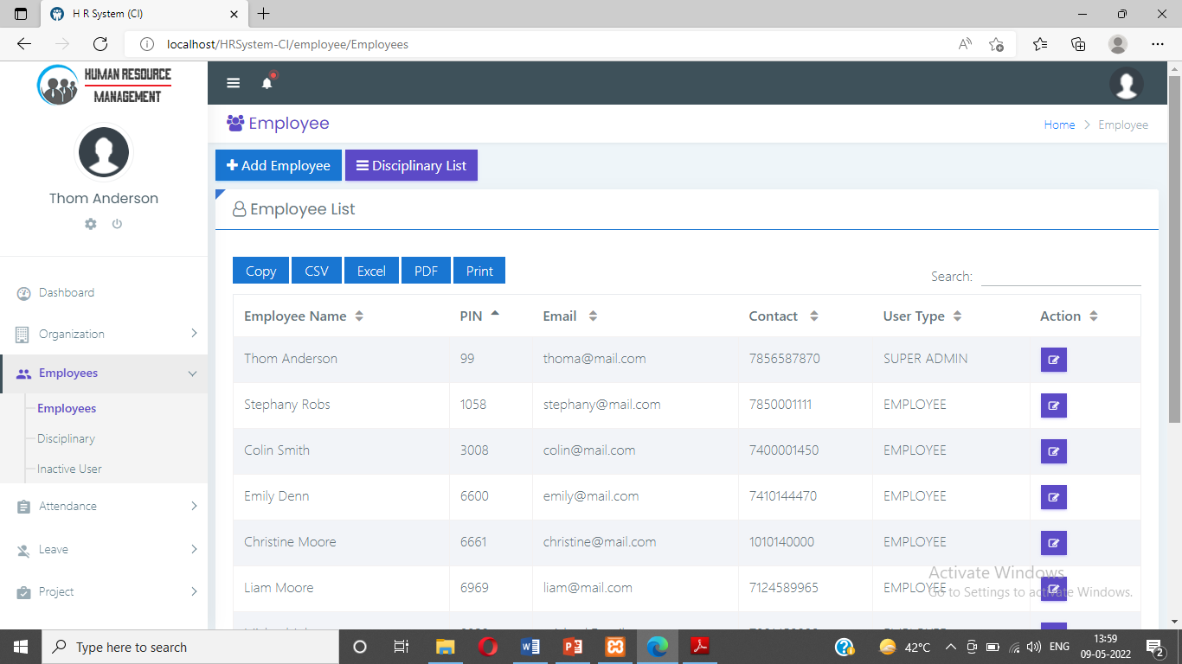

1. Attendance :

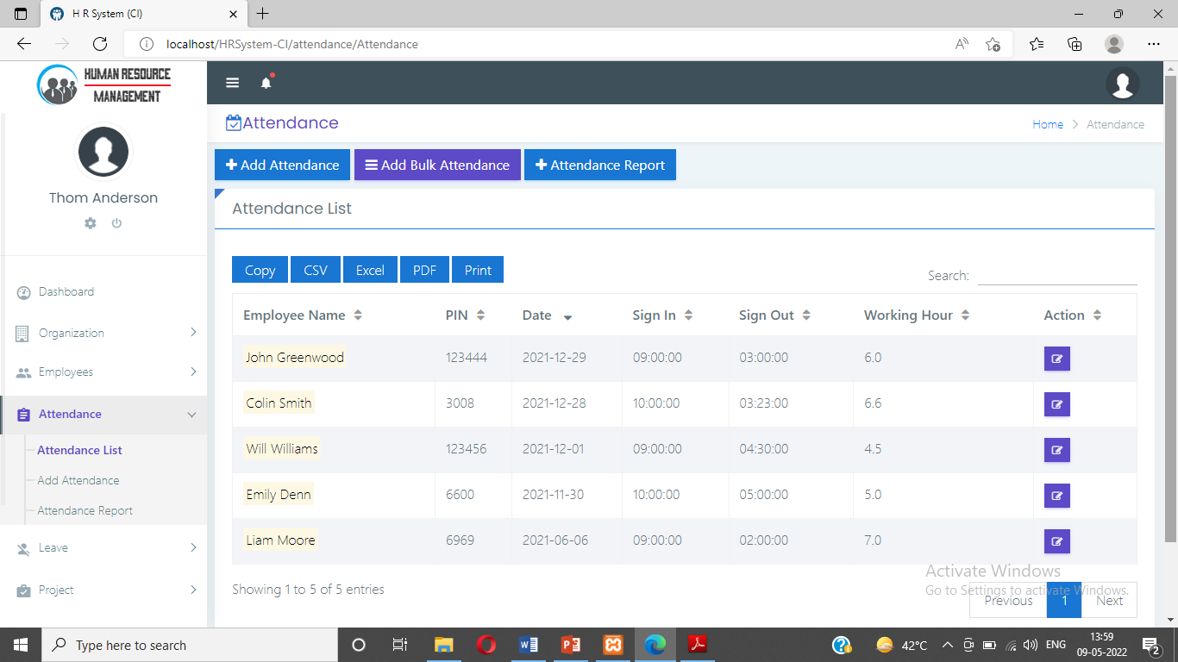

1. Leave Application :

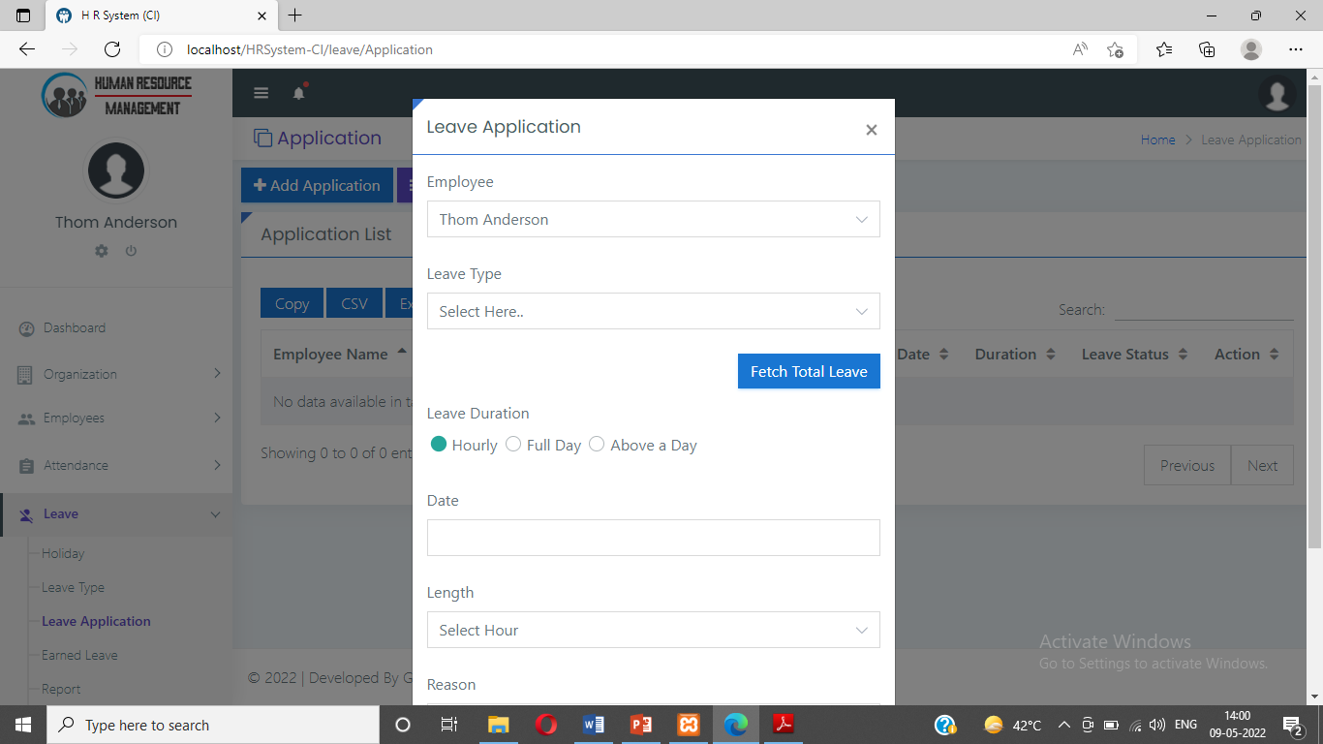

5) Project :

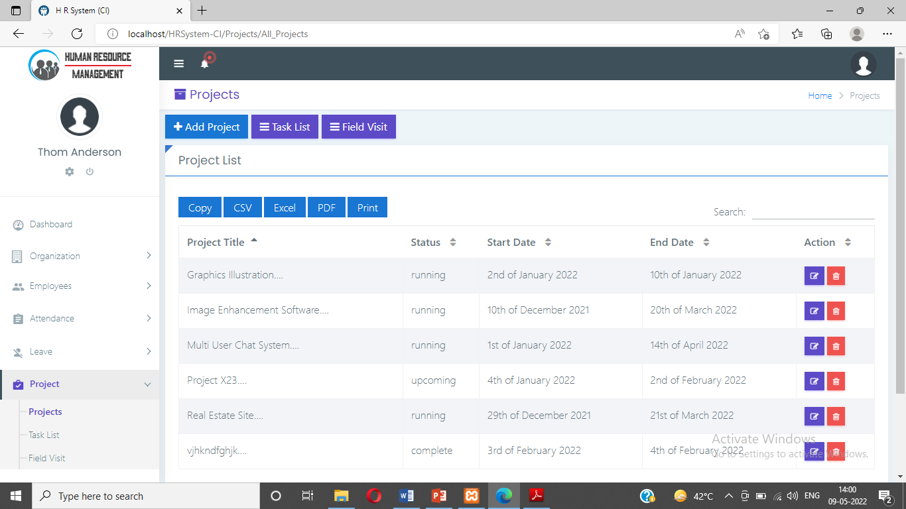

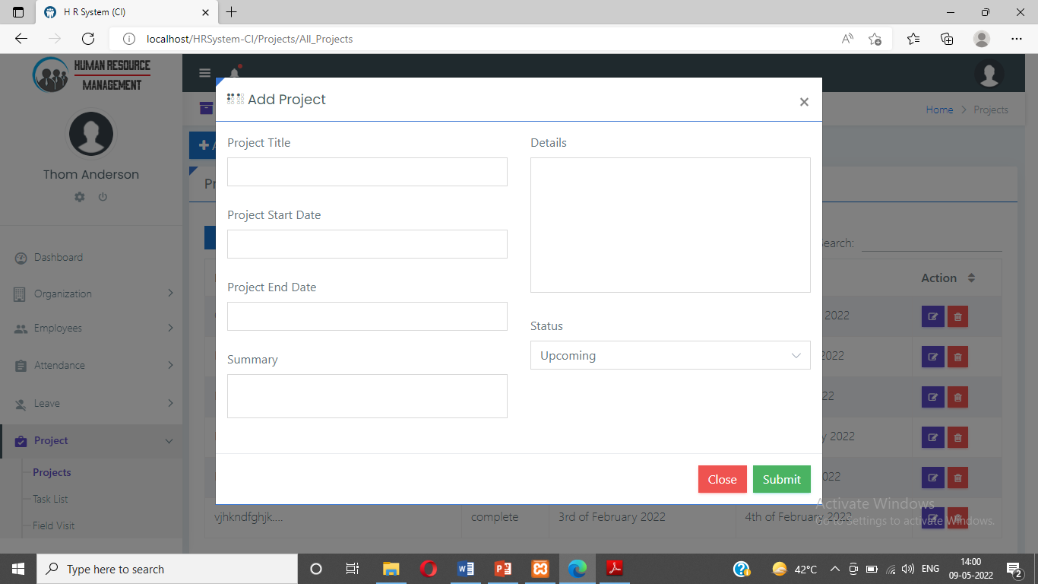

6) Task Management :

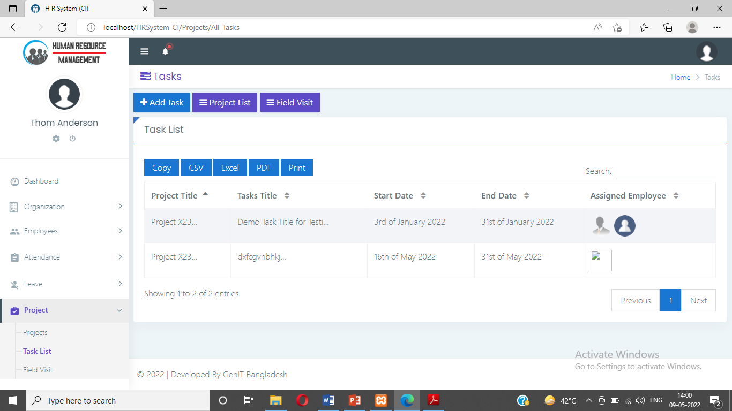

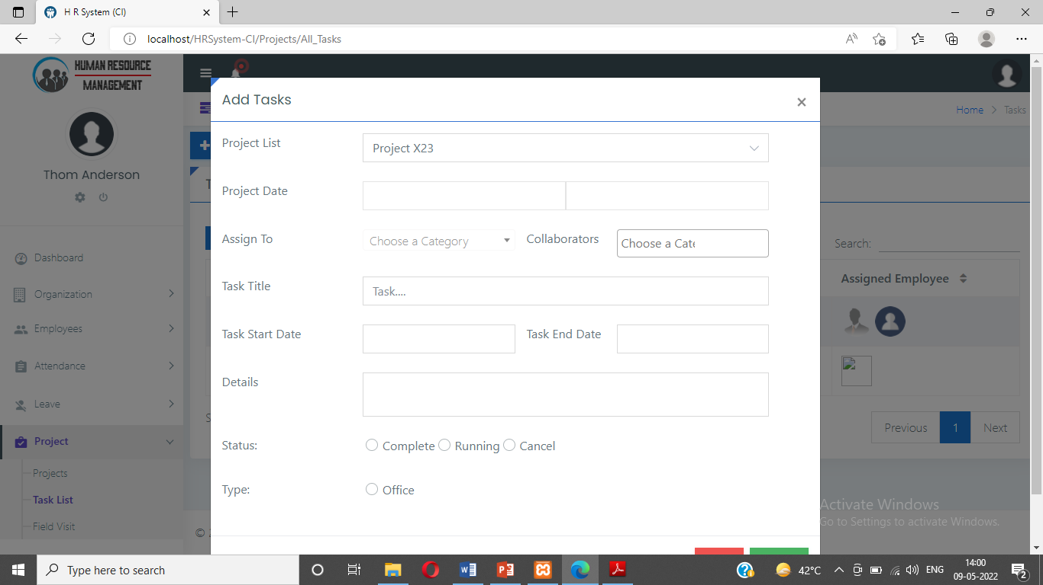

**Employee Dashboard :**

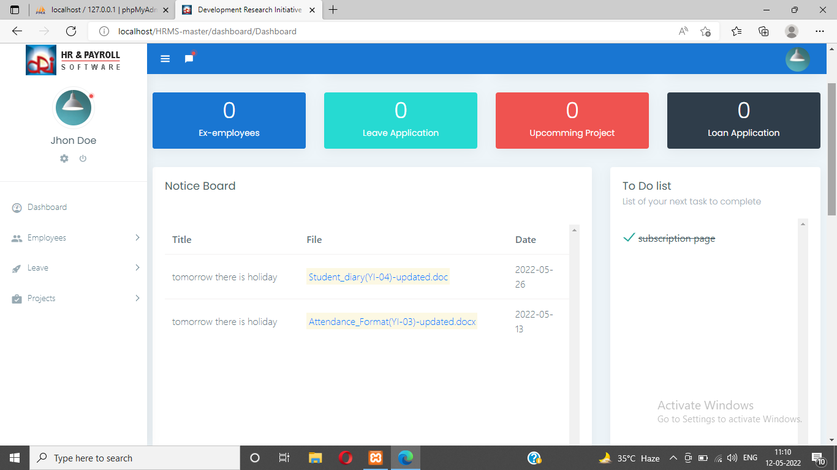

**Leave Application :**

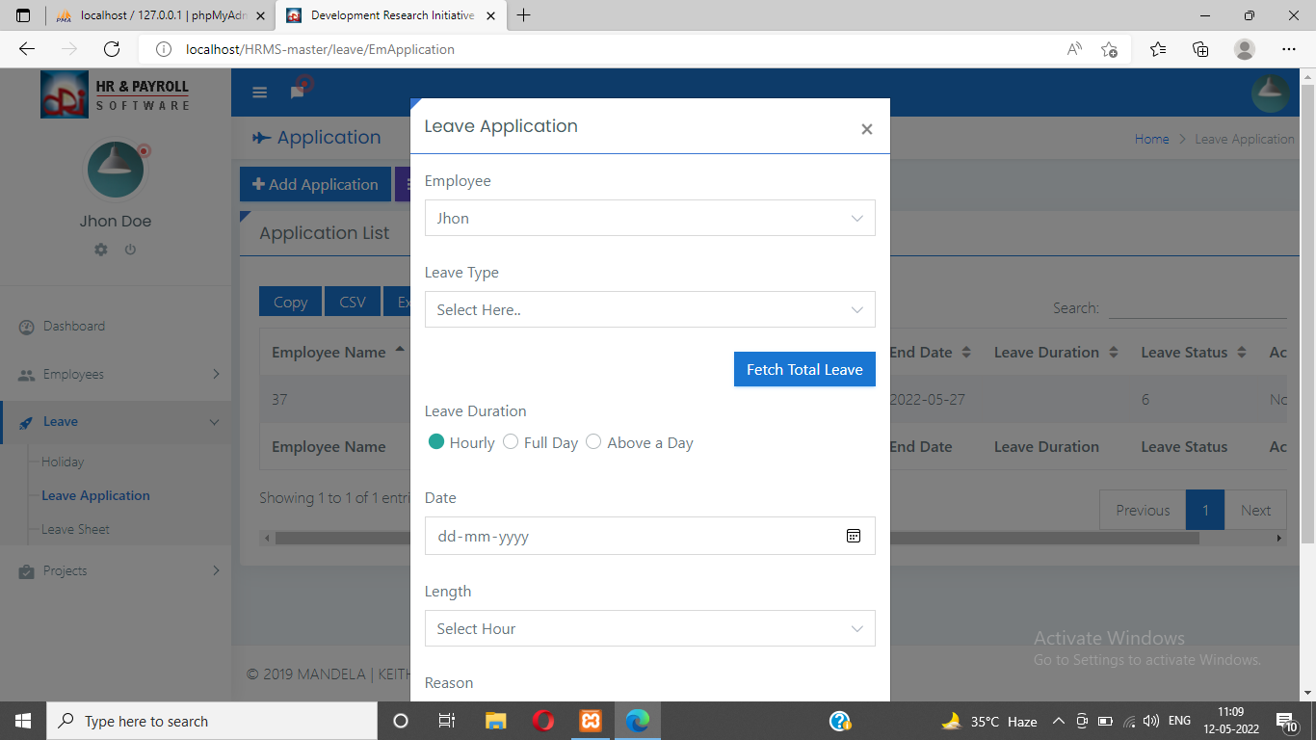

**Project/Task Management :**

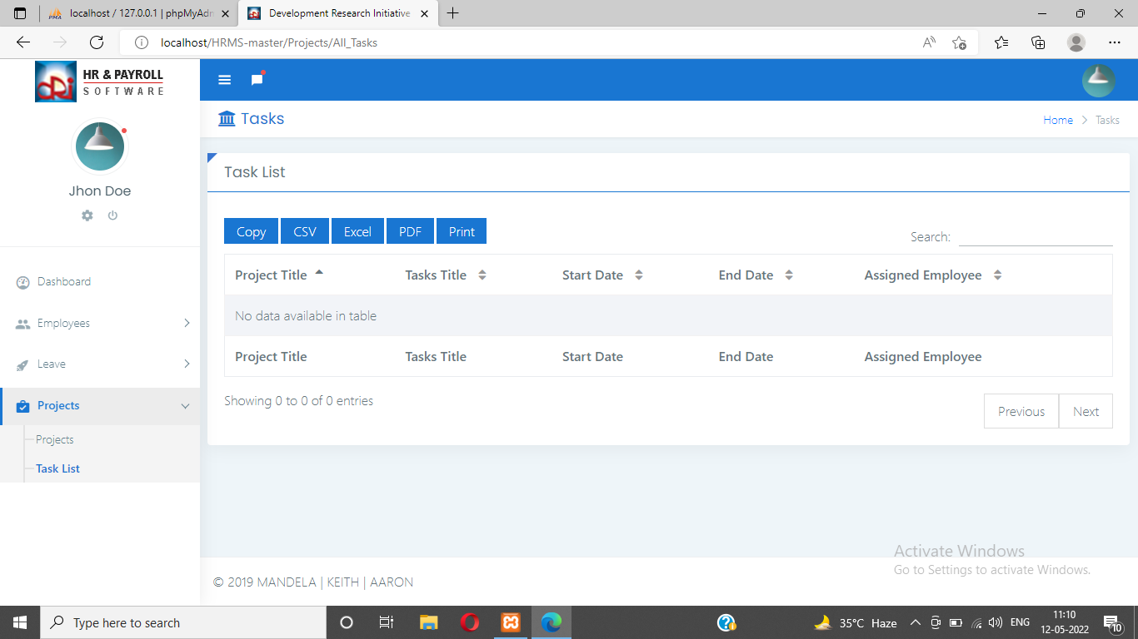

# CHAPTER 5

FUTURE SCOPE AND CONCLUSION

### CHAPTER 05 FUTURE SCOPE AND CONCLUSION

**5.1 FUTURE SCOPE AND CONCLUSION**

**Conclusion:**

The system was analyzed according to it and work on establishing a system that manages human resources according to the foundation of any institution. Through the use of the system, the manager is able to rely on him to manage and control employee data, as well as to manage attendance and absence records. By using the program, the system administrator can extract reports by employees and all related information. Employee can manage his data easily.

* In a very short time, the collection will be obvious,simple and sensible.
* It will help a person to know the management of passed year perfectly nad vividly.

# CHAPTER 6 LITERATURE CITED

### CHAPTER 6: LITERATURE CITED

### REFERENCES

### G. Ying, T. bin and G. Xiao-hui, "J2EE-based human resources s management information system design and implementation," 2nd IEEE International Conference on Computer Science and Information Technology, Beijing, 2009, pp. 25-28. doi: 10.1109/ICCSIT.2009.5234604.

### H. Kesen, "How e-HR optimizes the human resource management process," 2012 3rd International Conference on System Science, Engineering Design and Manufacturing Informatization, Chengdu, 2012, pp. 369-372. doi: 10.1109/ICSSEM.2012.6340751

### H. Ouyang and X. Lu, "On the Construction of a Human Resources Management Information System Based on CSCW for Institution of Higher Education," International Conference on E-Learning, E-Business, Enterprise Information Systems, and E-Government, Hong Kong, 2009, pp. 290-293. doi: 10.1109/EEEE.2009.79

### A.S. Navaz, A.S. Fiaz, C. Prabhadevi, V. Sangeetha & S. Gopalakrishnan, Human Resource Management System. CoRR, 2007. abs/1309.5351.