Some research on how Keycloak's session management can enhance security in a system:

Keycloak is an open-source identity and access management solution that provides authentication, authorization, and user management capabilities. Session management in Keycloak refers to the process of managing a user's authentication session after they have logged in.

The workflow of session management in Keycloak can be broken down into the following steps:

* User Authentication: The user logs in to the Keycloak application using their credentials, which can be username/password, social login, or multifactor authentication.
* Session Creation: After successful authentication, Keycloak creates a session for the user. This session contains information about the user's identity, including their username, roles, and other attributes.
* Session Management: Keycloak manages the user's session by tracking the user's activity on the application. If the user is inactive for a certain period of time, Keycloak can terminate the session to ensure security.
* Session Timeout: Keycloak allows administrators to set a session timeout for users, which can be based on user activity or a fixed time period. This can help prevent unauthorized access if a user forgets to log out of the system or leaves their computer unattended.
* Session Revocation: The user can manually revoke their session by logging out of the application. Additionally, Keycloak can revoke sessions automatically if the user's account is disabled, deleted, or if their password is reset.
* Single Sign-On (SSO): Keycloak provides SSO functionality, allowing users to authenticate once and access multiple applications without having to re-enter their credentials.
* Token Refresh: Keycloak provides refresh tokens to enable users to obtain new access tokens without having to re-enter their credentials. These tokens have a longer lifespan than access tokens and can be used to refresh the session when it is about to expire.

Role-Based Access Control: Keycloak provides Role-Based Access Control (RBAC) functionality, which allows administrators to define roles and assign permissions to users based on their roles. This can be useful for implementing fine-grained access control in a system where users have different levels of permissions based on their role.

By implementing RBAC, setting session timeouts and revoking sessions when necessary, providing refresh tokens, and enabling SSO, Keycloak can provide a secure and user-friendly solution for managing user sessions in such a system. Additionally, the use of a policy-based cryptosystem can further enhance security by enforcing fine-grained access control based on user attributes.

Keycloak provides built-in support for RBAC, including the ability to define roles, assign permissions to roles, and assign roles to users and groups. This means that RBAC is a first-class citizen in Keycloak, and it is easy to set up and manage RBAC policies within the system.

Here is an example sequence diagram of session management in Keycloak:

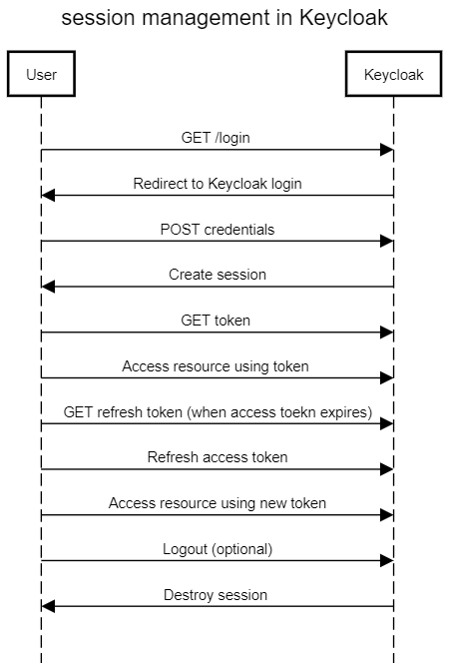

Explanation of the sequence diagram:

1. The user initiates the session management workflow by accessing a protected resource.
2. The server redirects the user to the Keycloak login page to authenticate and obtain a token.
3. The user submits their credentials to Keycloak for authentication.
4. Keycloak creates a session and generates an access token and a refresh token for the user.
5. The server verifies the access token and grants the user access to the protected resource.
6. The user can access the protected resource until their access token expires.
7. When the access token expires, the user can request a new access token using the refresh token.
8. Keycloak refreshes the access token and returns a new access token to the user.
9. The user can continue to access the protected resource using the new access token.
10. Optionally, the user can log out of the session.
11. Keycloak destroys the user's session.

This sequence diagram includes the use of refresh tokens, which allows users to obtain new access tokens without having to re-authenticate with Keycloak every time their access token expires.

Refresh tokens:

Refresh tokens are important in session management because they allow users to obtain new access tokens without having to re-authenticate with the identity provider (in this case, Keycloak) every time their access token expires. Here are some of the key reasons why refresh tokens are important:

1. Improved user experience: When a user's access token expires, they may need to go through the authentication process again to obtain a new access token. This can be inconvenient and time-consuming, particularly if the user needs to access a resource frequently. Refresh tokens help to improve the user experience by allowing users to obtain new access tokens seamlessly and without interruption.
2. Enhanced security: Refresh tokens have a longer lifespan than access tokens, and they can be revoked at any time. This means that if a refresh token is stolen or compromised, the damage that can be done is limited because the token can be invalidated by the identity provider. Additionally, because users do not need to provide their credentials every time they need a new access token, there is less opportunity for their credentials to be compromised in transit.
3. Better performance: Because refresh tokens allow users to obtain new access tokens without having to go through the authentication process again, this can help to reduce the load on the identity provider and improve the overall performance of the authentication system.

Overall, refresh tokens are an important part of session management because they help to balance security and usability, and provide a better user experience for accessing protected resources.