Assignment #5

Develop a web application (Application 1) using Spring MVC and JSP for Library Management. A librarian can login to application and manage books.

However, the details of the books and authors are maintained on a separate server (Application 2) which exposes RESTful webservices using Spring Boot to support CRUD operations on books data.

A book must be associated with an author. Authors needs to be configured in Database (not to be added through UI). While adding a book, authors will be shown in the dropdown to choose from the list.

REST APIs for CRUD operations on Author has to be provided, however no separate UI is needed for Author Management.

Following functionalities are expected

Librarian Login/Logout

Books listing

Add a book

Edit a book details REST APIs for CRUD operations on authors data

REST APIs for CRUD operations on books data

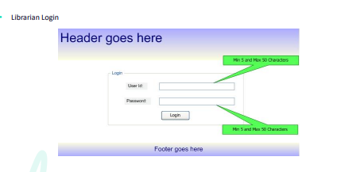

**OUTPUT :**

The complete assignment should be done using Spring MVC, Tomcat, Spring Boot and Hibernate only. • Well documented HTML, JS and CSS files

• Code should follow Java Coding Standards, Guidelines and best practices

• Follow best practices for restful webservices

• Use of appropriate HTTP codes and exception handling for REST APIs.

• Server to server webservice communication