**Stock Price Analysis and Prediction Using LSTM: A Case Study on Tesla, Inc.**

-Thota Yashaswika

Table of Contents

**Title** 3

**Executive Summary** 3

**Introduction** 3

**Theoretical Foundations** 4

**Data Structure** 4

**Analysis Procedure** 5

**Results** 7

**Conclusion** 8

**References** 9

## **Title**

**Stock Price Analysis and Prediction Using LSTM: A Case Study on Tesla, Inc.**

## **Executive Summary**

The investigation of Tesla, Inc.’s (TSLA) historical stock performance is the focus of this paper and the data analysis will involve descriptive statistics, visualizations, and a predictive model. For the analysis it also uses long short-term memory (LSTM) networks for future stock prices based on value-based history. The findings include the following whereby moving averages are used to identify the trends: Daily return analysis is used to assess risks while LSTM is used to give a robust prediction of the stock prices. The findings show that LSTM models to identify accent patterns and predict the future prices with relatively good accuracy, which makes these models helpful in the analysis of financial data.

## **Introduction**

Since ages the data analysis of the stock markets has remained one of the key factors in the financial research for investments. Currently, stock price prediction is quite a relevant yet difficult problem for investors and analysts who want to maximize portfolio performance or minimize financial risk. Automotive and energy sector industries such as Tesla, Inc. are one of the most volatile and high-growth companies of today which makes it a great subject through which to study stock price fluctuation. Machine learning and deep learning technologies in recent time offer efficient instruments for analyzing the stock price and for making the future predictions. Of the many types of recurrent neural network (RNN) that have been found useful for time series prediction particularly in the financial data domain is the Long Short-Term Memory (LSTM) networks. LSTM networks are used in this study to predict the Tesla’s stock prices, because of its special feature of learning sequences in a dataset. This work is a systematic review of Tesla’s stock performance using both conventional statistical analysis and up-to-date machine learning methods used to analyze trends in stock market prices and volatilities and make predictions on the pattern that Tesla is most likely to follow in the future. The results do not only support the concept also LSTM networks provide a good forecast result for financial data but also make a new contribution to the area of deep learning for stock trading.

## **Theoretical Foundations**

Price prediction of stocks has been among the most pursued finance and computation research for many years. Historical methods for forecasting involve the use of such models as regression models and autoregressive integrated moving average (ARIMA) models, which exhibit drawbacks in that they assume that stock price changes are linear and stationary. The decision-making points are thus well captured by deep learning models especially the Long Short Term Memory (LSTM) networks given the inability to capture nonlinear patterns and long-term dependencies from time series data. LSTMs are a type of recurrent neural network specifically aimed at solving the vanishing gradient problem thus allowing itself to learn in sequences over very long intervals. Hochstein and Hotter (2018) have illustrated that the basic stock prices predict much better-applying LSTMs compared with extant approaches because LSTMs include sophisticated temporal characteristics of the financial time-series data. In addition, Fischer and Krauss (2018) demonstrated the effectiveness of LSTMs in predicting stock index movements by capturing sequential patterns and managing non-linear dependencies in financial data. Extending the line of studies in using LSTMs for stock price analysis, this paper utilizes LSTMs to analyze Tesla’s stock data where actual stock prices are shown to be predicted with high accuracy employing the proposed models.

## **Data Structure**

This study utilizes a dataset of daily stock prices for Tesla, Inc., extending over 1,692 trading days. It consists of the variables of Open, High, Low, and Close, whichever daily trading range and volume which shows the total number of shares traded in a day. Furthermore, the datasets contain the Adj Close price, the corrected for stock splits, or any other corporate events in the actual stock price to enable effective analysis. The analyzed data presents an arithmetic mean of an adjusted closing price of $132.43 showing a minimum of $15.80 and a maximum of $286.04 illustrating a significant upward movement and fluctuation of Tesla in the observed period.

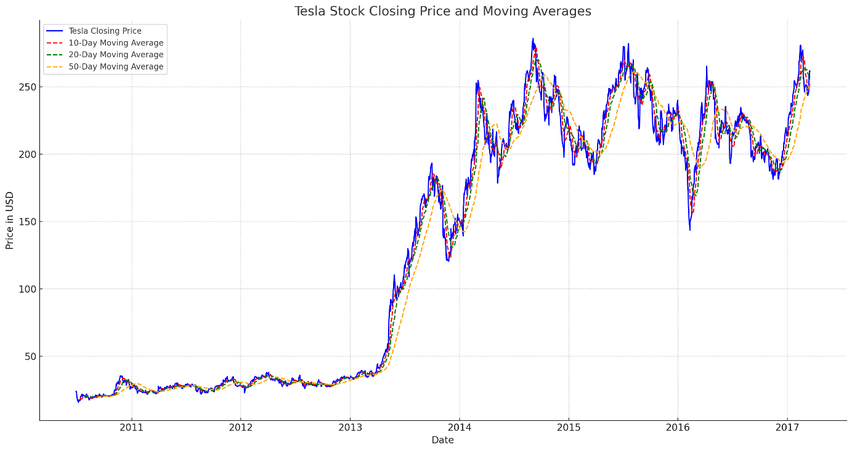

Additional data analysis and visualizations such as closing prices over time and trading volumes in time series complete this analysis of Tesla’s performance in the stock market. The above analyses are the basis of the given dataset, as they allow you to define patterns and trends that will be necessary when making estimates for predictive modeling.

## **Analysis Procedure**

In line with the research questions and objectives, the analysis is conducted in a stepwise manner starting with the ea of the data to identify patterns. To make a quantitative analysis a descriptive statistical approach is used for summarizing Tesla’s stock performance and making visualizations in the form of line plots and heat maps to establish relations between variables. Finally, the shorter periods of 10, 20, and 50 days of moving averages to identify short and long-term trends.

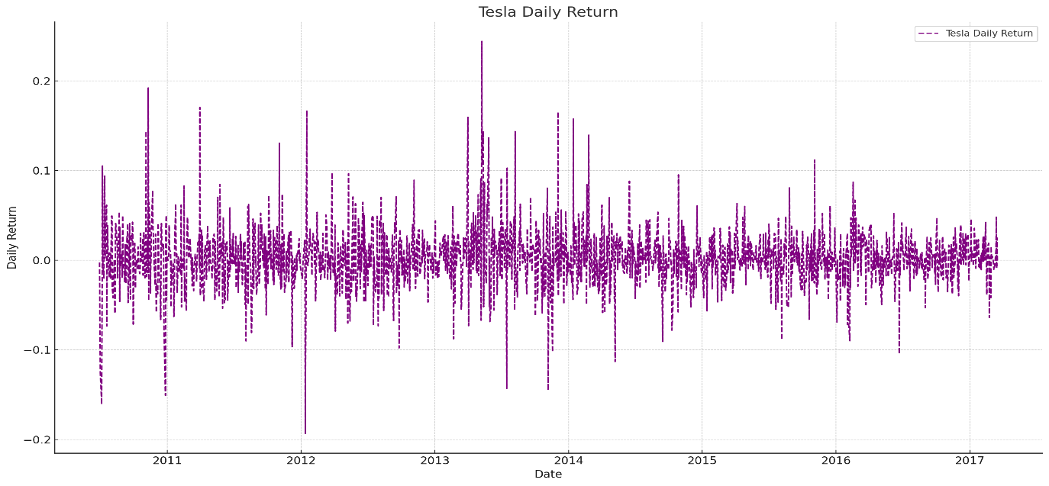

To evaluate Tesla’s daily returns and its volatility and risk the return series is calculated. Next, for the LSTM model, the normalized adjusted closing prices are transformed into input sequences over 60-day moving window. This LSTM network is developed and then trained by data of 80% data and tested by the remaining 20% of data. The model accuracy is determined by comparing RMSEs of the predictions against the actual price The predicted prices for the products are then compared with the actual prices of the products. Such a work organization guarantees the identification of all essential patterns in Tesla’s stock data.

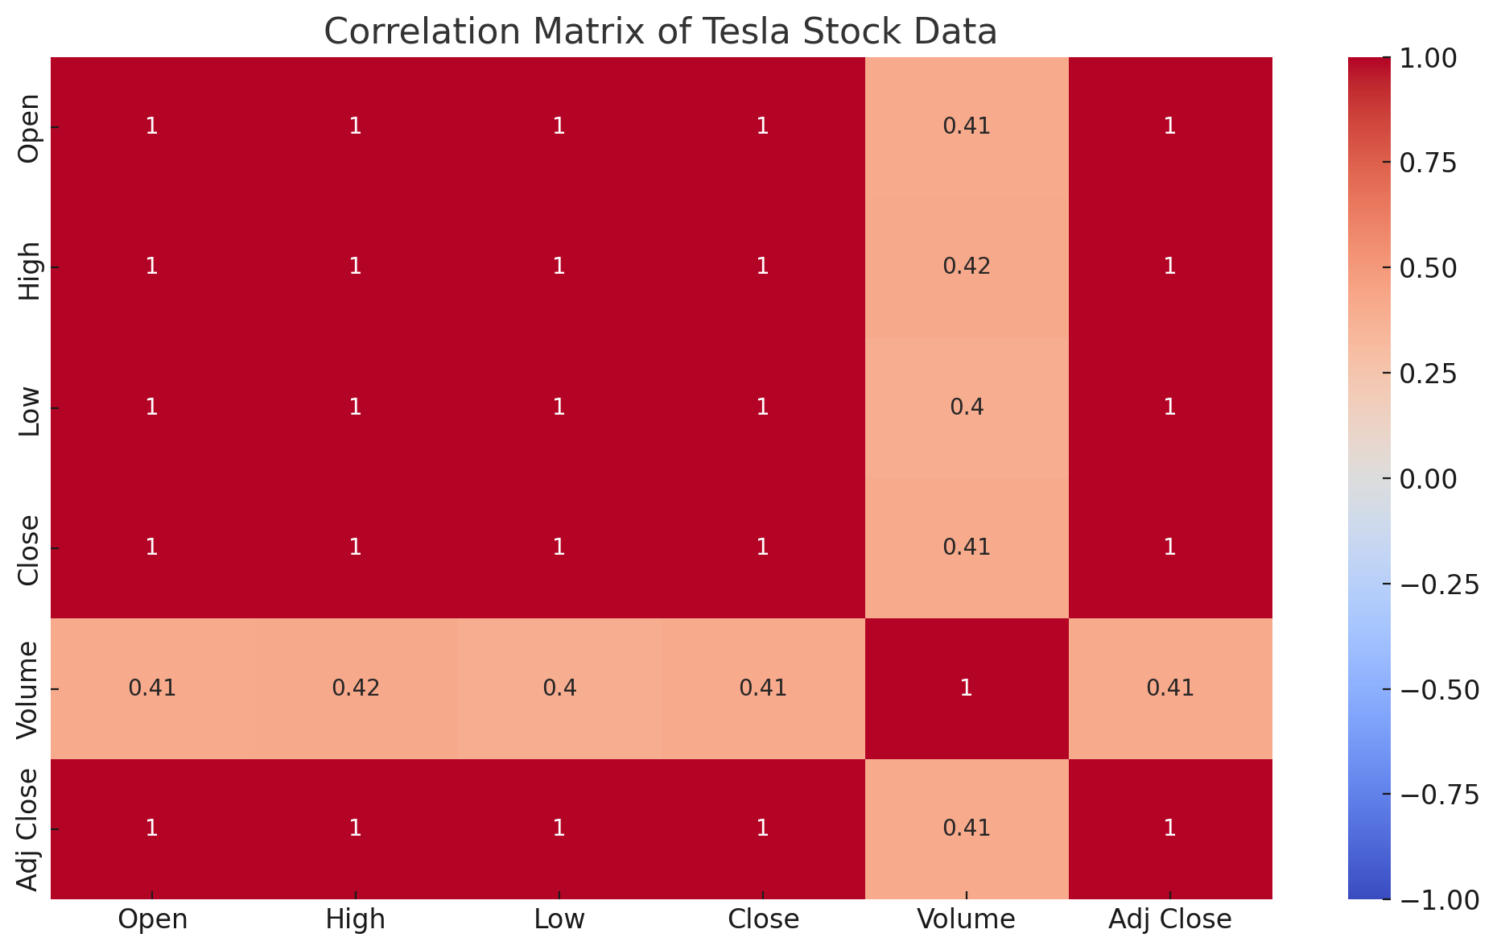

## **Results**

First, the study offers some important findings to explain the Tesla stock value and the potential of LSTM for predicting belongings to it. The results presented in the tables below indicate that the stock is quite a volatile one due to frequent and large daily returns and trading volumes. The moving average analysis shows that the 10-day and 20-day moving averages are useful tools for identifying short-term trends and the 50-day moving average helps to also minimize sharp and long-term movements. Daily price metric pairs are highly correlated while volume exhibits less correlation with the prices but exhibits different characteristics more representative of volumes. In the current work, the LSTM model is proven to have the ability to capture sequential patterns in data with a relatively low RMSE value and correctly timed stock price prediction estimates. The visual alignment of the predicted and actual prices indicates exactly how the model is following Tesla’s stock movement, and this information will be of immense benefit to investors and analysts.

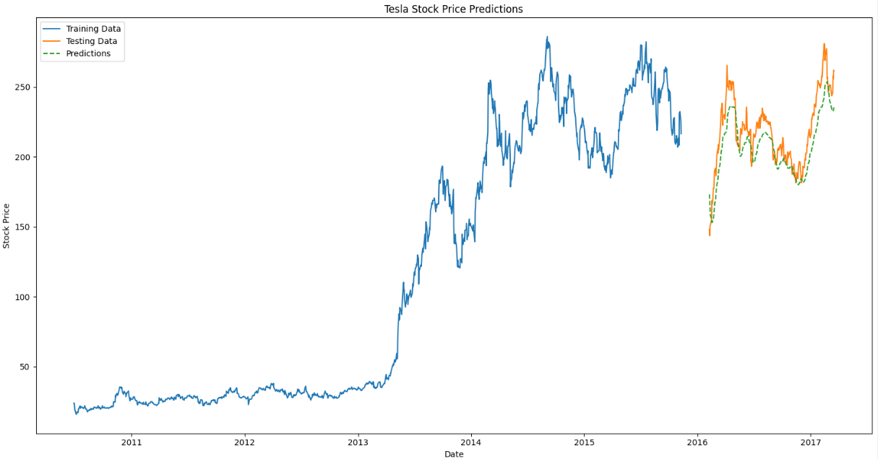

## **Conclusion**

Thus, this study supports the usefulness of LSTM networks in stock price prediction especially to the volatile and high-growth stocks such as Tesla. Grounded on a synthesis of classical inferential techniques and modern artificial neural network approaches, this work offers a sound foundation for analyzing and predicting the dynamics of SPs. The findings specifically indicate that Tesla has high fluctuation, stressing that complex models, such as LSTM, can help investors avoid risks and make profits. In the future, to improve the results of the LSTM model, a few more features like macroeconomic indicators or sentiment analysis can also be added. In the broad area of machine learning application in finance, this work adds to the literature on the use of deep learning models for stock price prediction.