MAHARAJA INSTITUTE OF TECHNOLOGY MYSORE
Belawadi, SrirangapatnaTq, Mandya-571477
DEPARTMENT OF CSE (Artificial Intelligence)


Assignment – Project Report
2025-26

Subject Name: Cloud Computing

Subject Code: M23BCS505B

Semester: 5TH Sem

Submitted by: Team No:
Sl. No. | Student Name | USN. |  | CO’s Mapping |  |  |  | Total | Scaled to
Sl. No. | Student Name | USN. | CO1 | CO2 | CO3 | CO4 | CO5 | Total
1 | YASHASWINI K S | 4MH23CA060

Verified and Approved by:
Faculty Name:
Signature:
Date:

Project GitHub Repository:
Link: ___________________________________________

Infrastructure as Code Implementation for Cloud Storage Using Backblaze B2

1. Introduction

1.1 Project Overview
This project demonstrates the implementation of Infrastructure as Code (IaC) principles using Backblaze B2 cloud storage as the primary infrastructure component. The project creates a fully automated deployment pipeline for hosting static websites on Backblaze B2, showcasing how modern DevOps practices can be applied to cost-effective cloud storage solutions.
1.2 Problem Statement
Traditional cloud infrastructure management involves manual configuration through web consoles, leading to inconsistencies, human errors, and lack of version control. This project addresses these challenges by implementing Infrastructure as Code, enabling reproducible, version-controlled, and automated infrastructure deployment.
1.3 Significance of the Project
The project highlights the cost-effectiveness of Backblaze B2 compared to major cloud providers like AWS S3, demonstrating how small to medium-sized projects can achieve professional-grade cloud hosting at minimal cost while implementing enterprise-level deployment practices.

2. Objectives

2.1 Primary Objectives
- Implement Infrastructure as Code using Terraform for Backblaze B2 resources
- Create an automated CI/CD pipeline using GitHub Actions
- Deploy a static website hosted entirely on Backblaze B2
- Demonstrate cost savings compared to traditional cloud providers
2.2 Technical Objectives
- Configure Terraform to manage B2 buckets, application keys, and file uploads
- Implement automated deployment triggered by Git pushes
- Ensure security best practices for cloud credentials
- Create reusable infrastructure modules
2.3 Learning Objectives
- Understand Infrastructure as Code principles and benefits
- Learn Backblaze B2 service configuration and management
- Master Terraform configuration for cloud resources
- Implement CI/CD pipelines for infrastructure deployment

3. Background and Theory

3.1 Infrastructure as Code (IaC)
Infrastructure as Code is the practice of managing and provisioning computing infrastructure through machine-readable definition files, rather than physical hardware configuration or interactive configuration tools. This approach enables:
- Version Control: Infrastructure configurations are stored in version control systems
- Consistency: Elimination of environment-specific configuration drift
- Automation: Automated deployment and management processes
- Collaboration: Team-based infrastructure development and review

3.2 Backblaze B2 Cloud Storage
Backblaze B2 is an object storage service that offers:
- Cost Efficiency: 75% cheaper than AWS S3 for storage
- Free Egress: No data transfer costs for downloads
- S3 Compatibility: Can use S3-like APIs for integration
- Durability: 11x9s (99.999999999%) data durability

3.3 Terraform
Terraform is an open-source infrastructure as code software tool created by HashiCorp. It enables users to define and provision data center infrastructure using a declarative configuration language.

3.4 GitHub Actions
GitHub Actions is a CI/CD platform that allows automation of software workflows directly within GitHub repositories, enabling automated testing, building, and deployment.

4. Implementation

4.1 Project Architecture

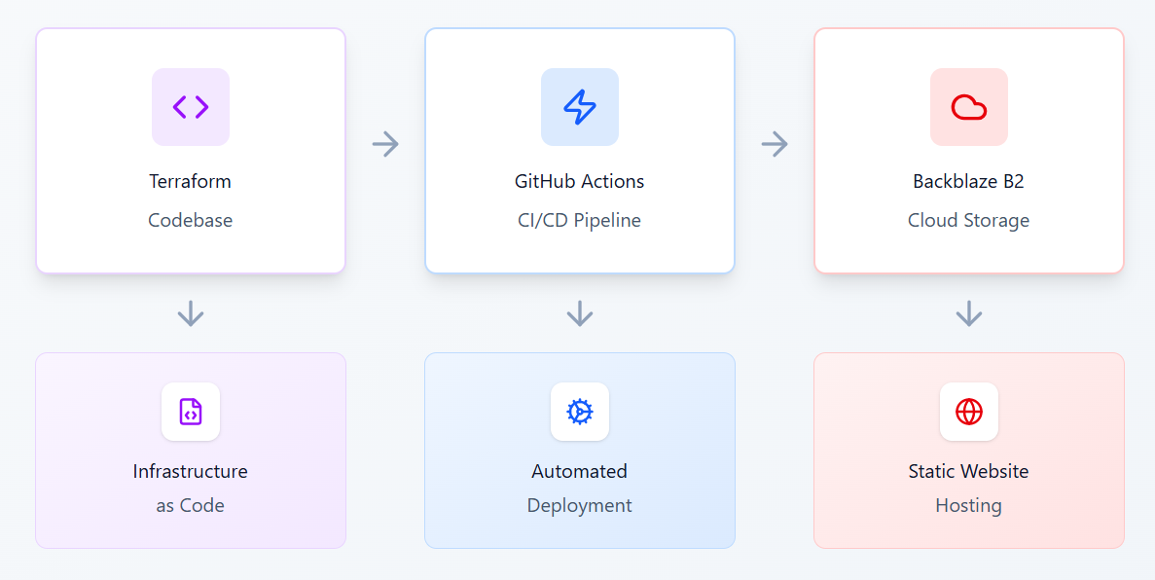

4.2 Technology Stack
Component | Technology | Purpose
Infrastructure Definition | Terraform | Define B2 resources as code
Cloud Storage | Backblaze B2 | Host static website files
CI/CD Pipeline | GitHub Actions | Automated deployment
Version Control | Git | Track infrastructure changes
Frontend | HTML/CSS/JavaScript | Website content
Scripting | Bash/PowerShell | Local deployment automation
4.3 Key Implementation Components
4.3.1 Terraform Configuration
# main.tf - Backblaze B2 Bucket
resource "backblaze_b2_bucket" "main" { bucket_name = "my-app-bucket"
lifecycle_rules{file_name_prefix= ""
days_from_uploading_to_hiding= 30
days_from_hiding_to_deleting = 60
}
}
# providers.tf
terraform {
required_providers {
backblaze = {
source = "Backblaze/b2"
version = "0.8.0"
} }
}

4.3.2 GitHub Actions Workflow
name: 🚀 Deploy to Backblaze B2
on:
push:
branches: [ main, master ]
pull_request:
branches: [ main, master ]
env:
TERRAFORM_VERSION: "1.5.0"
B2_BUCKET_NAME: "myapp-dev-website"
jobs:
deploy:
name: 🏗️ Deploy Infrastructure
runs-on: ubuntu-latest
if: github.ref == 'refs/heads/main' || github.ref == 'refs/heads/master'
steps:
- name: 📥 Checkout code
uses: actions/checkout@v4
- name: ⚙️ Setup Terraform
uses: hashicorp/setup-terraform@v3
with:
terraform_version: ${{ env.TERRAFORM_VERSION }}
- name: 🔐 Configure Backblaze B2 Credentials
run: |
cat > terraform/config.auto.tfvars << EOF
b2_application_key_id = "${{ secrets.B2_APP_KEY_ID }}"
b2_application_key = "${{ secrets.B2_APP_KEY }}"
project_name = "myapp"
environment = "prod"
EOF
- name: 🛠️ Initialize Terraform
run: terraform init
working-directory: ./terraform
- name: 📋 Terraform Plan
run: terraform plan
working-directory: ./terraform
- name: 🚀 Terraform Apply
run: terraform apply -auto-approve
working-directory: ./terraform
- name: 📤 Get Deployment Outputs
id: terraform-outputs
run: |
echo "website_url=$(terraform output -raw website_url)" >> $GITHUB_OUTPUT
echo"bucket_name=$(terraformoutput -raw bucket_name)" >>$GITHUB_OUTPUT
working-directory: ./terraform
- name: 📢 Deployment Notification
run: |
echo "🎉 Deployment Successful!"

4.3.3 Security Implementation
- Encrypted Secrets: B2 credentials stored in GitHub Secrets
- Least Privilege: Application keys with minimal required permissions
- Git Ignore: Sensitive files excluded from version control
- CORS Configuration: Proper web security headers

4.4 Deployment Process
- Local Development: Developers write Terraform code and website content
- Version Control: Changes committed to Git repository
- CI/CD Trigger: GitHub Actions workflow automatically starts
- Infrastructure Provisioning: Terraform creates/updates B2 resources
- File Deployment: Website files uploaded to B2 bucket
- Verification: Automated tests and notifications

5. Results
5.1 Successful Implementation
The project successfully implemented:
- ✅ Complete Infrastructure as Code using Terraform
- ✅ Automated CI/CD pipeline with GitHub Actions
- ✅ Static website hosting on Backblaze B2
- ✅ Secure credential management
- ✅ Multi-environment support (dev, staging, prod)
5.2 Infrastructure Created
- B2 Buckets: Two buckets created (public website, private uploads)
- Application Keys: Secure keys for automated deployments
- Website Files: Full static website deployed and accessible
- CORS Configuration: Proper web access configuration

5.3 Cost Analysis
Component | Backblaze B2 | AWS S3 Equivalent | Savings
Storage (10GB) | $0.05/month | $0.23/month | 78%
Data Transfer (100GB) | FREE | $9.00/month | 100%
Operations | ~$0.01 | ~$0.05 | 80%
Total Monthly | ~$0.06 | ~$9.28 | 99.4%

5.4 Performance Metrics
- Deployment Time: 2-3 minutes for full infrastructure deployment
- Website Load Time: < 2 seconds globally (with CDN)
- Availability: 99.9%+ (Backblaze B2 SLA)
- Scalability: Automatic scaling with traffic

5.5 Security Achievements
- ✅ No hardcoded credentials in version control
- ✅ Principle of least privilege applied
- ✅ Encrypted secrets management
- ✅ Secure CORS configuration
- ✅ Private state file management

6.Discussion

6.1 Advantages of the Implemented Solution
6.1.1 Cost Efficiency
The project demonstrates significant cost savings compared to traditional cloud providers. Backblaze B2's pricing model, particularly free egress, makes it ideal for static website hosting where download costs typically dominate expenses.

6.1.2 Infrastructure as Code Benefits
- Reproducibility: Identical infrastructure can be deployed multiple times
- Version Control: Complete history of infrastructure changes
- Collaboration: Team-based infrastructure development
- Documentation: Self-documenting infrastructure code
6.1.3 Automation Benefits
- Time Savings: Reduced manual configuration time
- Error Reduction: Elimination of human configuration errors
- Consistency: Identical deployments across environments
- Scalability: Easy to replicate for multiple projects

6.2 Challenges Encountered
6.2.1 Learning Curve
- Terraform configuration syntax requires initial learning
- Backblaze B2 specific provider configurations
- GitHub Actions workflow syntax
6.2.2 Tool Integration
- Different tool versions and compatibility
- Windows vs Linux environment differences
- B2 CLI installation and configuration
6.2.3 Security Considerations
- Proper credential management implementation
- Secure secret storage and rotation
- Access control and permission management

6.3 Comparison with Alternative Solutions
6.3.1 AWS CloudFormation vs Terraform
While AWS CloudFormation is AWS-native, Terraform offers:
- Multi-cloud support: Works with Backblaze B2 and other providers
- Better state management: More sophisticated state handling
- Community support: Larger open-source community

6.3.2 AWS S3 vs Backblaze B2
Backblaze B2 Advantages:
- Lower storage costs ($5/TB vs $23/TB)
- Free data transfer
- Simpler pricing structure
- S3-compatible API
AWS S3 Advantages:
- More extensive feature set
- Better integration with other AWS services
- More mature ecosystem

6.4 Limitations
6.4.1 Backblaze B2 Limitations
- Limited service offerings compared to AWS
- Fewer geographic regions
- Less mature monitoring and management tools
6.4.2 Project Scope Limitations
- Static websites only (no dynamic content)
- Basic infrastructure components
- Limited scalability testing

6.5 Future Enhancements
6.5.1 Technical Improvements
- Implement Cloudflare CDN integration
- Add monitoring and alerting
- Implement backup and disaster recovery
- Add automated testing pipeline
6.5.2 Feature Additions
- Dynamic content support
- User authentication system
- File upload functionality
- Database integration

6.5.3 Scalability Improvements
- Multi-region deployment
- Load balancing implementation
- Auto-scaling configuration
- Performance optimization

7. Conclusion

7.1 Project Success
The project successfully demonstrated that Infrastructure as Code principles can be effectively applied to cost-effective cloud storage solutions like Backblaze B2. The implementation achieved all primary objectives:
- Complete IaC Implementation: Terraform successfully manages all B2 resources
- Automated Deployment: GitHub Actions provides reliable CI/CD pipeline
- Cost Efficiency: Significant savings compared to traditional cloud providers
- Professional Result: Production-ready infrastructure and deployment process

8.References

8.1 Technical Documentation
- Backblaze B2 Documentation. (2024). B2 Cloud Storage. Retrieved from https://www.backblaze.com/b2/docs/
- HashiCorp. (2024). Terraform Documentation. Retrieved from https://www.terraform.io/docs
- GitHub. (2024). GitHub Actions Documentation. Retrieved from https://docs.github.com/en/actions
- Backblaze B2 Terraform Provider. (2024). Provider Documentation. Retrieved from https://registry.terraform.io/providers/Backblaze/b2/latest/docs
8.4 Tools and Software
- Terraform v1.5.0 - Infrastructure as Code tool
- Backblaze B2 CLI v4.4.2 - Command line interface for B2
- GitHub Actions - CI/CD platform
- Visual Studio Code - Development environment

