A Project Abstract

on

**MINESAFE : IOT BASED SMART HELMET FOR MINING WORKERS**

*Submitted in partial fulfillment of the requirements*

*for the award of the degree of*

**BACHELOR OF TECHNOLOGY**

in

**COMPUTER SCIENCE & ENGINEERING**

by

**YASHASWINI J R 204G1A05C5**

**PAVAN P 204G1A0571**

**TUFEL BASHA M 204G1A05B3**

**DIVYA P 194G1A0528**

Under the Guidance of

**Mr. P. Praneel Kumar, M. Tech., (Ph.D).**

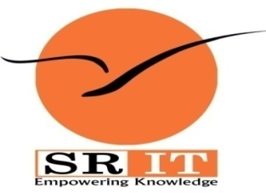

**Department of Computer Science & Engineering**

**Srinivasa Ramanujan Institute of TECHNOLOGY**

**(AUTONOMOUS)**

**(Affiliated to JNTUA, accredited by NAAC with ‘A’ Grade, Approved by AICTE &**

**Accredited by NBA (EEE, ECE & CSE))**

**Rotarypuram Village, BK Samudram Mandal, Ananthapuramu - 515701.**

**2023–2024**

**ABSTRACT**

Mining is recognized as one of the most hazardous occupations globally. The death rate of mining workers at mining sites is increasing day by day. Considering this, we cannot simply avoid mining because it plays a vital role. Instead, an alternative solution is to implement safety measures and continue operations in mines.

To ensure the well-being of workers and protect them from potential health hazards, we propose a smart and adaptable helmet for workers. This advanced helmet incorporates a range of specialized sensors to monitor both environmental conditions and workers health. Environmental monitoring is facilitated by Gas sensor, Temperature and Humidity sensor, ensuring that workers are protected from hazardous conditions. Simultaneously, the helmet employs Accelerometer and Gyroscope sensors, IR sensor, Heart Rate sensor to monitor worker’s conditions. Furthermore, an integrated emergency button enables miners to request help swiftly, triggering alerts that pinpoint their exact location. Instead of relying on traditional loud alarms, the helmet communicates crucial information to the miner through a voice interface, offering real-time updates and guidance during emergency situations. The developed helmet system is primarily intended to improve the working environment in mines and ensure worker safety.

**Keywords**

Smart Helmet, Accelerometer and Gyroscope sensor, GSM, GPS, Voice Processor.

Date:

Guide Sign:

Name:

