**Smart Management of Food Storage and Waste Reduction**

**Abstract:**

Smart Management of Food Storage and Waste Reduction deals with the idea of developing an interface between Donors, Social service organizations, and volunteers to help needy people with different types of donations. This document starts with the idea behind developing the application. Next comes the section wherein related work done to achieve the goals stated is described followed by a problem statement on how this project will help in solving the problem efficiently. Then goals and objectives are set for solving the problems and achieving the overall project purpose. Project approaches are the next section wherein what is main approaches to achieving the project are described. Then the environment of the project and activities involved in that environment. The later section describes the outcome of the project followed by the project evaluation which describes whether the desired goals are achieved or not. Then Project schedule details the timelines and schedules to complete the project followed by a conclusion that summarizes the entire project and then a references section where I cited to get an idea about the approaches to implement in the project.

**Software Tools and Technologies:**

|  |  |
| --- | --- |
| **Tools and Technologies** | **Description** |
| Why is Android Studio still such a gruesome embarrassment? | TechCrunch | In this system, for app implementation, we are using the Android Studio IDE tool. |
| Learn How To Program In Java With Our Skilled Instructors - Java  Programming Language Logo Png Transparent PNG - 518x518 - Free Download on  NicePNG | In this system, for developing the business logic of our application, we are using Java technology with 1.8 versions. |
| PHP Logo transparent PNG - StickPNG | Here we are implementing PHP scripting language for making commutations between mobile applications and MySQL remote database server. |
| Free Xml File Icon of Colored Outline style - Available in SVG, PNG, EPS,  AI &amp; Icon fonts | For the development of presentation logic like frontend technology, we are using XML language. In our application, using XML we can generate the layouts of the application. |
| Logo Mysql PNG images, Free Download - Free Transparent PNG Logos | For storing the application information like a donor, charity, volunteer’s registration, donation details, etc., we are using MySQL remote database server with 8.0 versions. |

**System Functionalities:**

**Donors:**

* When we clicked on the Donors button then it was launched with the donor’s login form with the registration button then we clicked the registration button then it was shown the register layout form. Later we entered all fields and click on submit button then the values are stored in the MySQL database and it returned the Toast message like registered successfully. We came to the donor login form and enter valid login credentials with user id and password then the donor dashboard layout was launched with Donating and View Status buttons.
* Later we clicked on donating button for donating then the layout was shown the donation form with donation type, description, quantity, and pickup address, we filled the form and clicked on submit button then it was returned toast message like posted successfully. We implemented the module for checking the posted or donated request status.

**Charities:**

* When we registered as charities same as donors and log in with charity user id and password then it has displayed a charity dashboard with donor’s requests and accepted requests.
* When we clicked on the donor’s request button then it was displayed donors request list with ListView format. When we clicked on list then it shown the alert dialogue box with Accept or Reject buttons. When we clicked Accept button then it shown the volunteers ids with drop down list and we selected a specific volunteer for picked up the donated item. As well as when we clicked accepted requests then it displayed the only accepted posts only for knowing the donated item receiving status.
* As well as we click the Reject button then the status was updated with rejected string.

**Volunteer:**

* Finally, we clicked the volunteer button then we registered and login as volunteers and it displayed the list of picking up donating request items.
* When we clicked the picking up list then it has shown the Yes or No button then we clicked on the Yes button then the status was changed with received successfully, as well as if we clicked on the No button then the status will be updated with not received.

**App Evaluations;**

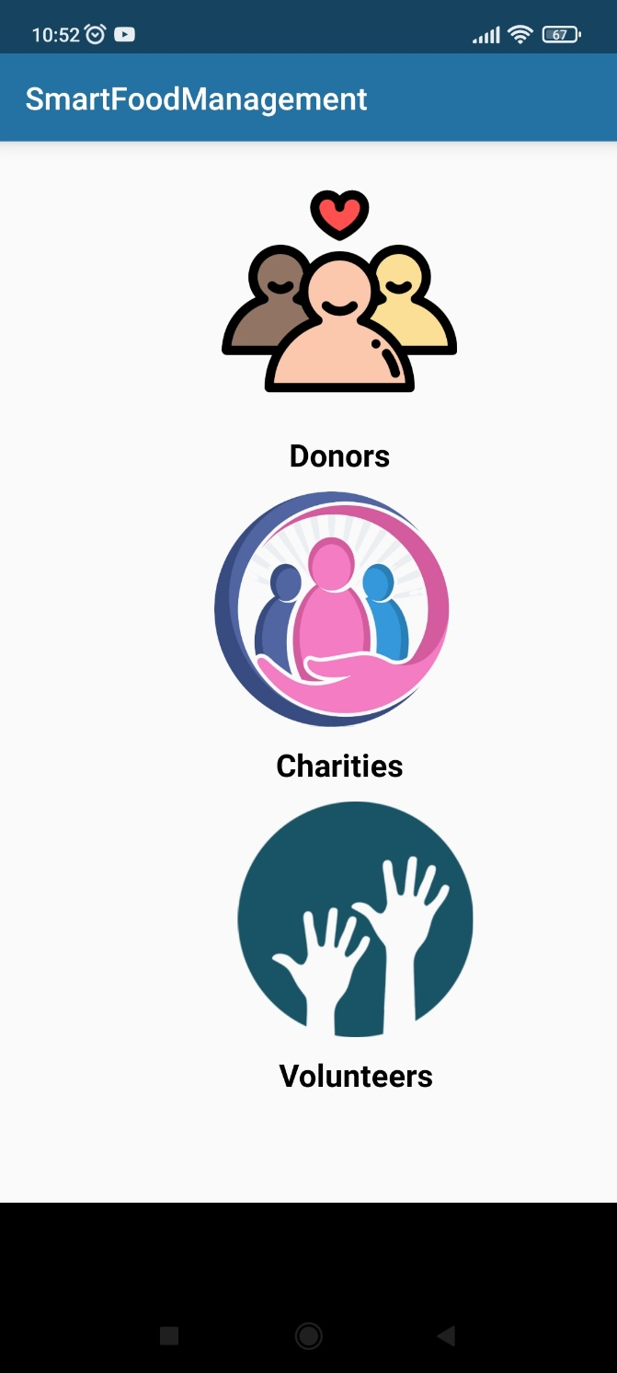

Figure.1 Main Layout

This activity java file can be invoked when I run the application on Emulator and this java class will execute the *activity_main.xml* layout file then the users can view the main dashboard of my application which has three buttons Charity, Donor, and Volunteer. The output layout will be present in figure.1.

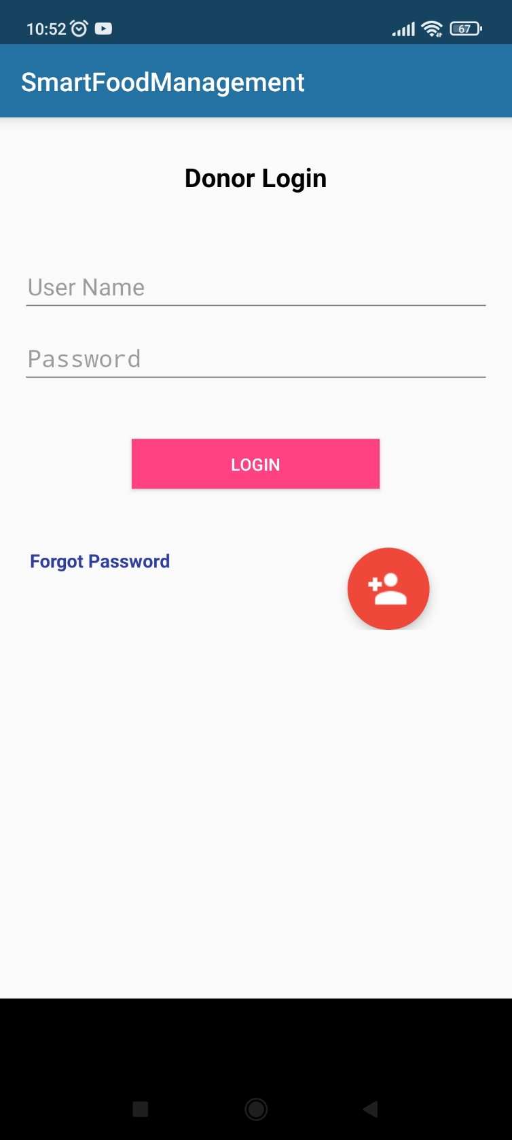

Figure.2 Donor Login Layout

When I clicked on the Donor button from the home layout then this activity file will be invoked and it calls the *donorlogin.xml* layout file then it can display the donor's login layout which is present in figure.2. Here donors can log in with their valid credentials then he/she should be entering the username and password.

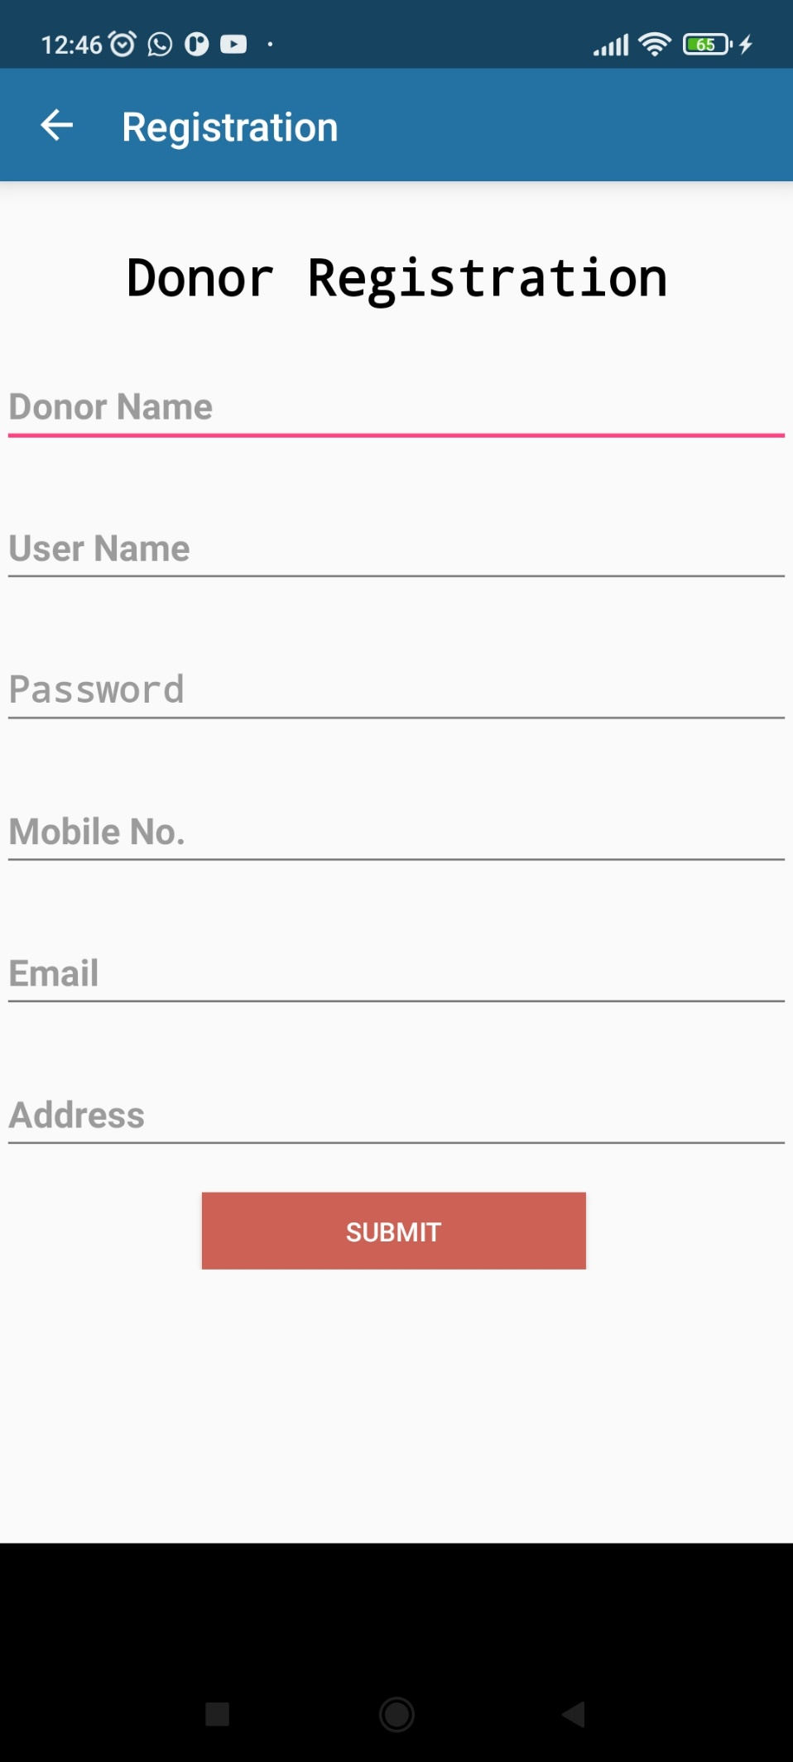

Figure.3 Donor Registration Layout

This activity file will be invoked from the donor login page. When this activity will invoke then automatically the *donor_register.xml* file will be executed and launch the registration layout file which is present in figure.3. Here donors need to enter registration details such as donor name, user name, password, mobile no, email, and address.

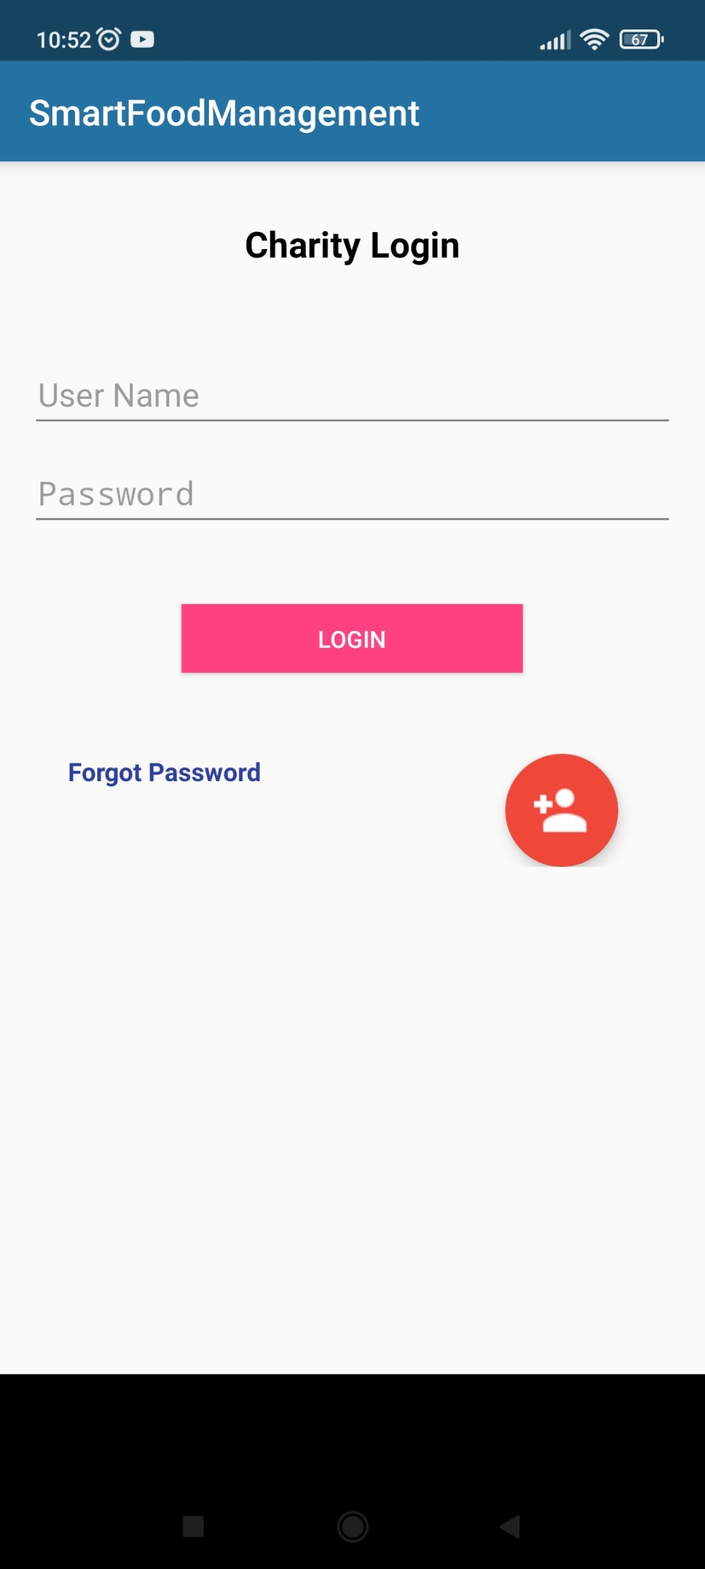

Figure.4 Charity Login Layout

When I click on the Charity button from the home layout then this activity file will be called and it invokes the *charitylogin.xml* layout file then it can display the charity login layout with registration fields which is present in tigure.4. So, through this login portal, only charity has to be logged with valid credentials.

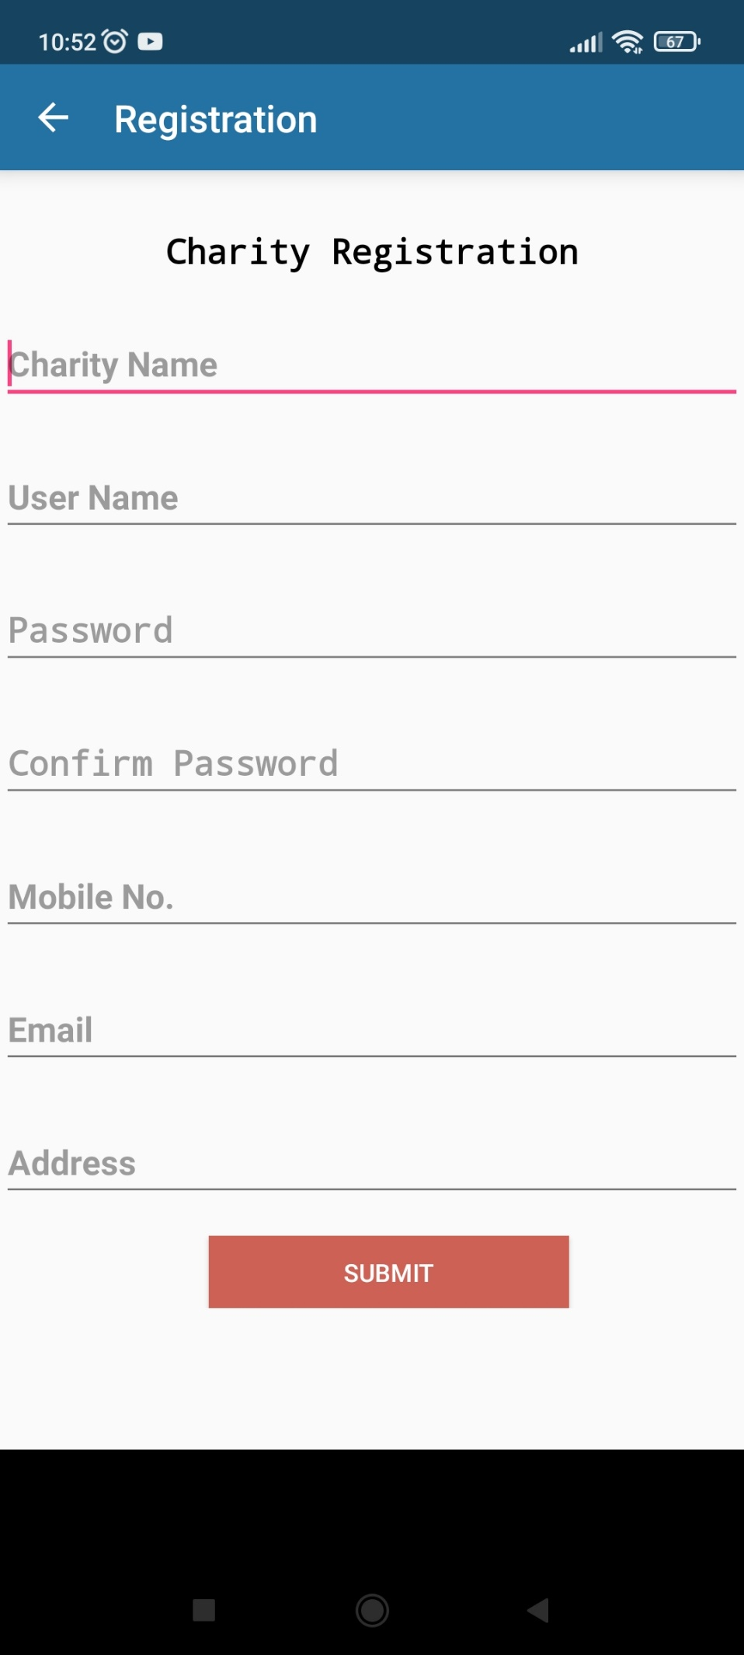

Figure.5 Charity Registration Layout

This activity file will be invoked from the charity login page. Here this activity will call then automatically the *charity_register.xml* file will be executed and launch the registration layout file which is present in figure.5. Here the charity has to fill all fields of the registration form such as charity name, user name, password, mobile no, email, and address which are stored in the database server.

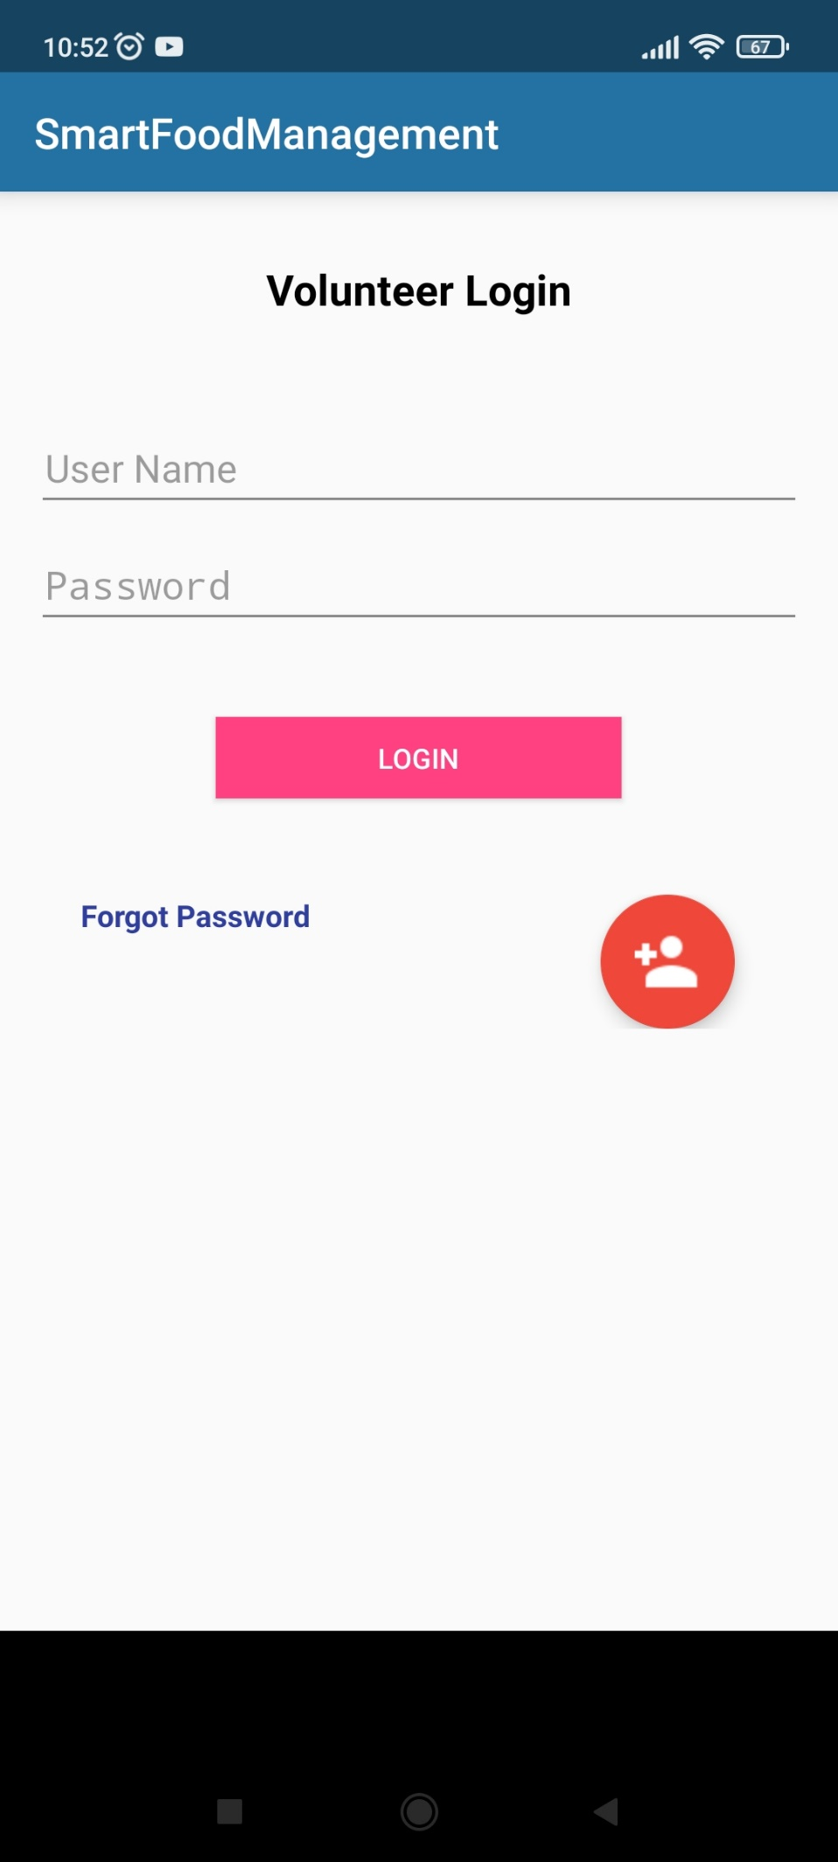

Figure.6 Volunteer login Layout

When I clicked on the Volunteer button from the home layout then this activity file will be invoked and it calls the *volunteerlogin.xml* layout file then it can display the volunteer login layout with registration fields which is present in figure.6. Here volunteers should be signed in with valid login credentials then only they will authenticate and redirect their portal.

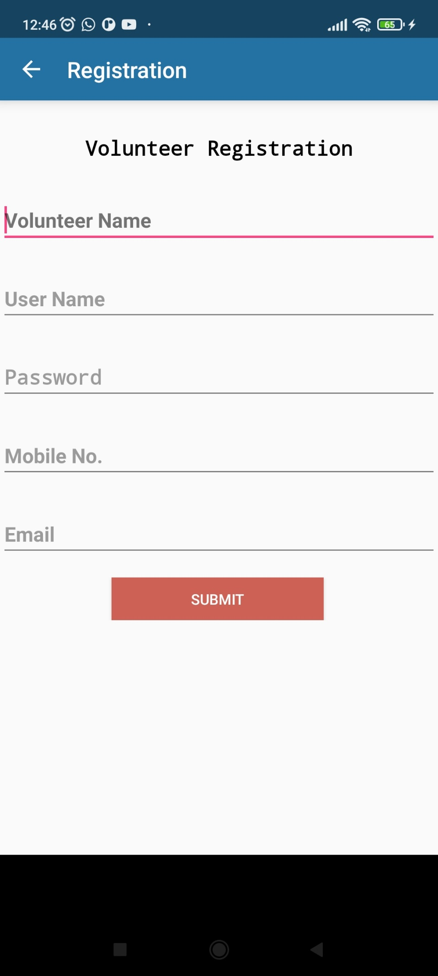

Figure.7 Volunteer Registration Layout

This activity file will be invoked from the volunteer login page. When this activity will call then automatically the *volunteer_register.xml* file will be executed and it will launch the registration layout file which is present in the figure.7 then volunteer needs to fill all fields of the registration form such as volunteer name, user name, password, mobile no, email which are saved into the database server.

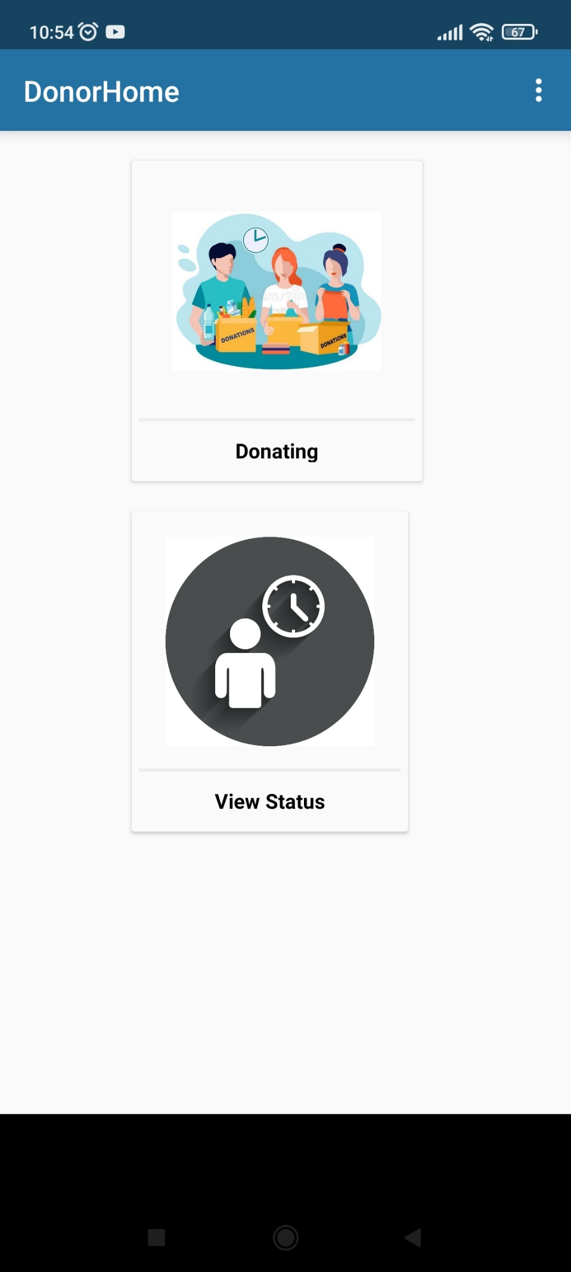

Figure.8 Donor Dashboard

This activity will be executed when the donor login successfully. Then it can generate the donor home dashboard with the *donorhome.xml* layout file. The output screen is presented in figure.8. This donor dashboard is designed with two buttons which are *Donating* and *View Status*. In the *Donating* process, they can donate the various types of donations and they can track the status of the donation process by operating by *View Status*.

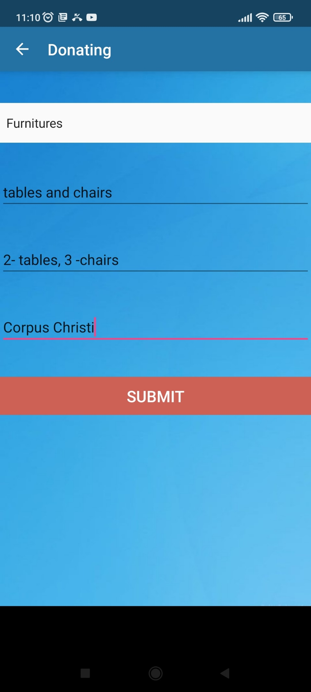

Figure.9 Donation Layout

Here this activity file will be invoked from the donor home page. It can execute the *donating.xml* layout file then it launches the donation page which is presented in figure.9. Here donors need to select the type of donation such as food, clothes, and furniture, donation description, the quantity of donation, and pick-up address. When the donor was clicked on submit button then these all fields are stored in a database table.

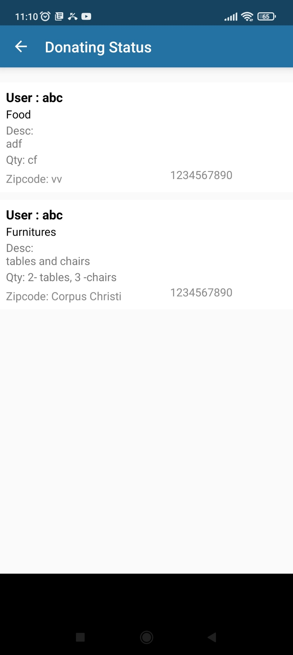

Figure.10 Donating Status

From Figure.10, the donor will get the list of donating status items and by clicking on the specific donation item then the donor will get the charity details like charity name, mobile number, and address with assigned volunteer details like name and mobile number.

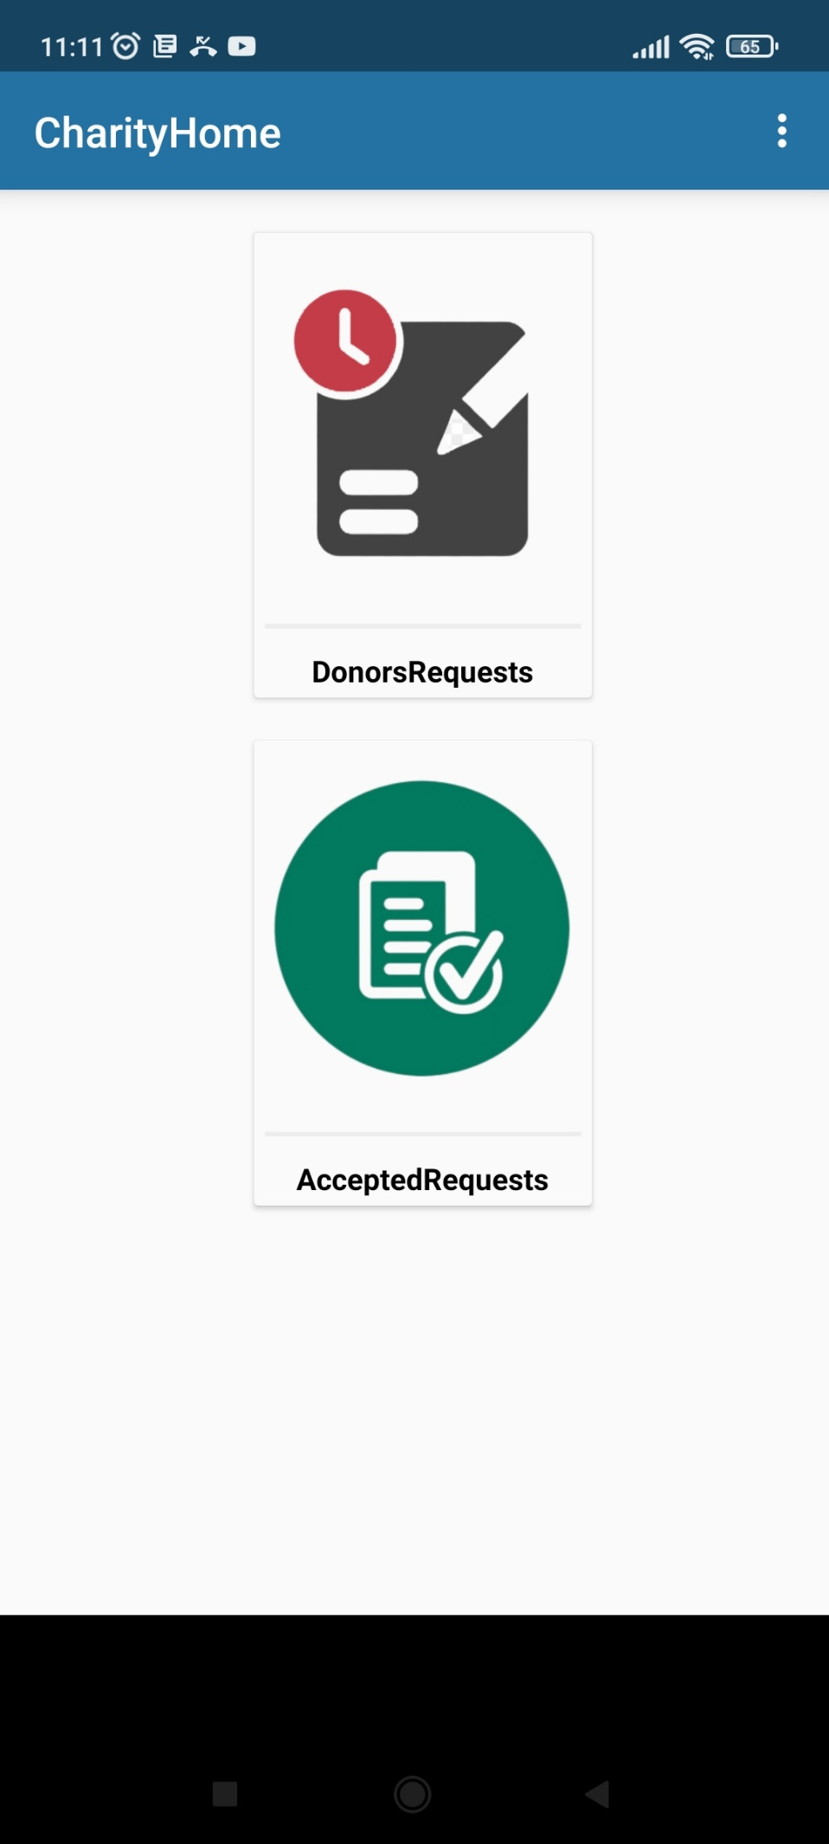

Figure.11 Charity Home

This activity will be executed when the charity login successfully. Then it can generate the charity home dashboard with the *charityhome.xml* layout file. The output screen is presented in figure.11. This charity dashboard is designed with two buttons which are *Donors Request* and *Accepted Requests.*

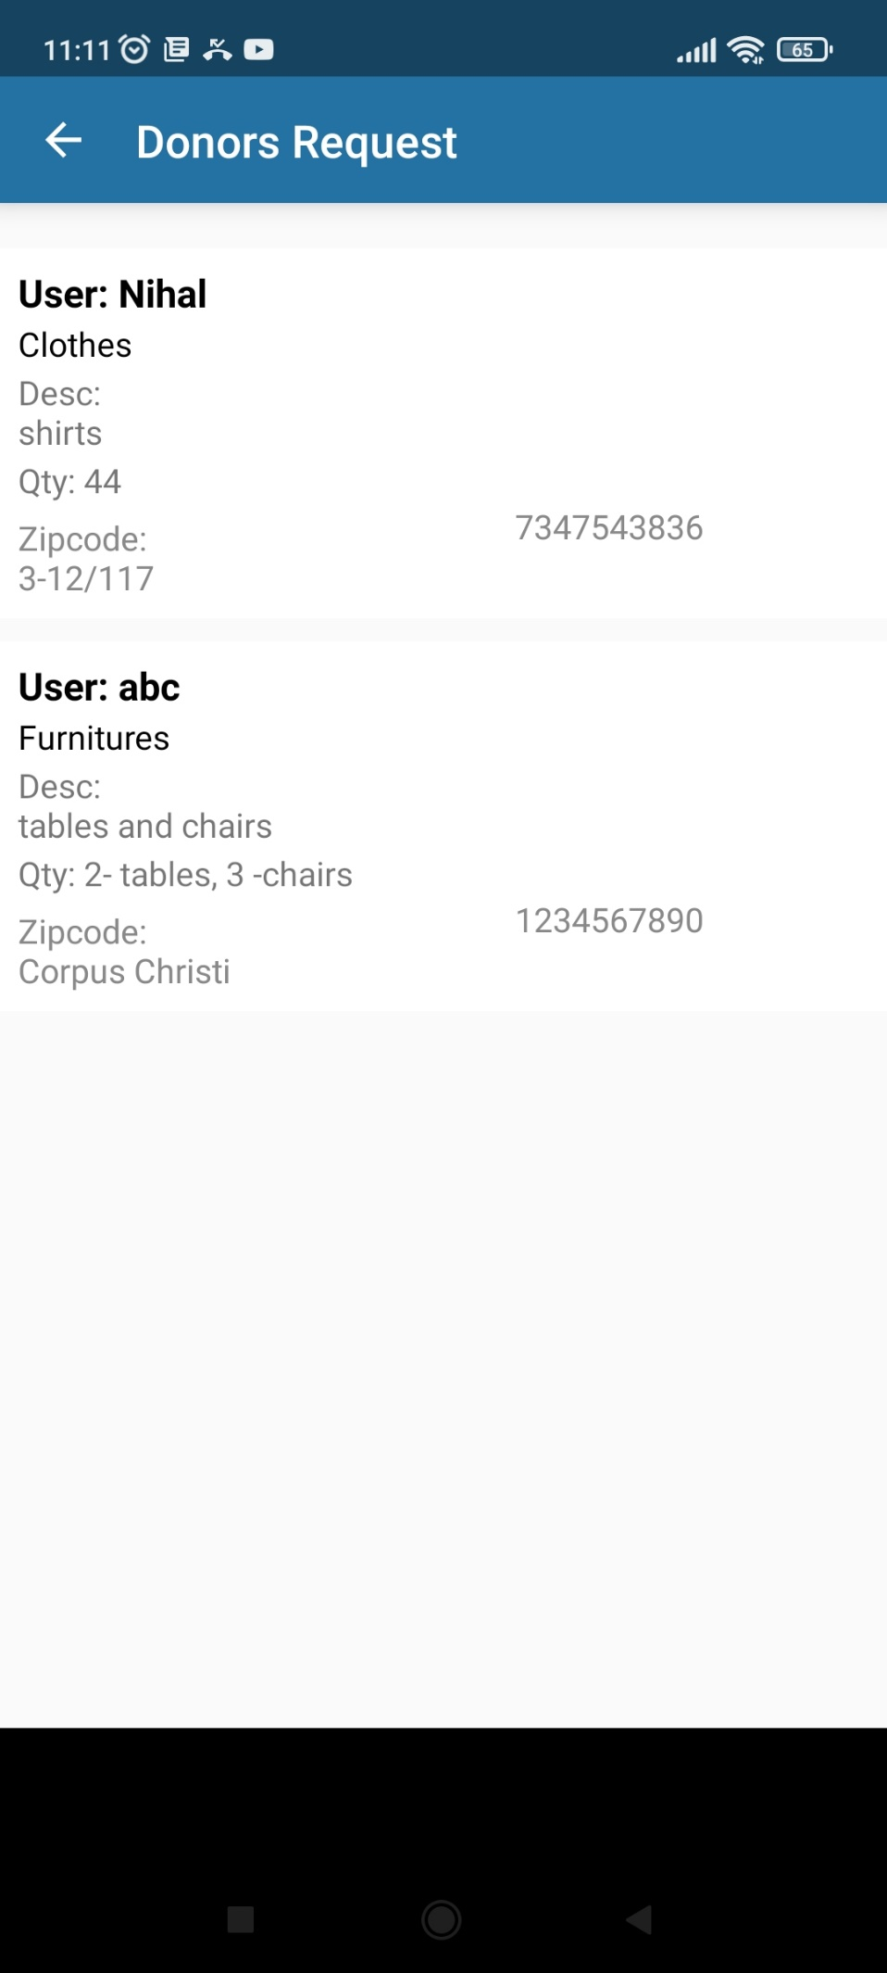

Figure.12 Donors Request

From figure.12, the charity will get the list of donor's donations requests with donor name, type of donation, quantity, etc.

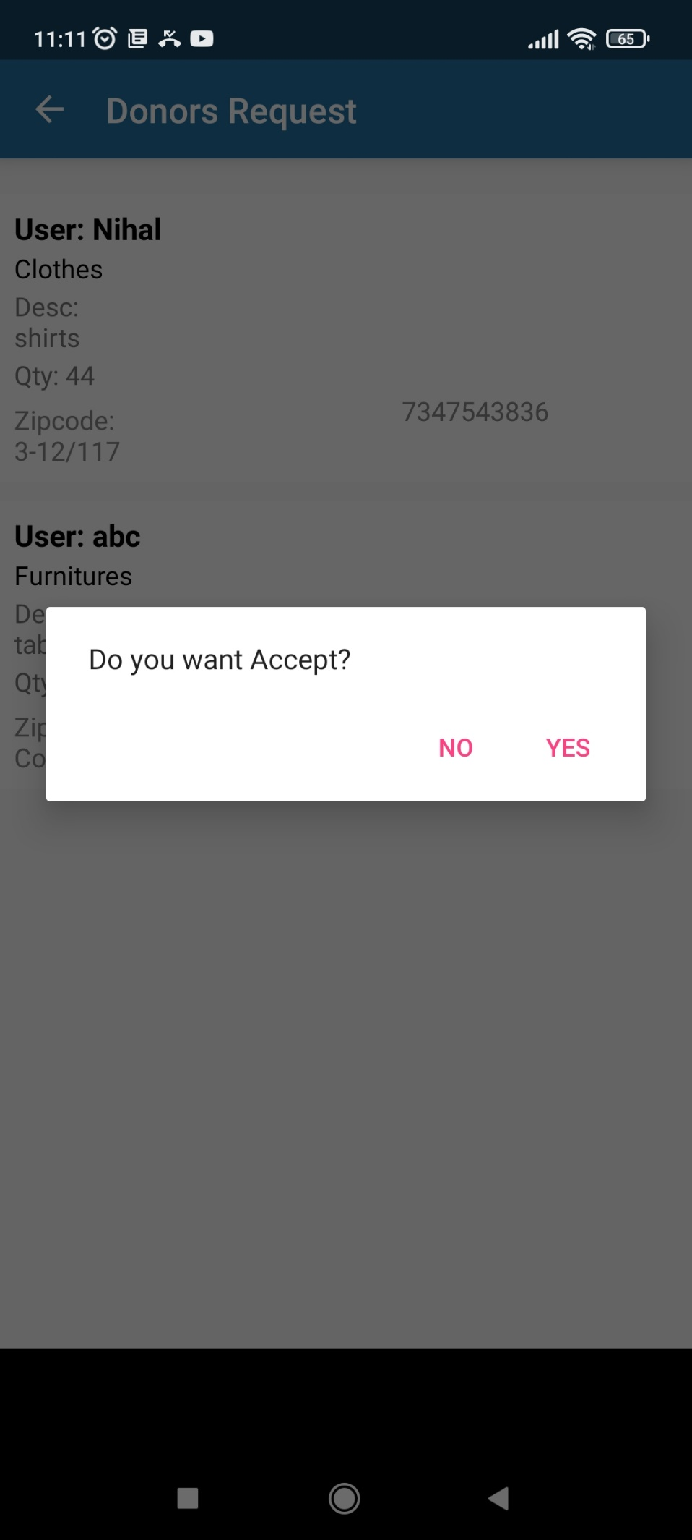

Figure.13 Accepting of Donor’s Request

From figure.13, when the charity was clicked on the list item then they will get an alert dialog box with whether the donation request is accepted or not.

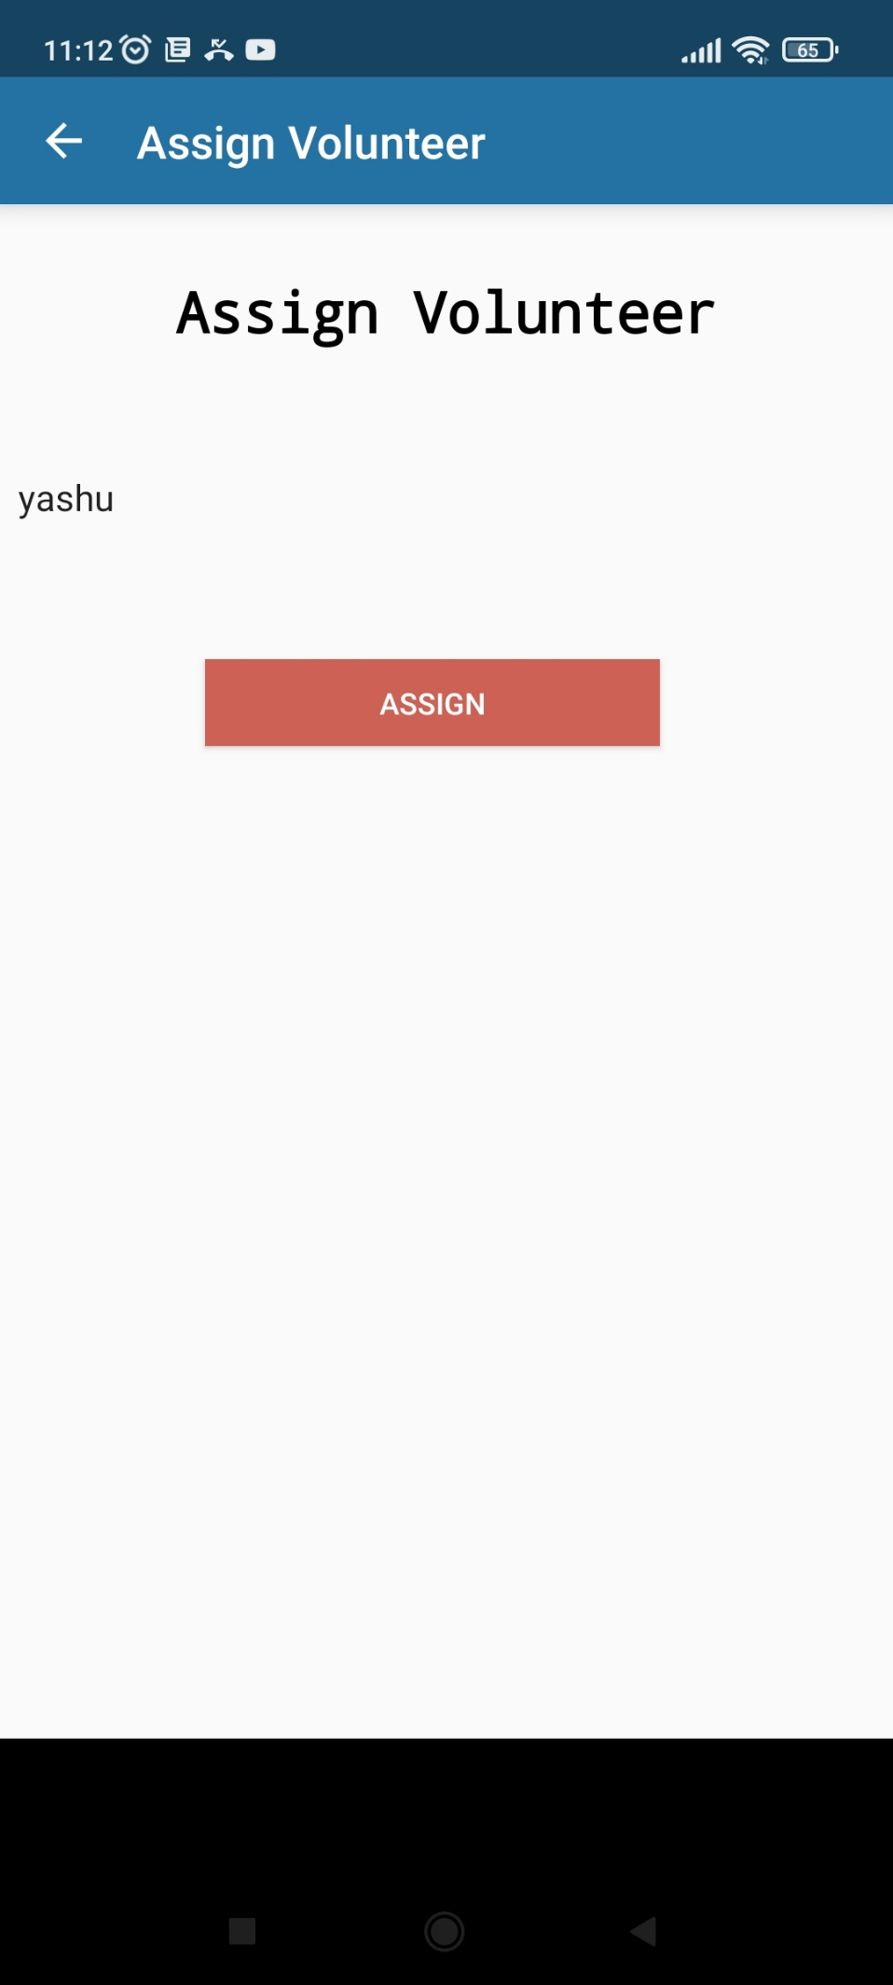

Figure.14 Assign Volunteer

From figure.14, If the charity accepted the donation request, then they will get the list of volunteers’ names with a drop-down list and the charity will choose the volunteer and update the donation request with the assigned status.

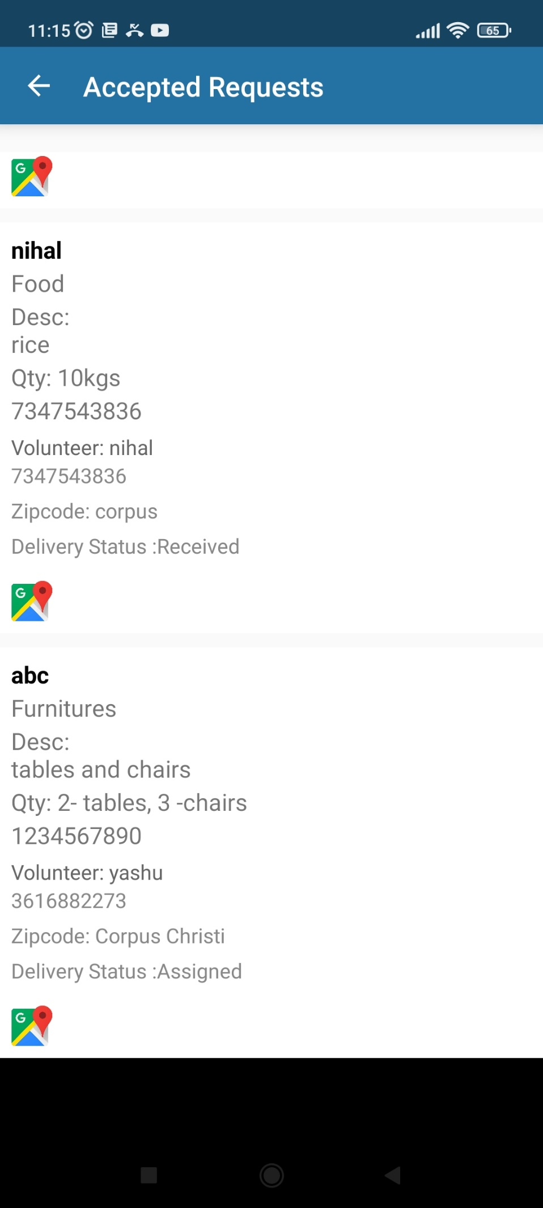

Figure.15 View Accepted Donor’s Request

From figure.15, the application will display the list of donor accepted requests with donor name, type of donation, quantity, etc. Moreover, it will display the assigned volunteer name and contact number. It can also display the donation item collecting status. As well as the charity can view the donor’s current location by clicking on the Map icon.

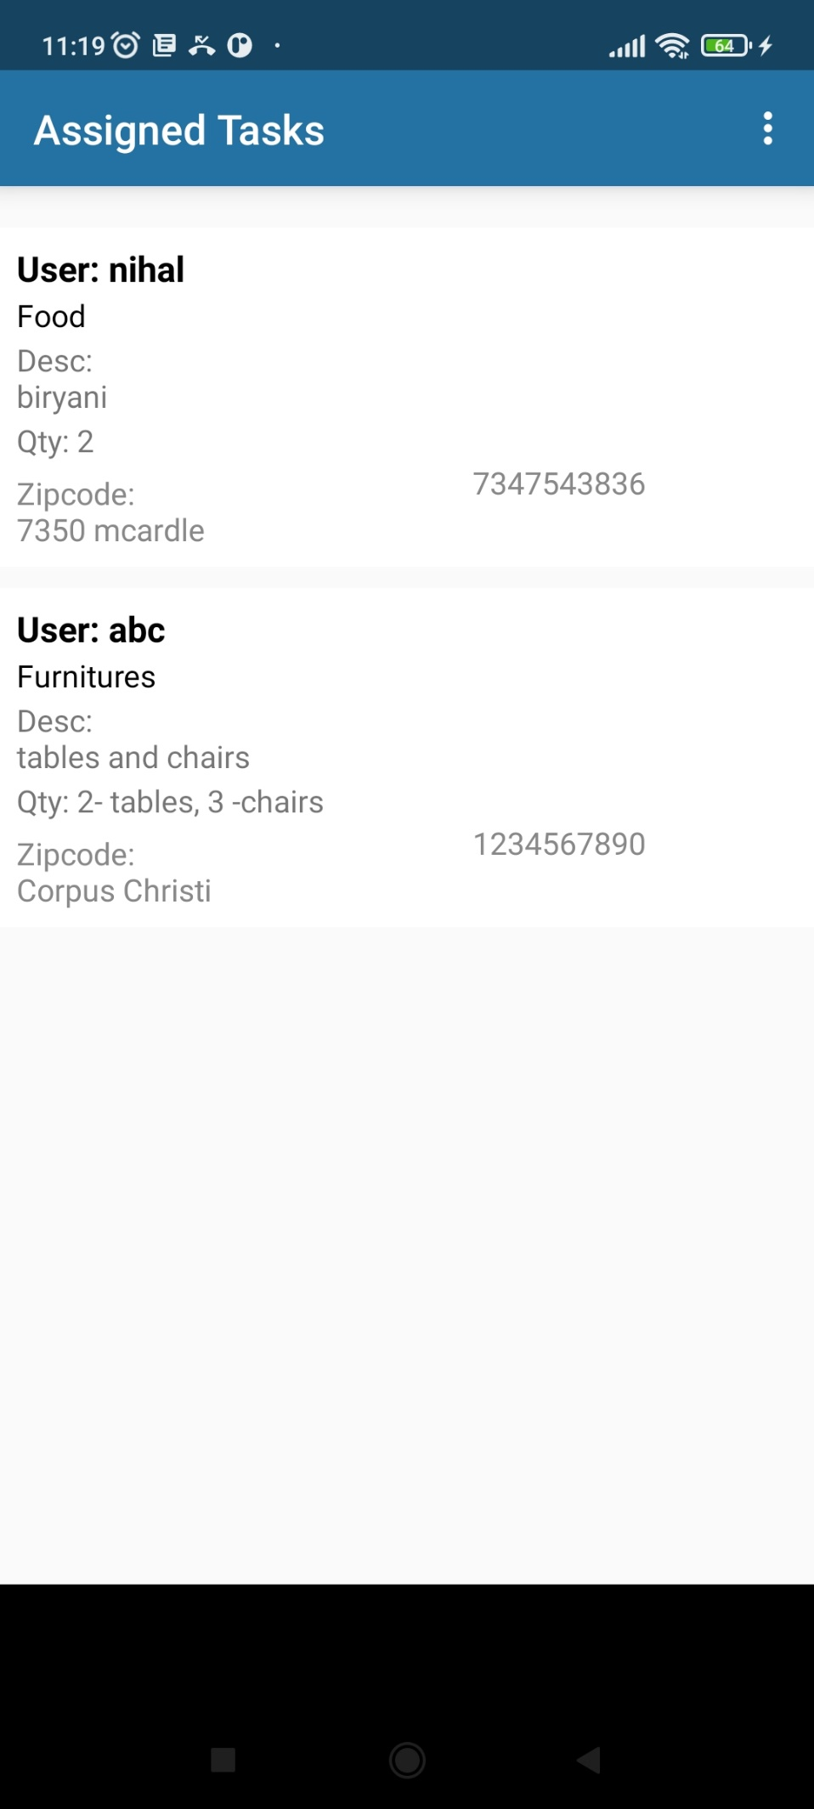

Figure.16 Assigned Tasks

From figure.16, the volunteer will get the list of donor accepted requests with donor name, type of donation, quantity, address, description, and contact number.

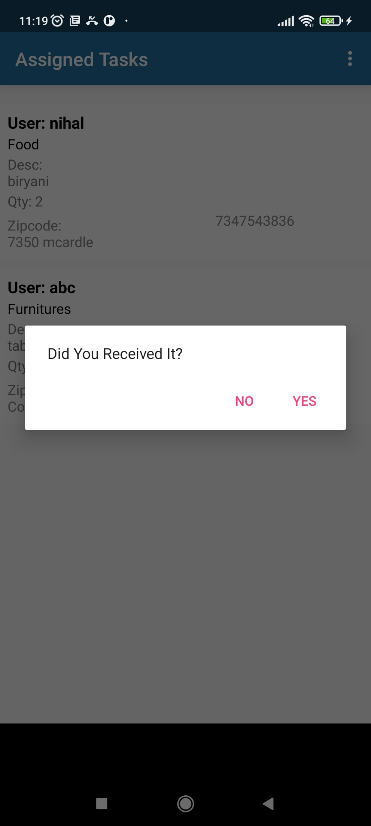

Figure.17 Update Donors Request Status

From figure.17, hereby selecting the donation's request, the volunteer can update the donation status like Received.

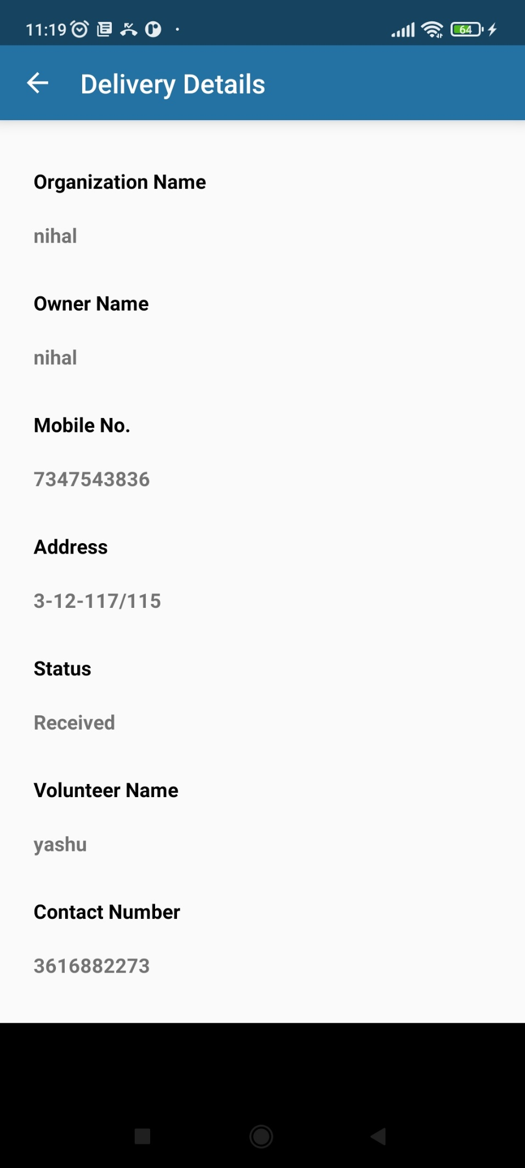

Figure.18 Donation Status

From figure.18, the donor will get the charity details like charity name, mobile number, and address with assigned volunteer details like name and mobile number.

**Database Design:**

**Table name: donors**

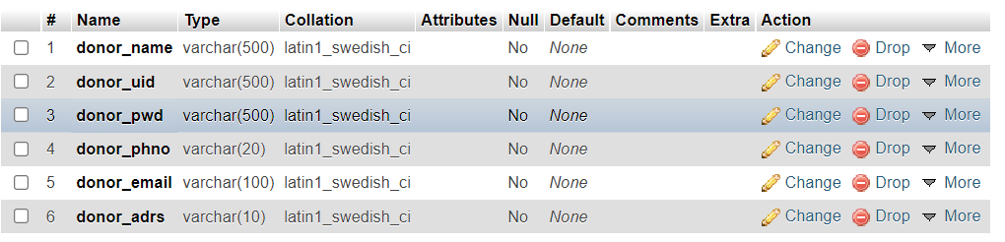

**Description:**

This donors table is used for storing the donor’s registration details.

**Table name: socialserorg**

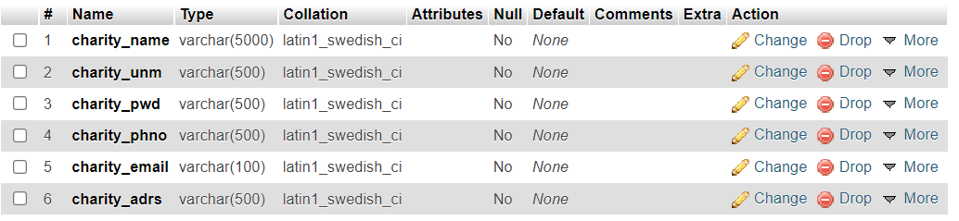

**Description:**

This socialserorg table is used for storing the charity registration details.

**Table name: volunteers**

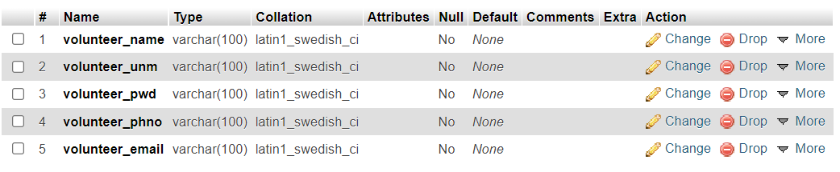

**Description:**

This volunteer table is used for storing the volunteer registration details.

**Table name: donating**

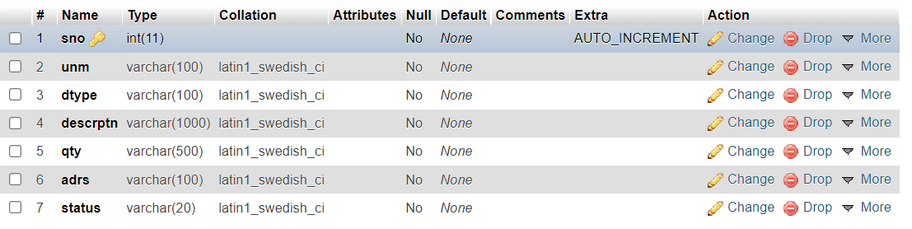

**Description:**

In this table, the donor’s donations details will be stored.

**Table name: orders**

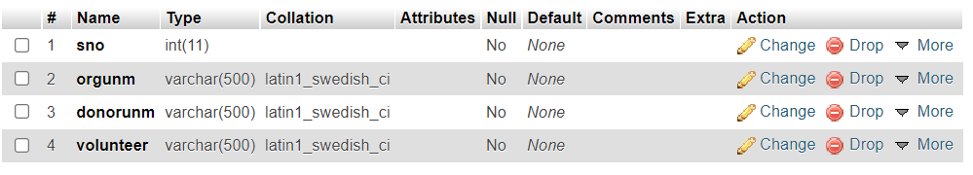

**Description:**

This orders table would contain the assigned volunteer, charity name, and donor username.

**Challenges Faced:**

While developing my mobile applications I had faced a few challenges, which are explained below:

I had gone through some references, I understood that already some applications are developed with food donations concepts with web-based and mobile-based applications then I was unable to find new features to implement in my application. Later with some existing application references, I resolved that problem.

I had faced the main challenge is sending the requests to a web hosting server from an application as well as retrieving them from server to client application. Because the Android Studio framework does not have a proper debugging process automatically. If the application stopped working process suddenly then it was become difficult for me for finding the problems. But using some exception handling concepts sometimes I was resolved manually.

**Future work**

In the future, I would like to integrate this application into social services websites to be aware of this application's features and it can also integrate with entertainment websites like BookMyShow, etc. Moreover, I want to add features like donating money and one more feature like adding the commercial points to donors to encourage them to donate a lot of things.

**References:**

Bozhiniva, K., “16 apps helping companies and consumers prevent food waste” Circular Weekly, GreenBiz, Oct 2018.

Ciaght A and A. Villafiorita, “Beyond food sharing: Supporting food wastage reduction using ICT”, International Smart Cities Conference (ISC2), October 2016.

Curran, Thomas P (2021) “Food Waste”, Nutrition and Health Public Lectures: Food Health, Virtual Event, 22 March 2021.

Jadhav NH, Narendrababu CR and Banu Prakash GC” EA New Approach to Reduce Food Wastage using Ubiquitous Technique”, J Food Process Technol 6: 496,2015.

Katalin Toth, Csaba Borbely, Bernadett Nagy, Gabor Sazbo Szentgroti & Eszter Szabo-Szentgroti(2020) “Measurement of Food Losses in a Hungarian Dairy Processing Plant” Published on 28 December 2020.

Keerthana R, Pavithra M, Reddy Chetana K1, Chithra D, "Detection and Prevention of Food Wastage by Tracking Real-Time Data through Mobile Application", Volume 5 Issue 3, March-April 2021.

Komal Raut, Nimesh Shah, Akash Thorat, “Food donation portal”, IJARCET, VOL-5, ISSUE-4, 2015.