2. Functional Requirements
The following requirements are specific to one particular user – supplier among the three users admin, manager and supplier
2.1 Login Page
- A role selection toggle (Admin / Manager / Supplier) is provided to allow the user to choose their login role.
- A textbox for Email/Username is provided for the user to enter their registered credentials. The system validates that the field is not empty and follows valid format.
- A password input field allows the user to enter their password with a show/hide option, and validates that the password has at least 6 characters.
- A CAPTCHA textbox is provided where the user must enter the displayed security code correctly for verification.
- A “Remember Me” checkbox allows the user to stay logged in on the device.
- A Login button submits the form after validating all required fields and displays error messages if any inputs are invalid.
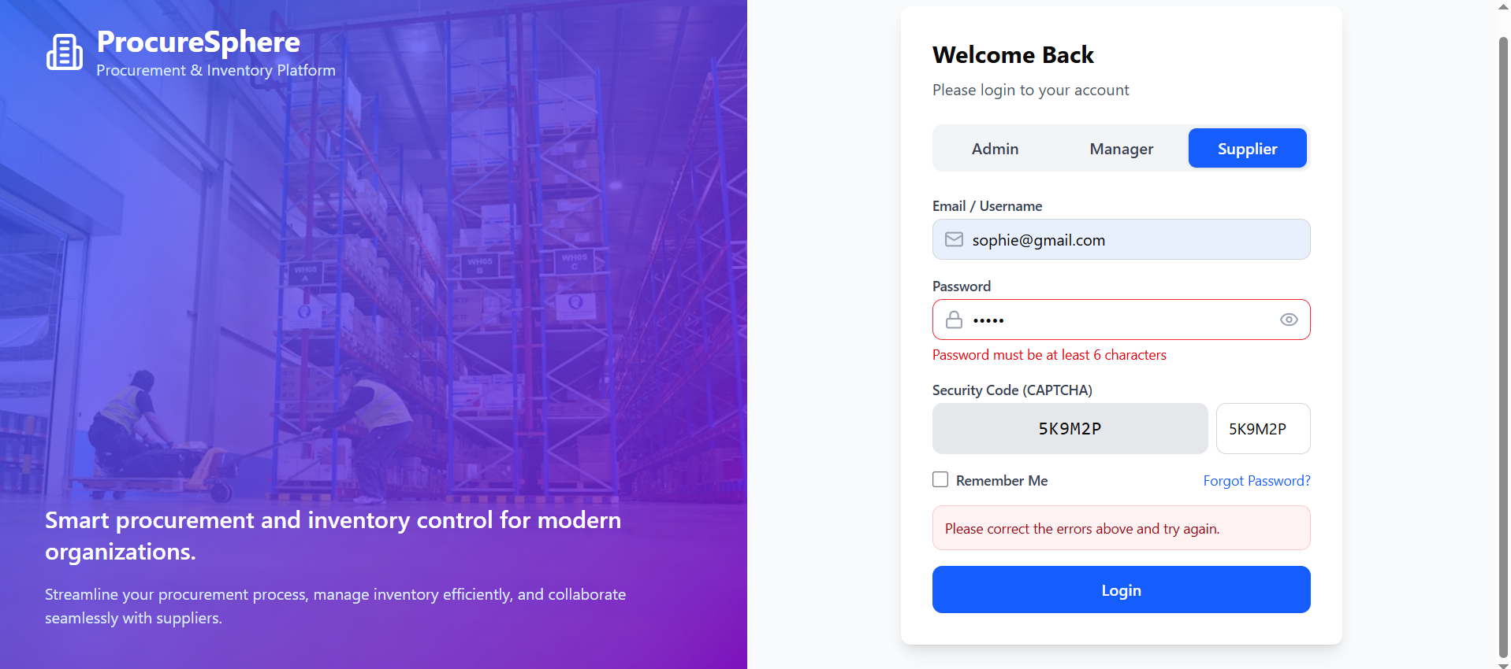

2.1 HomePage
It should contain a top panel with the following navigations:
- Search
- Create order
- Notifications
- Settings/User profile
The left frame should have the following features
- Dashboard
- Product Catalog
- Create Order
- Order History
- Delivery Tracking
- Inventory Monitoring
(As shown in Figure 2.2)
2.2 Dashboard
- A search textbox is provided in the header to allow users to search for products, orders, or suppliers.
- Summary cards display key information such as Total Products, Active Suppliers, Pending Orders, and Low Stock Alerts.
- A “Create Order” button allows users to quickly navigate to the order creation page.
- Quick action cards provide shortcuts to features such as Create Order, Browse Product Catalog, Track Deliveries, and View Reports.
- A recent orders table displays recent procurement transactions with order details and status.
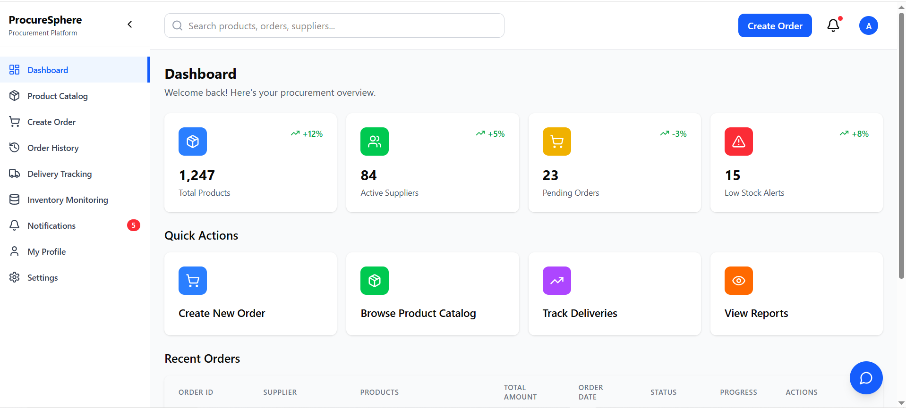
Fig: 2.2

2.3 Product Catalog
- A product search textbox allows users to search products by entering keywords.
- A category dropdown and supplier dropdown allow users to filter products.
- A sort dropdown enables sorting products by options such as Name A–Z.
- An “In Stock Only” checkbox filters products that are currently available.
- Each product is displayed in a product card with details such as product name, supplier, price, and stock status.
- An “Add to Order” button allows users to add the selected product to the procurement order.
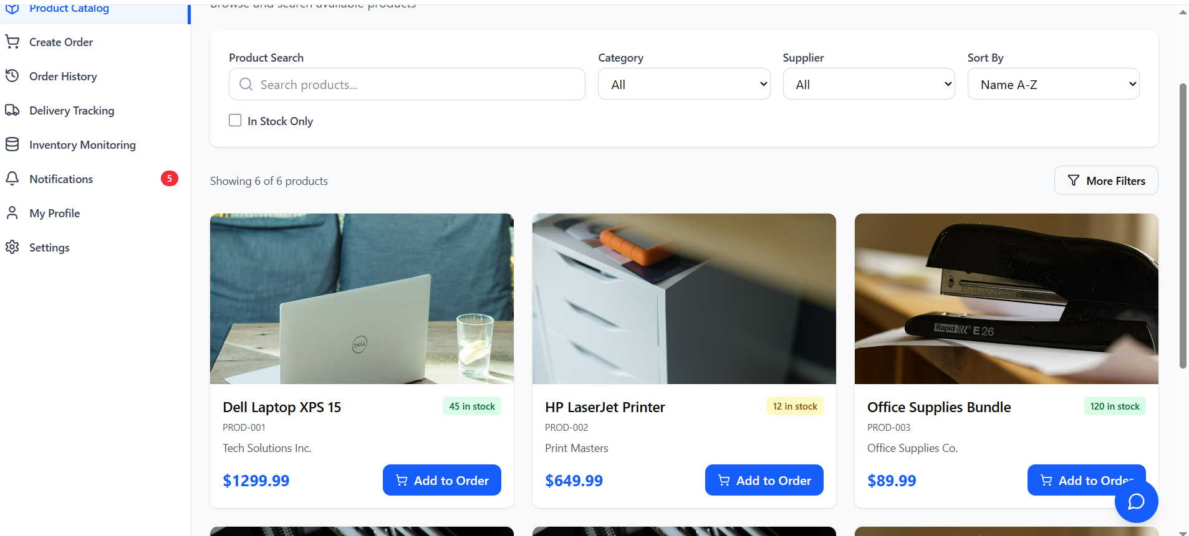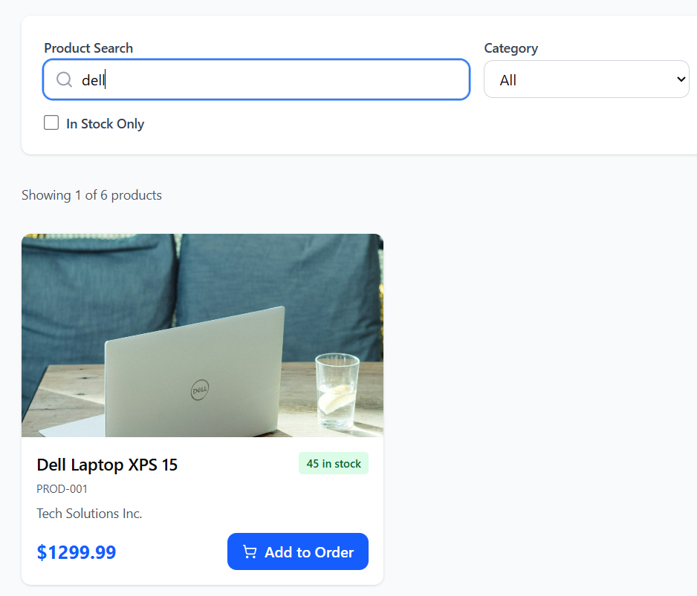
Fig:2.3
2.4 Create Order
- A multi-step progress indicator guides the user through the order creation stages.
- A textbox for Order Title allows the user to enter the order name and validates that it is not empty.
- A supplier dropdown allows the user to select a supplier and is a required field.
- A department textbox allows the user to enter the requesting department.
- Priority level radio buttons (Low, Medium, High, Urgent) allow the user to select order priority.
- A payment method dropdown allows the user to choose the payment type.
- A budget code textbox validates the input format before submission.
- A date picker allows the user to select the expected delivery date, ensuring it is not earlier than the current date.
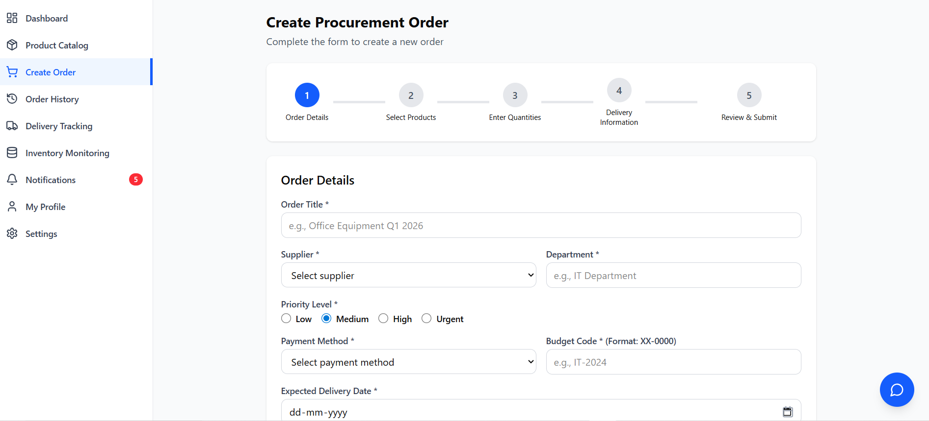
Fig: 2.4
2.5 Chatbot Assistance 
A floating chatbot provides assistance to the user for navigating in the application.

2.6 Profile
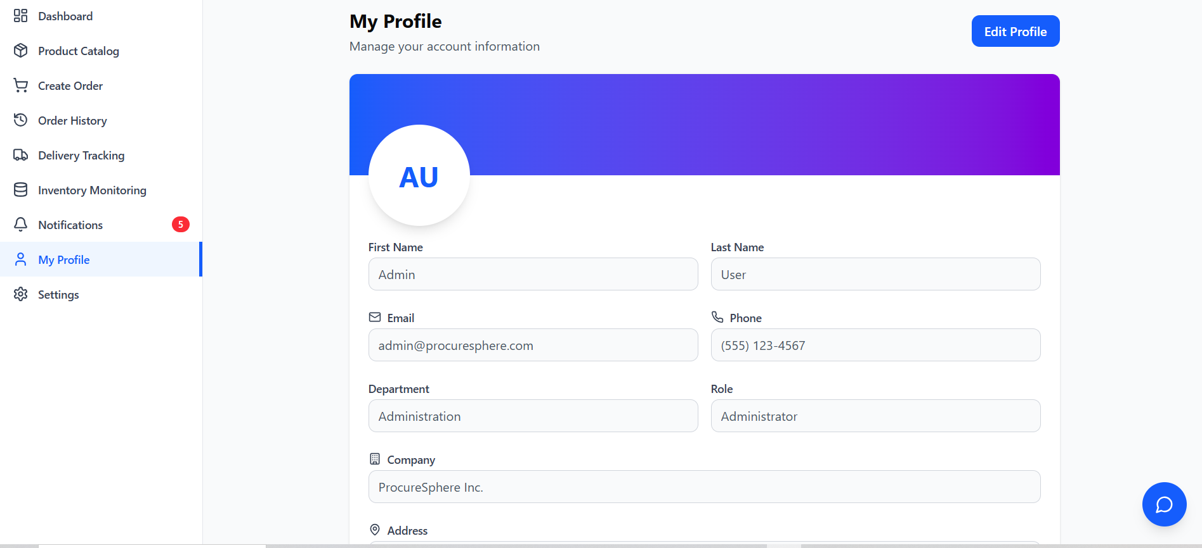
The page includes a sidebar navigation menu that allows users to access modules such as Dashboard, Orders, Inventory, Notifications, Profile, and Settings. The profile section displays user details in text fields like First Name, Last Name, Email, Phone, Department, Role, Company, and Address, with validations such as required fields, valid email format, and numeric phone input. An Edit Profile button enables users to modify their information, while the avatar, notification badge, and chat button provide additional interface functionality.

