1. **E-commerce Platform Search Function**

**Code:**

import java.util.*;

class Product{

int productId;

String productName;

String category;

public Product(int a,String b,String c)

{

this.productId=a;

this.productName=b;

this.category=c;

}

public void display()

{

System.out.println("ID: "+productId+" Name: "+productName+" Category: "+category);

}

}

class Searching{

public static int Linear(Product[] p,int id)

{

for(int i=0;i<p.length;i++)

{

if(p[i].productId==id)

return i;

}

return -1;

}

public static int Binary(Product[] p,int id)

{

int low=0,high=p.length-1;

boolean flag=false;

while(low<=high)

{

int mid=(low+high)/2;

if(p[mid].productId==id)

return mid;

else if(p[mid].productId<id)

low=mid+1;

else

high=mid-1;

}

return -1;

}

}

public class Main

{

public static void main(String args[])

{

Product p[]={

new Product(19,"Laptop","Electronics"),

new Product(5,"Phone","Electronics"),

new Product(3,"Shoes","Fashion"),

new Product(15,"PC","Electronics"),

new Product(8,"Shirt","Clothing"),

new Product(10,"Trouser","Clothing"),

new Product(7,"Oven","KitchenAppliance"),

new Product(11,"Stove","KitchenAppliance"),

new Product(4,"Car","Transport"),

new Product(2,"Bike","Transport")

};

System.out.println("Original array: \n");

for(int i=0;i<p.length;i++)

{

p[i].display();

}

System.out.println();

int ans=Searching.Linear(p,10);

if(ans!=-1)

{

System.out.println("Linear Search Found at index: "+ans);

p[ans].display();

}

else

System.out.println("Product does not exist");

System.out.println();

Arrays.sort(p,Comparator.comparingInt(pro->pro.productId));

System.out.println("Products After Sorting ID for binary search");

for(int i=0;i<p.length;i++)

{

p[i].display();

}

System.out.println();

int res=Searching.Binary(p,11);

if(res!=-1)

{

System.out.println("Binary Search Found at index: "+res);

p[res].display();

}

else

System.out.println("Product does not exist");

}

}

**Output:**

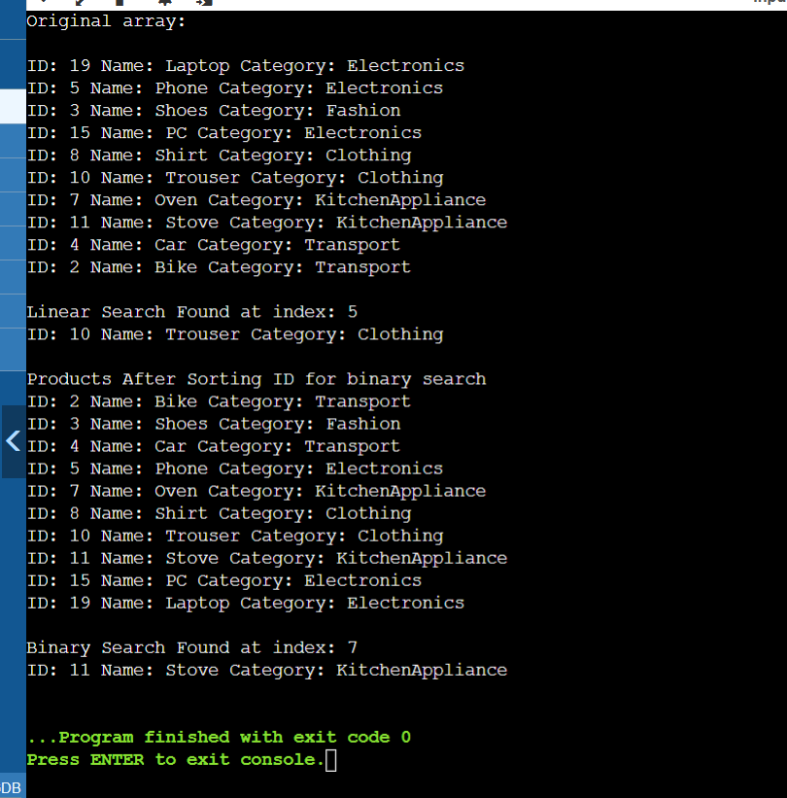

1. Financial Forecasting

**Code:**

public class Main

{

public static double exp(double r,int n)

{

if(n==0)

{

return 1;

}

return r*exp(r,n-1);

}

public static double futurevalue(int n,double amt,double r)

{

return amt*exp(1+r,n);

}

public static void main(String[] args) {

int y=6;

double amount=2000;

double rate=0.2;

double ans=futurevalue(y,amount,rate);

System.out.println("The future value after "+y+" years: "+ans);

}

}

**Output:**

