**Exercise 1**: Implementing the Singleton Pattern

**Code:**

class Logger

{

private static Logger instance;

private Logger()

{

System.out.println("Logger Initialised");

}

public static Logger getInstance()

{

if(instance==null)

{

instance=new Logger();

}

return instance;

}

public void log(String m)

{

System.out.println("[Log]: "+m);

}

}

public class Test{

public static void main(String[] args)

{

Logger log1= Logger.getInstance();

Logger log2= Logger.getInstance();

log1.log("This is the 1st log message");

log2.log("This is the 2nd log message");

if(log1==log2)

{

System.out.println("Both are the same instance");

}

else

System.out.println("Different instances,It is not a Singelton pattern");

}

}

**Output:**

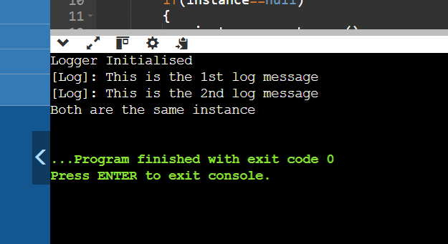

__________________________________________________________________________________

**Exercise 2:** Implementing the Factory Method Pattern

**Code:**

interface Document{

void open();

}

class WordDocument implements Document{

public void open()

{

System.out.println("Opening the Word document");

}

}

class PdfDocument implements Document{

public void open()

{

System.out.println("Opening the PDF document");

}

}

class ExcelDocument implements Document{

public void open()

{

System.out.println("Opening the Excel document");

}

}

abstract class DocumentFactory{

public abstract Document createDocument();

}

class WordDocumentFactory extends DocumentFactory{

public Document createDocument()

{

return new WordDocument();

}

}

class PdfDocumentFactory extends DocumentFactory{

public Document createDocument()

{

return new PdfDocument();

}

}

class ExcelDocumentFactory extends DocumentFactory{

public Document createDocument()

{

return new ExcelDocument();

}

}

public class Test

{

public static void main(String args[])

{

DocumentFactory word=new WordDocumentFactory();

Document worddoc = word.createDocument();

worddoc.open();

DocumentFactory pdf= new PdfDocumentFactory();

Document pdfdoc= pdf.createDocument();

pdfdoc.open();

DocumentFactory excel= new ExcelDocumentFactory();

Document exceldoc= excel.createDocument();

exceldoc.open();

}

}

**Output:**

