Creating a database using mongodb and mongoose:

NAME : MAKIREDDY SRI SATYAYASHASWINI DEVI
EMAIL :yashaswinimakireddy@gmail.com
PHONE NO :9515840249
ROLL NO : 20T91A0551 (CSE)
COLLEGE NAME : GIET Engineering College
Database using mongoose:

- Creating database and collection:

Used commands:
-use (database name): To create database
-db.createCollection.(“collection name”) : To create collection

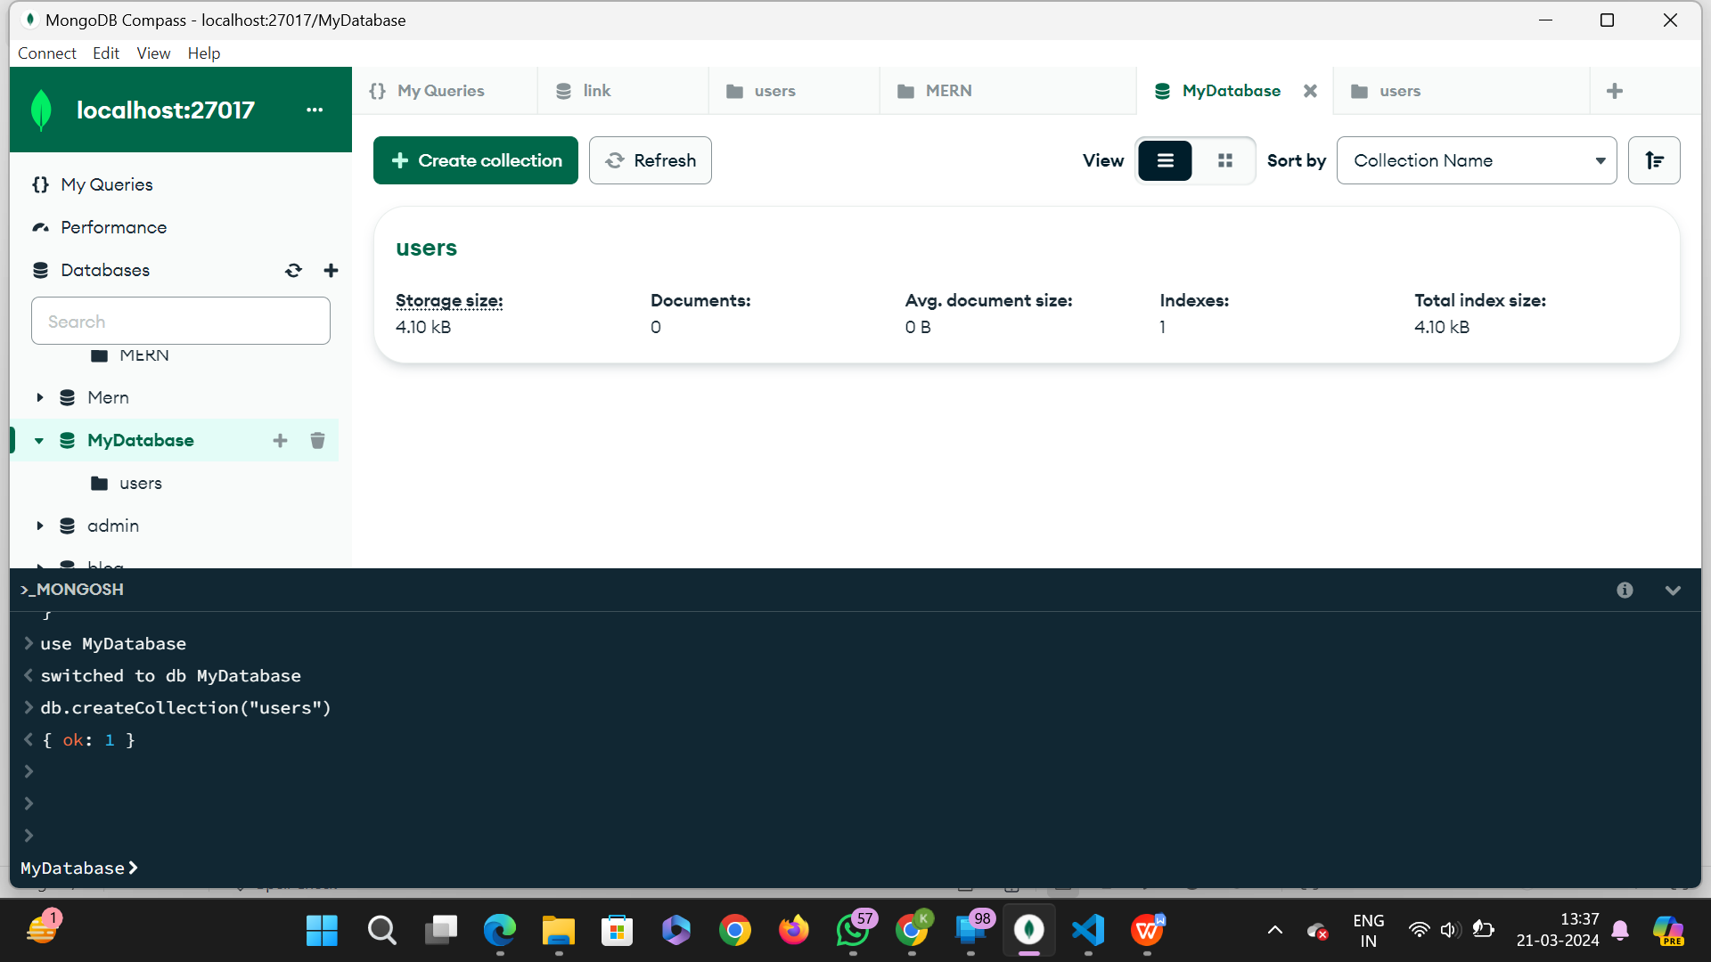

- Inserting documents:

Used commands:
-db.collectionName.insertMany([{data1},{data2},{data3}]) : To insert multiple data into the database.

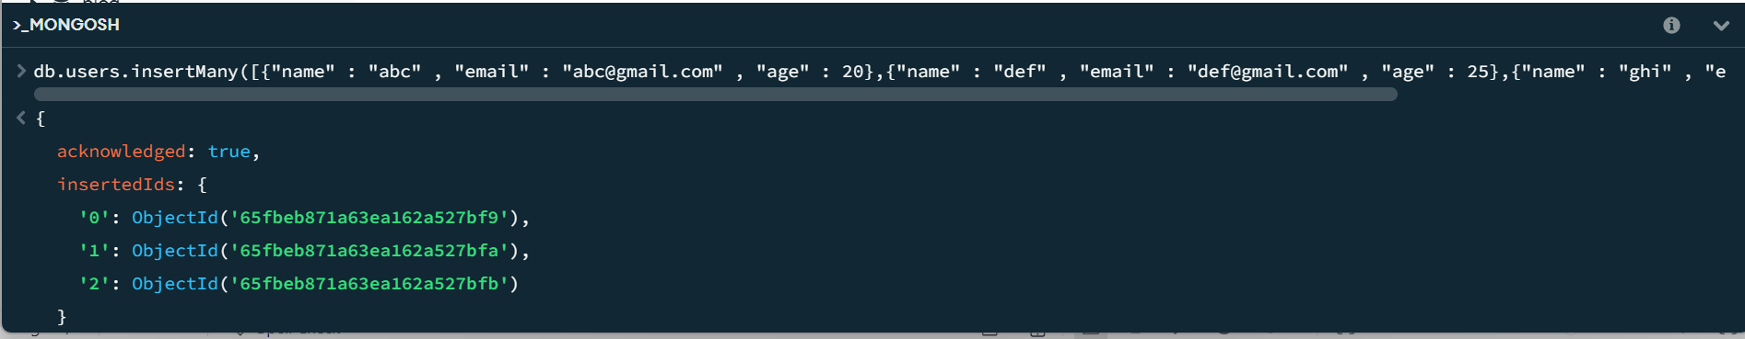

Output:

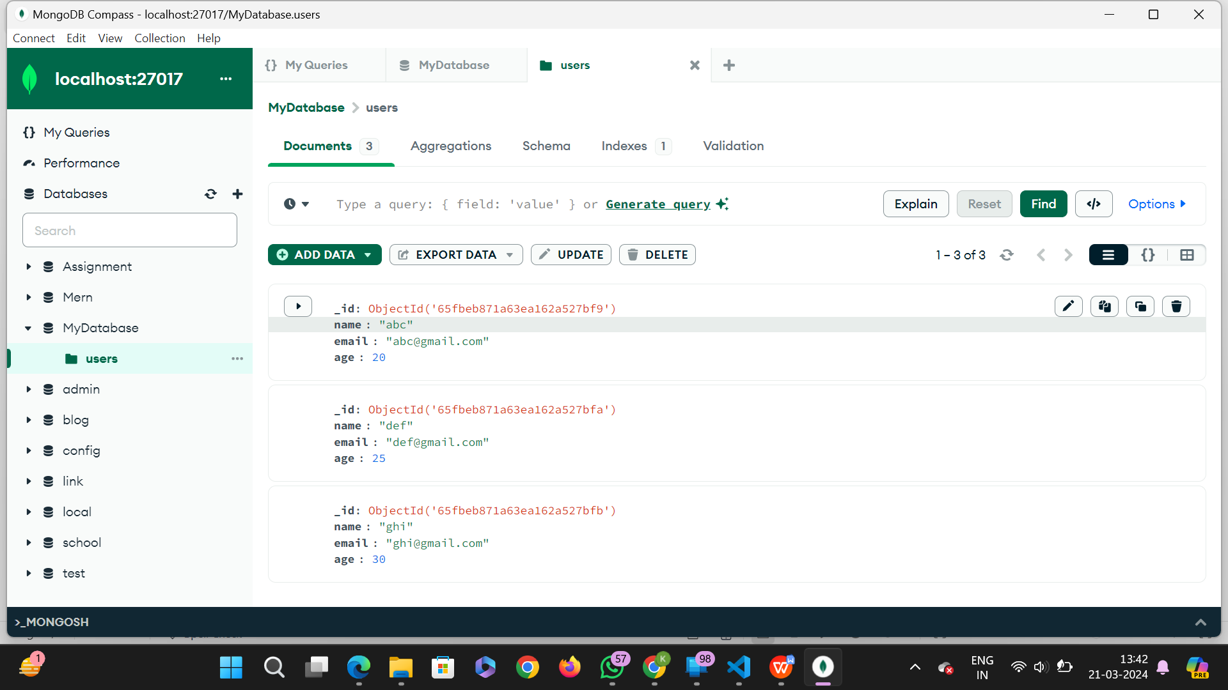

- mongoose query to retrieve “all users from the users collection“:

Used commands:
-db.users.find({}) : To retrive all the users data from the database.

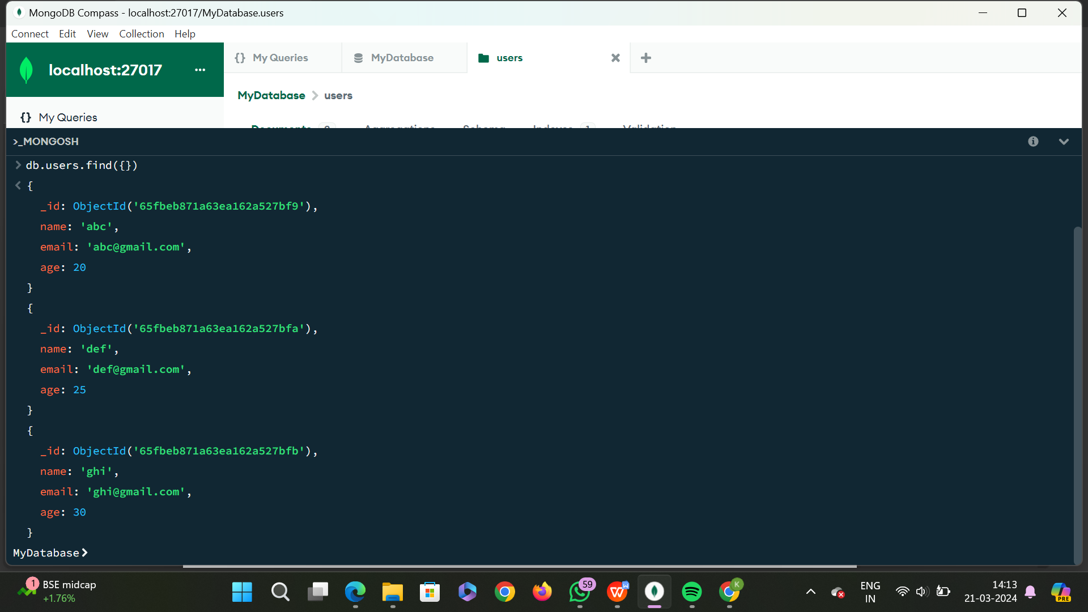

- mongoose query to “Users with an age greater than or equal to 30. ” :

Used commands:
-db.collectionName.find({parameters}) : To retrieve data from the users with an age greater than or equal to 30.
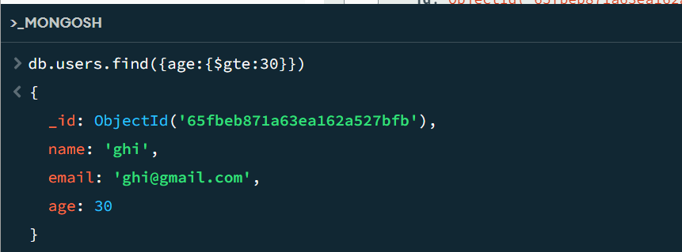

- Update the age of a user with a specific email address.

Used commands:
-db.collectionName.updateOne({default value}, {update value}) :
To update the age of a user with a specific email address.

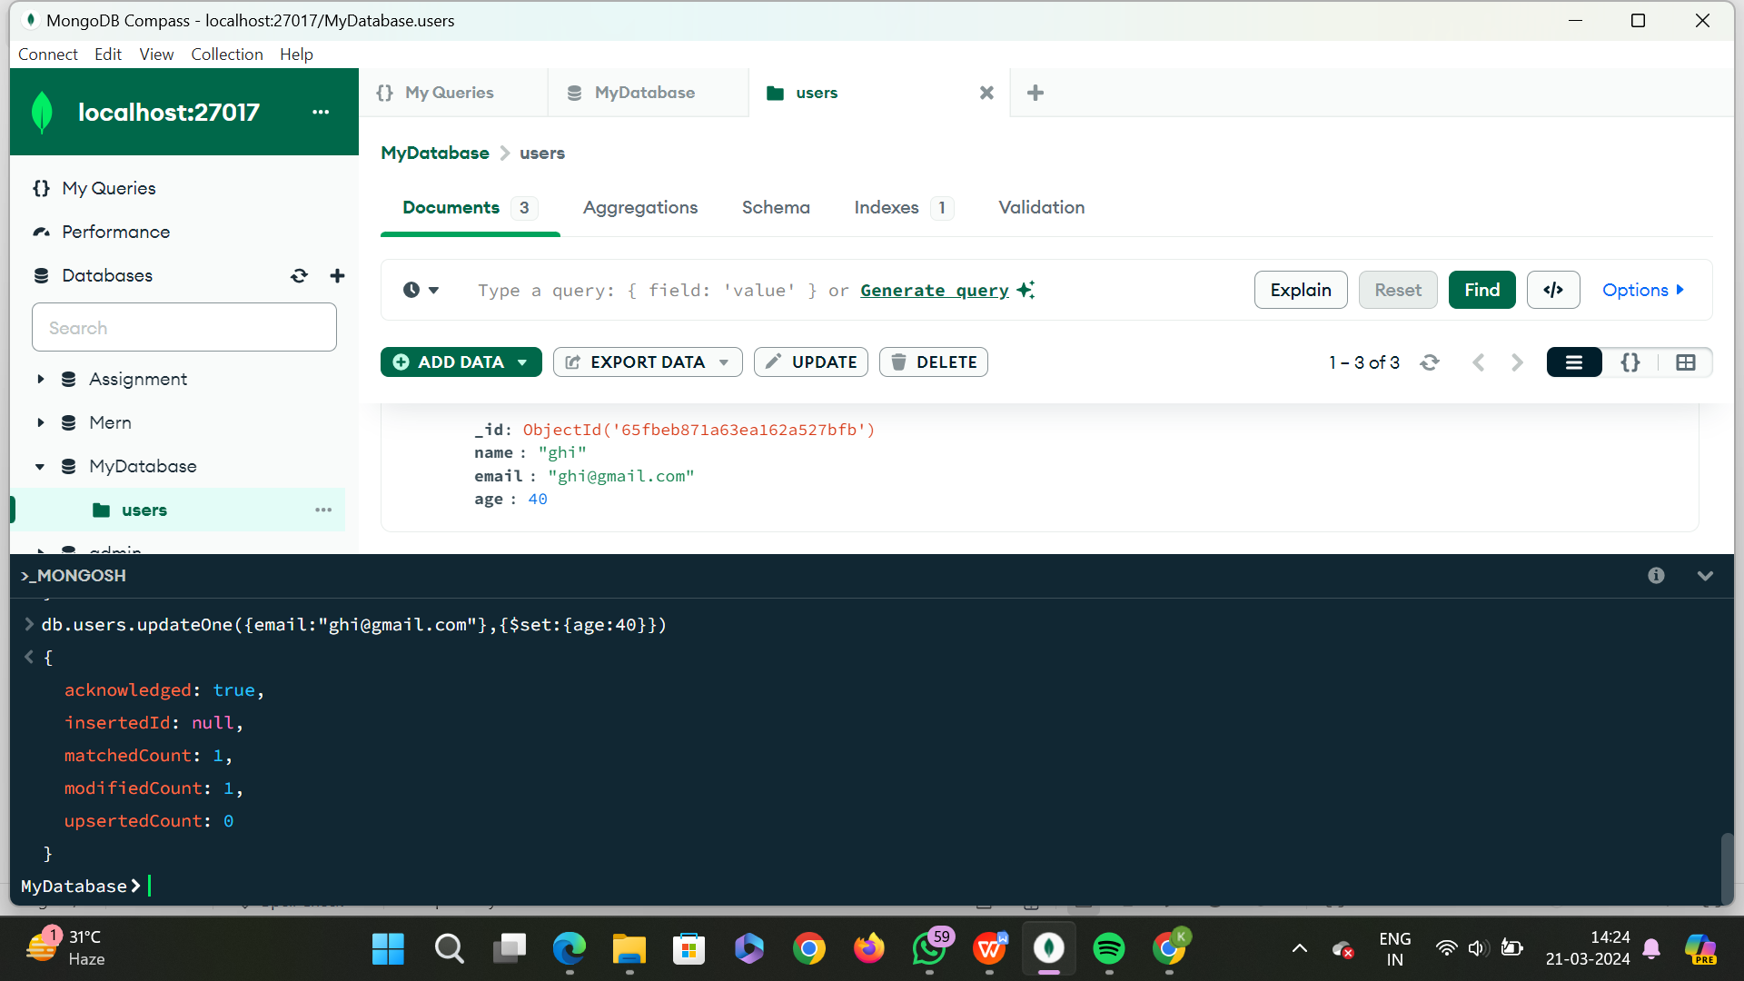

- Delete a user document based on a specific email address.

Used commands:
-db.collectionName.deleteOne : To delete a user document based on a specific email address.

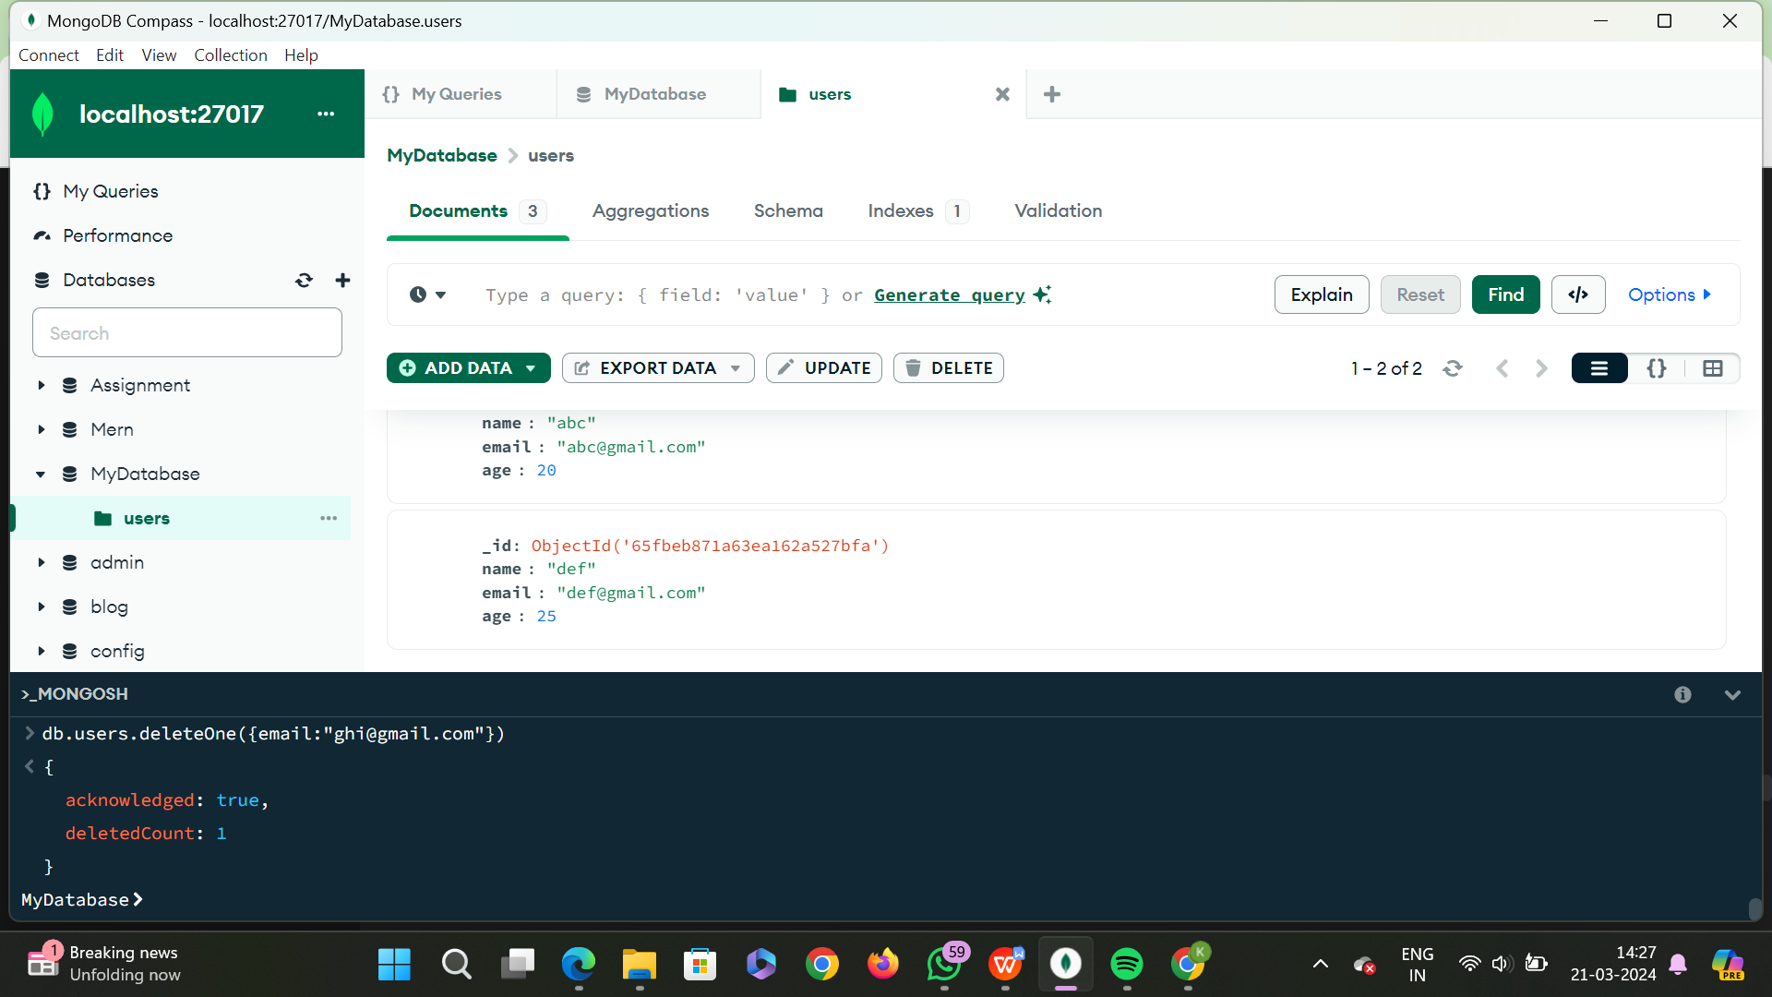

- Create an index on the email field of the users collection.

