**What is DAX?**

DAX is a collection of functions, operators, and constants that can be used in a formula, or expression, to calculate and return one or more values.

DAX helps you create new information from data already in your model.  
  
**Benefits of DAX**  
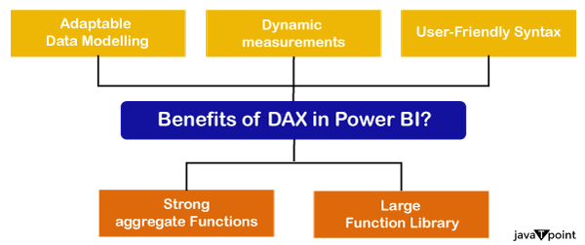  
  
**Limitations of DAX:**   
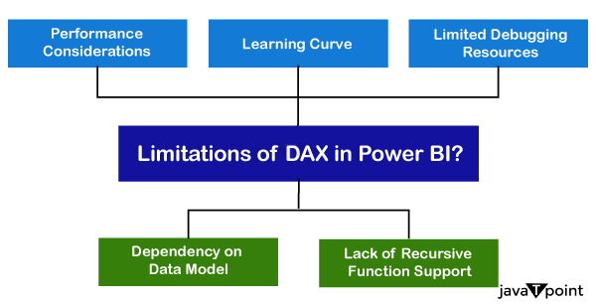

**Formulas used for project:**

**1. Get Average BPM**

Average BPM = AVERAGE('Spotify-2000-Prepared'[Beats Per Minute (BPM)])

**2. Average Energy**

Average Energy = AVERAGE('Spotify-2000-Prepared'[Energy])

**3. Average Popularity**

Average Popularity = AVERAGE('Spotify-2000-Prepared'[Popularity])

**4. Most Popular Genre**

Most Popular Genre =

VAR GenrePopularity =

SUMMARIZE(

'Spotify-2000-Prepared',

'Spotify-2000-Prepared'[Top Genre],

"TotalPopularity", SUM('Spotify-2000-Prepared'[Popularity])

)

VAR TopGenre =

TOPN(

1,

GenrePopularity,

[TotalPopularity], DESC

)

RETURN

FIRSTNONBLANK(

SELECTCOLUMNS(TopGenre, "Genre", 'Spotify-2000-Prepared'[Top Genre]),

BLANK()

)

**5. Total songs count**

Song Count = COUNTROWS('Spotify-2000-Prepared')

**6. Total genre count**

Total genere = DISTINCTCOUNT('Spotify-2000-Prepared'[Top Genre])

**7. Total number of artist**

Total number of artist = DISTINCTCOUNT('Spotify-2000-Prepared'[Artist])

**8. Total number of songs**

Total number of songs = DISTINCTCOUNT('Spotify-2000-Prepared'[Title])

**9.Total time duration**

Total time duration = SUM('Spotify-2000-Prepared'[Length (Duration)])