Software Design Description

FTP Client and Server

Prepared By:

Yashavanth Chowrikoppalu

January 2nd 2015

1.Scope
- This report will define the high level design and technology decisions of the File Transfer System.
- This sdd defines and describes the use of each view, the architectural constraints of the system, the functional requirements with a significant impact on the architecture, use-case realization, and subsystems of the application, performance issues and constraints.

2. References
[14] Software Engineering Standards Committee of the IEEE Computer Society, “IEEE Recommended Practice for Software Design Descriptions”, IEEE Std 1016-1998.

3.Definitions

File Transfer Protocol : File Transfer Protocol is a protocol used for transfer of files between two
computers that are directly connected to each other over a private network.

FTP Server : Component of FTP, which runs on the machine on which the files are shared or
copied from. This acts as a peer to the FTP client ( another component ) and handles
communication. Server can run on many configurations based on configuration file or the
command line options.

FTP Client : Component of FTP, which runs on the machine to which the files are copied to
from another machine. This communicates with FTP Server (as mentioned above) and issues
commands to get files transferred.
4. Considerations for producing an SDD

4.1 SDD within the life cycle
In the design part of our waterfall model life cycle we define our sdd. After determining the requirements and specifications as the cycle goes through design part we make a prototype of our software design. Before implementation it is vital to design the software to be more controlled on coding part. As the cycle shows if there is a problem in maintenance about the design part we can go back and fix it.

4.2 Purpose of an SDD
The purpose of this sdd is to define and describe the use of each view, the architectural constraints of the system, the functional requirements with a significant impact on the architecture, use-case realization, concurrency aspects, the layers and subsystems of the application, performance issues and constraints.

5. Design Description Information

Introduction
The Software Design Descriptions (SDD) provides an architectural overview of File Transfer Application. This

document presents to various stakeholders, different types of abstraction It aims to provide the stakeholders a clear

understanding of the system.

Architectural Representation
The views used to document the File Transfer System in current phase are:

Deployment view
Audience: Deployment managers.

Area: Topology: describes the mapping of the software onto the hardware and shows the system's

distributed aspects.

Related Artifacts: Deployment model.

Use Case view
Audience: all the stakeholders of the system, including the end-users.
Area: describes the set of scenarios and/or use cases that represent some significant, central functionality of the system.
Related Artifacts : Use-Case Model, Use-Case documents

Architectural Goals and Constraints
This section describes the software requirements and objectives that have some significant impact on the architecture.

Technical Platform
File Transfer System will be deployed onto a Linux System ( Not Cross Platform supported )

Transaction
User initiates transaction by issuing custom commands that are available in File Transfer System client.

Security
The system must be secured, so that a user can authenticate before initiating file transfer.
Basic security behaviors:
- Authentication: Login using at least a user name and a password
- Authorization: according to their profile, online user must be granted or not allowed to receive some files.
- Data integrity : Data sent across the network cannot be modified by a middlebox.
- Confidentiality : Data may or may not be encrypted for transfer. (Initially not supported)
- Auditing : Every transaction will be logged.

Performance
Performance is not guaranteed as the file transfer speed is more dependent on the link behavior and statistics.

User Interface
Initially the system will use Shell as the interactive interface, which may be extended with graphical

interface.

Use-Case View

This section provides a functional overview of the system by a use-case diagram.

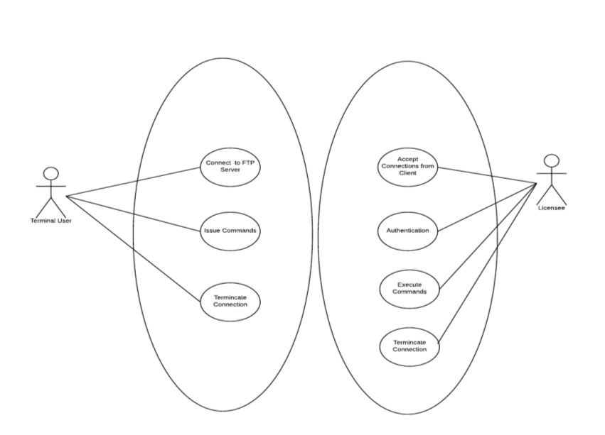
Use-Case Realizations
Not the scope of this phase.

Deployment View

Logical Structure

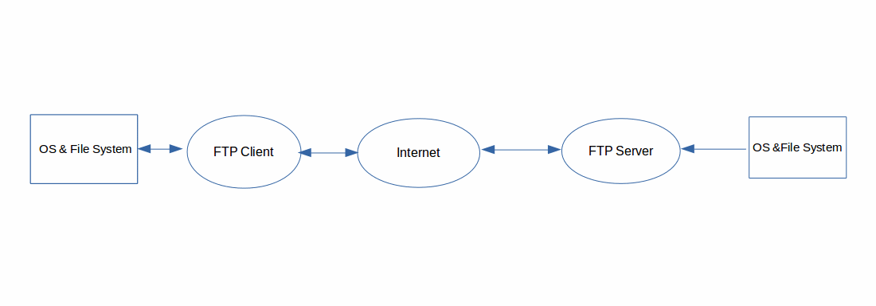
Physical structure
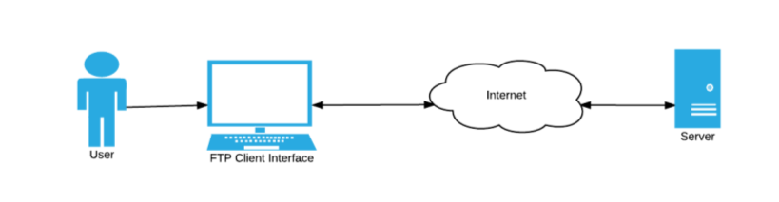

System Modules
In order to provide the basic functionality of the File Transfer System, each component (
FTP server and FTP client) consists of different modules. Each module provide distinct
functionality as well as well defined interface, so that they are loosely coupled.

FTP Server :

FTP server consists of following modules.

1. Parser Module : Parses the configuration file or command arguments.

2. Listener Module : Opens and creates the listening socket for accepting new connections.
3. Connector Module: Provides basic functionality of reading and writing of data and maintains connection
information, including ip address, port and
4. Command Module: Provides a database of commands and validation of commands from the
client and executes the associated actions.

5. Authorization Module : Provides authentication service for connection
request. Also, authorization for accessing the files from a specific directory.

6. Logger Module : Provides auditing functionality for connections.
7. Socket poller module: Provides basic asynchronous event handling of sockets.
8. Buffer Module : Provides basic buffer handling operations including storing and reading from buffer.

FTP Client:

FTP client consists of the following modules.

1. Connector Module: Provides basic functionality of socket operations including open, close

read and write operations on sockets.

2. Commander Module: Provides a database of commands and validation of commands from the

client and executes the associated actions.

3. Parser Module : Parses the configuration file or command arguments.

4. Core Module : main module which starts the application.
5. Logger Module : Provides auditing functionality for connections.

6. Interface Module : Provides basic interface for user, accepts input from user and displays the

information to the user.
7. Socket poller module: Provides basic asynchronous event handling of sockets.
8. Buffer Module : Provides basic buffer handling operations including storing and reading from buffer.
9. Window Module : Provides an end user interface. Accepts user input and display output.

Class Diagram :

In separate documents attached.

