Contents
Past impact of TFT 2
Foundation principle of TFT 2
Key components of TFT 2
Equation of TFT 3
Why TFT over XGBoost or any other tree-based models? 4
TFT Architecture 5
Covariates 5
Implementation of TFT using Darts 6

Temporal Fusion Transformers

Past impact of TFT
- TFT was used by Uber in 2018 to forecast the demand for the number of rides
- It increased the forecast accuracy by 15%

Foundation principle of TFT
- TFT are advanced deep learning models designed specifically for time series forecasting, they integrate multiple data sources and dynamically adjust to temporal patterns and this significantly improves the accuracy

Key components of TFT
- Attention Mechanism – Enables the model to focus on the most relevant parts of the data at each time step thus enhancing the prediction
- LSTM Encoders and Decoders – These components help capture long term dependencies in the data
- Static covariates – Feature that do not change over time but are crucial for model’s performance
- Multi-horizon forecasting – Similar to other forecasting models such as ARIMA and LSTM, TFT is also capable of producing forecast for multiple time periods in one go i.e., if I want to forecast the annual sales of my product, I can get that using the monthly sales data as it would return the forecast for the entire 12 months in one go. But the way (attention mechanism) it produces this forecast makes it more reliable than the other two
- Dynamic feature prioritization – TFT’s attention mechanism assigns varying weights to features, prioritizing their importance for accurate forecasts. For each forecast horizon (month), TFT learns a unique set of attention weights across all features — amplifying the ones most relevant to that specific horizon and suppressing the ones that carry weak signal. Important: This means while forecasting for December, it would assign different weights to the features and while forecasting for May, it would assign different weights to the features.
- Flexibility – TFT can accept a wide variety of inputs. These are –
- Static covariates – Features that do not change over time. They are fixed throughout the entire course of time starting from the initial time period when training began till the time period when forecasting begins
- Time-varying known future inputs – Features that vary with time and which are known for the future
- Time-varying observed inputs – Features that change over time but whose future values you don’t know such as past promotional offers or past competitor pricing

Equation of TFT
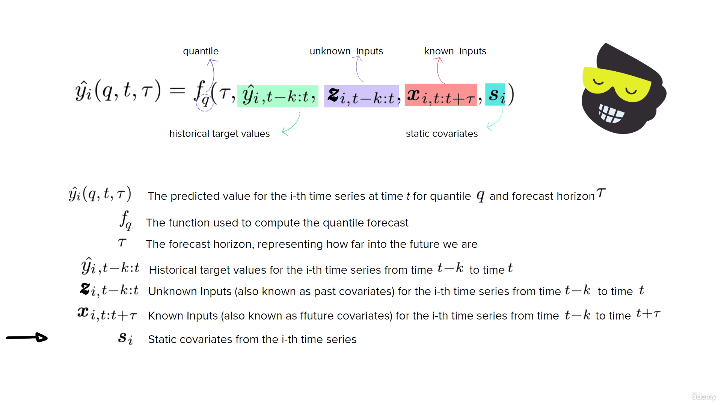

- TFT can be used as a global model to generate multi-horizon forecasts for multiple time series in one go. Here (in the image above), the i-subscript tells me that only
Key points:
- For my use-case, if I give (into the data) the ID of the retailer which is a string and is made up like (10690_SPLENDOR_+_DISC_SELF_SPOKE_BLACK) then TFT will use this as ID of the time series only. This will help the model to identify which series it is currently learning from
- However, this is simply an ID for TFT, in order to make the model learn that not only these two IDs one is (10690_SPLENDOR_+_DISC_SELF_SPOKE_BLACK) and other is (10690_SPLENDOR_+_DISC_KICK_SPOKE_RED) are different but also in what way they are different, we use static covariates such as – Dealer Code, Dealer City, Model Name, etc.

Why TFT over XGBoost or any other tree-based models?

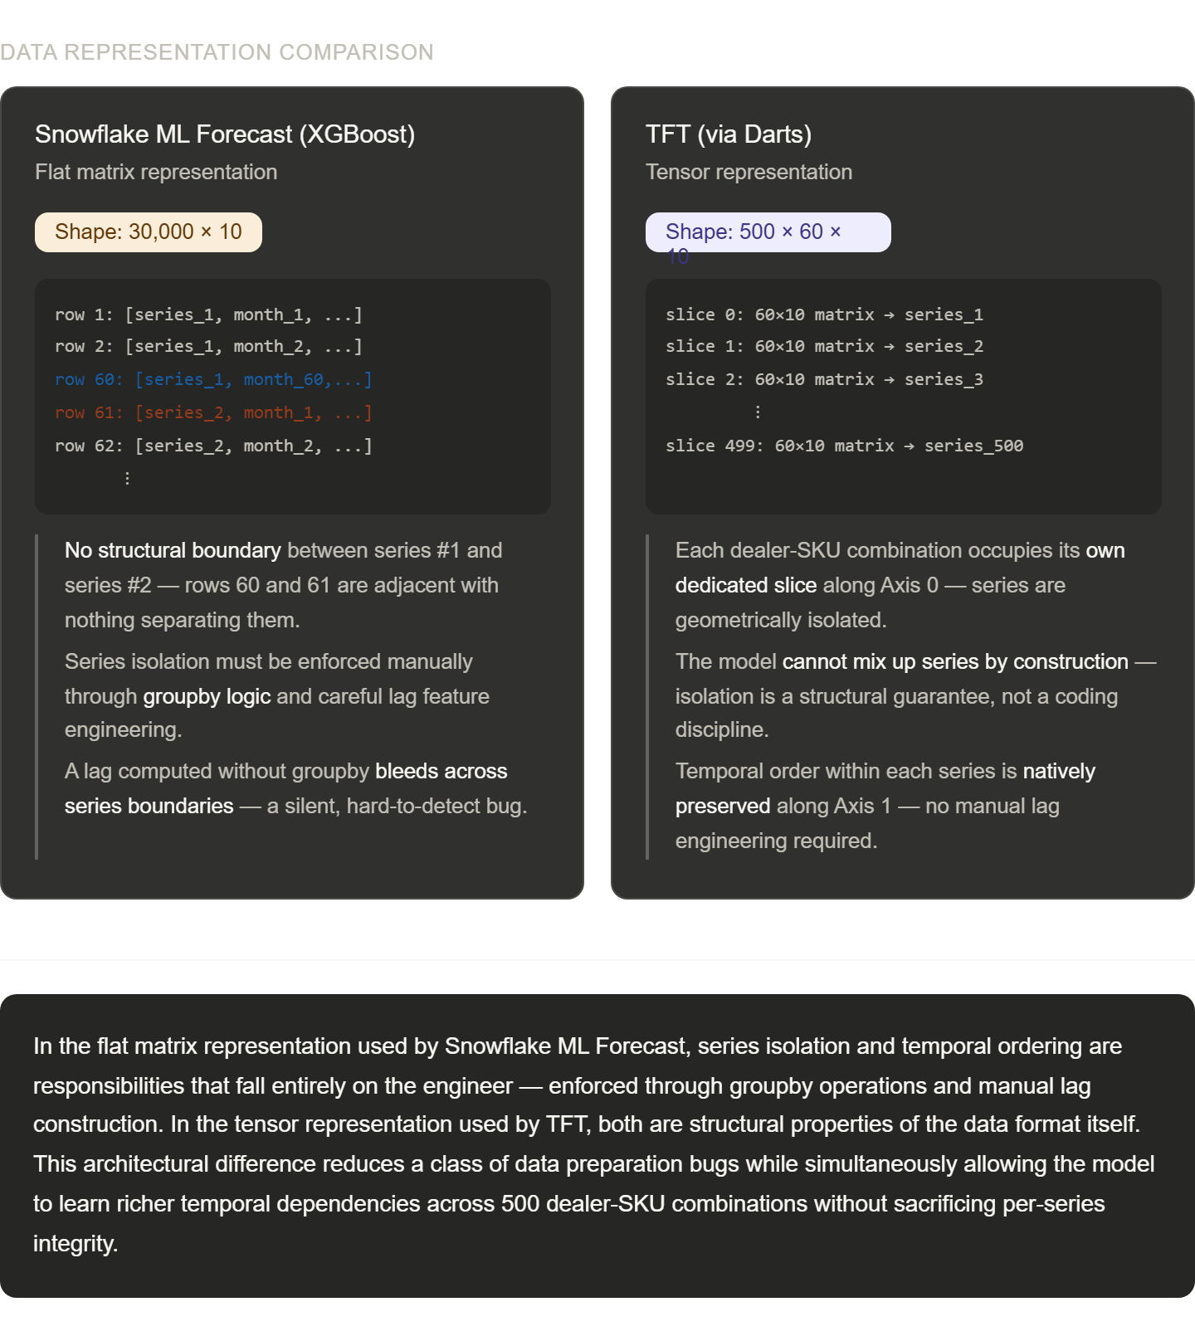

TFT Architecture
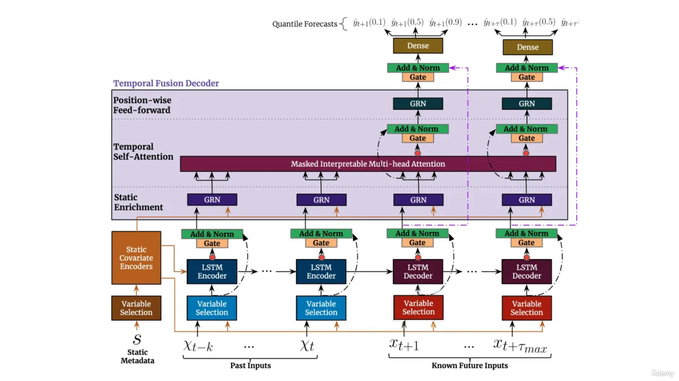

Covariates
- Covariates can be called as exogeneous variables or regressors that are given to the model which further help it in generating the forecasts. In the context of TFT, there can be 3 types of covariates –
- Past covariates – These are the features for which we know the past values but we do not know the future values such as –
- Market share of the product
- Rainfall
- Promotional offers (assuming I don’t know the kind of offers that will be run in the future)
- Future covariates – These are the features for which we know the past values as well as the future values such as –
- Holidays
- Marriage days
- Static covariates - These are the features that remain unchanged throughout the entire cycle i.e., from the month when training started to the month when prediction/forecasting is taking place such as –
- Dealer city
- Bike Brand
- Bike colour
- Ignition type
- Wheel type

Implementation of TFT using Darts
- Link to the documentation

- First step is to let the model learn that time is moving ahead by inferring the different components of the time. In order to do that, there is an argument called as add_encoders in the function. The benefit of using this argument is “darts automatically infer the various covariates from the datetime index without having to manually encode stuff”. Link to the explanation of add_encoders argument

- Link to the explanation of Darts TimeSeries data structure

