PROCESS DOCUMENTATION
SOQ & Monthly Forecast — Operating Steps
Internal reference guide for running the monthly forecast and SOQ generation pipeline
Note: This document contains two questions addressed to Dhanunjai, marked clearly in amber boxes below. Please add your answer directly under each question — the rest of the document's structure and formatting doesn't need to change.

Steps to Create Monthly Forecast
(This is after the forecast from the model is ready.)
Step 1 — Standardize series names
Run the query in the .txt file named Query_to_make_series_name_consistent to replace the first two chevrons (<>) with underscores (_) and enclose the series name in quotes.
Step 2 — soq_step3_code.py
- Change the name of FORECAST_TABLE to the table where the SOQ Step 2 forecast is stored.
- Increment the run version by 1.
- Set STOCK_DATE_TYPE to 'end'.
- Set MONTHS to the first date of the forecast month (e.g., for July's forecast, MONTHS = '2026-07-01').
- Output table: MOP_DATABASE.SOQ.SOQ_BASE_TABLE_FINAL_CONCATENATED
Step 3 — soq_step4_code.py
Includes A/B/C classification rules and Safety Stock day allocation for each category.
- Increment the run version by 1.
- Set STOCK_DATE_TYPE to 'end'.
- Set MONTHS to the first date of the forecast month (e.g., for July's forecast, MONTHS = '2026-07-01').
- Output table: SOQ_DATA_FINAL_VERSION_2
Step 4 — soq_step5_code.py
Includes A/B/C classification rules and Safety Stock day allocation for each category.
- Increment the run version by 1.
- Output table: SOQ_DATA_FINAL_VERSION_WITH_AO_VERSION_4
Step 5 — soq_step6_code.py

❓ QUESTION FOR DHANUNJAI #1
soq_step6_code.py also has A, B, and C assignment — if we change the A/B/C percentage, do I need to make that change here too, in addition to soq_step4_code.py? Look at the code screenshot below
Answer:

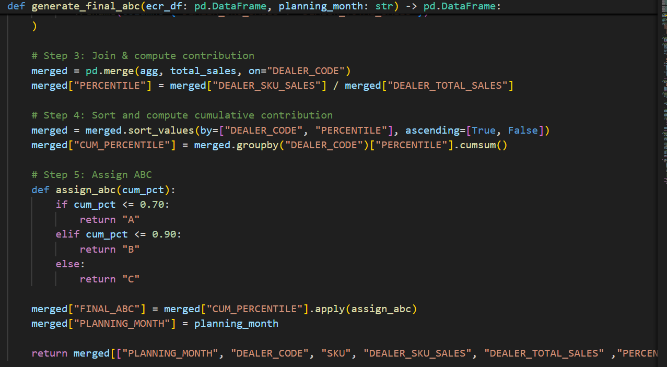
- Modify planning_month in the config dictionary to the month for which the forecast is being generated.
- Output table: MOP_DATABASE.SOQ.RETAIL_ALL_MONTHS
Step 6 — SQL queries (soq_step7_sql_queries.txt)
- Run query 1. Make the following changes:
- PLANNING_MONTH — set to the month for which the forecast is being shared.
- STOCK_DATE_PERIOD — set to 'end'.
- RUN_VERSION — set per the run version decided in soq_step3_code.
- Run query 2 as-is.

❓ QUESTION FOR DHANUNJAI #2
If I were to share the Dealer-SKU level prediction with business, which table should I prefer — MOP_DATABASE.DISPATCH_AUTOMATION_OBL.PREDICTION_SKU_DATA or MOP_DATABASE.DISPATCH_AUTOMATION_OBL.PREDICTION_SKU_DATA_TBL?
Answer:

Step 7 — Publish forecast to the dashboard
Objective: make the forecast visible on the dashboard. Run the legacy notebooks PROGATI DISPATCH AUTOMATION ALL SCRIPTS NEW LOGIC and Weekly Dispatch Summary A.
7.1 PROGATI DISPATCH AUTOMATION ALL SCRIPTS NEW LOGIC (legacy notebook)
- Covers Daily Truck Dispatch.
- Executed multiple times. Case: preparing the forecast for the current month — run this after SOQ Step 7.
Modifications required:
- Cell 1 (Step 1) — In the config dictionary, replace any "last month" reference with the current date. In fetchpredictedsales, set RUN_VERSION to the SOQ run version.
- Cell 3 (Step 2) — In the config dictionary, set CALDAY to the current forecast month.
- Cell 4 (Step 3) — Add holiday data (default: all Sundays in the month — confirm with Priya, OBD team).
- Cell 7 (Step 8) — Add holiday data, same approach as Step 3.
Run this before the Weekly Dispatch Summary A notebook.
Frequency: daily, between 11:00 AM and 12:30 PM.
Validation checks — all must pass:
- AllTrucks.UNITS_TO_BE_DISPATCHED ≤ InvSnapshot.EOD_AVAILABLE_QUANTITY
- FINAL_B2G ≤ AllTrucks.UNITS_TO_BE_DISPATCHED ≤ Dispatchable.MAX_QTY
- FINAL_B2G ≤ MinTrucks.UNITS_TO_BE_DISPATCHED ≤ Dispatchable.MAX_QTY
7.2 Weekly Dispatch Summary A
- Also a truck dispatch notebook — calculates next week's B2G.
- Executed for SOQ forecasting; run only after PROGATI DISPATCH AUTOMATION ALL SCRIPTS NEW LOGIC.
- Frequency: Weekly. 1st of every month followed by 8th, 15th, and 22nd.

Modifications required:
- Cell config_dict — change CAL_DATE and CALDAY to the current month.
- Add holiday_data.
- In config_dict, locate the UDF fetchSafetyStockDays and update RUN_VERSION in the safety_stock query.
- Only the top 2 cells need to be run.
Validation: confirm REORDER_LEVEL equals LEAD_TIME_STOCK + SAFETY_STOCK.

Steps to Create SOQ
Step 1 — Standardize series names
Run the query in the .txt file named Query_to_make_series_name_consistent to replace the first two chevrons (<>) with underscores (_) and enclose the series name in quotes.
Step 2 — soq_step3_code.py
- Change the name of FORECAST_TABLE to the table where the SOQ Step 2 forecast is stored.
- Increment the run version by 1.
- Set STOCK_DATE_TYPE to 'first'.
- Set MONTHS to the first date of the month for which SOQ is being generated (e.g., for August's SOQ, MONTHS = '2026-08-01').
- Output table: MOP_DATABASE.SOQ.SOQ_BASE_TABLE_FINAL_CONCATENATED
Step 3 — soq_step4_code.py
Includes A/B/C classification rules and Safety Stock day allocation for each category.
- Increment the run version by 1.
- Set STOCK_DATE_TYPE to 'first'.
- Set MONTHS to the first date of the month for which SOQ is being generated (e.g., for August's SOQ, MONTHS = '2026-08-01').
- Output table: SOQ_DATA_FINAL_VERSION_2
Step 4 — soq_step5_code.py
Includes A/B/C classification rules and Safety Stock day allocation for each category.
- Increment the run version by 1.
- Output table: SOQ_DATA_FINAL_VERSION_WITH_AO_VERSION_4
Step 5 — Generate SOQ
Run the query in the .txt file titled query_to_generate_soq. Different service levels (e.g., 80, 85, 90, 95) can be set to produce results.

Tables to Remember
Table | Data it consists of
MOP_DATABASE.DISPATCH_AUTOMATION_OBL.PREDICTION_SKU_DATA | Dealer-SKU level predictions
MOP_DATABASE.DISPATCH_AUTOMATION_OBL.Weekly_dispatch_summary_updated | Table which displays the forecast in the dashboard

