Steps to create monthly forecast (This is after forecast from the model is ready):
Step 1 – Run this query in SQL (mentioned in the .txt file named Query_to_make_series_name_consistent) to replace first two chevrons (<>) with underscores (_) and enclose the series name with quotes.
Step 2 – All these steps/modifications will be done in soq_step3_code.py file:
- Change the name of the FORECAST_TABLE to the table in which forecast from SOQ Step 2 is stored
- Increment the run version by 1
- Make STOCK_DATE_TYPE as ‘end’
- Make MONTHS as the first date of the month for which forecast is being generated. For example, when forecast for July was being generated, I kept MONTHS as ‘2026-07-01’
- Output table is - MOP_DATABASE.SOQ.SOQ_BASE_TABLE_FINAL_CONCATENATED

Step 3 – All these steps/modifications will be done in soq_step4_code.py file. soq_step4_code.py has A, B, and C classification rule as well as Safety Stock days allocation to each of the 3 categories
- Increment the run version by 1
- Make STOCK_DATE_TYPE as ‘end’
- Make MONTHS as the first date of the month for which forecast is being generated. For example, when forecast for July was being generated, I kept MONTHS as ‘2026-07-01’
- Output table is - SOQ_DATA_FINAL_VERSION_2.

Step 4 – All these steps/modifications will be done in soq_step5_code.py file. soq_step5_code.py has A, B, and C classification rule as well as Safety Stock days allocation to each of the 3 categories
- Increment the run version by 1
- Output table is - SOQ_DATA_FINAL_VERSION_WITH_AO_VERSION_4.

Step 5 – All these steps/modifications will be done in soq_step6_code.py file.
Question for Dhanunjai - soq_step6_code.py also has A, B, and C assignment, if we are changing the A, B, and C percentage, then apart from making the change in soq_step4_code.py, I have to make that change in this step too, correct?
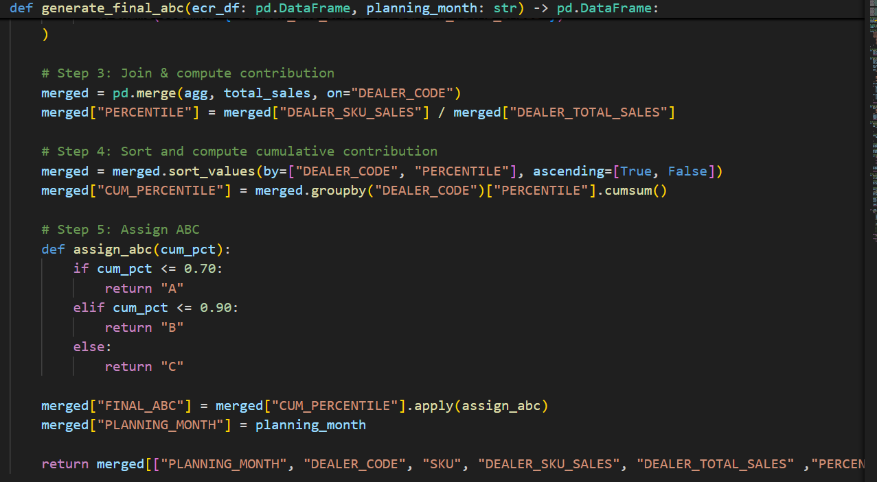
- Modify the planning_month in the config dictionary to the month for which forecast is being generated
- Output table is - MOP_DATABASE.SOQ.RETAIL_ALL_MONTHS.

Step 6 – This is about running the sql queries in the .txt file titled as - soq_step7_sql_queries.
- Run query 1 in the .txt file. In this query, make the following changes –
  - PLANNING_MONTH to be made as per the month for which forecast is being shared
  - STOCK_DATE_PERIOD is to be made ‘end’
  - RUN_VERSION as per the RUN_VERSION for forecast that is decided from soq_step3_code

- Run query 2 in the .txt file as it is.
Question for Dhanunjai – If I were to share the Dealer-SKU level prediction with business, which table should I prefer? MOP_DATABASE.DISPATCH_AUTOMATION_OBL.PREDICTION_SKU_DATA or MOP_DATABASE.DISPATCH_AUTOMATION_OBL.PREDICTION_SKU_DATA_TBL

Step 7 – Now the objective is to ensure that the forecast is visible in the dashboard. In order to do that, one has to run the legacy notebooks - PROGATI DISPATCH AUTOMATION ALL SCRIPTS NEW LOGIC and Weekly Dispatch Summary A
1. PROGATI DISPATCH AUTOMATION ALL SCRIPTS NEW LOGIC - This a legacy notebook.
-> This is Daily Truck Dispatch
-> This shall be executed multiple times -
A. While preparing the forecast for the current month : After executing SOQ Step 7, this will be executed.
Following modifications need to be done -
1. In Step 1 (cell1) - Change config dictionary, wherever last month is mentioned, I have to put current date. In fetchpredictedsales, change the RUN_VERSION to whatever was the RUN_VERSION of SOQ

2. In Step 2 (cell3) - Again change the config dictionary, CALDAY to be changed to current month for which forecast needs to be shared

3. In Step 3 (cell4) - Add holiday data - All the Sundays for the month is the general rule but I need to check with Priya from OBD team

4. In Step 8 (cell7) - Add holiday data - Same that was done for Step 3

-> Ensure to run before weekly dispatch summary A legacy notebook

-> Frequency of executing this PROGATI DISPATCH AUTOMATION ALL SCRIPTS NEW LOGIC: Daily after 11am and before 12:30pm.

-> Validation checks that should pass through :
1. AllTrucks.UNITS_TO_BE_DISPATCHED <= InvSnapshot.EOD_AVAILABLE_QUANTITY : This should be the case
2. FINAL_B2G <= AllTrucks.UNITS_TO_BE_DISPATCHED <= Dispatchable.MAX_QTY : This should be the case
3. FINAL_B2G <= MinTrucks.UNITS_TO_BE_DISPATCHED <= Dispatchable.MAX_QTY : This should be the case

2. Weekly Dispatch Summary A

-> This is also truck dispatch to calculate "next week's B2G"

-> This shall also be executed for SOQ forecasting. This will only be executed after PROGATI DISPATCH AUTOMATION ALL SCRIPTS NEW LOGIC.

-> Following modifications to the code will be done -
1. In cell named config_dict : Change CAL_DATE and CALDAY to the date to current month.
2. Add holiday_data as well
3. In config_dict cell, find the UDF named - fetchSafetyStockDays and change the RUN_VERSION in safety_stock query
4. Only the top 2 cells need to be run

-> Validating if the execution was successful : Ensure that REORDER_LEVEL is equal to LEAD_TIME_STOCK + SAFETY_STOCK

Steps to create SOQ

Step 1 – Run this query in SQL (mentioned in the .txt file named Query_to_make_series_name_consistent) to replace first two chevrons (<>) with underscores (_) and enclose the series name with quotes.
Step 2 – All these steps/modifications will be done in soq_step3_code.py file:
- Change the name of the FORECAST_TABLE to the table in which forecast from SOQ Step 2 is stored
- Increment the run version by 1
- Make STOCK_DATE_TYPE as ‘first’
- Make MONTHS as the first date of the month for which SOQ is being generated. For example, when SOQ for August was being generated, I kept MONTHS as ‘2026-08-01’
- Output table is - MOP_DATABASE.SOQ.SOQ_BASE_TABLE_FINAL_CONCATENATED

Step 3 – All these steps/modifications will be done in soq_step4_code.py file. soq_step4_code.py has A, B, and C classification rule as well as Safety Stock days allocation to each of the 3 categories
- Increment the run version by 1
- Make STOCK_DATE_TYPE as ‘first’
- Make MONTHS as the first date of the month for which SOQ is being generated. For example, when SOQ for August was being generated, I kept MONTHS as ‘2026-08-01’
- Output table is - SOQ_DATA_FINAL_VERSION_2.

Step 4 – All these steps/modifications will be done in soq_step5_code.py file. soq_step5_code.py has A, B, and C classification rule as well as Safety Stock days allocation to each of the 3 categories
- Increment the run version by 1
- Output table is - SOQ_DATA_FINAL_VERSION_WITH_AO_VERSION_4.

Step 5 – Run the query in the .txt file titled as - query_to_generate_soq. One can set different service levels like 80,85,90, and 95 to get the results.

