Lab 4 Part 2

Yashesh Patel

Q1. grep --color -n 'Towns\|Union' mountainList.txt

Q2. Grep --color 'Rabun' mountainList.txt|wc

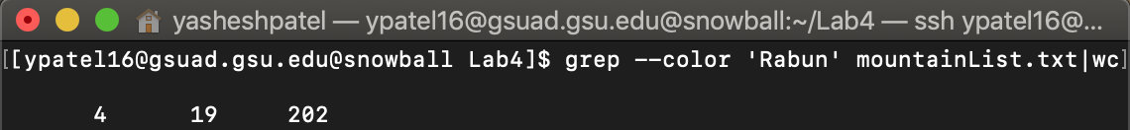

Q3. grep -c 'Rabun' mountainList.txt|wc

Q4.

A)

B)

C) -n suppresses the automatic printing of pattern space

D) It suppresses the printing of pattern space, then it substitutes “ridge high point” with “r.h.p” in the text then prints out the statement from the text file

Q5. sed 's/^ \*// p' mountainList.txt

Q6. sed 's/^ \*// p' mountainList.txt > newList.txt

Q7. Sed -n '/^ \*/ p' mountainList.txt

Q8. sed '/Union County/d' mountainList.txt

Q9. sed -r 's/,([^,]\*){3},/,/g' mountainList.txt

Q10. awk -F, ‘{print $1 "," $5}' mountainList.txt

Q.11 sed 1i\ 'Table Eleven Highest Mountains in Georgia' mountainList.txt

Q12. sort -t, +0 -1 mountainList.txt

Q13. sort -t, -r +2 -3 mountainList.txt

Q14.

Q15. sed – r ‘s/(^[A-Z]$\,) (^[A-Z]$[y])/\1,\2/g’ mountainList.txt