

END SEMESTER PROJECT

Project Title: Automatic Power Factor Correction

Electrical Network Analysis

Class/Section:
BEE-16C

Submitted To:
Sir Habeel Ahmed

Date of Submission:
12-05-2025

Submitted By:
Yashfeen Zahra | 504292
Museera Itlish | 505629
Zainab Azfer Ali | 502554
Syed Faizan Ali Rizvi | 501258

Abstract:

Effective power utilization is crucial because of increased power requirements and heavy utilization of inductive loads such as submersible water pumps, which decrease the power factor and also decrease system efficiency. This project demonstrates an Automatic Power Factor Correction (APFC) device with an Arduino ATmega328 microcontroller, which measures voltage and current continuously, computes the phase angle, and changes capacitor banks automatically to enhance the power factor.

A 16x4 LCD display is used to get current system updates in real time. The system was tested on a submersible pump and was able to raise the PWM power factor from 0.66 to 0.92, lowering losses and increasing efficiency. This economical, scalable, and automated solution is particularly applicable to rural, agricultural, and small industrial applications, where stable and efficient power systems are essential.

Introduction:
In AC systems, power factor—defined as the ratio of active to apparent power—indicates how efficiently electrical power is used. Inductive loads like submersible pumps, common in rural areas, reduce power factor by causing current to lag voltage, increasing reactive power and energy losses.
Poor power factor leads to higher electricity bills, transmission losses, and utility penalties. To counter this, capacitor banks are used to supply leading reactive power, improving efficiency.
This project implements an Arduino-based Automatic Power Factor Correction (APFC) system. Using a PZEM-004T module, it measures voltage, current, and power factor in real time. The ATmega328 microcontroller calculates the phase angle and automatically switches capacitors to correct the power factor, with system data shown on a 16x4 LCD.
Tested on a submersible pump, the system improved the power factor from 0.66 to 0.92, demonstrating its effectiveness for rural and small industrial setups.
Components Used:

· Arduino
· PZEM Module
· Relay module
· Capacitor bank
· LCD
· Bulb
· Submersible pump
· Power supply
Power Triangle:
The APFC system enhances power system efficiency by optimizing the power triangle:

- Minimizes Reactive Power (Q): Capacitors balance inductive loads, reducing the reactive portion.

- Reduces Phase Angle (θ): Pulls voltage and current closer together, enhancing power factor (cos θ).

- Brings Apparent and Real Power into alignment: Minimizes the difference between real (P) and apparent power (S), making it more efficient.

- Stabilizes Voltage: Reduced current consumption minimizes voltage drops over extended cables.

- Reduces Losses and Expenses: Lower power triangle implies reduced energy losses and electric bills.

- Increases Efficiency: Increases power factor appreciably (e.g., from 0.66 to 0.92) without the requirement for unity.
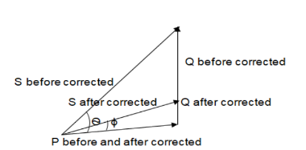

Block Diagram:
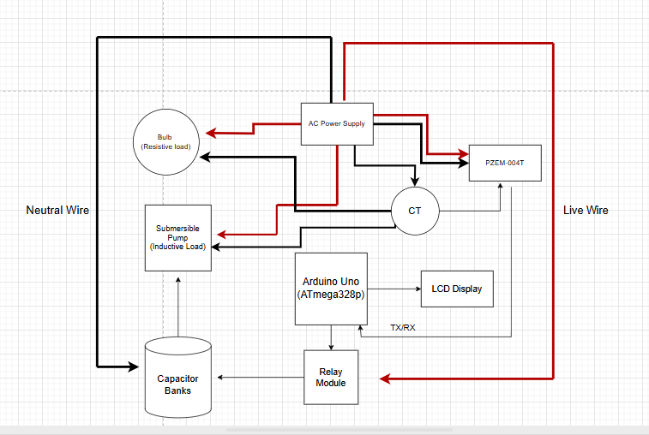

Working Principle:

The Automatic Power Factor Correction (APFC) unit is designed to control and improve the power factor of AC loads (particularly inductive loads like submersible pumps and bulbs) by automatically switching capacitors into and out of the circuit.
The system starts with an AC power source, which feeds the load like a bulb or motor. Such loads always reduce the power factor since they are inductive in nature, making the current lag behind the voltage.
A PZEM-004T power monitoring module is connected in series with the load. It measures significant electrical parameters: voltage, current, active power, apparent power, and power factor. The module communicates with the Arduino Uno (ATmega328) via serial communication. The Arduino samples these values on a continuous basis. When it detects a power factor lower than a pre-defined threshold like 0.90, it calculates the level of reactive power compensation needed. It provides control signals to a relay module connected to capacitors in response.
The load is paralleled with the capacitor bank, which provides the leading reactive power to balance the lagging reactive power by the inductive loads. The correction serves to bring the current into phase with the voltage, hence improving the power factor.

An LCD 16x4 display is interfaced with Arduino to display real time values such as power factor, voltage and current. This provides the user with immediate feedback.

Summary of Connections:

- AC supply → Load (pump/bulb)

- PZEM module → series connected with load → TX/RX to Arduino

- Arduino Uno → regulates relay module → switches capacitors

- Capacitor bank → parallel connected to load

- LCD display → interfaced to Arduino through I2C or digital pins

The system operates continuously in a loop, adjusting in real-time under load conditions for efficient use of power and lowered electricity bills.
Simulation:

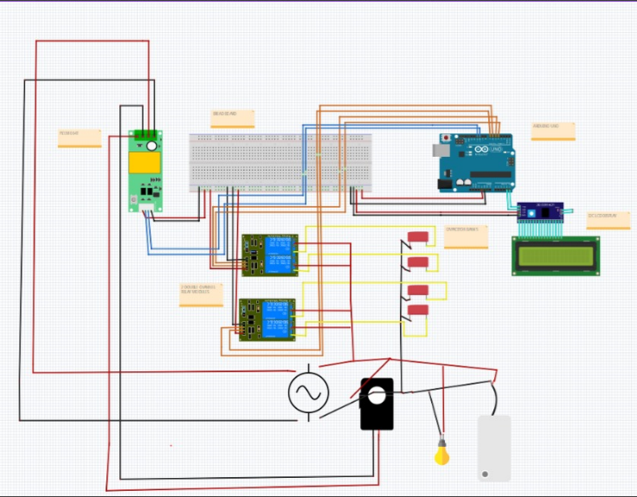

Hardware :

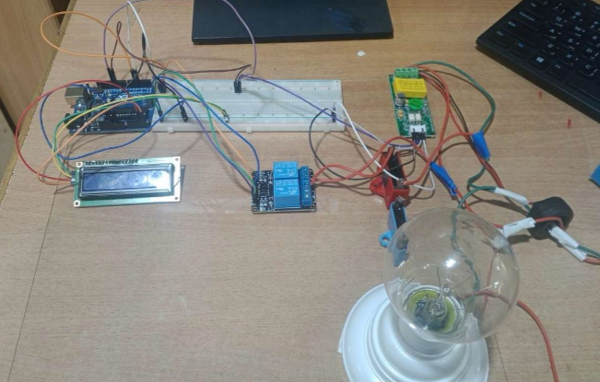

Advantages and Applications:

- Cost Saving:
The system saves electricity bills by optimizing the power factor, reducing penalties imposed by the utility for reactive power usage.

- Energy Efficiency:
By reducing the phase angle difference between current and voltage, the system saves wasted reactive power, enhancing energy consumption.

- Ideal for Rural Areas and Small Industries:
It's best suited for rural use and small industrial applications where inductive loads such as tube lights and water pumps are used. It's easy, inexpensive and not much work is needed to maintain it.

Limitations and Future Work:

Limitations:
- The range for correction is constrained to the capability of the connected capacitor bank.

- The system is reactive and reacts only after power factor falls and not predictive.

- There are no IoT or remote control features present as of now.

Future Work:

- IoT Integration: Real-time monitoring and remote control through mobile apps or cloud dashboards.

- Wireless Monitoring: Utilizing Wi-Fi or GSM modules to report performance data to utility providers or users.

- Smart Control Logic: Applying predictive algorithms or machine learning to improve correction.

Conclusion:

The APFC system implemented with an Arduino, PZEM module, and capacitor bank efficiently enhances power factor by automatically compensating for the lagging current due to inductive loads. It is economical, energy saving, and suitable for rural applications and small industry units. The project showcases how microcontroller based automation can be used to enhance power quality, minimize energy losses, and decrease electricity bills.

