## Stored Cross-Site Scripting

**Software Name:** Hospital Management System

**Download Link:** *https://www.campcodes.com/downloads/complete-online-hospital-management-system-using-php-and-mysql-source-code/*

**POC(s):**

**Step 1:** Access the URL and log in as an admin, as shown in the screenshot.

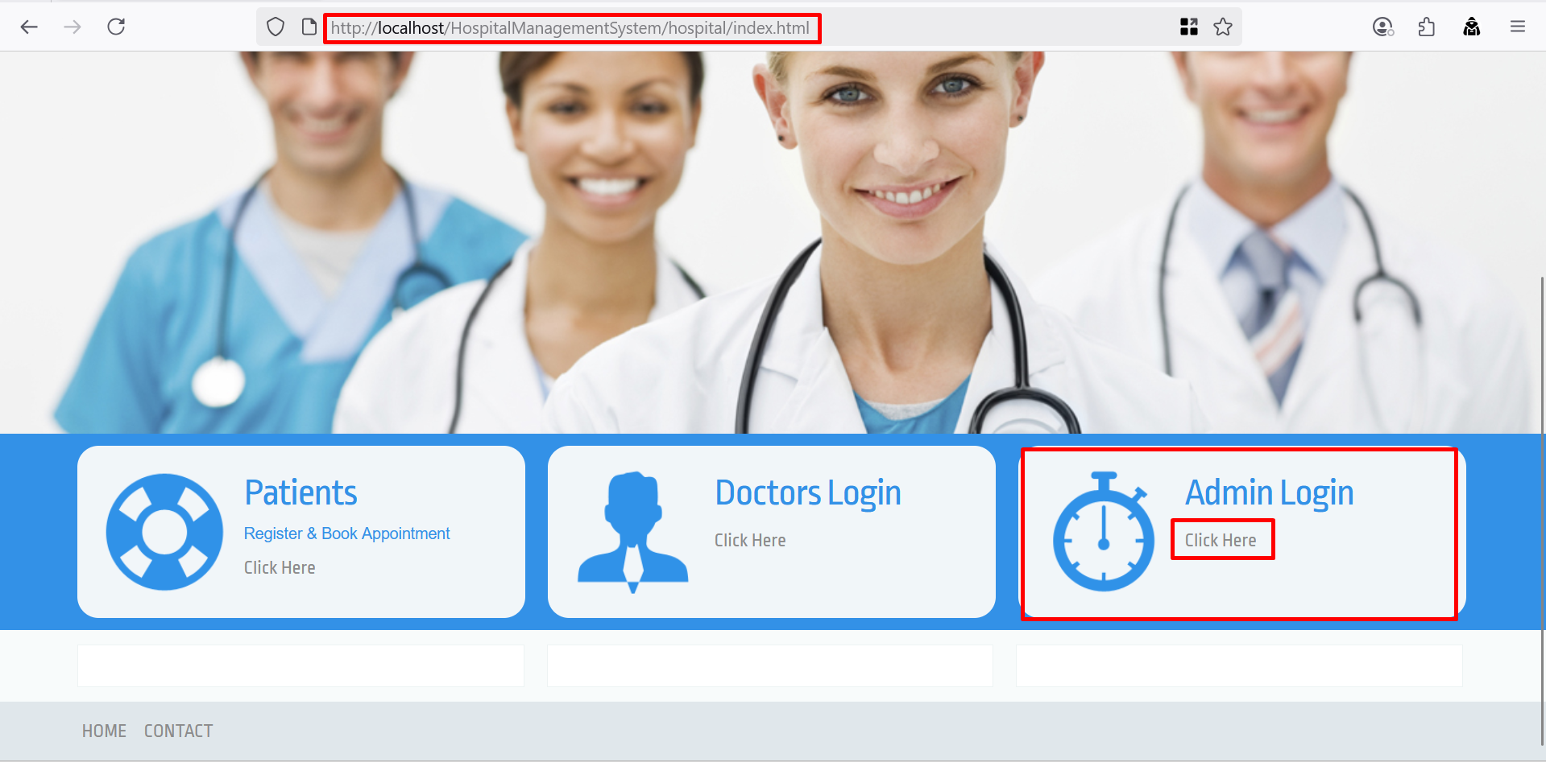

**Step 2:** After successfully logging in, click on “Doctors” and then select “Doctor Specialization,” as shown in the screenshot below.

**Step 3:** Click the edit icon under the “Action” column, as shown in the screenshot below.

**Step 4:** Enter the following payload into the “Edit Doctor Specialization” field and click the “Update” button, as shown in the screenshot below.

**Payload:** “*<img src=x onerror=confirm(document.cookie)>*”

**Step 5:** After successfully updating the doctor specialization, click on “Doctors” and then select “Doctor Specialization.” It can be observed that the payload executes successfully, indicating that the application does not properly sanitize user input, resulting in Stored Cross-Site Scripting (XSS).

