***PROJECT 1: SQL DATA EXPLORATION***

Create Database PortfolioDatabase

USE PortfolioDatabase

/*

Select *

From CovidDeaths

Select *

From CovidVaccination

*/

1. **Display Data from Table 1: Covid Deaths**

Select *

From PortfolioDatabase.dbo.Covid_Deaths

Order by 3,4

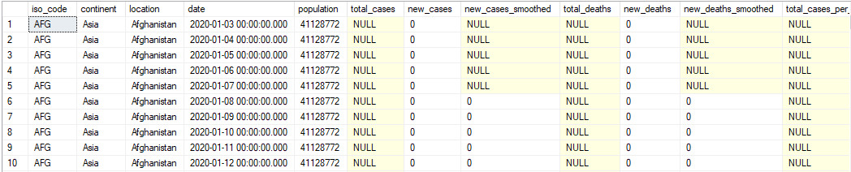

1. **Display Data from Table 2: Covid Vaccination**

Select *

From PortfolioDatabase..Covid_Vaccination

Order by 3,4

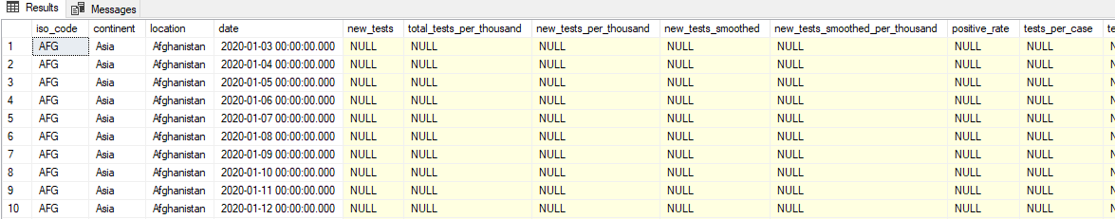

1. **Display Data from Table 1: Covid Deaths after Data Cleaning**

Select location, date, total_cases, new_cases, total_deaths, population

From PortfolioDatabase.dbo.Covid_Deaths

Order by 1,2

--ALTER TABLE PortfolioDatabase..Covid_Deaths

--ALTER COLUMN total_cases float

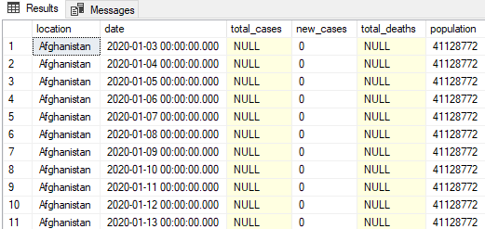

**A. Total Cases Vs Total Deaths**

**--(Shows likelihood of dying if you contract Covid in Your Country)**

1. **Countrywise Death Ratio:**

Select location, date, total_cases, total_deaths, (total_deaths/total_cases) AS death_percent

From PortfolioDatabase.dbo.Covid_Deaths

Order by 1,2

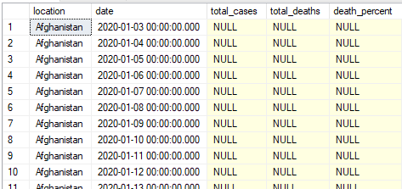

1. **Countrywise Death Percent:**

Select [location],[date],[total_cases],[total_deaths], [total_deaths]/[total_cases] * 100 AS death_percent

From [PortfolioDatabase]..[Covid_Deaths]

Order By 1, 2

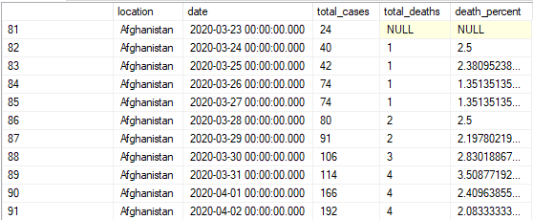

1. **India Death Percent:**

Select [location],[date],[total_cases],[total_deaths], [total_deaths]/[total_cases] * 100 AS death_percent

From [PortfolioDatabase]..[Covid_Deaths]

Where [location] like 'INDIA'

Order By 1, 2

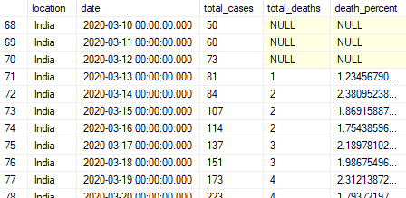

**B. Looking at Total Cases Vs Population**

**--(Shows percentage of Population got Covid)**

1. **India Morbidity Percent:**

Select [location],[date],[total_cases],[Population], [total_cases]/[Population] * 100 AS morbidity_percent

From [PortfolioDatabase]..[Covid_Deaths]

Where [location] like 'INDIA'

Order By 1, 2

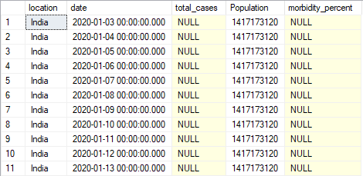

1. **Countrywise Morbidity Percent:**

Select [location],[date],[total_cases],[Population], [total_cases]/[Population] * 100 AS morbidity_percent

From [PortfolioDatabase]..[Covid_Deaths]

Order By 1, 2

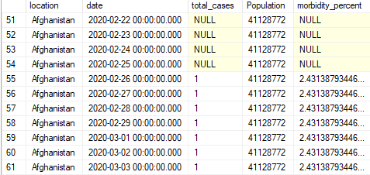

**C. Looking at Countries with Highest Infection Rate compared to Population**

**-- (Shows highest infection rate in your country)**

1. **Countrywise Infected Rate:**

Select [location],[Population], MAX([total_cases]) as highest_infection, MAX([total_cases]/[Population]) * 100 AS percentage_population_infected

From [PortfolioDatabase]..[Covid_Deaths]

Group by [population], [location]

Order By percentage_population_infected desc

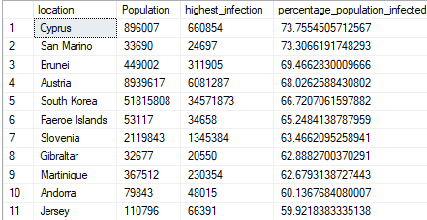

1. **India Infected Rate:**

Select [location],[Population], MAX([total_cases]) as highest_infection, MAX([total_cases]/[Population]) * 100 AS percentage_population_infected

From [PortfolioDatabase]..[Covid_Deaths]

Where [location] like 'INDIA'

Group by [population], [location]

Order By percentage_population_infected desc



**D. Looking at Highest Death Count per Population**

**-- ( Showing Highest Death Count per Population)**

1. **Countrywise Highest Death Count**

Select [location],MAX(cast(total_deaths AS int)) As total_death_count

From [PortfolioDatabase]..[Covid_Deaths]

Group by [location]

Order By total_death_count desc

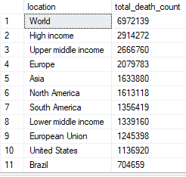

**E. Looking at Highest Death Count per Population by Continent**

**-- (Showing Highest Death Count per population by Continent)**

1. **Countrywise Highest Death Count:**

Select continent,MAX(cast(total_deaths AS int)) As total_death_count

From [PortfolioDatabase]..[Covid_Deaths]

Where continent is not null

Group by continent

Order By total_death_count desc

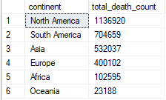

1. **Locationwise Highest Death Count:**

Select location,MAX(cast(total_deaths AS int)) As total_death_count

From [PortfolioDatabase]..[Covid_Deaths]

Where continent is not null

Group by location

Order By total_death_count desc

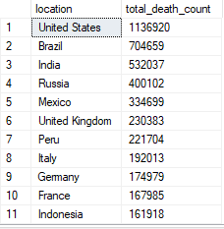

**F. Max Death Count Global Numbers**

1. **Highest Number of Cases, Deaths recorded:**

Select [date], [total_cases],[total_deaths], [total_deaths]/[total_cases] * 100 AS death_percent

From [PortfolioDatabase]..[Covid_Deaths]

Where continent is not null

group by [date]

Order By 1, 2



1. **Highest Number of Cases, Deaths recorded by date:**

Select [date], SUM(new_cases)

From [PortfolioDatabase]..[Covid_Deaths]

Where continent is not null

Group By [date]

order by 1,2

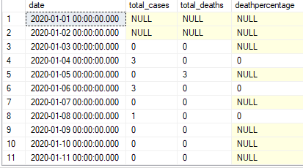

**G. Total Population VS Vaccination**

Select *

From [PortfolioDatabase]..[Covid_Deaths] CD

JOIN [PortfolioDatabase]..Covid_Vaccination CV

ON CD.[location]=CV.[location]

AND CD.[date]=CV.[date]

1. **Using CTE**

With POPvsVAC (Continent,Location,Date,Population,new_vaccinations,RollingPeopleVaccinated)

AS

(

Select CD.[continent],CD.[location],CD.[date],CD.[population],CV.[new_vaccinations],

SUM(CAST(CV.[new_vaccinations] AS bigint)) OVER (PARTITION BY CD.[location] Order BY CD.[location],CD.[date]) AS RollingPeopleVaccinated

--(RollingPeopleVaccinated/CD.[population])*100

From [PortfolioDatabase]..[Covid_Deaths] CD

JOIN [PortfolioDatabase]..Covid_Vaccination CV

ON CD.[location]=CV.[location]

AND CD.[date]=CV.[date]

Where CD.[continent] is not null

--order by 2,3

)

Select *, (RollingPeopleVaccinated/Population)*100 AS total_people_vaccinated

From POPvsVAC

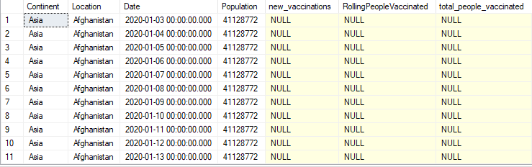

1. **Using Temp Table**

Drop Table if exists #PercentPopulationVaccinated

Create Table #PercentPopulationVaccinated

(

Continent nvarchar (255),

Location nvarchar (255),

Date datetime,

Population float,

New_vaccination bigint,

RollingPeopleVaccinated bigint,

)

Insert into #PercentPopulationVaccinated

Select

CD.[continent],

CD.[location],

CD.[date],

CD.[population],

CV.[new_vaccinations],

SUM(CAST(CV.[new_vaccinations] AS bigint)) OVER (PARTITION BY CD.[location] ORDER BY CD.[location], CD.[date]) AS RollingPeopleVaccinated

From [PortfolioDatabase]..Covid_Deaths CD

JOIN [PortfolioDatabase]..Covid_Vaccination CV

ON CD.[location]=CV.[location]

AND CD.[date]=CV.[date]

Where CD.[continent] is not null

Select *, CAST(RollingPeopleVaccinated AS float)/Population*100 AS total_people_vaccinated

FROM #PercentPopulationVaccinated

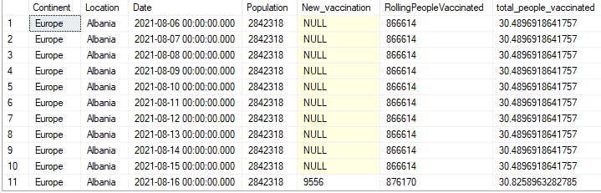

**H. Create View to store data for visualization:**

Create View PercentPopulationVaccinated AS

Select

CD.[continent],

CD.[location],

CD.[date],

CD.[population],

CV.[new_vaccinations],

SUM(CAST(CV.[new_vaccinations] AS bigint)) OVER (PARTITION BY CD.[location] ORDER BY CD.[location], CD.[date]) AS RollingPeopleVaccinated

From [PortfolioDatabase]..Covid_Deaths CD

JOIN [PortfolioDatabase]..Covid_Vaccination CV

ON CD.[location]=CV.[location]

AND CD.[date]=CV.[date]

Where CD.[continent] is not null

Select *

From PercentPopulationVaccinated

