TECHNICAL PROJECT REPORT
SecureLayer
A Zero-Trust, Privacy-First Platform for Secure Document Distribution
Single-use access | Forensic watermarking | Edge-AI threat detection | Authenticated encryption

Project | SecureLayer
Submitted by | Yash Hasija | Shubham Sabale |Ruchita Mahajan | Advait Kokane
Project guide | Mr. Sandeep Sir
Institution / Department | Dept. of AI&DS – DY Patil institute of technology – pimpri
Date | October 2026

Contents
1 | Executive Summary | What SecureLayer is and its key specifications
2 | Problem Statement & Objectives | The gap SecureLayer is designed to close
3 | System Architecture Overview | Four pillars, layered design, end-to-end flow
4 | Module 1: Access Request & Single-Use Allowance | Directory, approval workflow, one-view enforcement
5 | Module 2: Secure File Viewer | In-memory rendering, watermarking, exfiltration controls
6 | Module 3: CamDetection Threat Mitigation | Edge-AI models, risk engine, screen shielding
7 | Module 4: Backend Security Architecture | Authentication, sessions, rate limits, encryption, audit
8 | Threat & Mitigation Matrix | Every threat mapped to its defence
9 | Technology Stack | Libraries, frameworks and runtimes
10 | Limitations & Future Scope | Design boundaries and planned enhancements
11 | Conclusion
A | Appendix: Screenshot Checklist | All image placeholders in one place

How to read this report: Sections 4 to 7 follow the four modules. Each frontend screen has a dashed image.

1. Executive Summary
SecureLayer is a zero-trust, privacy-first document distribution platform. It is built to stop document leakage, unauthorised snooping and visual data exfiltration, such as photographing a screen with a phone or reading over someone's shoulder.
Most sharing systems stop protecting a file once it has been opened. SecureLayer extends protection into the viewing session itself, and even into the physical environment around the screen, through four coordinated pillars:
- Access Request & Single-Use Allowance: documents are discoverable but never readable until the owner approves, and each approval can be used for exactly one view.
- Secure File Viewer: documents are decrypted and rendered in memory only, with forensic watermarking and exfiltration controls.
- CamDetection: an in-browser computer-vision engine that detects absent users, extra onlookers and recording devices, and hides the document instantly.
- Hardened Backend: passwordless OTP login, rotating session tokens, tiered rate limiting, AES-256-GCM encrypted storage and an immutable audit log.

1.1 Key Specifications at a Glance
Area | Specification
Application stack | React front end, Node.js / Express API gateway, MongoDB database
Authentication | Passwordless email OTP, 6 digits, generated with a CSPRNG; valid 5 minutes, max 5 attempts
Session tokens | Access JWT (HS256) valid 15 min, held in memory; 64-byte opaque refresh token valid 7 days, rotated on every use
Access model | Owner-approved, single-use (one-view) allowance; auto-expires on first delivery
File encryption | AES-256-GCM, unique 12-byte IV per file, 16-byte authentication tag
Face detection model | MediaPipe BlazeFace (short-range) via @mediapipe/tasks-vision, about 6 FPS (every 150 ms)
Object detection model | TensorFlow.js COCO-SSD (lite_mobilenet_v2), about 6 FPS, confidence threshold 20%; classes: cell phone, remote, laptop, tablet
Camera data handling | 100% on-device inference; no frames, video or facial templates leave the browser
Rate limits | Global 100 req / 15 min / IP; OTP request 3 / hour / email; auth verify 20 / 15 min / IP
Watermark | Viewer email + open timestamp, repeated across the page at -30 degrees

2. Problem Statement & Objectives

2.1 Problem Statement
Conventional controls (passwords, roles, encrypted transport and storage) protect a file only until it is displayed. After that, it is exposed to threats software access control cannot see.
Threat | Scenario | Why conventional systems miss it
Screen photography | A user or bystander photographs the screen with a phone. | The capture happens outside the computer; no software event is generated.
Shoulder surfing | A second person reads the screen alongside the authorised user. | The system has no awareness of who is physically present.
Unattended screen | The user walks away with a confidential file still open. | Session timeouts are too slow and ignore physical presence.
Reusable access | A shared link, token or approval is forwarded or replayed. | Permissions are persistent rather than consumable.
Copy, save and print | Text is copied, or the file is saved or printed from the viewer. | Standard viewers deliberately expose these functions.
Credential attacks | Stolen or guessed passwords, session theft through XSS. | Passwords and long-lived tokens remain reusable secrets.

2.2 Objectives
- Make every document access explicit, owner-approved and non-replayable.
- Keep decrypted content in memory only, with no download, cache or disk copy.
- Detect physical-world threats (people, phones, absence) in real time without sending any camera data off the device.
- Make any leak attributable by marking every view with the viewer's identity and time.
- Remove password-based risk and harden every server endpoint with defence in depth.

2.3 Design Principles
Principle | How it is applied
Zero trust | Nothing is trusted by default. Every request is authenticated, authorised and audited, and a file approval is consumed after one use.
Privacy by design | Computer vision runs locally in the browser. Only anonymous event labels reach the server.
Defence in depth | Controls exist at the network edge, session layer, application layer, storage layer and viewing layer.
Least privilege | Role-based permissions plus resource-level ownership checks on every private endpoint.

3. System Architecture Overview

3.1 The Four Pillars
Pillar | Responsibility | Core technologies
1. Access Request & Allowance | Zero-trust discovery and single-consumption viewing permissions | React UI, Express controllers, MongoDB request records
2. Secure File Viewer | Isolated in-memory rendering, watermarking, exfiltration blocking | react-pdf (canvas), SVG overlay, Blob URLs
3. CamDetection | Edge-AI tracking of presence, onlookers and recording devices | MediaPipe BlazeFace, TensorFlow.js COCO-SSD, risk engine
4. Hardened Backend | Authentication, authorisation, encryption, rate limiting, audit | Node.js, Express, JWT, bcrypt, AES-256-GCM, Helmet

3.2 Layered Architecture
Client Browser | Directory & Access UI: discovery, requests, approvals  SecureFileViewer: in-memory rendering, watermark overlay, blocking modal  CamDetection: BlazeFace + COCO-SSD at about 6 FPS, risk engine with hysteresis
REST API over HTTPS | access token in header | refresh token in HttpOnly cookie
Backend Gateway (Node.js / Express) | Ingress: Helmet (CSP, HSTS), strict CORS allowlist  Control: tiered rate limiter, JWT verification, RBAC, single-use expiry guard
Decrypt-and-stream, only after every check passes
Data Layer | Private storage: AES-256-GCM encrypted files named by UUID  MongoDB: users, requests, hashed OTPs and tokens, append-only audit log
Figure 3.1: Layered view of the SecureLayer architecture

3.3 End-to-End Journey of a Confidential File
Step | Event | Control applied
1 | User signs in with an email OTP | CSPRNG OTP, bcrypt hash, 5-minute expiry, rate limits
2 | User discovers a file in the Global Directory | Metadata only; storage keys and content withheld
3 | User requests access; owner is notified | Request logged with IP and User-Agent; email alert to owner
4 | Owner approves; requester is notified | Owner / admin authorisation only
5 | Requester opens the file; approval is set to EXPIRED at once | Approval verified, file decrypted and streamed; replay returns 403
6 | Viewer renders canvas, watermark and camera guard; all actions logged | Exfiltration controls; CamDetection for HIGHLY_CONFIDENTIAL; immutable audit log

4. Module 1: Access Request & Single-Use Allowance
Sharing in SecureLayer is ephemeral and consumable. Unlike platforms where sharing creates persistent permissions or public URLs, every grant to another user's file is valid for one view only.

4.1 Global Directory Discovery
The Global Directory (GlobalFiles page) lets users see which documents exist across the organisation without being able to read them. The backend returns only safe metadata and strips every internal field.
Shown to the requester | Never exposed
File name, MIME type, size, creation date | Decrypted file content
Owner email and confidentiality rating | Internal storage keys and file paths
The requester's own request status (PENDING, APPROVED, DENIED, EXPIRED) | Encryption parameters (IV, authentication tag)
The user's own files are excluded from the list | Other users' request records

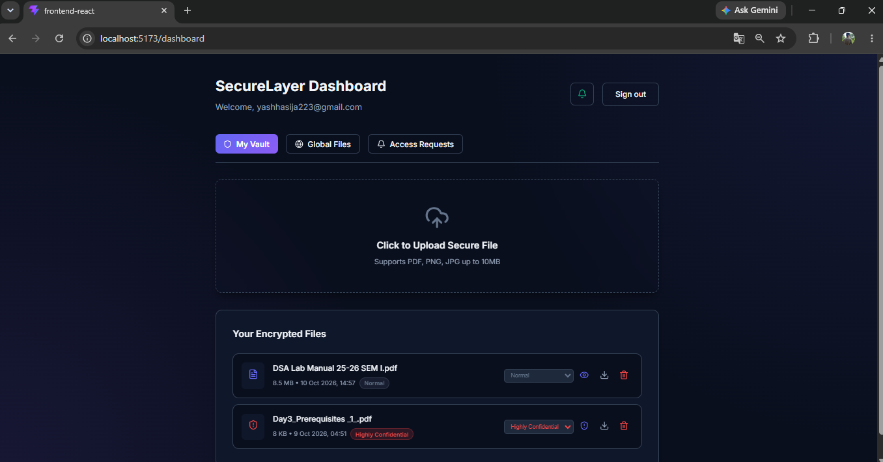
Figure 4.1: Global Directory showing organisation-wide file metadata

4.2 Access Request Lifecycle
A request is recorded with status PENDING after the system confirms that the file exists and that the requester is not the owner. Denied or expired requests can be raised again, which resets the status to PENDING.
Status | Meaning | Next possible transition
PENDING | Request submitted; waiting for the owner's decision | APPROVED or DENIED
APPROVED | Owner has granted one viewing allowance | EXPIRED (on first view)
DENIED | Owner rejected the request | Requester may re-request (PENDING)
EXPIRED | The single allowance has been consumed | Requester may re-request (PENDING)

- Owner notification: an automated email names the requester and the document. Owners can opt out of email alerts in dashboard preferences.
- Audit trail: each request writes a FILE_ACCESS_REQUESTED record with IP address and User-Agent.
- Authorised decisions only: only the true file owner, or a system administrator, can approve or deny.
- Approval notice: on approval the requester receives an email that the document is unlocked for viewing.

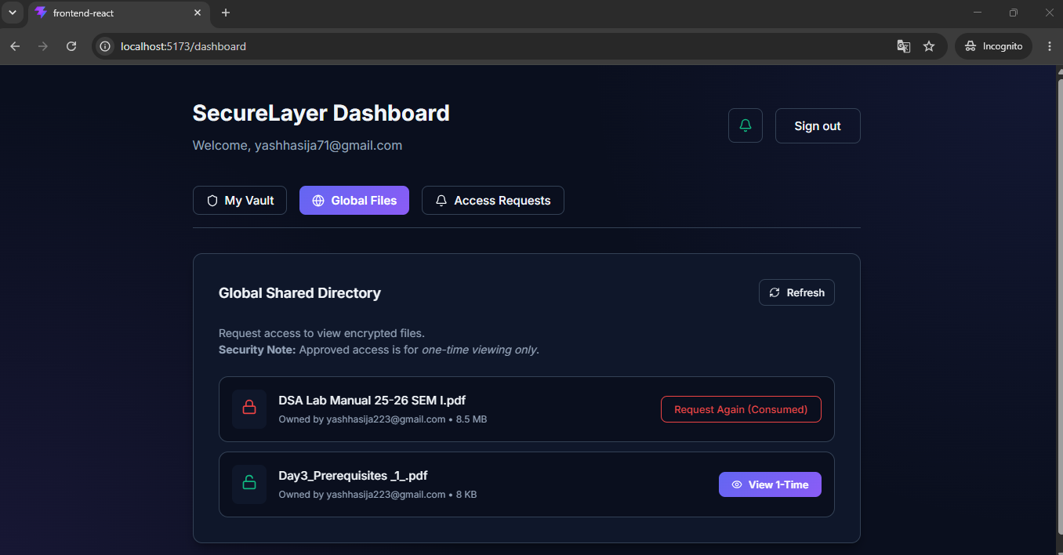
Figure 4.2: Request Access action and live status badges
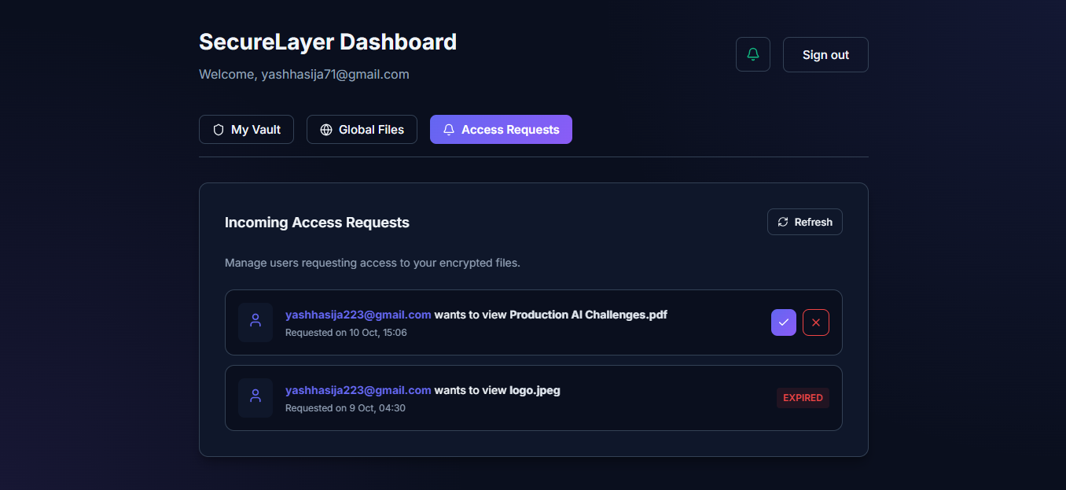
Figure 4.3: Owner inbox of incoming access requests

4.3 Single-Use Allowance Enforcement
This is one of the most critical protections in the project. When the authorised user opens the file, the server verifies the APPROVED record, decrypts the file, streams it to the client and, immediately after sending the payload, changes the request to EXPIRED.
Mechanism | Effect
Server-side revocation on stream | The approval is consumed the moment the decrypted payload is delivered.
Replay prevention | Refreshing, re-fetching or reusing a network session token returns 403 Forbidden.
Optimistic UI invalidation | The front end marks the item EXPIRED in memory as soon as streaming begins, preventing double-clicks and confusing states.

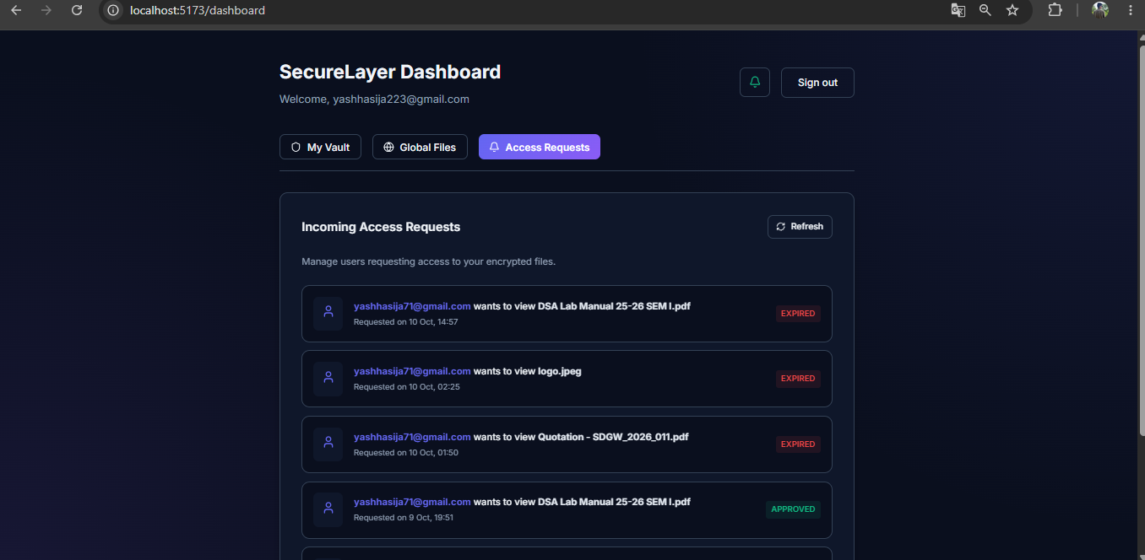

5. Module 2: Secure File Viewer
The viewer (SecureFileViewer) ensures that a document cannot be copied, downloaded, printed or inspected once it has been decrypted.

5.1 In-Memory Rendering Architecture
Control | Behaviour
Direct-to-memory decryption | Files are requested as binary blobs with authenticated session headers. They are never written to disk or the browser cache.
Canvas-isolated PDF rendering | react-pdf converts each PDF page into an HTML5 canvas element.
Text layer disabled | Text cannot be dragged, highlighted, selected or copied.
Annotation layer disabled | Hyperlinks, form inputs and interactive widgets are stripped, preventing embedded phishing links and data leakage.
Image shielding | PNG and JPEG files are rendered with drag-and-drop and selection turned off.
Ephemeral object URL | A temporary blob URL is created on load and revoked with URL.revokeObjectURL() when the viewer closes, destroying the local reference.

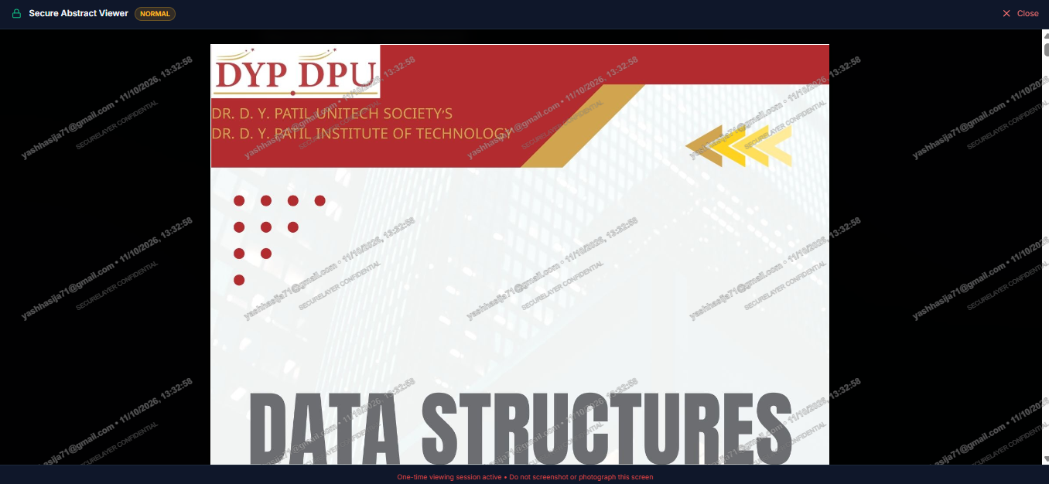

Figure 5.1: Secure viewer rendering a document on canvas

5.2 Forensic Dynamic Watermarking
A repeating SVG watermark is superimposed across the entire document area. If a photograph or screenshot of the screen ever leaks, it identifies who viewed the file and when.
Content | 1) The authenticated user's exact email address. 2) The local timestamp (date, hour, minute, second) when the file was opened.
Orientation | Rotated -30 degrees and tiled across the whole screen
Styling | Semi-transparent white fill with a dark outline stroke, legible on dark, white and photographic content
Interaction | Non-interactive (pointer events pass through), so scrolling and navigation are unaffected and the layer cannot be highlighted
Layering | High z-index overlay above the canvas

5.3 Exfiltration Prevention & Browser Hardening
Control | What it blocks
Context-menu lockdown | Right-click is suppressed across the viewport, removing Save Image As, Inspect Element and Print.
Print / Save shortcuts | Ctrl/Cmd + P (print / save as PDF) and Ctrl/Cmd + S (save) are intercepted.
Developer-tool shortcuts | F12, Ctrl + Shift + I and Cmd + Option + I are intercepted.
Visual isolation | Full-screen fixed modal with a near-opaque backdrop and heavy blur hides all dashboard information behind it.
One-time session footer | A banner states that the session is monitored and single-use, and that screen capture violates policy.

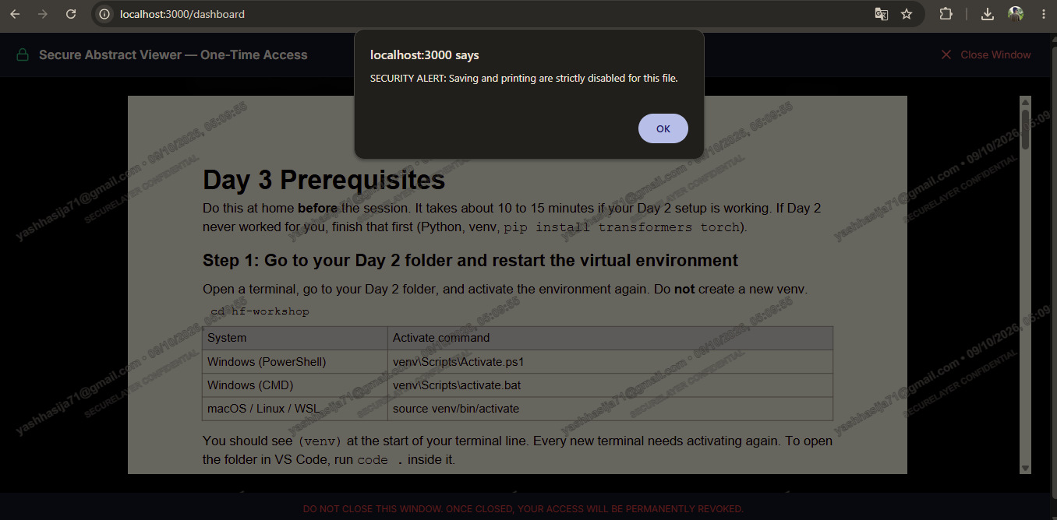

Figure 5.3: Blocked-action alert

6. Module 3: CamDetection Threat Mitigation
When a document is classified HIGHLY_CONFIDENTIAL, SecureLayer activates CamDetection. This browser-native Edge-AI engine watches the viewing environment for visual security risks. It is implemented by the useCamDetection hook and the riskEngine module.

6.1 Operating Flow
State | What happens | Outcome
1. Idle | User opens a HIGHLY_CONFIDENTIAL file | Consent dialog is shown
2. Consent | User is told why the camera is needed and what is monitored | Decline: viewer closes. Accept: continue
3. Initialising | WebAssembly and GPU models load | Failure: view blocked with an error state
4. Running | Frames analysed continuously by both models | Risk level LOW (normal) or HIGH
5. HIGH risk | Threat confirmed by the risk engine | Opaque SecurityOverlay hides the document
6. Recovery | Scene stays clear until the persistence counter returns to 0 | Overlay lifts, back to LOW

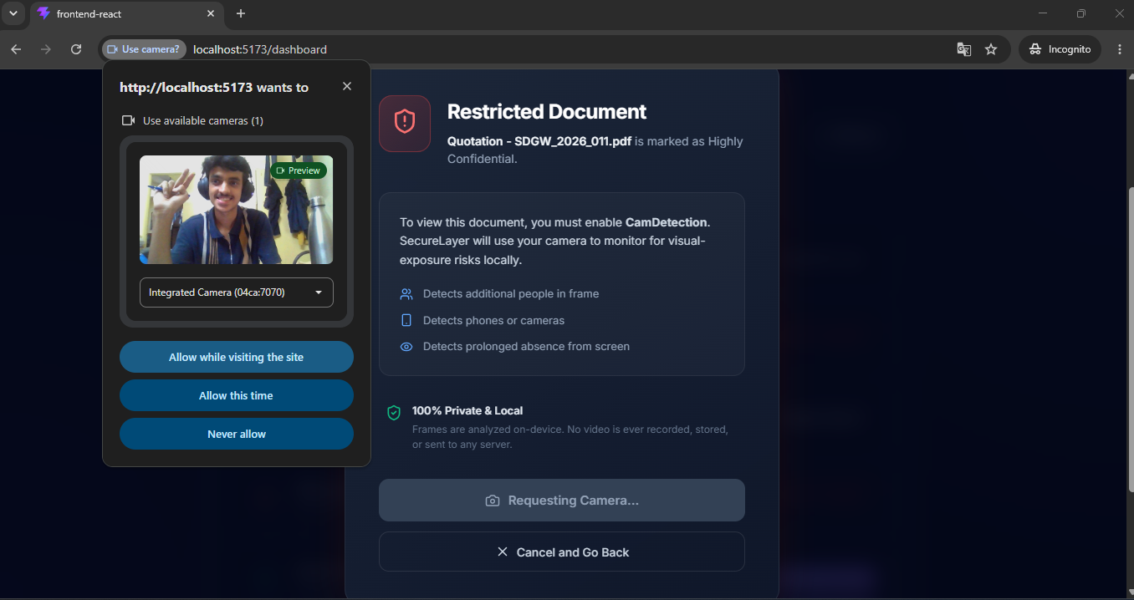

Figure 6.1: Camera consent dialog

6.2 Edge-AI and Privacy-First Design
- Zero video streaming: all inference runs on the client's GPU/CPU via WebAssembly and WebGL. No camera frame, video feed or biometric facial template ever leaves the device.
- Anonymous telemetry: only high-level event strings reach the audit log, for example CAMDETECTION_HIGH_RISK and PHONE_DETECTED.
- Presence, not identity: the system counts faces; it never recognises who they are.

6.3 Machine-Learning Models
Attribute | Face detection | Object / device detection
Framework | Google MediaPipe Tasks Vision (@mediapipe/tasks-vision), WebAssembly runtime | TensorFlow.js (@tensorflow/tfjs) with @tensorflow-models/coco-ssd
Model | BlazeFace Short-Range, a lightweight single-shot (SSD) detector optimised for web and mobile GPUs | MobileNetV2 (lite_mobilenet_v2) backbone with an SSD detection head
Purpose | Locate face bounding boxes and count faces (presence, not identity) | Detect recording-capable hardware in the frame
Classes used | Human face | cell phone, remote, laptop, tablet (filtered from 80 COCO classes)
Inference rate | About 6 FPS (150 ms interval loop) | About 6 FPS
Confidence threshold | Model default | 20% (0.20), tuned for sensitivity to blurred or poorly lit frames

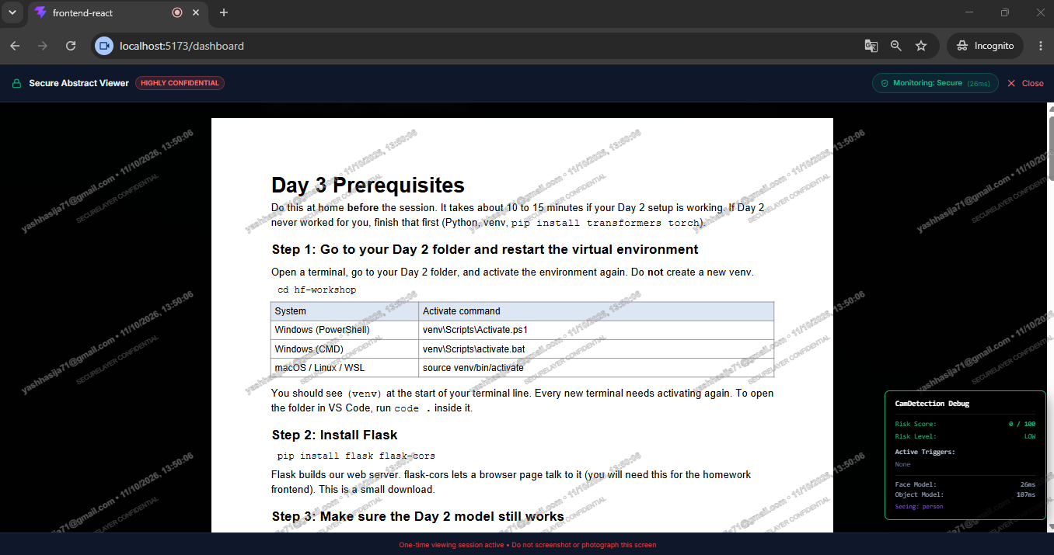
Figure 6.2: CamDetection running in normal (LOW risk) state

6.4 Detection Vectors
Event | Threat | Trigger | Approx. time
PHONE_DETECTED | Smartphone, camera or tablet aimed at the display | 2 consecutive positive frames | ~300 ms
MULTIPLE_FACES | Shoulder surfing by a second person (face count 2 or more) | 3 consecutive positive frames | ~450 ms
FACE_ABSENT | Authorised user has left the screen (0 faces) | 8 consecutive negative frames | ~1.2 s

6.5 Algorithmic Risk Engine
Raw vision output flickers from frame to frame; a phone at 21% confidence can drop to 19% for a single frame. Reacting to every frame would make the shield strobe. The risk engine therefore stabilises decisions in two stages.

A. Temporal frame persistence
A threat must persist across consecutive frames before it is accepted (see the table above). The longer window for face absence tolerates a sneeze, a glance down or a posture change without a false alarm.

B. Schmitt-trigger hysteresis lock
- Once a threat raises the state to HIGH and locks the screen, recovery is deliberately asymmetric.
- When a phone is lowered, the persistence counter decrements slowly, frame by frame.
- The screen stays locked until the counter returns all the way to 0.
- Risk scores use hysteresis: moving from LOW to HIGH needs a score of 60 or more, and dropping back needs the score to fall well below that entry threshold.

6.6 UI Shielding & Hardware Integration
CamConsentDialog | Privacy modal shown before the webcam is powered on; access stays paused until explicit consent.
SecurityOverlay | On HIGH risk, or if the detector becomes unavailable, an opaque blurred shield (rgba(30, 0, 0, 0.97)) covers the viewport and hides the canvas while preserving viewer state.
Video pipeline fix | Browsers throttle video with display:none, so the feed is sized 640x480 and set to opacity 0.001 with pointer-events none to keep GPU pipelines active.
Developer HUD | In development mode: real-time inference latency (ms), live risk score (0-100), active triggers and detected classes.

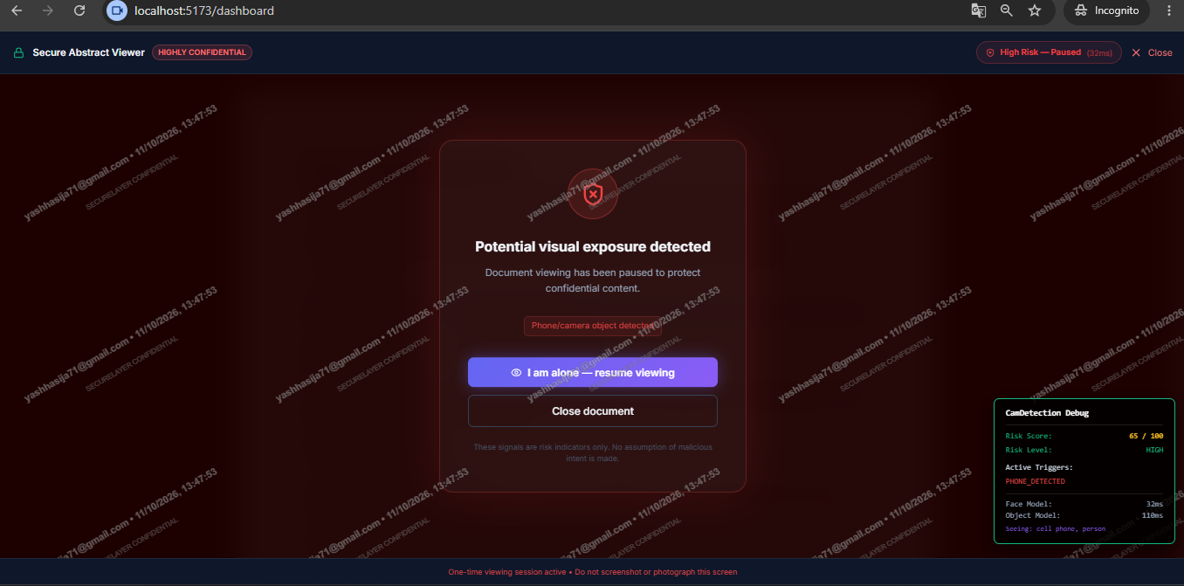

Figure 6.3: SecurityOverlay: recording device detected (PHONE_DETECTED)
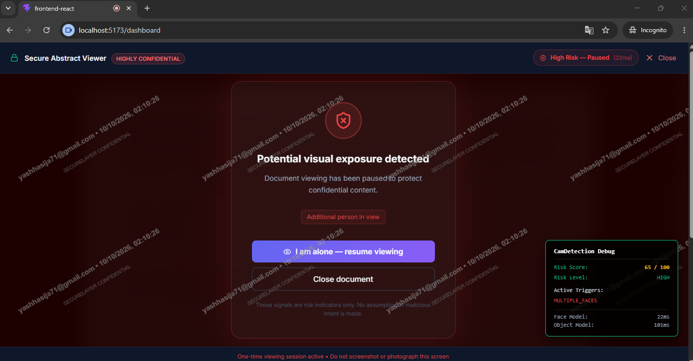.
Figure 6.4: SecurityOverlay: multiple faces detected (MULTIPLE_FACES)
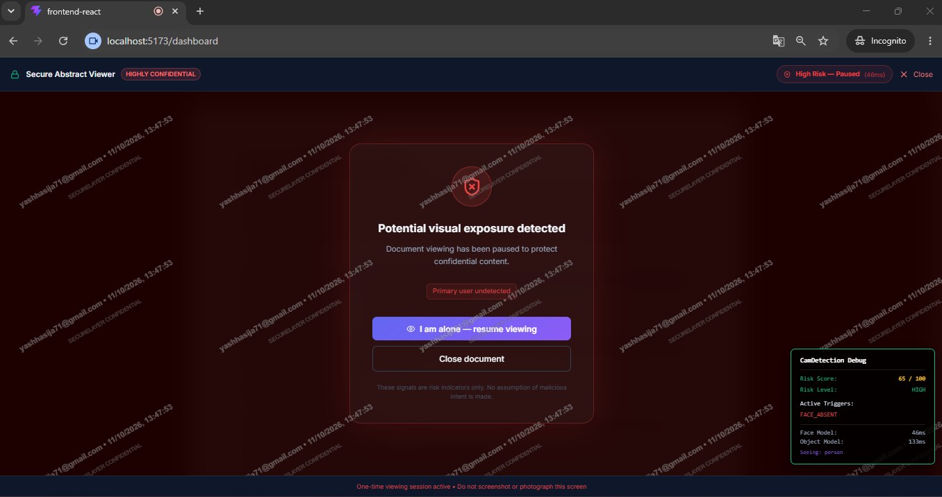
Figure 6.5: SecurityOverlay: user absent or detector unavailable

7. Module 4: Backend Security Architecture
The backend is a layered Express application on MongoDB that enforces security on every inbound request.

7.1 Request Pipeline
Order | Layer | Detail
1 | Security headers (Helmet) | Restrictive Content Security Policy; HSTS 1-year max-age with subdomains and preload; cross-origin isolation; MIME-sniffing prevention
2 | CORS validation | Strict origin allowlist (frontend origin, localhost:5173, localhost:3000, production URLs); wildcard (*) rejected with credentials
3 | Layered rate limiters | Global, OTP-request and auth-verify tiers (section 7.4)
4 | Passwordless authentication | CSPRNG OTP with bcrypt storage
5 | Dual-token session lifecycle | Short-lived access JWT plus rotating refresh token
6 | RBAC and authorisation | Permission middleware plus resource-level ownership checks
7 | Encrypted storage | AES-256-GCM, UUID-named files in private storage
8 | Immutable audit logging | Append-only AuditLog collection

7.2 Passwordless Cryptographic Authentication
Removing passwords eliminates credential stuffing and password-database cracking.
OTP generation | 6-digit code from crypto.randomInt (CSPRNG), unpredictable
OTP storage | Hashed with bcrypt (10 rounds) before saving to MongoDB (OTPVerification); plaintext never stored
Expiry | 5 minutes, enforced by a database TTL index that auto-deletes the record
Attempt limit | Maximum 5 verification attempts; exceeding it deletes the record immediately
Single use | A successful verification deletes the OTP at once
Delivery | emailProvider.js is injected through an abstract interface, so SMTP, Ethereal test mail or an SMS provider can be swapped in without touching auth logic

7.3 Dual-Token Session Architecture & Rotation
Token | Properties
Access token | JWT signed with HS256; valid 15 minutes; held only in client memory (React state), never localStorage, which limits exposure to XSS token harvesting
Refresh token | Opaque 64-byte cryptographically random string; valid 7 days; stored in the database only as a SHA-256 hash
Cookie flags | HttpOnly (invisible to JavaScript); SameSite=Strict (CSRF defence); Secure in production (HTTPS only); Path=/api/auth (sent only to auth routes)
Rotation | Every call to /api/auth/refresh revokes the old refresh token and issues a new one. Reuse of a compromised token causes a mismatch that invalidates the session chain.
Live revocation check | The auth middleware re-checks user status in the database on every verification, so a deactivated user is cut off mid-session.

7.4 Multi-Tiered Rate Limiting
Limiter | Limit | Keyed by | Purpose
Global API | 100 requests / 15 minutes | IP address | Stops scrapers and traffic floods
OTP generation | 3 requests / 1 hour | Normalised email (e.g. otp:user@example.com) | Stops email bombing and messaging-cost abuse
Auth verification | 20 attempts / 15 minutes | IP address | Prevents brute-force code guessing

7.5 Role-Based Access Control
- Permissions are defined centrally in rbacDefinitions.js, not as scattered inline strings.
- Front-end checks are cosmetic only; every route enforces permission through the requirePermission middleware.
- Controllers also verify ownership: regular users can touch only files they own or files with a valid access approval.
Role | Permissions
USER | file.read, file.upload, file.download, file.delete.own
ADMIN | user.manage, file.share, file.delete, audit.read (plus elevated file and user access)

7.6 AES-256-GCM Encrypted Storage
Algorithm | aes-256-gcm (authenticated encryption)
Initialisation vector | Fresh 12-byte (96-bit) CSPRNG IV for every upload; never reused with the master key
Authentication tag | 16-byte (128-bit) GCM tag per file; if a single byte of ciphertext is changed or corrupted, decryption aborts
Master key | 256-bit key loaded from environment variables at startup; never stored in the database
Storage naming | Files saved as <uuid>.enc in a private folder; original file names never appear in paths, eliminating directory traversal

7.7 Error Handling & Audit Logging
- Information-leak prevention: the central error handler logs stack traces on the server and returns generic, sanitised error codes to clients in production.
- Immutable audit trail: an append-only AuditLog collection records who, what, when, IP address, User-Agent and status.
- Events recorded: logins and failed attempts, uploads, views, deletions, permission denials, access requests and camera events. Passwords, OTPs and encryption keys are never logged.

8. Threat & Mitigation Matrix
Threat vector | Scenario | SecureLayer defence
Physical screen photography | A user or bystander photographs the screen with a phone. | CamDetection COCO-SSD: phone detected over 2 frames at 20% confidence; opaque SecurityOverlay.
Shoulder surfing | A second person stands behind the viewer. | BlazeFace: 2 or more faces over 3 consecutive frames; document shielded until they leave.
Unattended screen | User leaves with a file open. | Face-absence detector: 0 faces over 8 frames (~1.2 s) hides the content.
Screen capture / printing | Ctrl+P, Ctrl+S or right-click menus. | Client event interception; context menu and developer-tool shortcuts blocked.
Text scraping / clipboard theft | User highlights and copies text. | Canvas isolation via react-pdf with renderTextLayer disabled.
Document leaks via external camera | Document captured by a separate camera. | Forensic SVG watermark (viewer email + timestamp) makes the leak attributable.
Replay & stolen links | A link or approved file is re-used or shared. | Single-use allowance marked EXPIRED during the first binary stream.
Database / disk compromise | Attacker gets the database or storage drive. | AES-256-GCM with unique IVs and auth tags; master key only in server memory.
Credential stuffing | Breached password lists are replayed. | Passwordless OTP: CSPRNG, bcrypt-hashed, 5-minute expiry, 5-attempt limit.
Session hijacking / XSS | Scripts harvest tokens from storage. | In-memory JWT and rotating HttpOnly refresh cookies.
Brute force & DoS | Bots flood authentication endpoints. | Multi-tier rate limiting: global, auth-verify and 3 OTPs per hour per email.

9. Technology Stack
Layer | Technology | Role in SecureLayer
Front end | React | UI, in-memory token state, viewer and overlays
PDF rendering | react-pdf | Canvas rendering with text and annotation layers disabled
Face detection | MediaPipe Tasks Vision, BlazeFace Short-Range | Face counting at about 6 FPS
Object detection | TensorFlow.js, COCO-SSD (lite_mobilenet_v2) | Phone / device detection at about 6 FPS
Back end | Node.js, Express | API gateway and business logic
Database | MongoDB | Users, requests, hashed OTPs and tokens, audit log
Security middleware | Helmet, CORS, rate limiter | Headers, origin control, throttling
Cryptography | AES-256-GCM, bcrypt, SHA-256, crypto.randomInt, JWT (HS256) | File encryption, OTP hashing, token hashing, session tokens
Notifications | emailProvider abstraction (SMTP / Ethereal) | OTP, request and approval emails

10. Limitations & Future Scope
This section records the design boundaries of the current implementation and the natural next steps. Understanding these is part of treating SecureLayer as a defence-in-depth system rather than a single guarantee.

10.1 Design Boundaries
- Browser-level controls are deterrents. Interception of shortcuts and context menus raises the effort of exfiltration but cannot stop operating-system screen capture or an external camera. This is why SecureLayer layers camera-based detection, watermark attribution and single-use access on top.
- Detection quality depends on the environment. Lighting, webcam quality and camera angle influence accuracy, which is why the object threshold is tuned for sensitivity and the risk engine filters single-frame noise.
- General-purpose object model. COCO-SSD is trained on generic classes; a phone held at an unusual angle may be harder to detect than a typical one.
- Single master key. The encryption key is loaded from environment memory; key rotation and external key management are not part of the current design.

10.2 Future Enhancements
- Fine-tune a dedicated recording-device detection model on phone-camera-at-screen imagery.
- Add head-pose and gaze estimation to confirm that a second face is actually reading the screen.
- Move to per-file data keys wrapped by a managed key service for rotation and revocation.
- Support time-boxed or view-count policies beyond the single-use model.
- Add an administrator dashboard for audit analytics and anomaly alerts.

11. Conclusion
SecureLayer establishes a unified security model spanning client-side computer vision, hardened front-end isolation and a cryptographic zero-trust backend. By pairing Edge-AI threat detection with single-use authorisation and authenticated encryption, it keeps sensitive files protected in transit, at rest and while actively displayed on a user's screen.
Its distinguishing contribution is the closed loop between who may open a file (owner-approved, one-time), what happens while it is open (in-memory canvas, watermark, camera guard) and what is recorded afterwards (immutable audit trail), all while keeping camera data strictly on the user's device.

