**DBMS LAB**

**WEEK 4**

**YASHI CHAWLA  
PES1UG19CS592**

**Sem5, I section**

Creating table and adding constraints for the given relational design:



Create database:

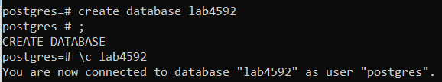

Create employee table:

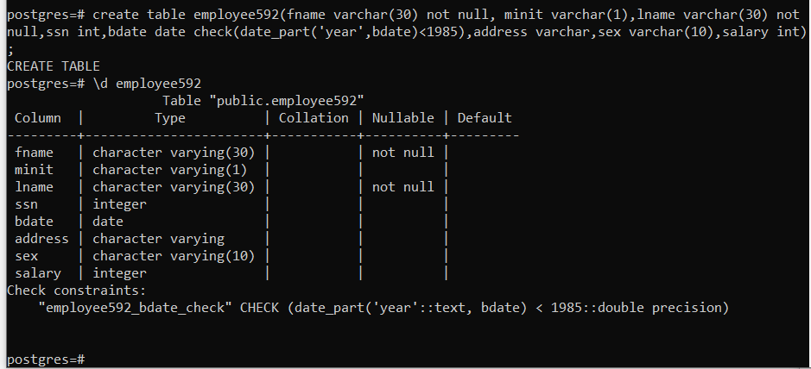

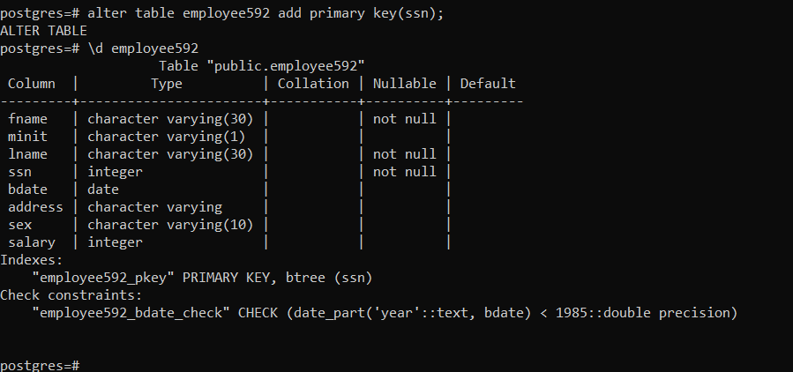

Create department table, add unique constraints to it: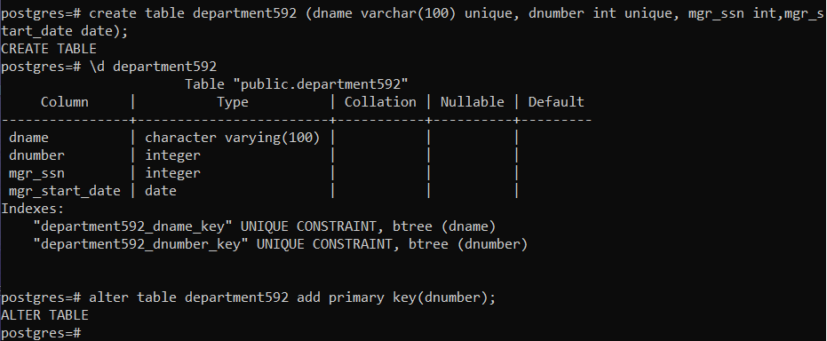

Create dept_location table with foreign keys:

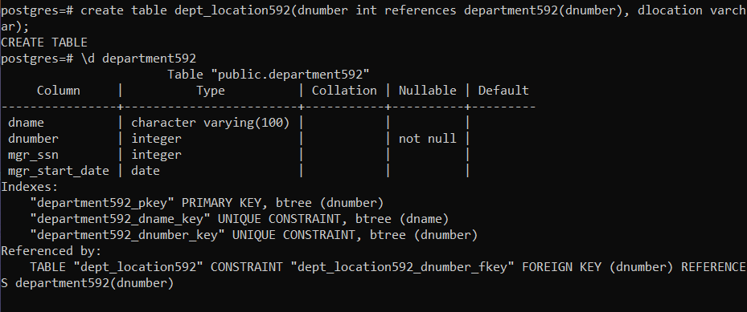

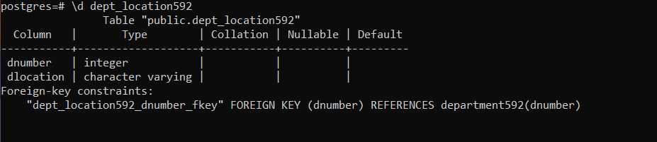

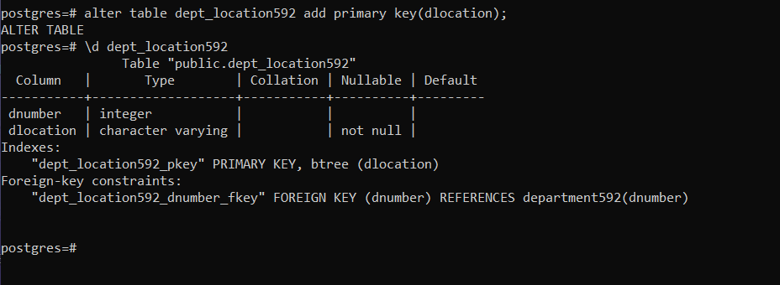

Create project table: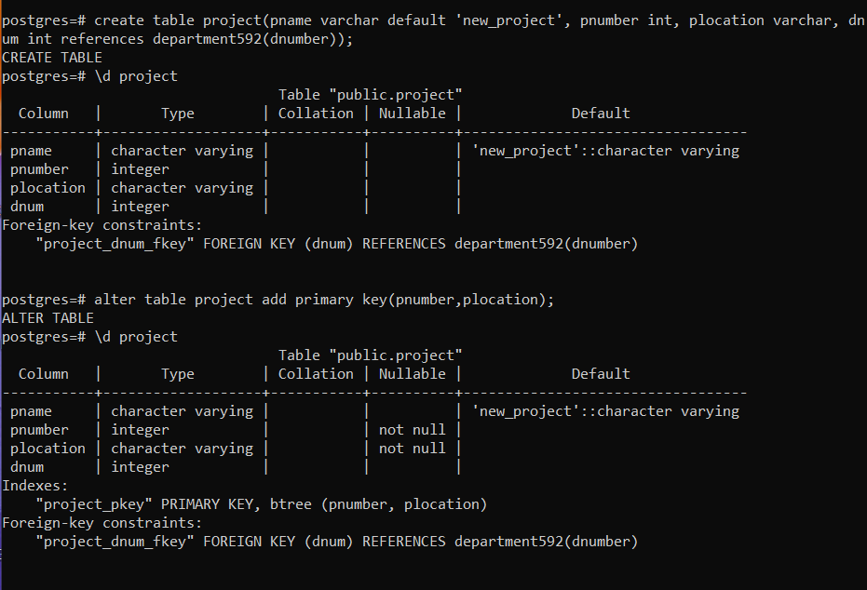



Create works_on table:

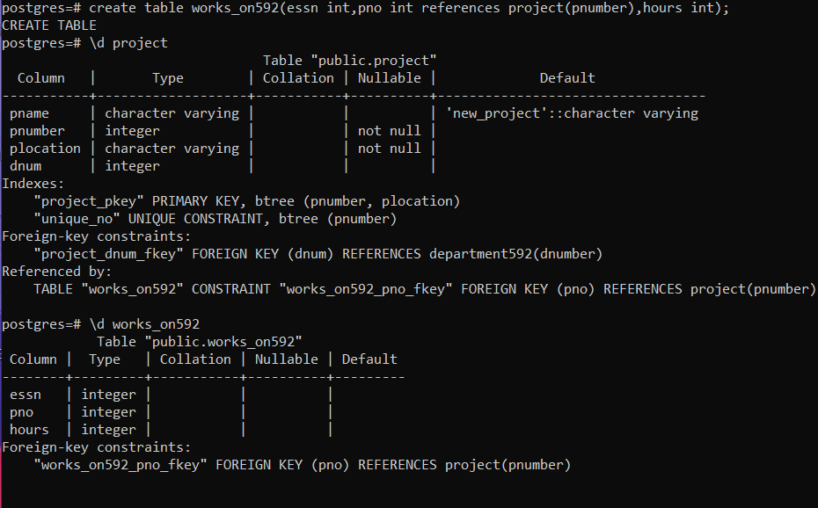

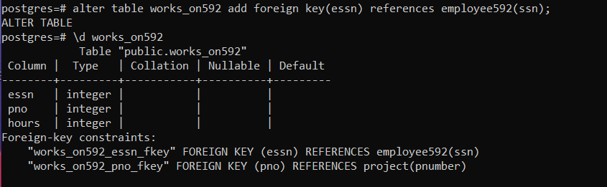

Create dependent table:

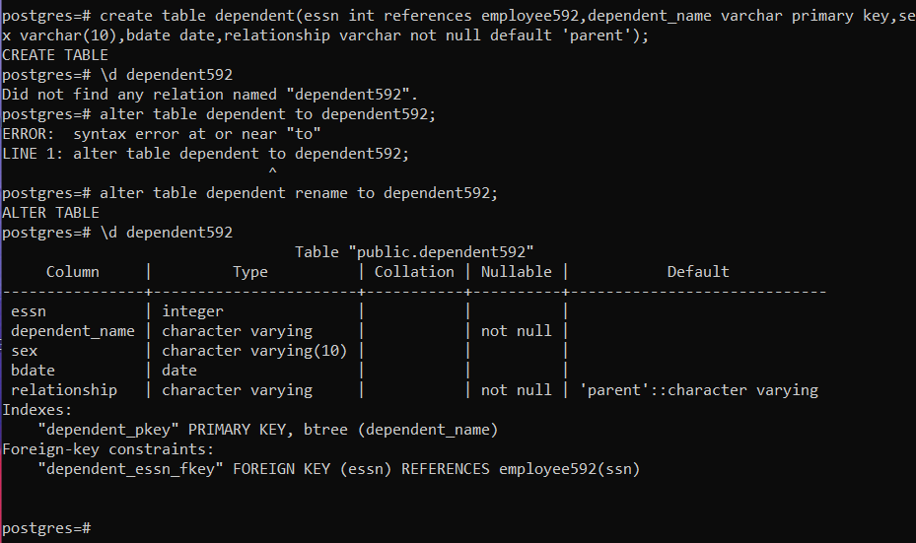  
list of tables created:

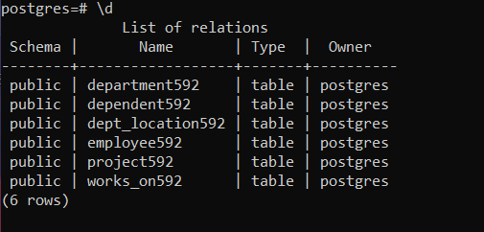

Adding columns to employee592: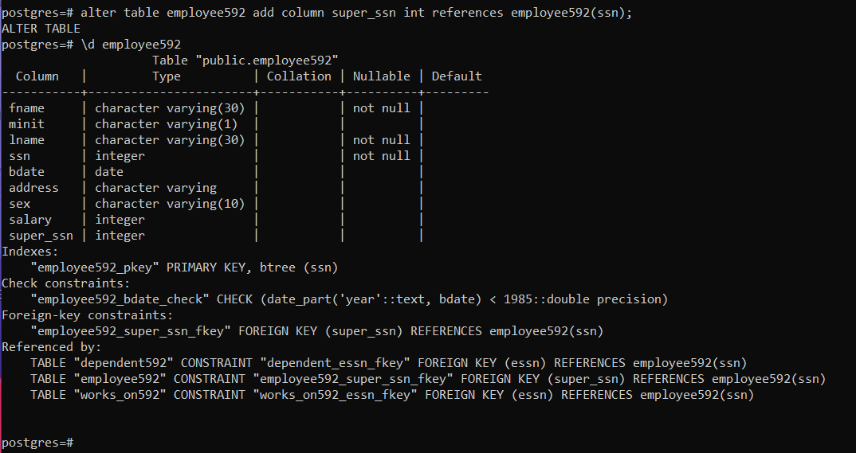

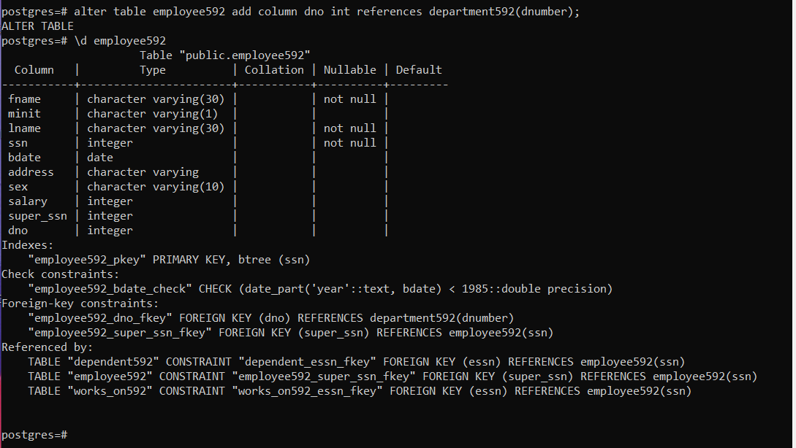

Final Screenshot of all tables’ details:

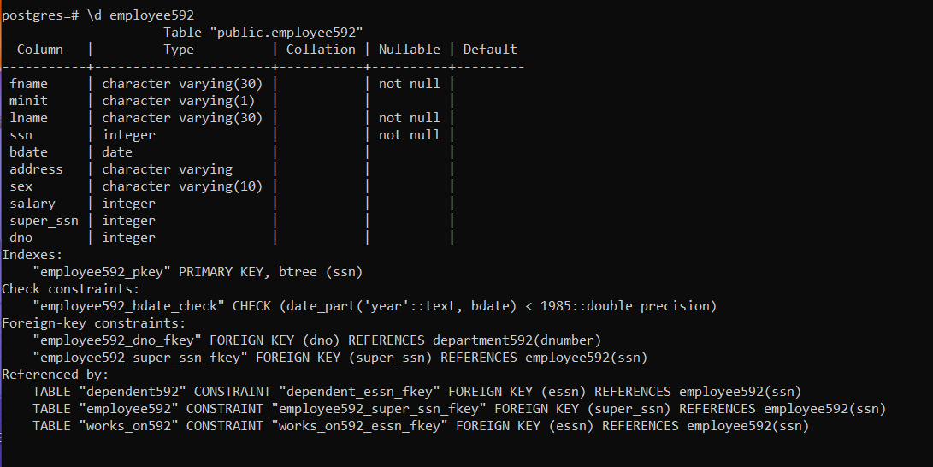

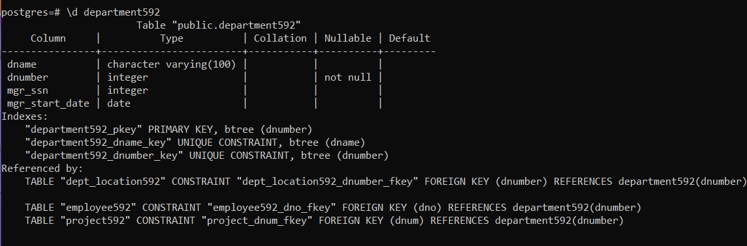

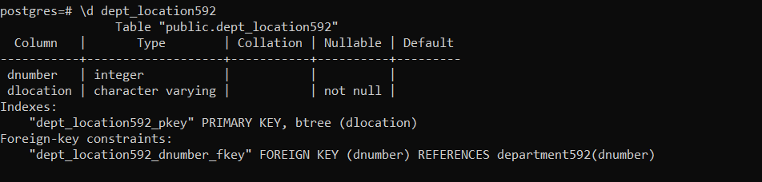

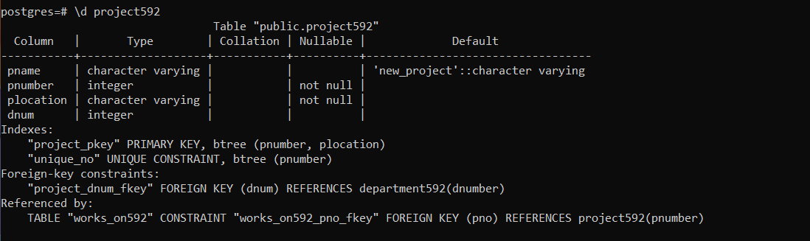

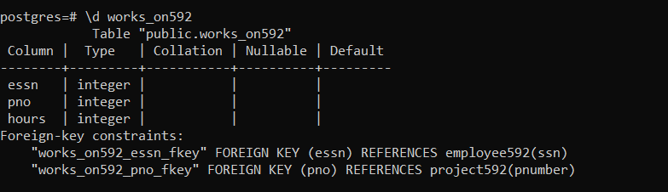

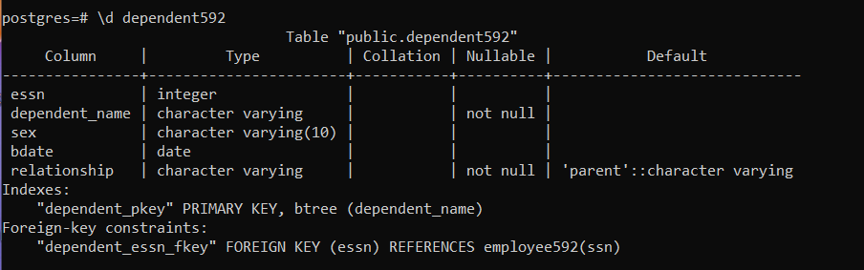

2. a. Creating/dropping views

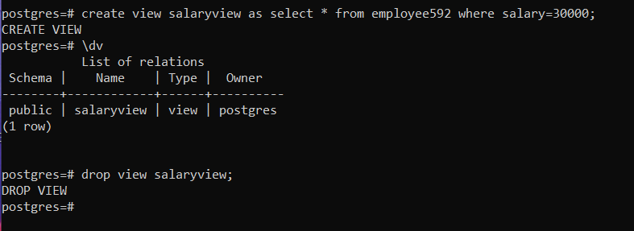

b. creating and granting access to users

granting select acer to user1:

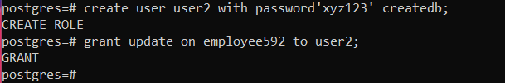

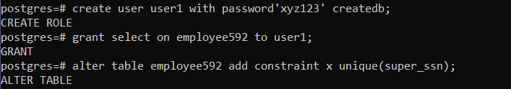

Granting all access to user3, 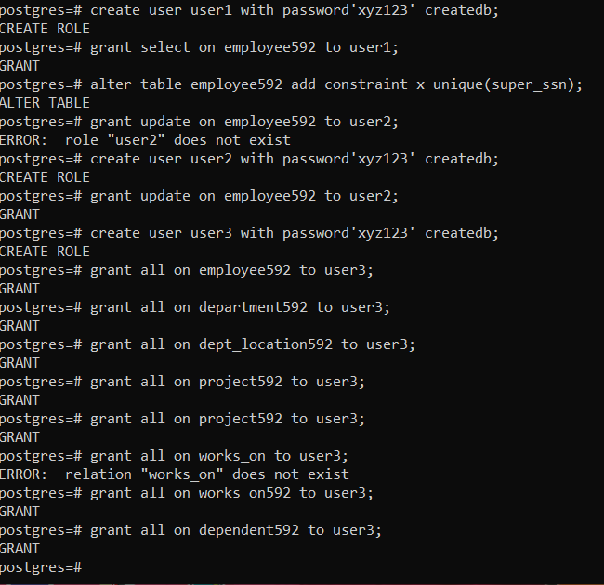

Grant delete, update to user 4, Revoking access:

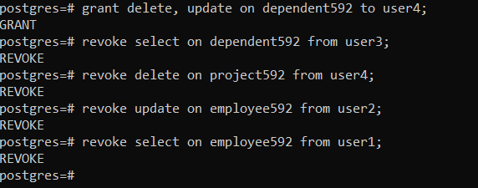

c. Adding a column called joindate with a constraint that it should be greater than the birthdate:

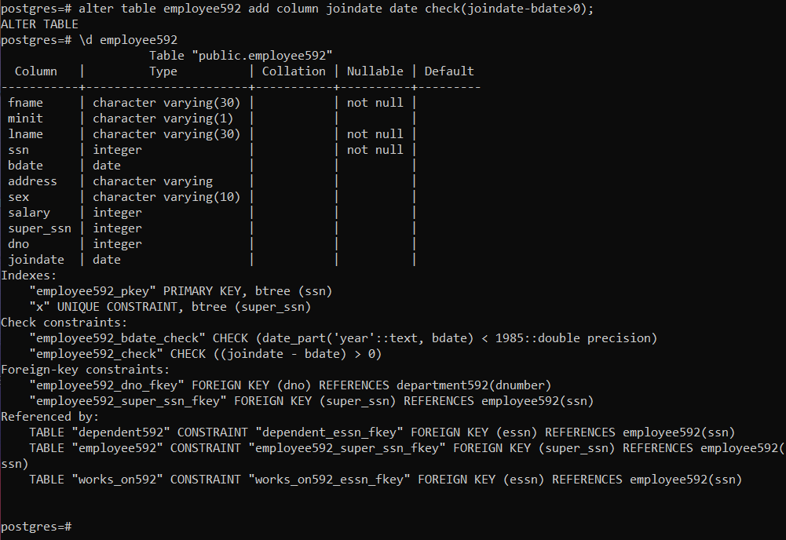

Removing a column:

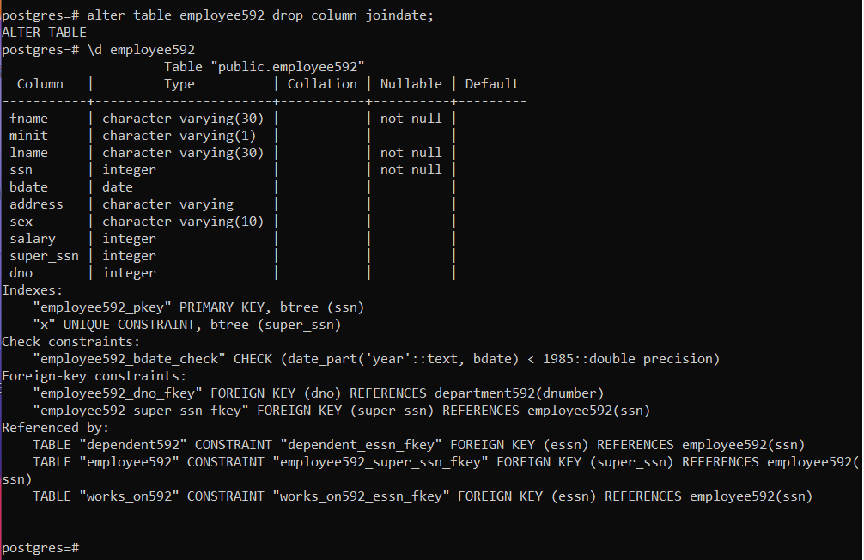

Adding a column called joindate again but with a different constraint that at the time of joining, the age should be greater than 21: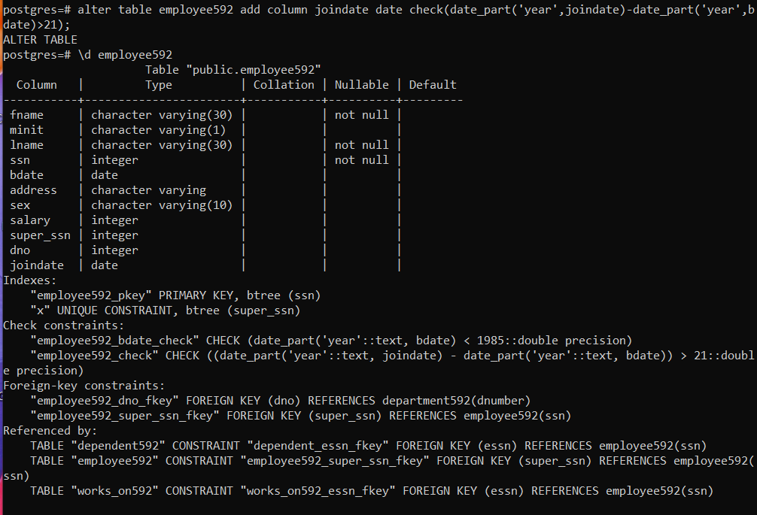

d. Delete and truncate tables

