**Week 5**

**DBMS LAB**

**PES1UG19CS592**

**Yashi Chawla**

**Section I**

1. **SQL DML**

Create table











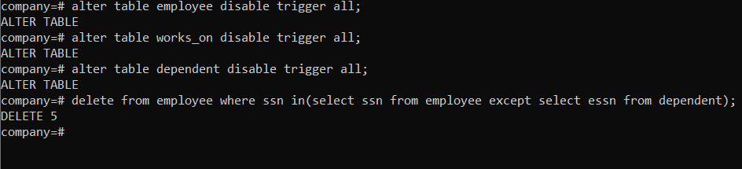

1. **Transactions**

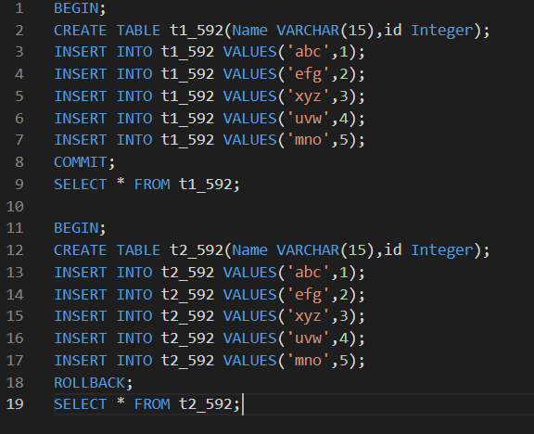

**Final transaction**

