**DBMS LAB  
WEEK 9 & 10**

**PES1UG19CS592**

**Yashi Chawla**

1. Create an employee table which contains employee details and the department he works for. Create another table department consisting of dname and number of employees. Write triggers to increment or decrement the number of employees in a department table when the record in the employee table is inserted or deleted respectively.

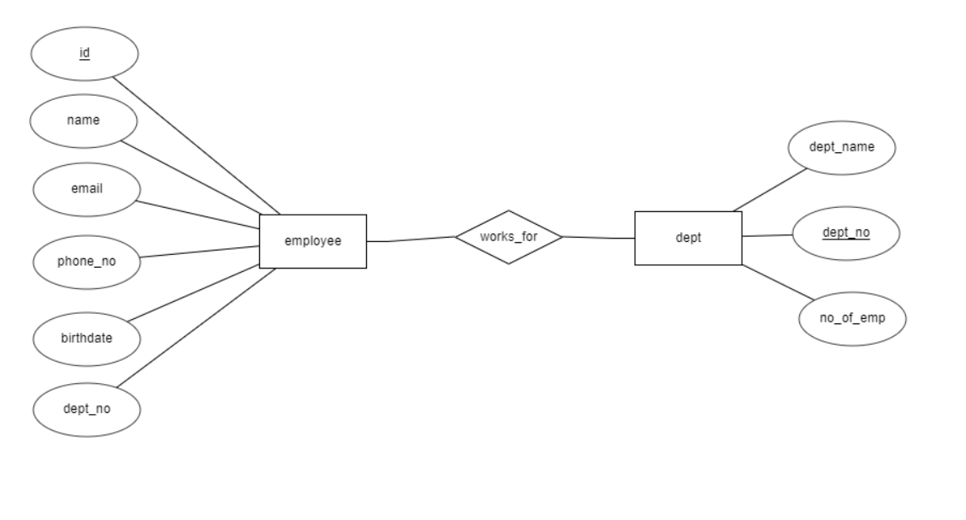

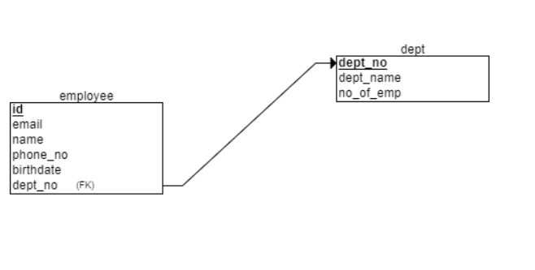

CREATE.sql

drop database employee;

create database employee;

\c employee

CREATE TABLE dept

(

    dept_name VARCHAR(50) NOT NULL,

    dept_no INT NOT NULL,

    no_of_emp INT NOT NULL,

    PRIMARY KEY(dept_no)

);

CREATE TABLE employee_details

(

    email VARCHAR(50) NOT NULL,

    name VARCHAR(50) NOT NULL,

    id INT NOT NULL,

    phone_no CHAR(10) NOT NULL,

    birthdate DATE NOT NULL,

    dept_no INT NOT NULL,

    PRIMARY KEY(id),

    FOREIGN KEY(dept_no) REFERENCES dept(dept_no)

);

-- trigger to increase number of employees in the department that the insertion was made in

CREATE OR REPLACE FUNCTION increment() RETURNS TRIGGER AS

$$

BEGIN

  UPDATE dept set no_of_emp=no_of_emp+1 where new.dept_no=dept.dept_no;

    RETURN new;

END;

$$

language plpgsql;

CREATE TRIGGER increment_number

     AFTER INSERT ON employee_details

     FOR EACH ROW

     EXECUTE PROCEDURE increment();

-- trigger to decrease number of employees in the department that the deletion was made in

CREATE OR REPLACE FUNCTION decrement() RETURNS TRIGGER AS

$$

BEGIN

  UPDATE dept set no_of_emp=no_of_emp-1 where old.dept_no=dept.dept_no;

    RETURN new;

END;

$$

language plpgsql;

CREATE TRIGGER decrement_number

    AFTER DELETE ON employee_details

    FOR EACH ROW

    EXECUTE PROCEDURE decrement();

INSERT.SQL ( for testing )

\c employee

insert into dept values('CSE',1,0);

insert into dept values('EEE',2,0);

insert into dept values('Mech',3,0);

insert into employee_details values ('abrandino0@hatena.ne.jp', 'Adaline Brandino', 1, '7524400096', '1997-02-16', 1);

insert into employee_details values ('hflippelli1@ameblo.jp', 'Hatti Flippelli', 2, '1025817726', '1991-05-10', 2);

insert into employee_details values ('cmacshane2@cyberchimps.com', 'Caddric MacShane', 3, '2512840590', '1999-07-22', 1);

insert into employee_details values ('cdaldan3@odnoklassniki.ru', 'Cad Daldan', 4, '6201054879', '1996-11-26', 2);

insert into employee_details values ('scoie4@amazon.de', 'Sylvan Coie', 5, '3143476971', '1999-03-02', 1);

insert into employee_details values ('wmacdavitt5@1und1.de', 'Wayne MacDavitt', 6, '3144736168', '1995-05-02', 3);

insert into employee_details values ('fgouldstraw6@miitbeian.gov.cn', 'Faustine Gouldstraw', 7, '8055483283', '1992-04-02', 2);

insert into employee_details values ('rpalister7@huffingtonpost.com', 'Rab Palister', 8, '9171160664', '1990-12-23', 3);

insert into employee_details values ('bjagels8@quantcast.com', 'Ber Jagels', 9, '6782063205', '1996-06-28', 2);

insert into employee_details values ('cmalthus9@biblegateway.com', 'Cristionna Malthus', 10, '3232737530', '1996-11-28', 2);

insert into employee_details values ('mincognaa@nature.com', 'Malchy Incogna', 11, '4779964782', '1992-12-08', 2);

insert into employee_details values ('dburgottb@bandcamp.com', 'Deonne Burgott', 12, '1951883479', '1996-03-17', 3);

insert into employee_details values ('dgrillsc@comcast.net', 'Dalston Grills', 13, '5016132428', '1995-08-21', 1);

insert into employee_details values ('msaddletond@histats.com', 'Milly Saddleton', 14, '8462521055', '1997-08-09', 2);

insert into employee_details values ('smcgrathe@microsoft.com', 'Sybille McGrath', 15, '5568667327', '1998-09-23', 2);

insert into employee_details values ('uparminterf@aol.com', 'Upton Parminter', 16, '6411778628', '1995-05-09', 3);

insert into employee_details values ('rphillcockg@eventbrite.com', 'Raquela Phillcock', 17, '4952090013', '1994-08-22', 2);

insert into employee_details values ('sdarraghh@51.la', 'Sula Darragh', 18, '2737136188', '1992-11-26', 1);

insert into employee_details values ('cmcgilvrayi@tmall.com', 'Cathie McGilvray', 19, '6167674075', '1992-11-12', 3);

insert into employee_details values ('fquarlessj@soundcloud.com', 'Farleigh Quarless', 20, '8318136141', '1995-01-13', 1);

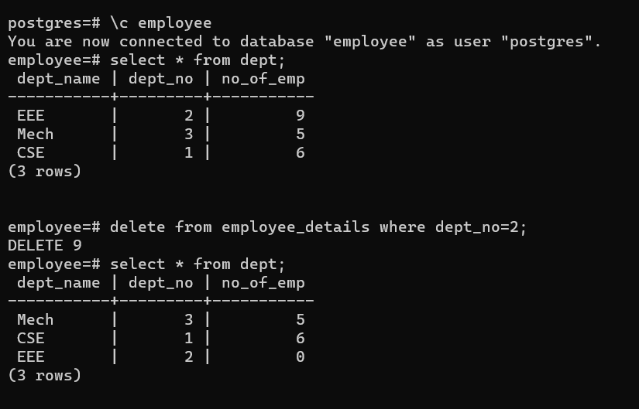

1. Create an order_item table which contains details like name, quantity and unit price of every item purchased. Create an order summary table that contains number of items and total price. Create triggers to update entry in order summary whenever an item is inserted or deleted in the order item table.

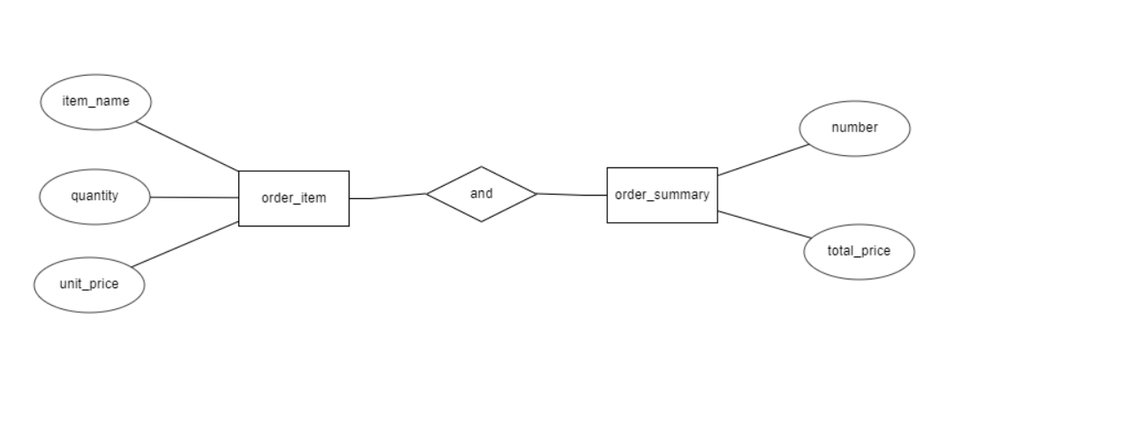

CREATE.sql

drop database order_details;

create database order_details;

\c order_details

CREATE TABLE order_item

(

  item_name VARCHAR(50) NOT NULL,

  quantity INT NOT NULL,

  unit_price INT NOT NULL

);

CREATE TABLE order_summary

(

  number_of_items INT NOT NULL,

  total_price INT NOT NULL

);

CREATE OR REPLACE FUNCTION increment() RETURNS TRIGGER AS

$$

BEGIN

  UPDATE order_summary set number_of_items=number_of_items+1;

  UPDATE order_summary set total_price=total_price+new.quantity*new.unit_price;

    RETURN new;

END;

$$

language plpgsql;

CREATE TRIGGER increment_number

     AFTER INSERT ON order_item

     FOR EACH ROW

     EXECUTE PROCEDURE increment();

CREATE OR REPLACE FUNCTION decrement() RETURNS TRIGGER AS

$$

BEGIN

  UPDATE order_summary set number_of_items=number_of_items-1;

  UPDATE order_summary set total_price=total_price-old.quantity*old.unit_price;

  RETURN new;

END;

$$

language plpgsql;

CREATE TRIGGER decrement_number

     AFTER DELETE ON order_item

     FOR EACH ROW

     EXECUTE PROCEDURE decrement();

insert into order_summary values(0,0);

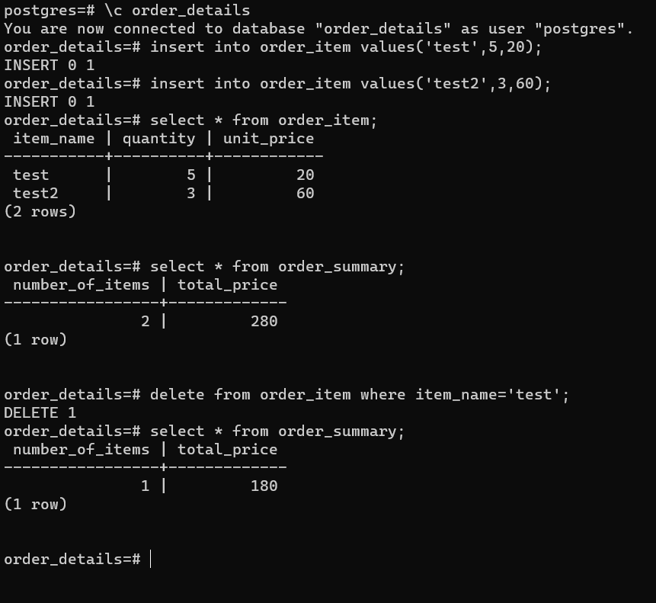

note: the instruction pdf does not specify the exact structure of the order_summary table. It could be implemented in two ways.

1. Each row would have number of items of a particular product (being redundant to the quantity in the order_item table) and the total price would be the quanity*unit price for each item.
2. It is a one row table, where number of items is the total number of items present in the order_item table and total price is the total summation of all item’s quantity into their unit price.

The 2nd has been implemented here.