Task-5: Exploratory Data Analysis (EDA)

Dataset: tested  
  
Python code:

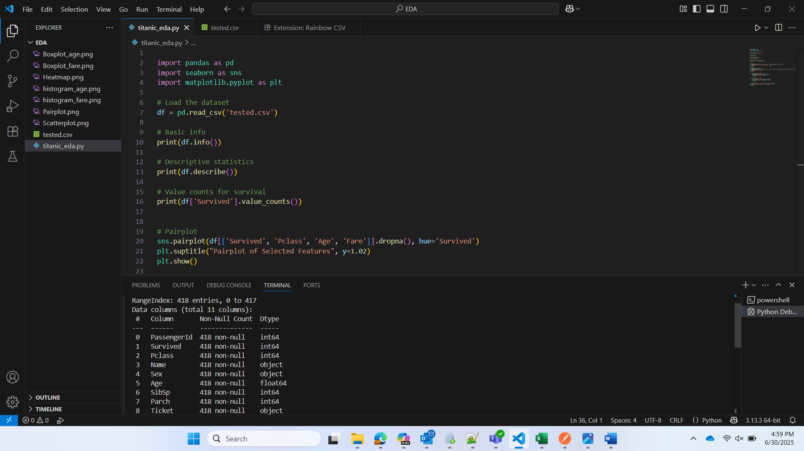  
  
Plots and Graphs:

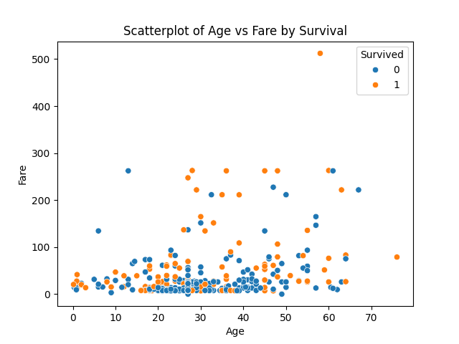

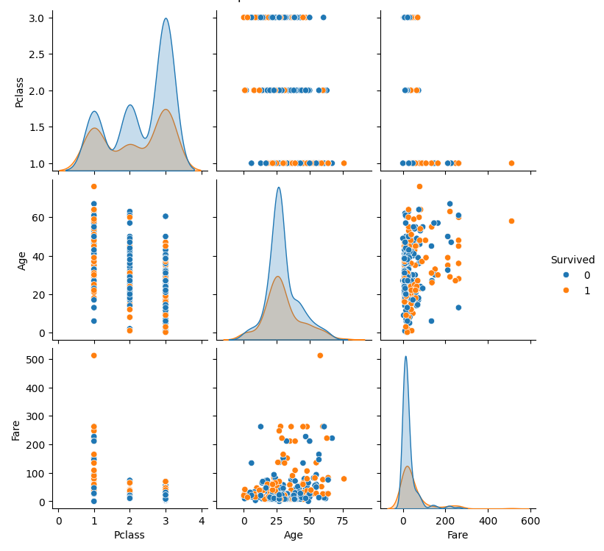

## Summary of Findings:

1. Survival rates vary significantly across passenger classes.

2. Age and Fare show some correlation with survival.

3. Higher-fare passengers tend to have higher survival rates.

4. Younger passengers show slightly higher survival rates.

5. There are outliers in Fare and Age distributions.

6. Correlation heatmap shows moderate relationships among features