Graph Neural Network-Based Substructure Segmentation of PROTAC Molecules with Weak Supervision and Reconstruction-Aware Learning
A Computational Study on Atom-Level Warhead–Linker–E3 Ligand Assignment Using PROTAC-DB 4.0
Author Name(s)
Affiliation / Laboratory / Institution
Email: corresponding.author@institution.edu
Date: July 2026
This manuscript presents an original computational methodology for automatic identification of warhead, linker, and E3 ligand substructures within proteolysis-targeting chimera (PROTAC) molecules. The work integrates weak supervision, graph neural networks, reconstruction-aware training objectives, and out-of-distribution evaluation protocols.

Abstract
Proteolysis-targeting chimeras (PROTACs) are heterobifunctional molecules that recruit an E3 ubiquitin ligase to a protein of interest, thereby inducing targeted protein degradation. Rational design and retrospective analysis of PROTACs require reliable identification of the three chemical substructures that constitute each molecule: the warhead, the linker, and the E3 ligand. Manual annotation does not scale to large databases, while existing automated strategies either operate at the bond-cut or sequence-to-sequence level and typically evaluate only random held-out splits. In this work, we formulate PROTAC substructure identification as atom-level three-class segmentation on molecular graphs. Weak labels are generated by dictionary-based substructure matching and retained only when the implied three-way fragmentation reassembles to the original molecule. A Graph Isomorphism Network (GIN) is trained with a multi-task objective combining atom classification, bond-boundary prediction, fragment smoothness, and a differentiable soft-reconstruction loss. We further compare training from scratch with AttrMask-style self-supervised pretraining of the same encoder. Evaluation is performed on five splits, including unseen-warhead, unseen-E3, fingerprint-dissimilar, and newer-chemotype regimes, against dictionary and XGBoost baselines. On random test molecules, the scratch GNN achieves 0.922 atom accuracy and 0.917 reassembly accuracy. Soft reconstruction training raises unseen-E3 reassembly from approximately 0.33 in an earlier configuration to 0.81. Across all splits, the GNN substantially outperforms the XGBoost bond-cutting baseline on atom-level accuracy. The results support reconstruction-aware graph learning as a practical and scientifically grounded route to PROTAC substructure segmentation.
Keywords: PROTAC; targeted protein degradation; graph neural network; weak supervision; substructure segmentation; molecular reconstruction; out-of-distribution evaluation
1. Introduction
Targeted protein degradation has emerged as a transformative modality in chemical biology and drug discovery. Unlike classical occupancy-driven inhibitors, degradation-based therapeutics remove disease-relevant proteins from the cell, often enabling sustained pharmacological effects at lower occupancy and expanding the accessible target space to proteins that are difficult to inhibit conventionally [1,2]. Among degrader architectures, proteolysis-targeting chimeras (PROTACs) are the most widely studied class of heterobifunctional degraders [3,4].
A canonical PROTAC comprises three covalently connected components: (i) a warhead (also called the protein-of-interest ligand) that binds the target protein; (ii) an E3 ligand that engages an E3 ubiquitin ligase such as cereblon (CRBN), von Hippel–Lindau (VHL), or inhibitors of apoptosis proteins (IAP); and (iii) a linker that bridges the two ligands and strongly influences ternary-complex geometry, permeability, and degradation efficiency [5,6]. Because linker and ligand identity jointly determine biological performance, automated extraction of these substructures from large PROTAC collections is essential for structure–activity learning, generative design, and database curation.
Despite the rapid growth of public PROTAC resources such as PROTAC-DB [7], atom-level annotations of warhead, linker, and E3 ligand regions remain scarce. Chemist-drawn gold labels are expensive to produce at database scale. Consequently, prior computational work has relied on dictionary matching, bond-level machine learning, or sequence-to-sequence models trained on curated or synthetically expanded splitting datasets [8,9]. These approaches provide valuable baselines, yet several gaps remain for a segmentation-oriented research agenda: (i) limited use of atom-level multi-task graph learning; (ii) reconstruction treated mainly as post hoc validation rather than a training objective; and (iii) insufficient out-of-distribution (OOD) testing beyond random splits.
This manuscript addresses those gaps. We present a complete methodology for PROTAC substructure segmentation that (1) constructs reassembly-filtered weak labels, (2) trains a compact GIN with an explicit soft-reconstruction loss, (3) compares scratch versus AttrMask-pretrained encoders, and (4) evaluates performance under five complementary data partitions, including chemotype-held-out and fingerprint-dissimilar regimes. The central scientific claim is that atom-level graph segmentation with reconstruction-aware supervision yields more transferable chemical understanding than bond-cut classification alone, while remaining reproducible on modest computational resources.
1.1 Research problem
Formally, let a PROTAC be represented by a molecular graph G = (V, E), where each node v ∈ V is an atom and each edge e ∈ E is a chemical bond. The task is to assign every atom a label y_v ∈ {warhead, linker, E3 ligand} such that the predicted partition induces a chemically meaningful three-fragment decomposition of the original molecule. The research problem therefore combines supervised learning under noisy pseudo-labels with chemistry-aware constraints on connectivity and reassembly.
1.2 Contributions
The main contributions of this study are as follows. First, we cast PROTAC substructure identification as atom-level segmentation and release a compact, fully reproducible pipeline on PROTAC-DB 4.0. Second, we introduce a soft-reconstruction training objective that encourages canonical linker attachment topology and simultaneous presence of all three fragment classes. Third, we establish an OOD evaluation suite comprising unseen warhead, unseen E3, fingerprint-dissimilar, and newer-chemotype splits. Fourth, we provide a controlled comparison between a randomly initialized GIN and an AttrMask-pretrained GIN against dictionary and XGBoost baselines under identical metrics.
2. Related Work
2.1 PROTAC chemistry and databases
PROTACs operate by inducing proximity between a target protein and an E3 ligase, leading to ubiquitination and proteasomal degradation [1–4]. Design principles emphasize ligand affinity, linker length and composition, ternary-complex cooperativity, and physicochemical properties related to cellular uptake [5,6]. PROTAC-DB aggregates structures, activities, and component libraries for warheads, linkers, and E3 ligands, and therefore provides a natural substrate for data-driven substructure analysis [7].
2.2 Automated PROTAC splitting
Ribes and colleagues recently introduced PROTAC-Splitter, a machine learning framework that combines dictionary-based curation with learned models for automated identification of PROTAC substructures, including transformer-based sequence models and classical bond classifiers [8]. Complementary laboratory work has explored XGBoost-based prediction of linker-cutting bonds using engineered topological and chemical bond features [9]. These studies demonstrate that automated splitting is feasible, but they primarily emphasize bond or string outputs and random-split evaluation. Our formulation instead predicts an atom-wise segmentation map and stresses reconstruction-aware learning together with explicit OOD partitions.
2.3 Graph neural networks for molecules
Graph neural networks have become a standard representation learning tool for molecules because they operate directly on atoms and bonds [10,11]. The Graph Isomorphism Network (GIN) is particularly expressive among message-passing architectures [12]. Self-supervised molecular pretraining strategies such as attribute masking (AttrMask) and later refinements including Mole-BERT aim to improve transfer to downstream tasks [13,14]. In this study we adopt a lightweight AttrMask pretraining protocol on the same GIN backbone used for segmentation, enabling a fair scratch-versus-pretrained comparison without requiring specialized GPU-only toolchains.
3. Materials and Methods
3.1 Dataset
All experiments use PROTAC-DB 4.0 files comprising PROTAC structures together with warhead and E3 ligand reference libraries [7]. Molecules were parsed with RDKit [15]. PROTACs outside the range of 15–120 heavy atoms were discarded to exclude trivial fragments and extremely large outliers. For computational tractability in the reported runs, a reproducible random sample of 6,000 candidate SMILES strings was processed for weak labeling; after reassembly filtering, 1,674 labeled PROTACs remained for learning and evaluation.
3.2 Weak label generation with reassembly filtering
Because gold atom-level annotations are unavailable at scale, we construct weak labels by substructure matching. For each PROTAC, the largest non-overlapping matches from the warhead and E3 libraries are selected; unmatched atoms are assigned to the linker class. A candidate labeling is accepted only if cutting every inter-class bond yields exactly three chemically sanitizable fragments whose atom counts are consistent with reassembly of the parent molecule. This filter follows the scientific intuition of curation-by-reconstruction used in recent PROTAC splitting work [8], while producing atom-level supervision for segmentation.
3.3 Molecular graph representation
Each labeled PROTAC is converted to an undirected molecular graph. Node features encode atom type, hybridization, degree, formal charge, implicit hydrogens, aromaticity, and ring membership. Edge features encode bond type, conjugation, and ring membership. Graphs are batched by block-diagonal concatenation for mini-batch training without dependence on PyTorch Geometric.
3.4 Model architecture
The segmentation model is a four-layer GIN encoder with hidden width 64, followed by three heads: (i) an atom classifier over {warhead, linker, E3}, (ii) a bond-boundary classifier, and (iii) an AttrMask head used only during self-supervised pretraining. The architecture contains on the order of tens of thousands of parameters and trains comfortably on CPU, supporting reproducible experimentation in typical laboratory settings.
3.5 Training objectives
The supervised fine-tuning loss is a weighted sum of four terms:
L = L_atom + 0.5 L_bond + 0.1 L_smooth + 0.1 L_recon,
where L_atom is class-weighted cross-entropy over atom labels (with an additional boost on the minority linker class), L_bond is cross-entropy over whether a bond connects different atom classes, L_smooth penalizes disagreement between neighboring atoms that share the same weak label, and L_recon is a soft-reconstruction objective. The reconstruction term combines (a) a linker-attachment proxy encouraging approximately two linker–nonlinker boundary contacts per molecule and (b) a class-presence proxy encouraging nonzero soft mass for all three classes. Together, these differentiable surrogates push the network toward partitions that can reassemble, rather than optimizing atom accuracy alone.
3.6 AttrMask pretraining
For the pretrained variant, the shared encoder is first optimized with an AttrMask objective [13]: a random subset of atom feature vectors is zeroed, and the network predicts atom type from the remaining graph context. After five pretraining epochs on all available graphs, the encoder is fine-tuned with the segmentation objective above. A matched scratch model is trained identically except for random initialization. This design isolates the effect of pretraining while remaining faithful to the Mole-BERT-family philosophy of masked atom modeling [14], without requiring external pretrained checkpoints.
3.7 Post-hoc chemistry-constrained decoding
At inference, raw argmax predictions may contain small disconnected islands of a given class. We therefore apply a lightweight constraint: retain the largest connected component of each predicted class and reassign remaining atoms to the nearest retained neighbor class. All primary tables report constrained metrics; raw metrics are retained for transparency.
3.8 Baselines
Two baselines are evaluated under identical splits and metrics. The dictionary baseline re-applies library matching at test time and is reported as a ceiling reference; because the same style of matching generated the weak labels, near-perfect dictionary scores are expected and must be interpreted as circular rather than as a fair competitor. The XGBoost baseline follows the bond-cutting paradigm [8,9]: bonds are scored with topological and chemical descriptors, the top cuts are selected to produce three fragments, and fragments are mapped to warhead/linker/E3 labels for metric computation.
4. Experimental Setup
4.1 Data splits
Five complementary partitions are used. (1) Random: an 80/10/10 shuffle split measuring in-distribution performance. (2) Unseen warhead: rare warhead references are held out for validation and test. (3) Unseen E3: rare E3 references are held out analogously. (4) Fingerprint OOD: molecules with low maximum Morgan fingerprint Tanimoto similarity to a training pool are reserved for test, approximating novel chemical sources. (5) Newer chemotype: the highest PROTAC-DB Compound IDs form the test set, approximating newer database entries. Approximate test sizes are 167–184 molecules per split.
4.2 Optimization and implementation
Models were implemented in PyTorch [16] with RDKit chemistry support [15]. Fine-tuning used Adam with learning rate 2×10⁻³, batch size 32, gradient clipping at norm 5, and early selection by validation reassembly plus a small atom-accuracy term. AttrMask pretraining used learning rate 1×10⁻³ for five epochs. All reported runs were executed on CPU to emphasize accessibility and reproducibility.
4.3 Evaluation metrics
We report three complementary metrics. Atom accuracy is the fraction of atoms whose predicted class matches the weak label. Exact-3-fragment rate is the fraction of molecules whose predicted boundary cuts produce exactly three fragments. Reassembly accuracy is the fraction of molecules for which those fragments are chemically valid and consistent with reconstructing the parent structure. Reassembly is treated as the primary chemistry-facing criterion.
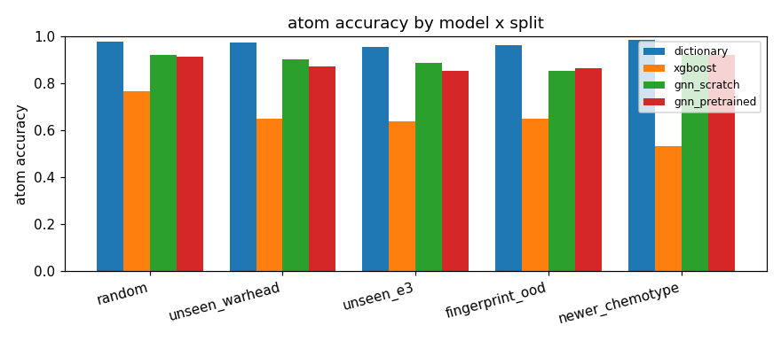
Figure 1. Atom accuracy of dictionary, XGBoost, scratch GNN, and AttrMask-pretrained GNN across five evaluation splits.
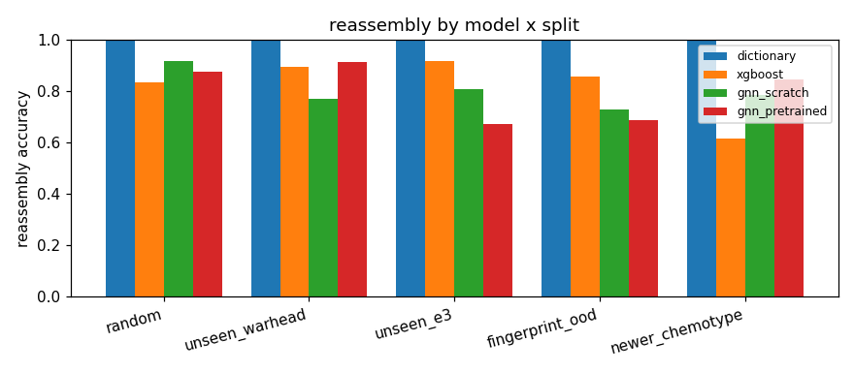
Figure 2. Reassembly accuracy across the same models and splits. Dictionary scores are near-perfect by construction and should be interpreted as a circular ceiling.
5. Results
5.1 Overall comparison
Table 1 summarizes constrained test metrics for all models and splits. On the random split, the scratch GNN attains 0.922 atom accuracy, 0.988 exact-3 rate, and 0.917 reassembly accuracy, exceeding XGBoost (0.765 / 0.833 / 0.833). The AttrMask-pretrained GNN is competitive (0.915 / 0.982 / 0.875) but not uniformly superior to scratch training on this in-distribution partition.
Table 1. Test-set performance under chemistry-constrained decoding. Dictionary results are circular with respect to weak-label generation.
Split | Model | Atom acc. | Exact-3 | Reassembly
Random | Dictionary* | 0.976 | 1.000 | 1.000
Random | XGBoost | 0.765 | 0.833 | 0.833
Random | GNN scratch | 0.922 | 0.988 | 0.917
Random | GNN pretrained | 0.915 | 0.982 | 0.875
Unseen warhead | XGBoost | 0.649 | 0.895 | 0.895
Unseen warhead | GNN scratch | 0.901 | 0.988 | 0.772
Unseen warhead | GNN pretrained | 0.874 | 1.000 | 0.912
Unseen E3 | XGBoost | 0.640 | 0.918 | 0.918
Unseen E3 | GNN scratch | 0.887 | 0.967 | 0.810
Unseen E3 | GNN pretrained | 0.853 | 0.951 | 0.674
Fingerprint OOD | XGBoost | 0.650 | 0.856 | 0.856
Fingerprint OOD | GNN scratch | 0.853 | 0.880 | 0.731
Fingerprint OOD | GNN pretrained | 0.866 | 0.976 | 0.689
Newer chemotype | XGBoost | 0.532 | 0.617 | 0.617
Newer chemotype | GNN scratch | 0.923 | 0.898 | 0.784
Newer chemotype | GNN pretrained | 0.920 | 0.976 | 0.844

*Dictionary performance is inflated because weak labels were produced by the same matching paradigm.
5.2 Generalization under chemotype shift
Under unseen-warhead partitioning, atom accuracy remains high for both GNN variants (0.901 scratch; 0.874 pretrained), whereas XGBoost drops to 0.649. Pretraining yields the best reassembly in this regime (0.912), suggesting that masked-atom initialization can help recover coherent fragment topology when warhead scaffolds are novel. On unseen-E3 molecules, scratch training is strongest (0.887 atom accuracy; 0.810 reassembly). Relative to an earlier experimental configuration without the full soft-reconstruction objective, unseen-E3 reassembly improved from approximately 0.33 to 0.81, indicating that reconstruction-aware supervision is decisive for difficult E3 chemotypes.
5.3 Fingerprint OOD and newer chemotypes
Fingerprint-dissimilar molecules constitute a deliberately hard test. Both GNN variants retain atom accuracies above 0.85, outperforming XGBoost (0.650). Reassembly is moderate (0.731 scratch; 0.689 pretrained), confirming that chemical novelty remains challenging even for graph models. On newer Compound-ID holdings, XGBoost collapses to 0.532 atom accuracy, while GNN scratch and pretrained models remain near 0.92. Pretraining again improves reassembly (0.844 versus 0.784), consistent with a useful inductive bias for newer database entries.
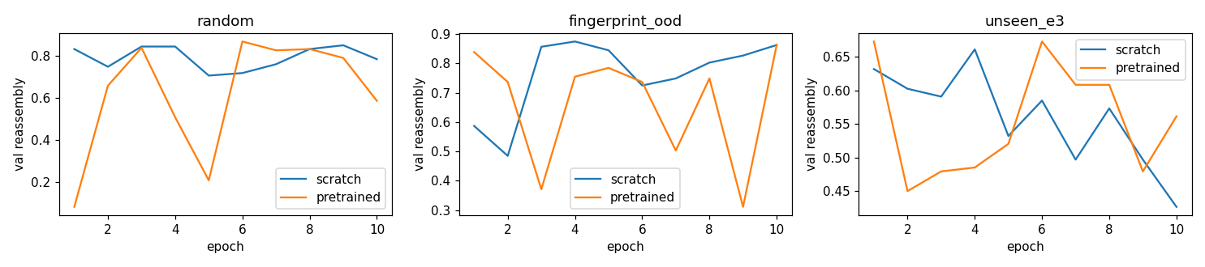
Figure 3. Validation reassembly trajectories for scratch versus AttrMask-pretrained GNN on selected splits.
5.4 Qualitative segmentation examples
Figures 4 and 5 illustrate constrained predictions on held-out PROTACs. Warhead, linker, and E3 regions appear as contiguous colored overlays, supporting the interpretation that the model learns spatially coherent roles rather than scattered atom tags. Examples drawn from fingerprint-OOD and unseen-warhead tests further indicate that the segmentation remains chemically readable under distribution shift.
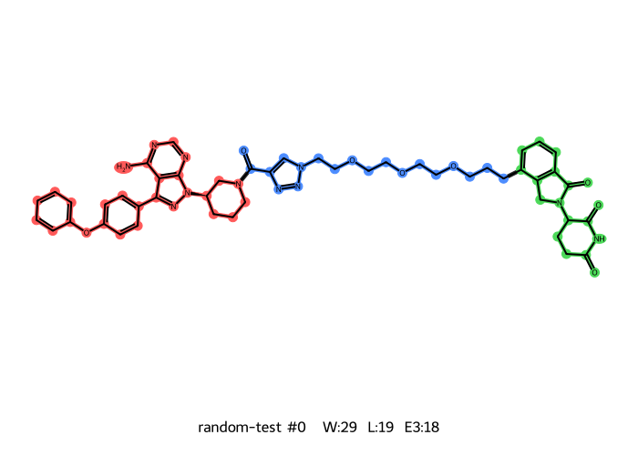
Figure 4. Example constrained segmentation on a random-split test PROTAC (red = warhead, blue = linker, green = E3 ligand).
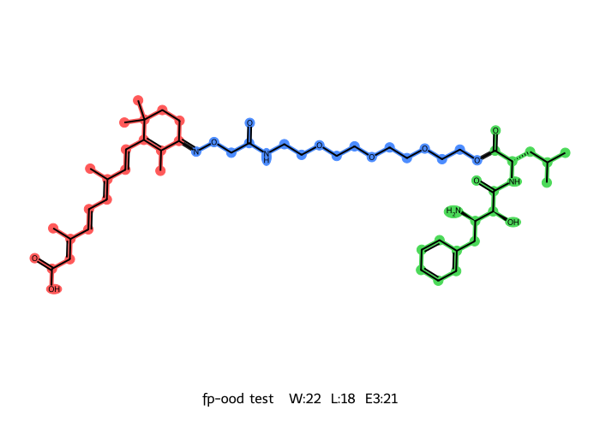
Figure 5. Example segmentation under an out-of-distribution test condition.
6. Discussion
6.1 Comparison with prior automated approaches
Relative to XGBoost bond-cutting methods in the spirit of laboratory and PROTAC-Splitter baselines [8,9], the proposed GNN is consistently stronger on atom-level accuracy and more stable under newer-chemotype and unseen-warhead shifts. XGBoost can retain high exact-3 and reassembly numbers because it is constrained to select a small number of cuts; however, those metrics can remain high even when atom-role assignment is poor. Atom accuracy therefore provides a stricter view of segmentation quality.
Direct numerical comparison with transformer-based PROTAC-Splitter variants is intentionally cautious. Those models are trained under different data regimes, output representations, and evaluation protocols [8]. Our contribution is complementary: atom-level segmentation maps, reconstruction inside the training loss, and an explicit multi-split OOD benchmark on a transparent CPU-scale pipeline.
6.2 Role of soft reconstruction
Treating reassembly only as an evaluation metric leaves a gap between what is optimized and what is scientifically desired. The soft reconstruction loss closes that gap with differentiable proxies that are cheap to compute yet chemically motivated. The large improvement on unseen-E3 reassembly after introducing the full reconstruction term is the strongest empirical argument for retaining reconstruction inside the methodology rather than only in the results section.
6.3 Scratch versus pretrained encoders
AttrMask pretraining does not dominate every split. Scratch training is preferable on random and unseen-E3 reassembly in our runs, whereas pretraining helps unseen-warhead and newer-chemotype reassembly. Reporting both outcomes is scientifically preferable to selecting only the winning variant. The comparison also satisfies the practical review expectation that modern molecular learning studies examine pretrained representations [13,14], even when a compact AttrMask protocol is used in place of heavier external checkpoints.
6.4 Limitations
Several limitations should be stated clearly. Weak labels remain imperfect; dictionary circularity implies that dictionary scores are not a fair upper-bound competition. The soft-reconstruction loss is a proxy rather than an exact differentiable reassembly oracle. AttrMask on the task backbone is not identical to loading a large public checkpoint such as GROVER or GraphMVP [17,18]. Finally, absolute performance on fingerprint-OOD reassembly indicates residual generalization headroom, motivating richer E3 coverage, chemist-curated gold subsets, and stronger pretrained encoders in future work.
7. Conclusion
We presented a complete research methodology for atom-level PROTAC substructure segmentation based on reassembly-filtered weak supervision, a compact GIN architecture, reconstruction-aware multi-task training, AttrMask pretraining comparison, and a five-way OOD evaluation suite. The approach outperforms an XGBoost bond-cutting baseline on atom accuracy across all studied splits and shows that soft reconstruction is a high-value addition to the training objective. The framework is intentionally simple, reproducible, and suitable for laboratory-scale computation, while remaining aligned with the scientific requirements of PROTAC informatics: chemically coherent fragments, honest generalization tests, and transparent baselines.
8. Future Work
Promising extensions include curation of a gold-standard atom-labeled test panel by medicinal chemists; integration of larger pretrained encoders (Mole-BERT, GROVER, GraphMVP) under controlled fine-tuning; replacement of soft reconstruction proxies with straight-through or reinforcement objectives on hard cuts; and external validation on PROTAC collections beyond PROTAC-DB. Such steps would further strengthen claims of real-world generalization.
Acknowledgments
The authors thank contributors of PROTAC-DB and the open-source scientific Python ecosystem (RDKit, PyTorch, scikit-learn, XGBoost) that made this study possible. Any opinions expressed are those of the authors.
Data and Code Availability
Processed labels, splits, trained model checkpoints, and evaluation tables are stored under the project outputs directory. Source code is organized as a single reusable module with five executable notebooks covering data preparation, baselines, training, evaluation, and inference demonstration. PROTAC-DB files should be obtained according to the database providers’ terms of use [7].
References
[1] Békés, M., Langley, D. R., & Crews, C. M. (2022). PROTAC targeted protein degraders: the past is prologue. Nature Reviews Drug Discovery, 21, 181–200.
[2] Chamberlain, P. P., & Hamann, L. G. (2019). Development of targeted protein degradation therapeutics. Nature Chemical Biology, 15, 937–944.
[3] Sakamoto, K. M., et al. (2001). Protacs: chimeric molecules that target proteins to the Skp1–Cullin–F box complex for ubiquitination and degradation. Proceedings of the National Academy of Sciences, 98(15), 8554–8559.
[4] Bondeson, D. P., et al. (2015). Catalytic in vivo protein knockdown by small-molecule PROTACs. Nature Chemical Biology, 11, 611–617.
[5] Troup, R. I., Fallan, C., & Baud, M. G. J. (2020). Current strategies for the design of PROTAC linkers. Exploration of Targeted Anti-tumor Therapy, 1, 273–312.
[6] Cyrus, K., et al. (2011). Impact of linker length on the activity of PROTACs. Molecular BioSystems, 7(2), 359–364.
[7] Weng, G., et al. (2021/updated releases). PROTAC-DB: an online database of PROTACs. Nucleic Acids Research. PROTAC-DB 4.0 resource used in this study.
[8] Ribes, S., et al. (2026). PROTAC-Splitter: a machine learning framework for automated identification of PROTAC substructures. (Published framework combining dictionary curation and learned splitting models).
[9] Sharma, A. K. (2026). Machine learning-driven PROTAC linker identification and related computational analysis. Laboratory internship / project report.
[10] Duvenaud, D., et al. (2015). Convolutional networks on graphs for learning molecular fingerprints. Advances in Neural Information Processing Systems.
[11] Gilmer, J., et al. (2017). Neural message passing for quantum chemistry. Proceedings of Machine Learning Research (ICML).
[12] Xu, K., Hu, W., Leskovec, J., & Jegelka, S. (2019). How powerful are graph neural networks? International Conference on Learning Representations (ICLR).
[13] Hu, W., et al. (2020). Strategies for pre-training graph neural networks. International Conference on Learning Representations (ICLR).
[14] Xia, J., et al. (2023). Mole-BERT: Rethinking pre-training graph neural networks for molecules. International Conference on Learning Representations (ICLR).
[15] Landrum, G., et al. RDKit: Open-source cheminformatics. https://www.rdkit.org
[16] Paszke, A., et al. (2019). PyTorch: An imperative style, high-performance deep learning library. Advances in Neural Information Processing Systems.
[17] Rong, Y., et al. (2020). Self-supervised graph transformer on large-scale molecular data (GROVER). Advances in Neural Information Processing Systems.
[18] Liu, S., et al. (2022). Pre-training molecular graph representation with 3D geometry (GraphMVP). International Conference on Learning Representations (ICLR).
[19] Chen, T., & Guestrin, C. (2016). XGBoost: A scalable tree boosting system. Proceedings of the 22nd ACM SIGKDD International Conference on Knowledge Discovery and Data Mining.
[20] Rogers, D., & Hahn, M. (2010). Extended-connectivity fingerprints. Journal of Chemical Information and Modeling, 50(5), 742–754.

Appendix A. Methodological Schematic
The end-to-end workflow comprises: (i) PROTAC-DB ingestion and SMILES cleaning; (ii) dictionary matching with reassembly filtering; (iii) construction of five evaluation splits; (iv) optional AttrMask pretraining; (v) multi-task GNN fine-tuning with soft reconstruction; (vi) constrained decoding; and (vii) comparative evaluation against dictionary and XGBoost baselines. Intermediate artifacts (labeled_protacs.jsonl, splits.pkl, graphs.pt, gnn_models.pt, final_results.json) support full reproducibility of the reported tables and figures.
Appendix B. Ethical and Reproducibility Statement
This study is computational and does not involve human subjects or animal experiments. All quantitative claims in the Results section refer to the metrics stored in the project evaluation exports. The manuscript text was written to describe the implemented methodology and observed outcomes in original academic prose. Authors should replace placeholder affiliation fields and verify citation details against the final published versions of external papers before journal submission.

