**TASK 2**

Yashika Sagar

CSE-AI (2nd Year)

CODE

(HTML)

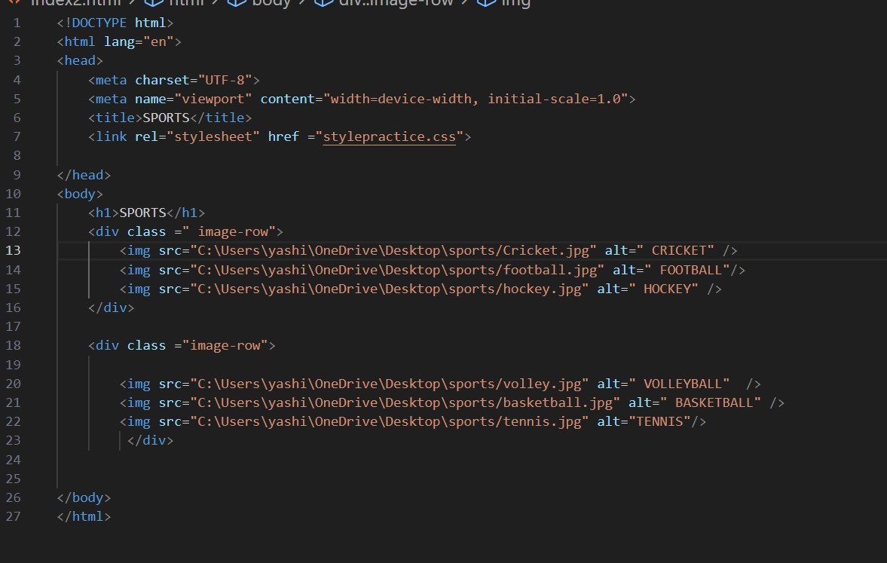

(CSS)

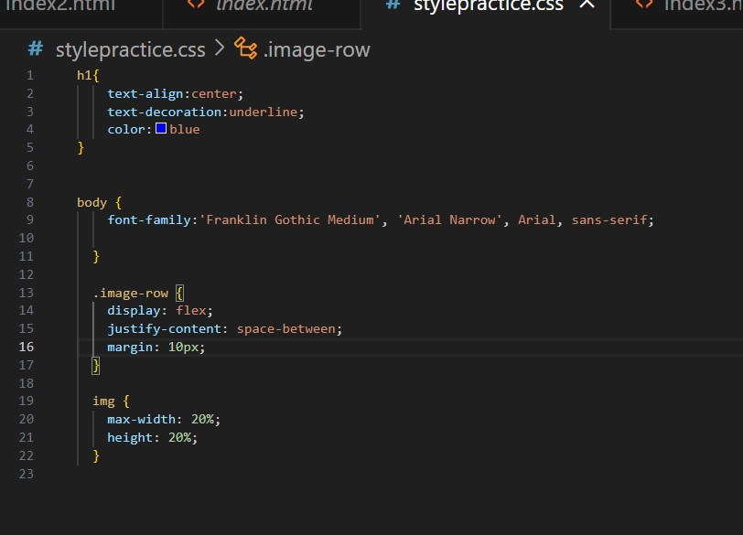

OUTPUT

