Q2 Create a user in linux with userid as 10001

- Add the user into the secondary group {sales} at time of creating the user

Ans:

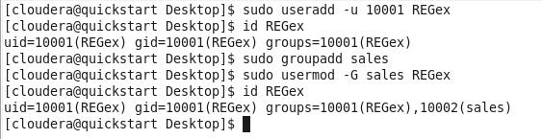

Q3: Try to move the file from local environment to any folder into hadoop ecosystem.

Ans:

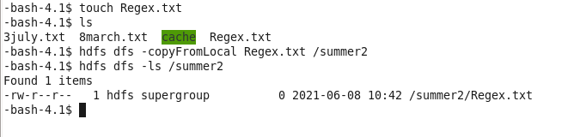

Q4: Create a empty file in any locaiton in hadoop

Ans:

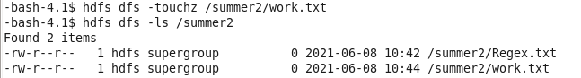



Q5 Change the permission of the folder & the files & subdirectories present inside the location of hadoop

- After that also verify the folder & also the internal files inside the folder

Ans:

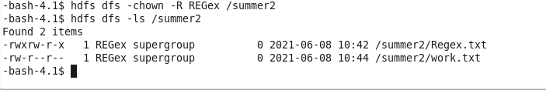

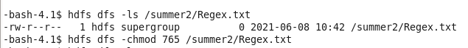



Q6 Change the replicaiton factor for any file present in hadoop to 3

- Also change the replication factor for any file while using the {put command } in hadoop to 3

Ans:

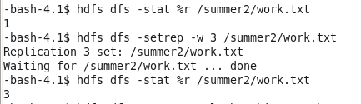

Q7 - Create any folder in hadoop

- Move the file from local to hadoop folder

- create one more file with data into local linux

- Try to copy the contents of new file from local machien to the hadoop environment now in the same folder

Ans:

