**1:Create Date class with members day,month ,year.Write no argument and parameterised constructor .Create two object s and initialize them using no argument and parameterised constructor**

**respectively.Print date using display function.**

#include<iostream>

using namespace std;

class Date{

private:

int day, month, year;

public:

Date(){

cout<<"--------Default value------------";

day= 1;

month= 1;

year=2001;

}

Date(int day, int month, int year)

{

//cout<<"--------Parameterized constructor--------";

this->day=day;

this->month=month;

this->year=year;

}

void display(){

cout<<"Date is: "<<day<<" - "<<month<<" - "<<year<<endl;

}

};

int main(){

int day,month,year;

cout<<"Enter day, month, year: ";

cin>>day>>month>>year;

Date dt(day,month,year);

dt.display();

return 0;

}

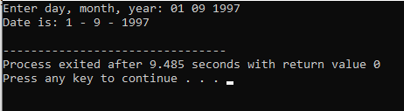

**2:Create Employee class with members id(int),name(string),dob(Date).Use above created Date class.**

**Write default and parameterised constructor in Employee Class.Write accept() function to accept information and display() to display emp information.**

#include<iostream>

using namespace std;

class Date{

private:

int day, month, year;

public:

Date(){

day= 1;

month= 1;

year=2001;

}

Date(int day, int month, int year)

{

this->day=day;

this->month=month;

this->year=year;

}

void accept(){

cout<<"\nEnter date of birth: ";

cin>>day>>month>>year;

}

void displayDate(){

cout<<"\nDOB : "<<day<<" - "<<month<<" - "<<year<<endl;

}

};

class Employee:public Date{

protected:

int id;

string name;

// Date dob;

public:

Employee(){

id=101;

name="abc";

}

Employee(int id,string name){

this->id=id;

this->name=name;

}

void accept() {

//cout<<"------------Employee details----------"<<endl;

cout<<"Enter id: ";

cin>>id;

cout<<"\nEnter name : ";

cin>>name;

}

void display(){

Date dob;

dob.Date::accept();

cout<<"\n\n--------------Employee details--------------"<<endl;

cout<<"Name : "<<name<<" id: "<<id<<endl;

dob.Date::displayDate();

}

};

int main(){

Employee emp1;

emp1.accept();

emp1.display();

return 0;

}

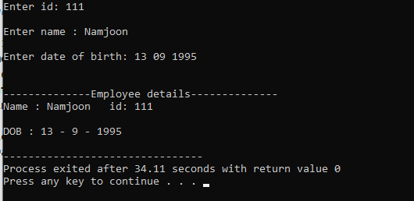

**3:Consider that payroll software needs to be developed for computerization of**

**operations of an ABC organization. The organization has employees.**

**3.1. Construct a class Employee with following members using private access**

**specifies:**

**Employee Id integer**

**Employee Name string**

**Basic Salary double**

**HRA double**

**Medical double=1000**

**PF double**

**PT double**

**Net Salary double**

**Gross Salary double**

**Please use following expressions for calculations://Note:Don't accept HRA,PF PT from user**

**\* HRA = 50% of Basic Salary**

**\* PF = 12% of Basic Salary**

**\* PT = Rs. 200**

**3.2. Write methods to display the details of an employee and calculate the gross**

**and net salary.**

**\* Goss Salary = Basic Salary + HRA + Medical**

**\* Net Salary = Gross Salary – (PT + PF)**

**Create Object of employee class and assign values and display Details.**