**Output :**

**(Using text-to-speech & speech-to-text conversions)**

**a)** Connection with the mail server is established (Authentication)

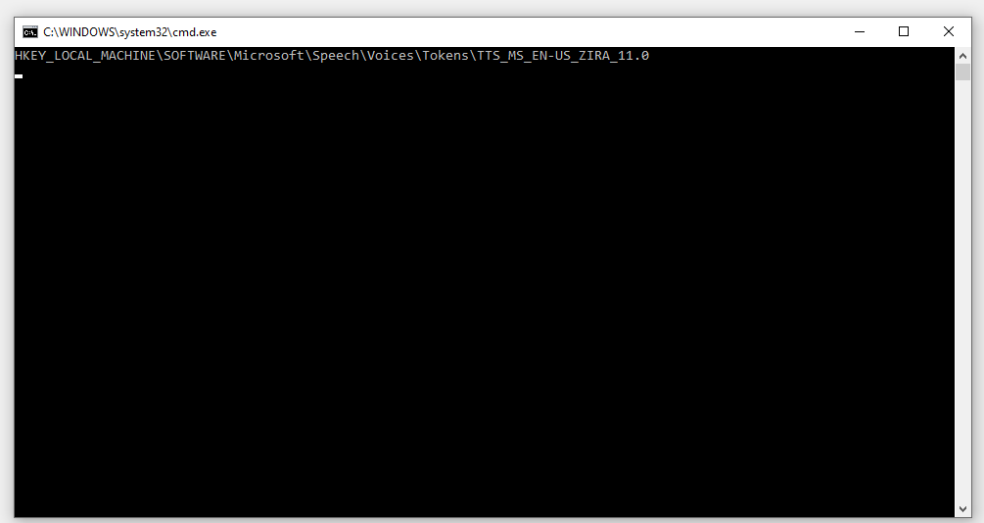

**b)** System has started giving commands to the client

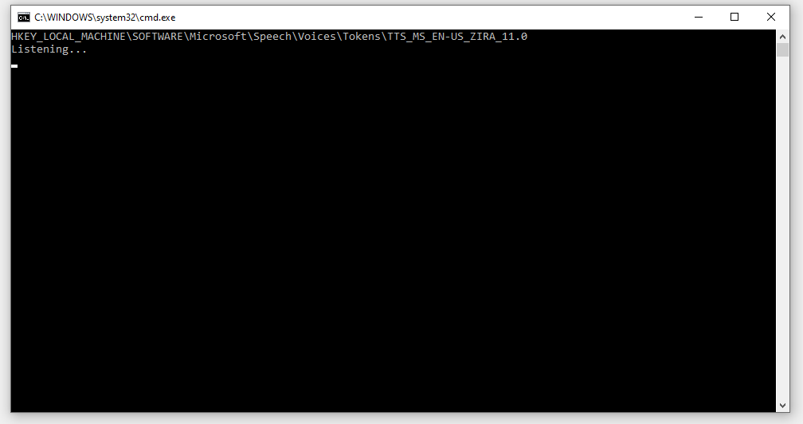

**c)** Send Email commands to be sent to the old user ids

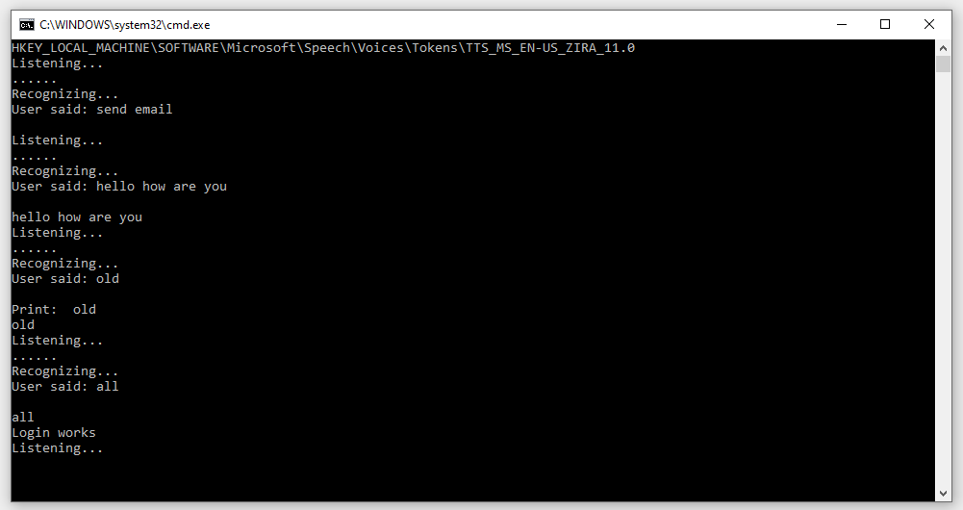

**d)** Send Email commands to be sent to the new user id

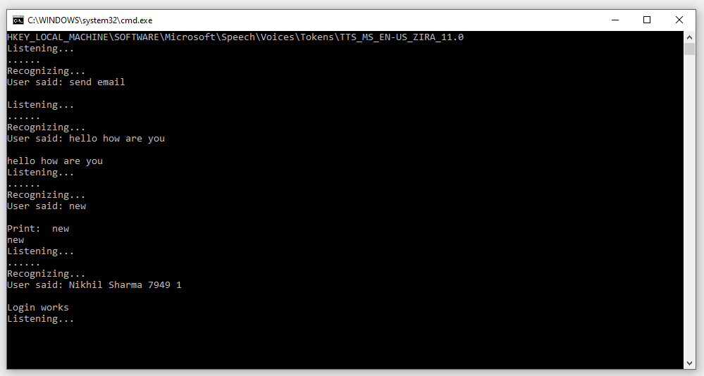

**e)** Check Email commands to the client

