**KalaConnect: Empowering Artisans with Generative AI**

**Prototype Deck for Gen AI Exchange Hackathon**

**1. Team Details**

* **Team Name:** Patta Gobhi
* **Members:**
  + Yashika Wadhwani
  + Arya Lokhande
  + Siddharth Nigam

**2. Brief About Your Prototype**

KalaConnect is an AI-driven e-commerce platform designed from the ground up to empower local Indian artisans. It addresses the critical challenge they face: a lack of digital marketing skills and resources to compete in the modern online marketplace.

Our prototype is more than just a storefront; it's a **creative partner**. Using Google Cloud's generative AI, KalaConnect provides artisans with a suite of intuitive tools to:

* **Tell Their Story:** Effortlessly generate compelling, multilingual product descriptions and narratives.
* **Create Professional Listings:** Automatically enhance product photos for a clean, professional look.
* **Reach a Wider Audience:** Instantly translate content and get SEO-friendly keywords to boost visibility.

The platform provides an end-to-end solution, from product idea to a live, beautiful e-commerce listing, all through a simple, accessible interface that even supports voice input in local languages.

**3. How is it different from other existing solutions?**

While platforms like Etsy, Amazon Karigar, and IndiaMart provide a marketplace, they place the entire burden of content creation, photography, and digital marketing on the artisan. KalaConnect fundamentally changes this dynamic.

|  |  |  |
| --- | --- | --- |
| **Feature** | **Existing Solutions (e.g., Etsy)** | **KalaConnect** |
| **Content Creation** | Manual; requires strong writing and marketing skills. | **AI-Automated;** Generates stories, descriptions, and SEO tags from simple inputs. |
| **Accessibility** | Requires typing and digital literacy. | **Voice-First;** Artisans can speak their story in their own language. |
| **Photography** | Requires professional photos for good results. | **AI-Enhanced;** Automatically removes backgrounds for a clean, studio look. |
| **Market Reach** | Listings are typically in one language. | **Instantly Multilingual;** Content is generated for multiple languages, expanding reach. |
| **Role of Platform** | Passive Sales Channel | **Active Creative Partner** |

Our solution doesn't just provide a space to sell; it actively helps create the high-quality digital assets needed to succeed.

**4. How will it be able to solve the problem?**

KalaConnect directly tackles the core challenges faced by Indian artisans:

1. **Lack of Digital Marketing Skills:** Our AI generates professional, persuasive marketing copy and SEO keywords, eliminating the need for specialized knowledge.
2. **Limited Resources:** The AI-powered image enhancement provides studio-quality product photos without the cost of a professional photographer or expensive software.
3. **Bridging Traditional and Modern:** The "Tone & Style" customization allows artisans to frame their traditional craft for different modern audiences (e.g., 'Luxury', 'Minimalist').
4. **Language Barriers:** By supporting voice input and generating multilingual content, we break down language and literacy barriers, making the digital world accessible to all.

By automating these difficult and time-consuming tasks, we empower artisans to focus on what they do best—creating beautiful crafts—while ensuring their stories and products reach the global audience they deserve.

**5. USP of the Proposed Solution**

* **Voice-First Content Creation:** Artisans can simply speak their story. Our platform handles the transcription and beautification, making it incredibly accessible.
* **AI Storytelling & Marketing Suite:** A single click generates compelling product narratives, social media-ready captions, and SEO-optimized tags in multiple languages.
* **Instant Professionalism:** AI-driven image enhancement automatically standardizes product photos, increasing buyer trust and appeal.
* **Hyper-Local to Global:** Seamless multilingual support and thematic filtering allow artisans to instantly connect with a diverse, worldwide customer base.

**6. List of Features Offered by the Solution**

* **Dual User Roles:** Separate, secure login and dashboard experiences for Artisans and Customers.
* **AI Content Generation:** Generate product descriptions and SEO keywords from basic product details.
* **Voice-to-Text Simulation:** Microphone inputs for all text fields to simulate real-time transcription.
* **AI Image Enhancement:** Automatic background removal for uploaded product images.
* **Multilingual Support:** The entire app interface and generated content can be switched between English and Hindi.
* **Tone & Style Customization:** Artisans can choose a "tone" (Heritage, Luxury, Modern, Festive) to guide the AI's writing style.
* **Full E-Commerce Functionality:** A public marketplace, product detail views, a shopping cart, and a checkout process.
* **Thematic Filtering:** Buyers can filter and shop for products based on the AI-generated story themes.
* **AI Audio Narration:** "Listen to the Story" feature on product pages using text-to-speech.

**7. Process Flow Diagram**

**Artisan User Flow**

**Customer User Flow**

**9. Solution Architecture Diagram**

The proposed solution is built on a modern, scalable, serverless architecture leveraging Google Cloud.

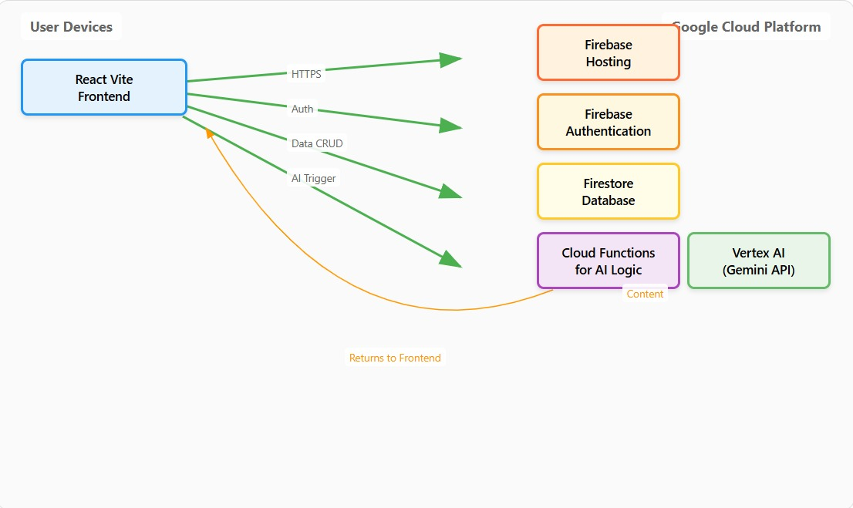

**10. Technologies Used**

* **Frontend:** React (with Vite), Tailwind CSS
* **Cloud Platform:** Google Cloud Platform (GCP)
* **Backend Services:** Firebase (for Hosting, Authentication, and Firestore Database), Cloud Functions (for serverless backend logic).
* **Generative AI:** Google's Gemini models accessed via the Vertex AI platform.
* **Programming Language:** JavaScript (ES6+)

**11. Estimated Implementation Cost (Optional)**

As a prototype, the implementation cost is minimal, primarily relying on the free tiers of Firebase and Google Cloud.

For a production-ready application, costs would be influenced by:

* **Google Cloud Usage:** Costs for Firebase, Cloud Functions, and Vertex AI are usage-based and will scale with the number of artisans and customers.
* **Development & Maintenance:** Salaries for a small team of developers to maintain and enhance the platform.
* **Marketing & Outreach:** Costs associated with reaching out to artisan communities and marketing the platform to buyers.

The serverless architecture ensures that operational costs remain low during initial stages and scale efficiently as the platform grows.