**USER INTERFACE DESIGN:**

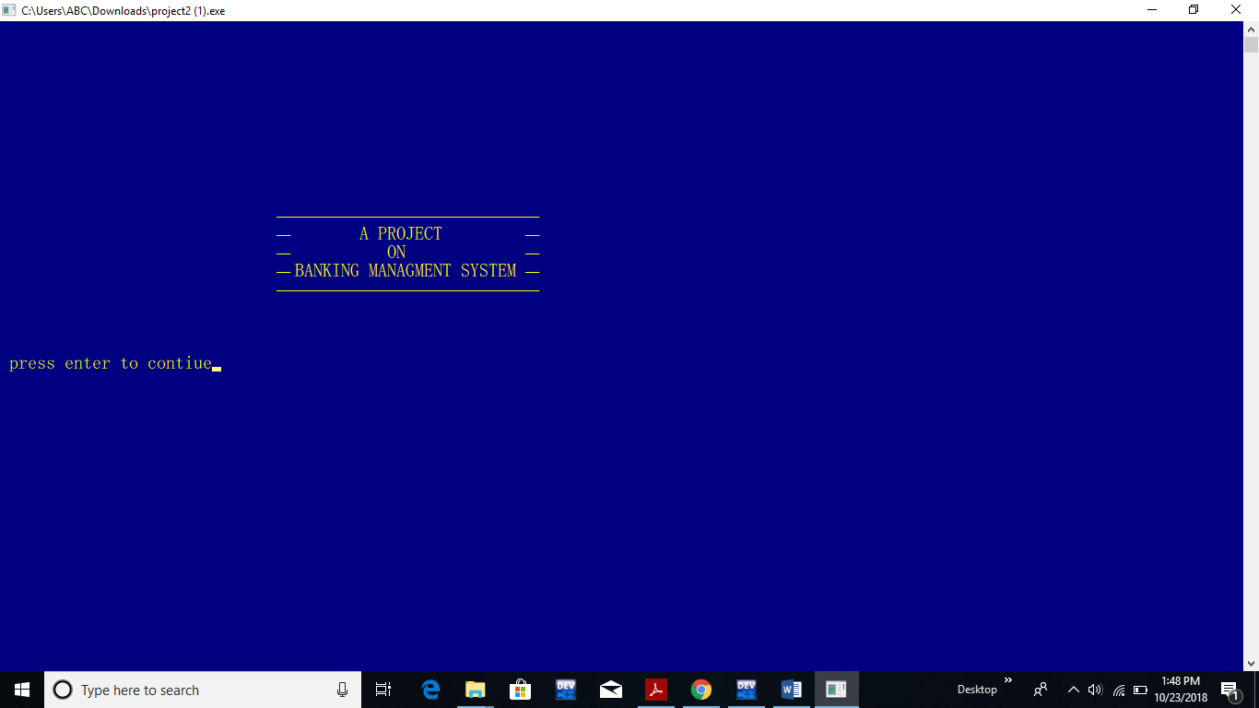

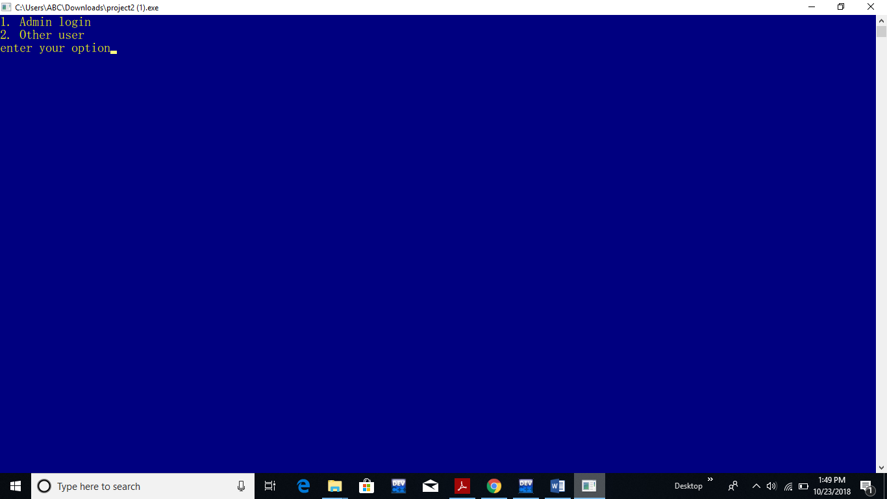

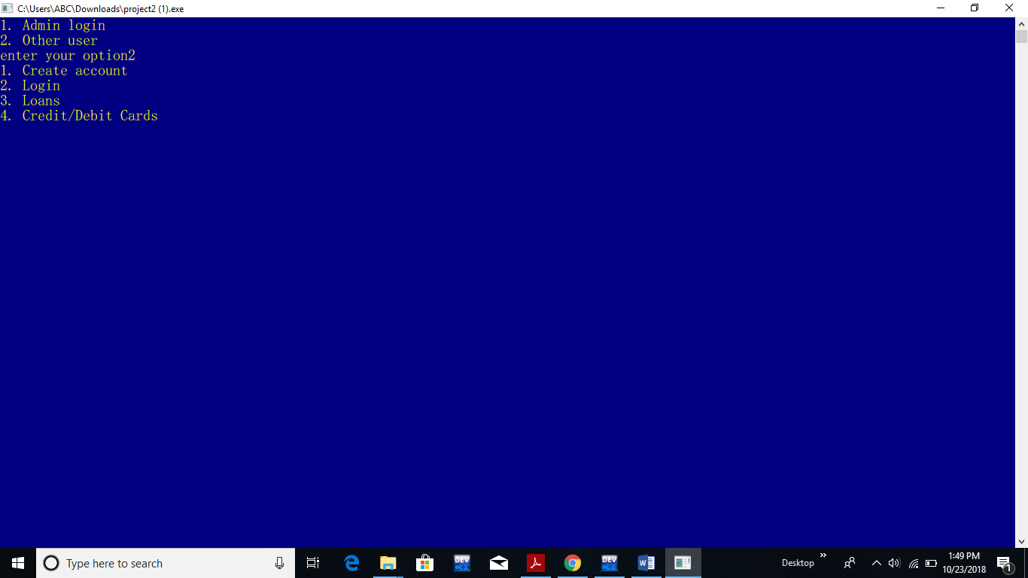

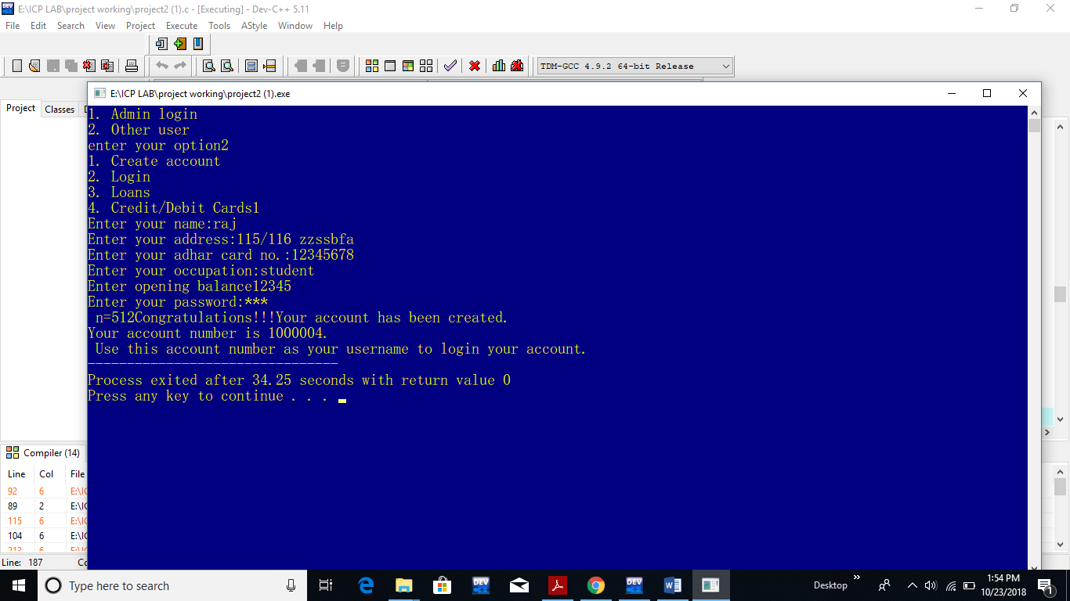

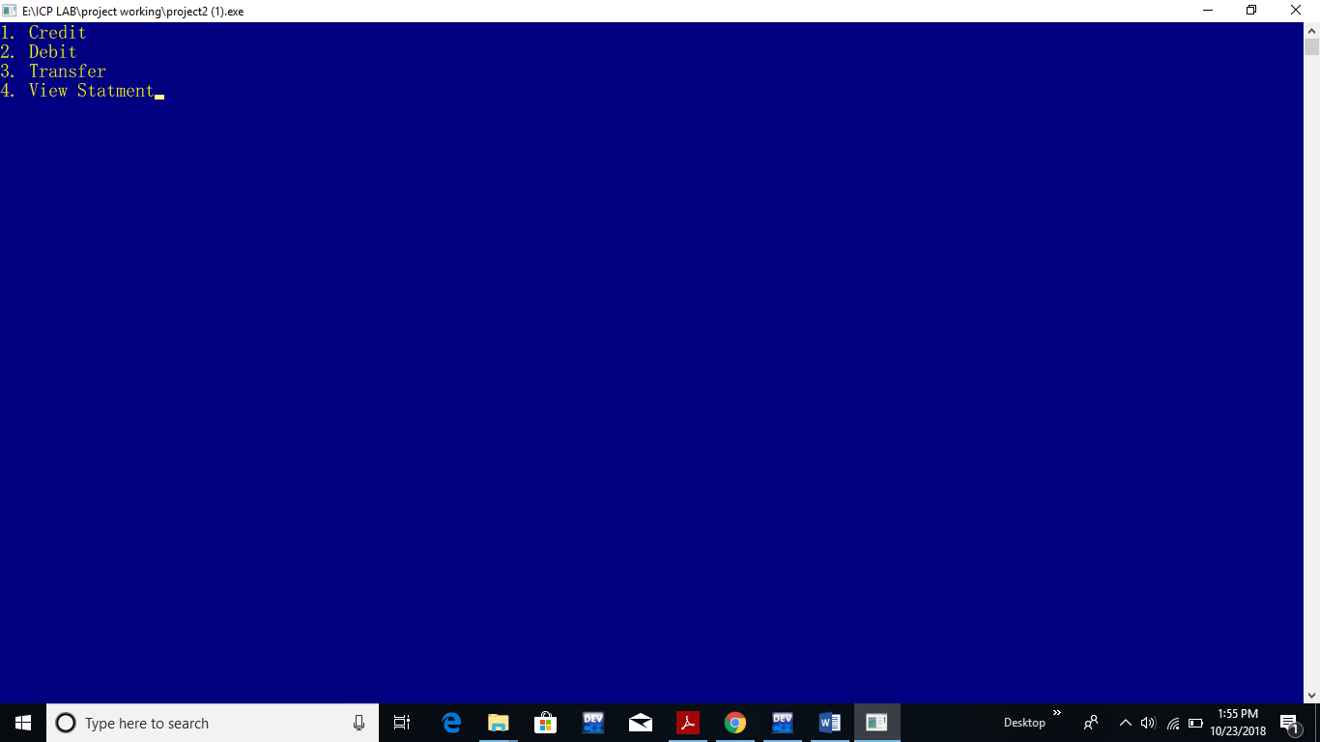

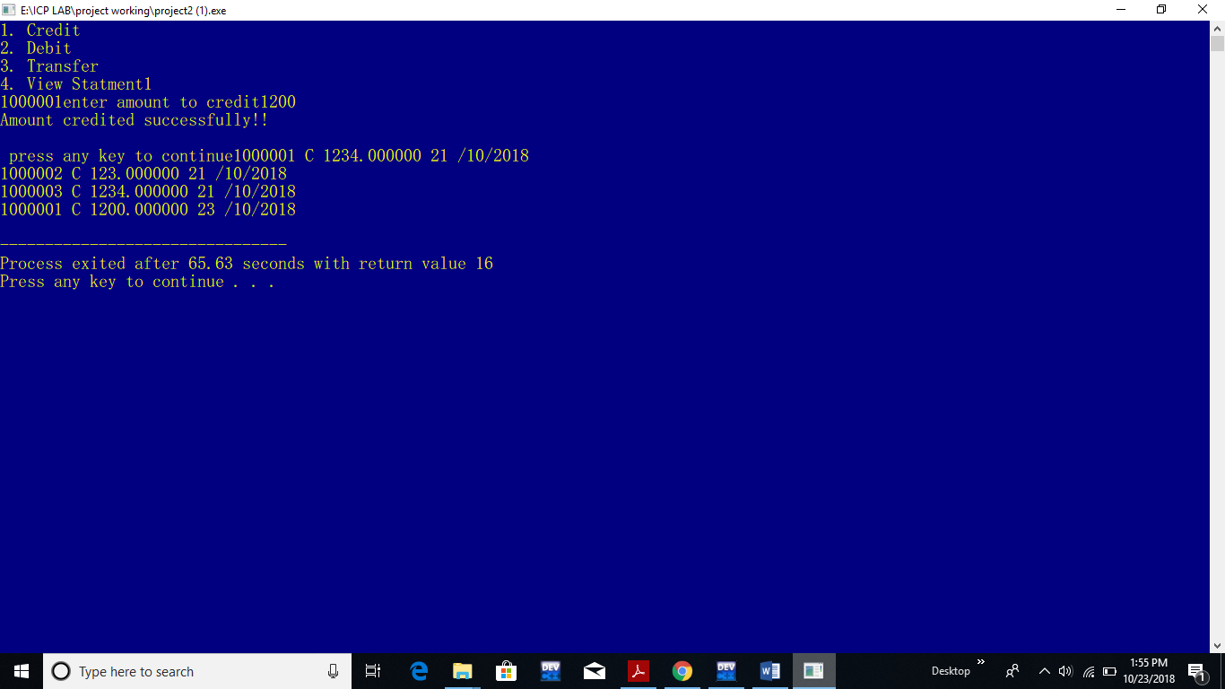

**Revised screenshots:**

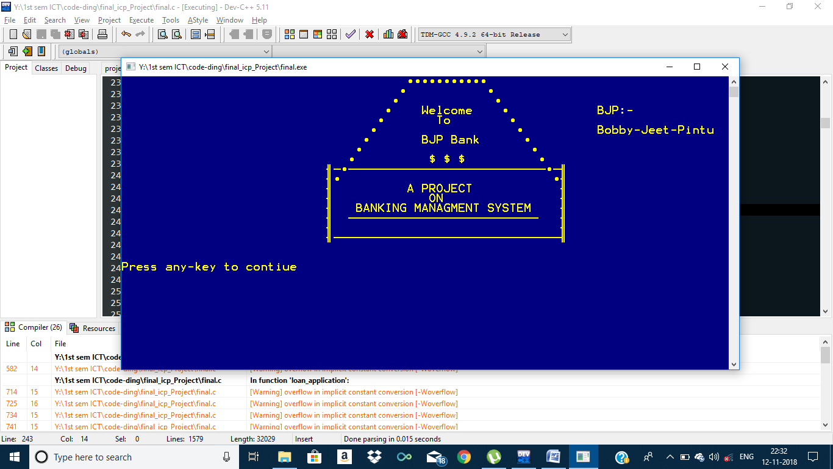

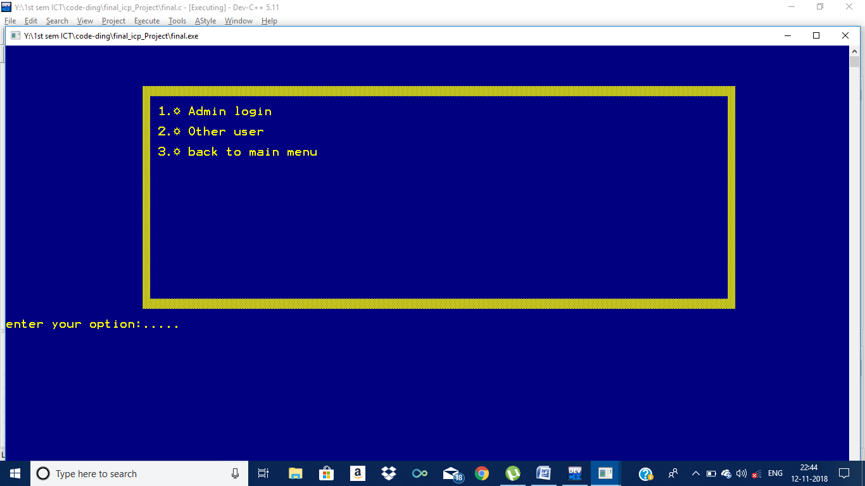

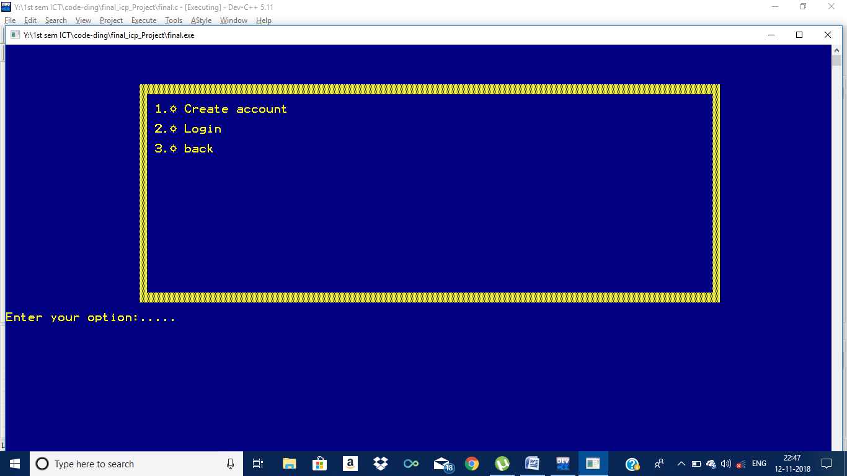

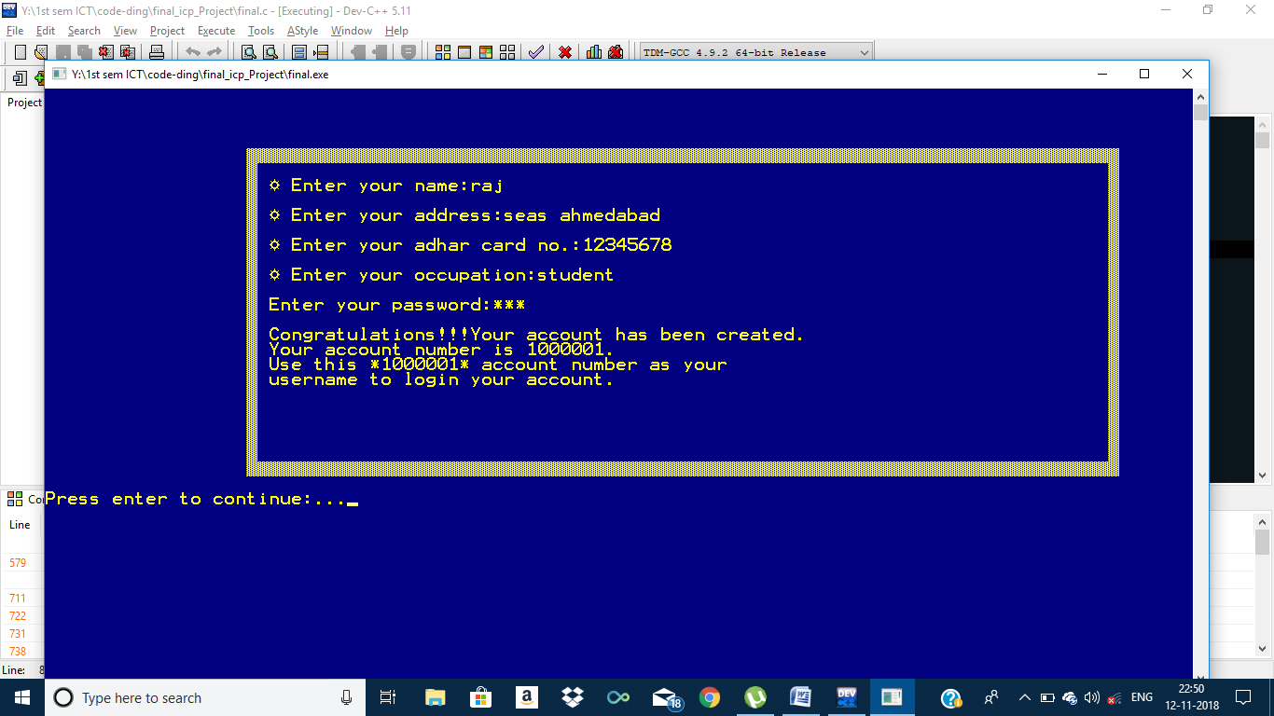

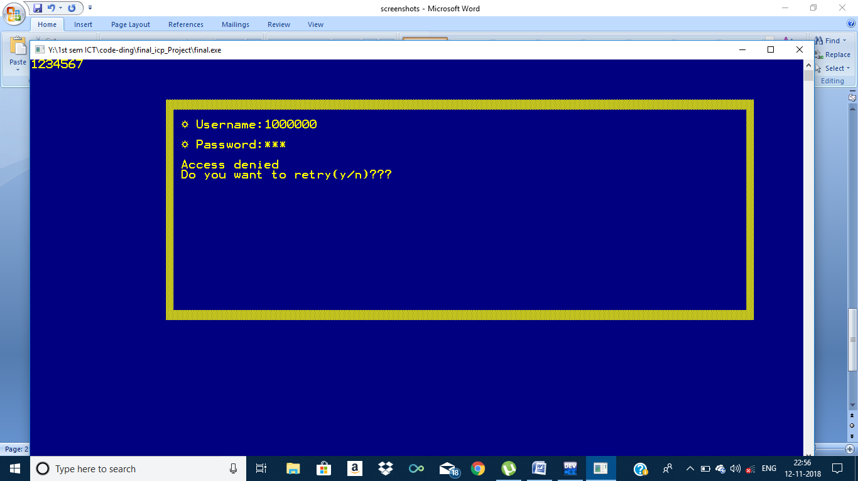

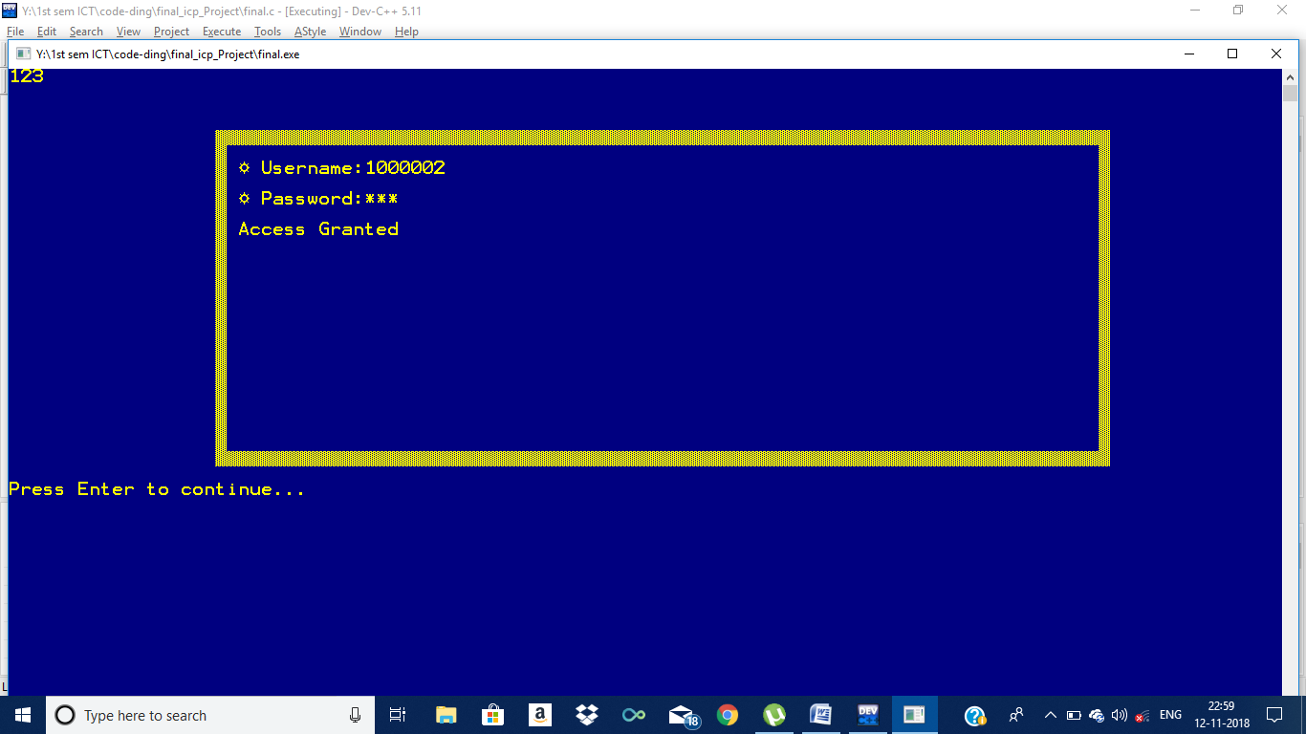

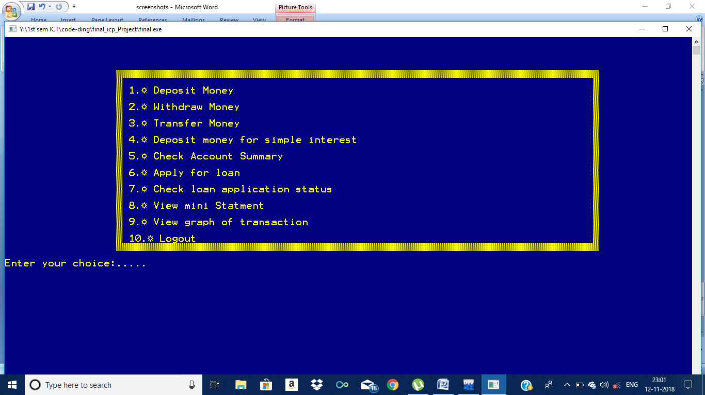

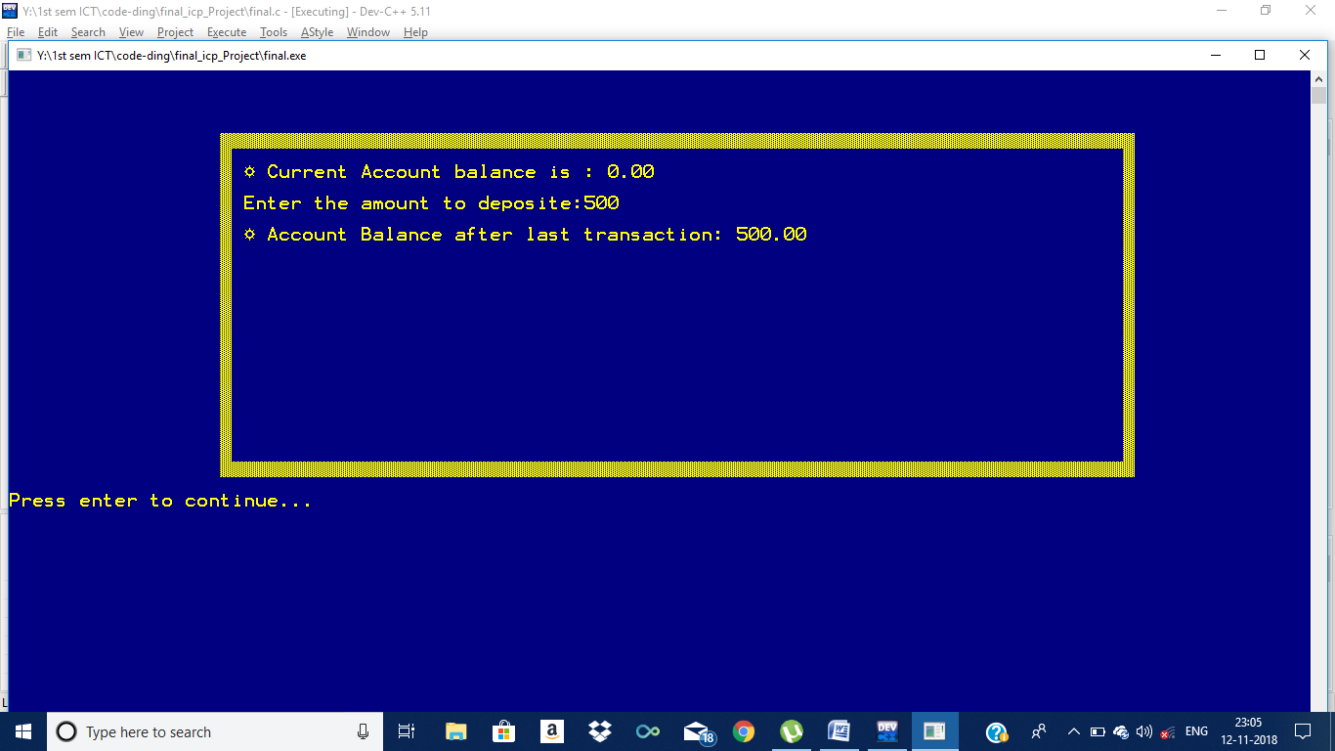

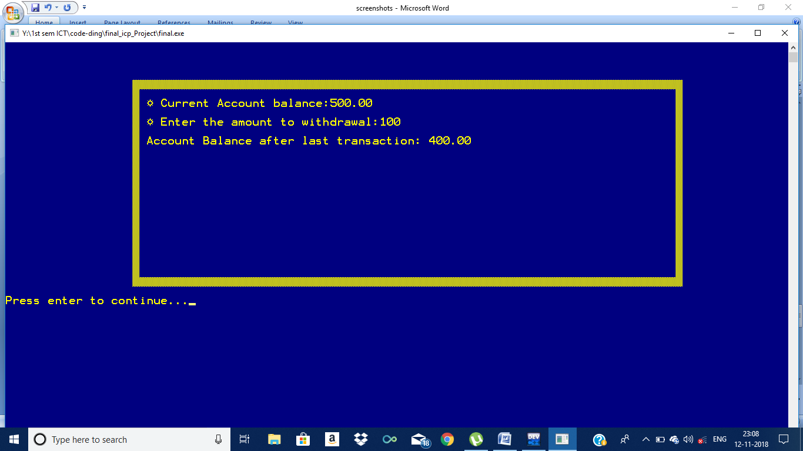

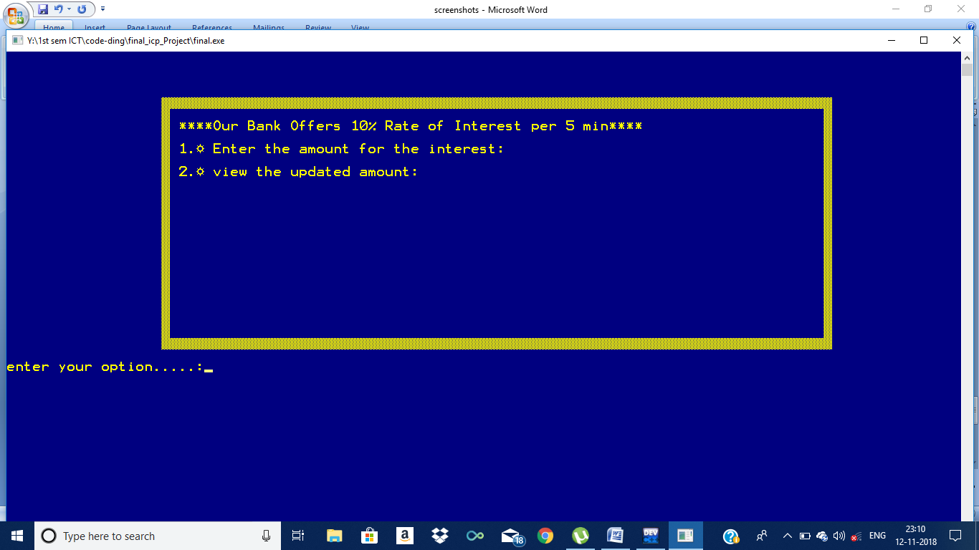

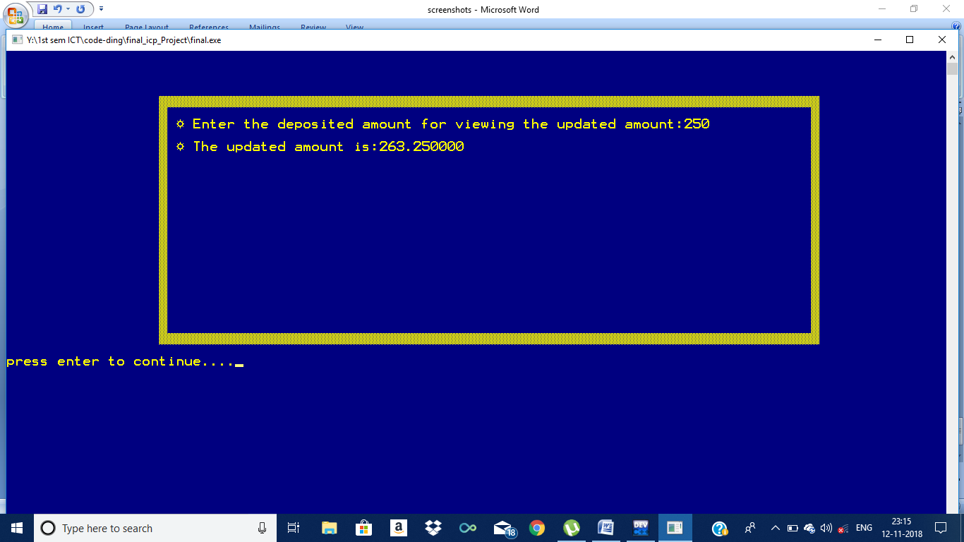

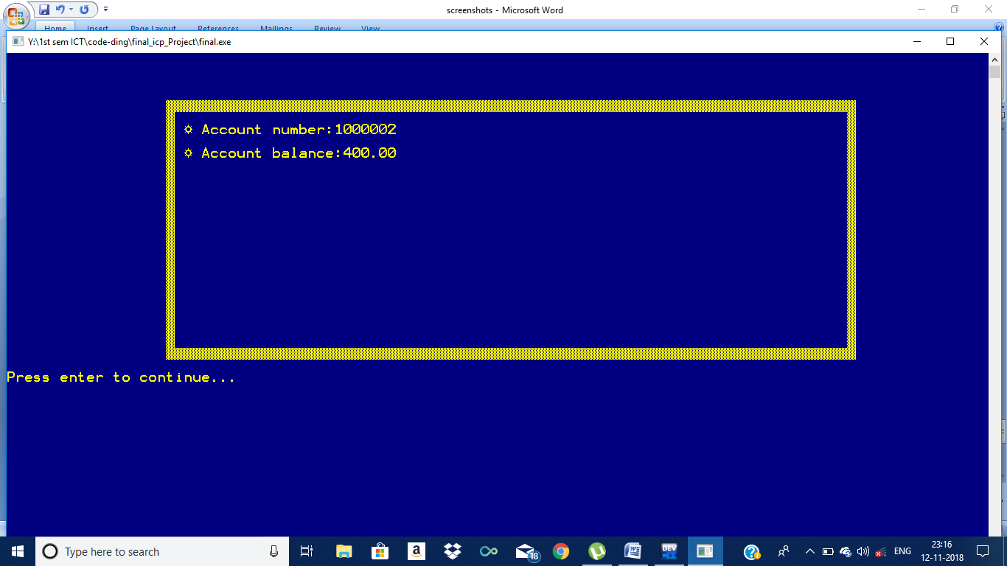

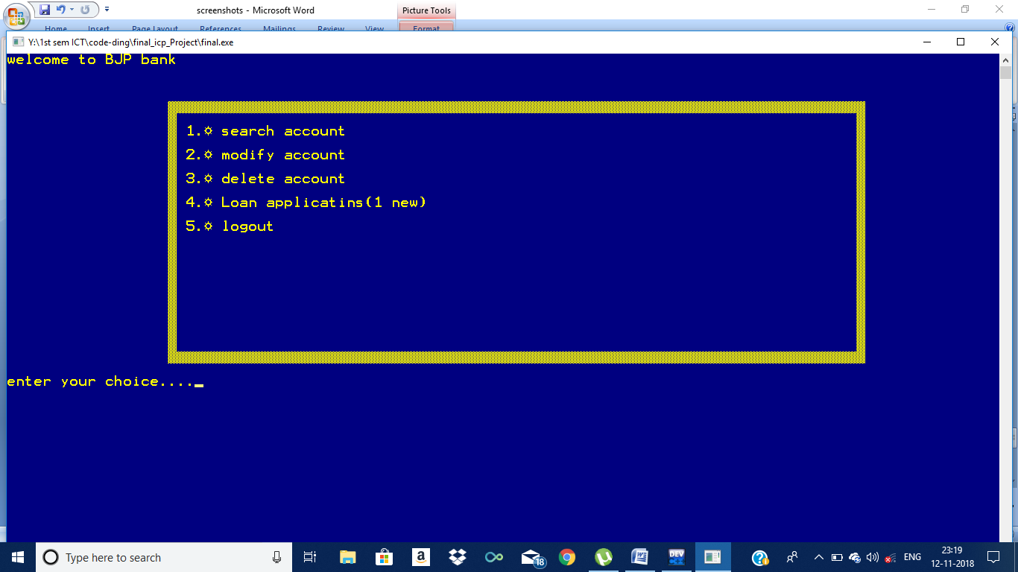

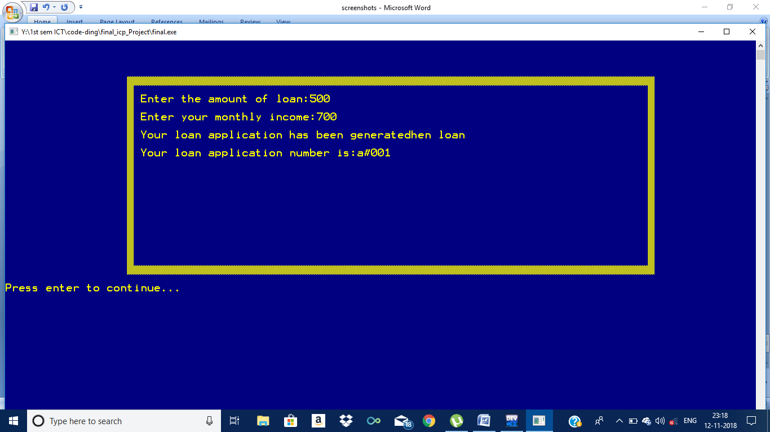

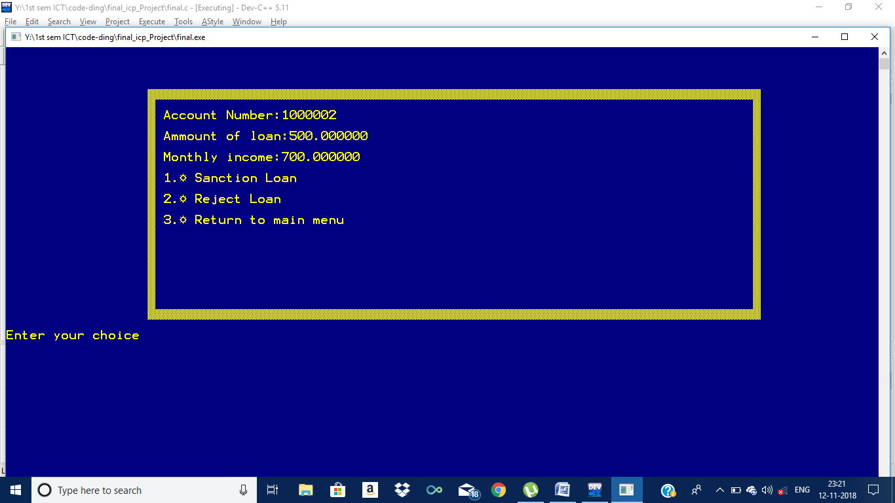

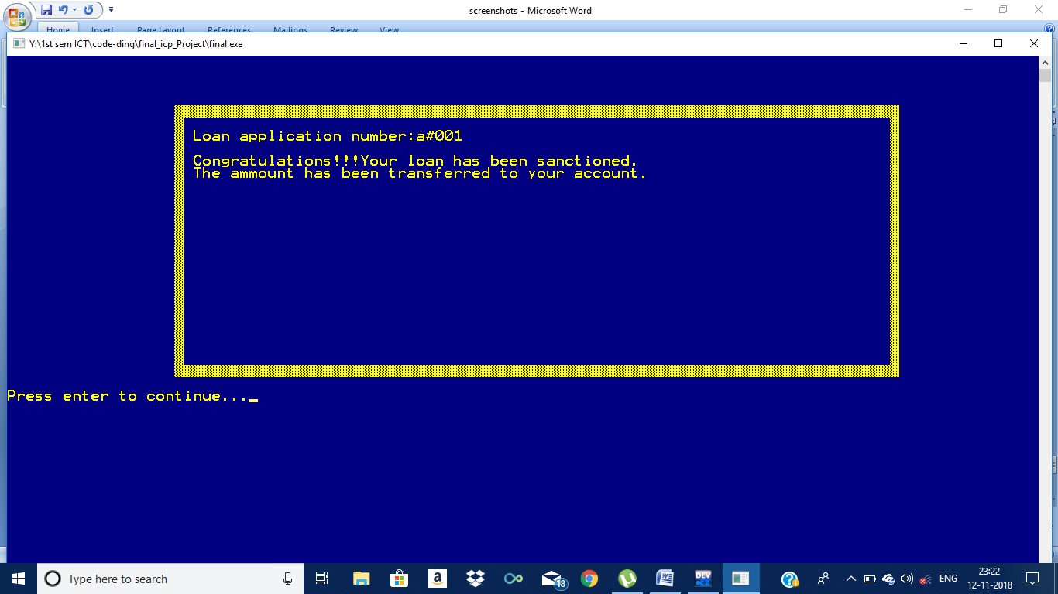

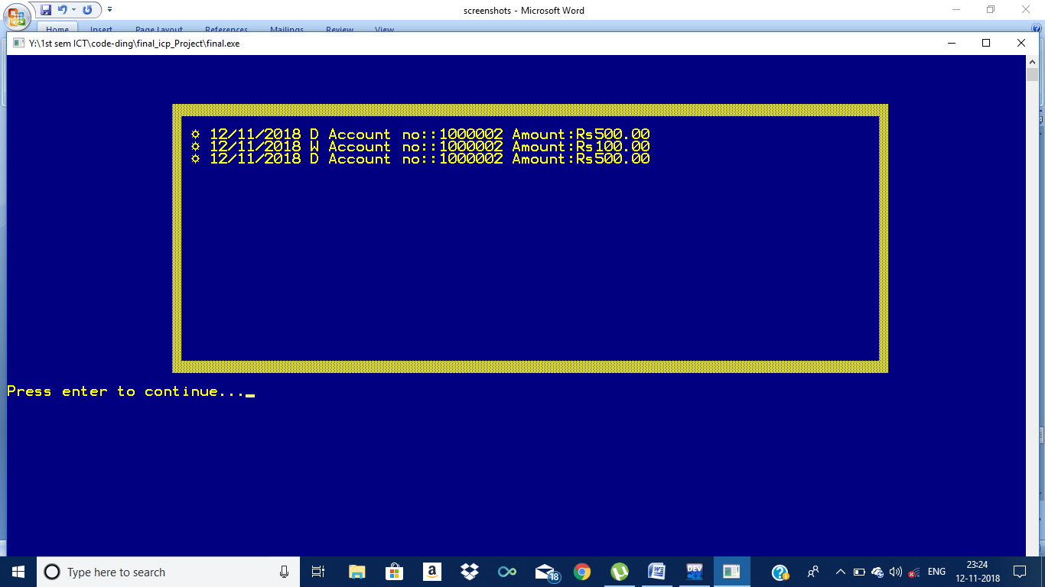

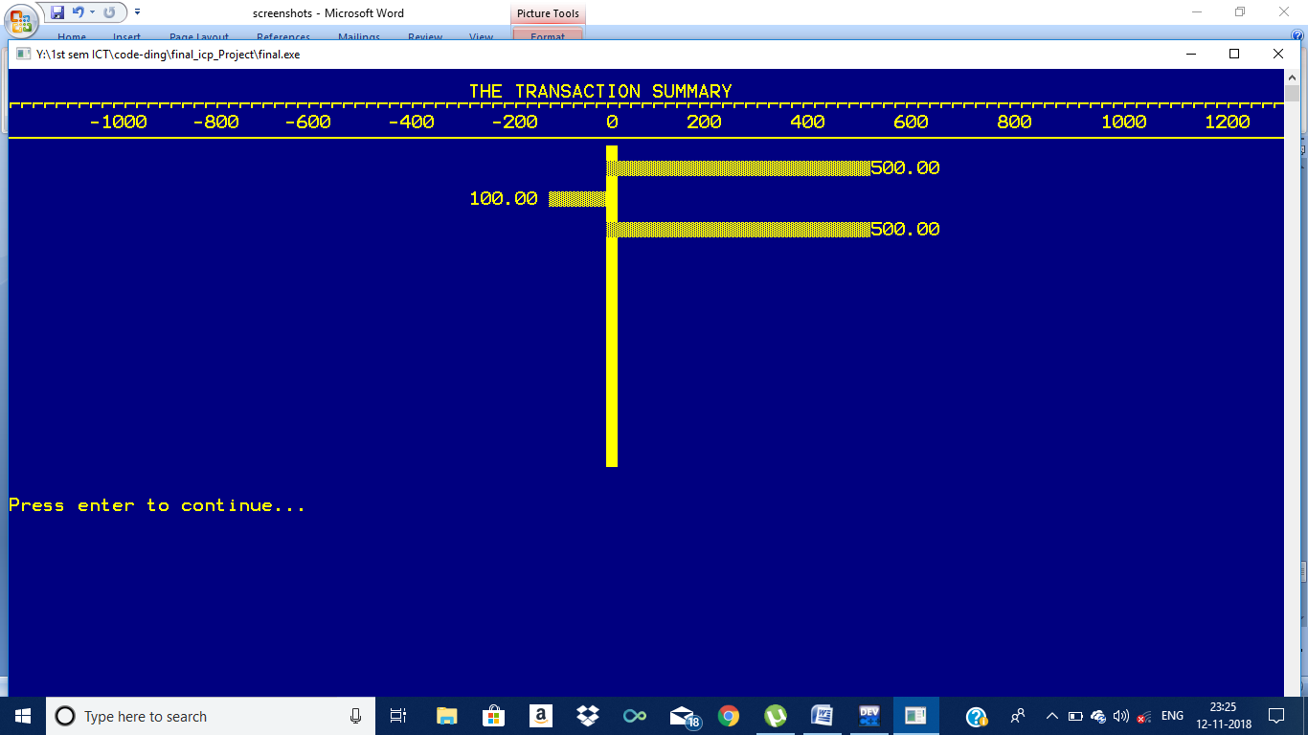

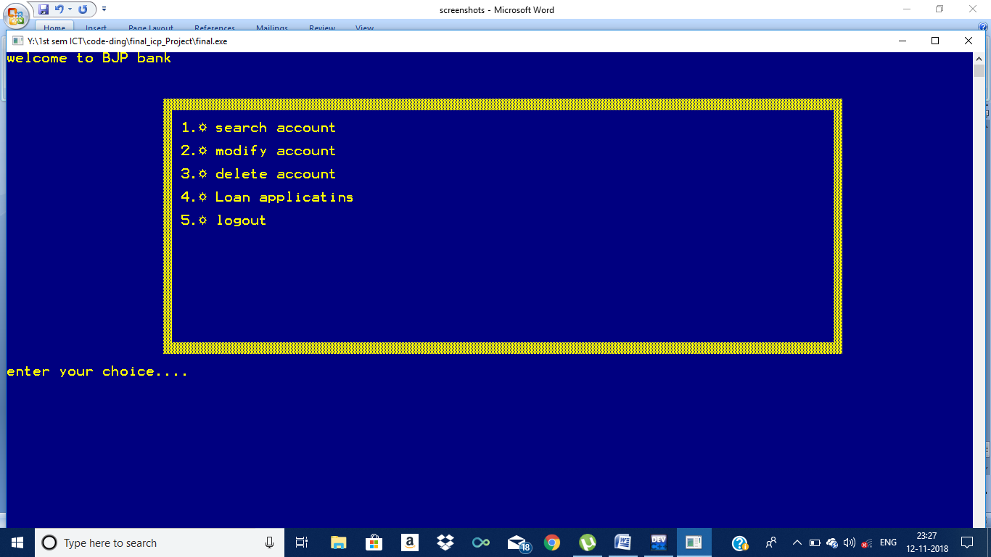

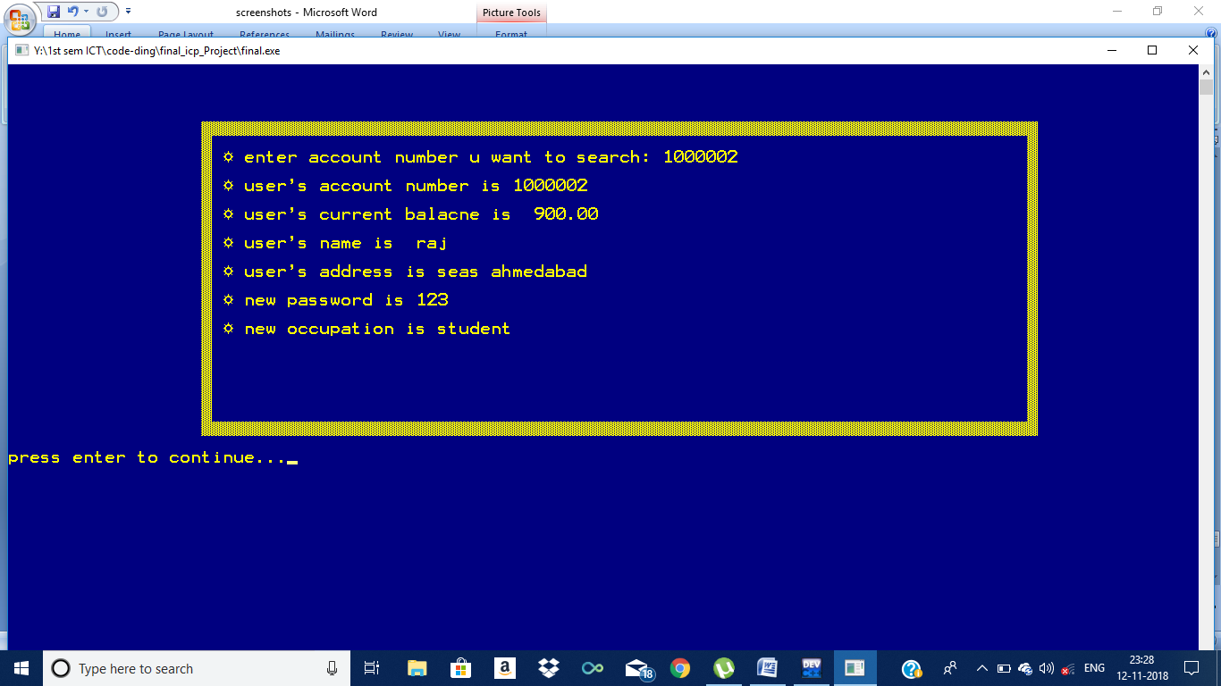

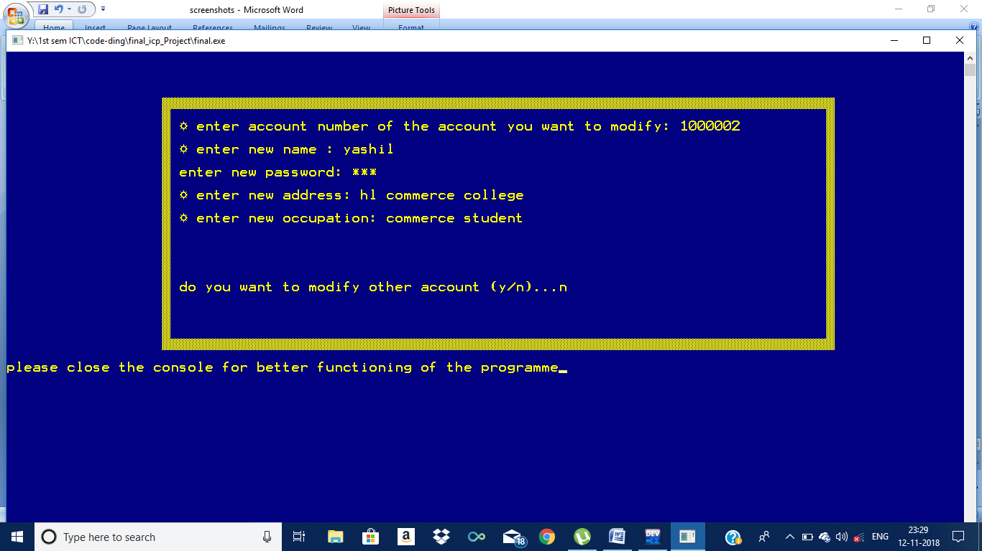

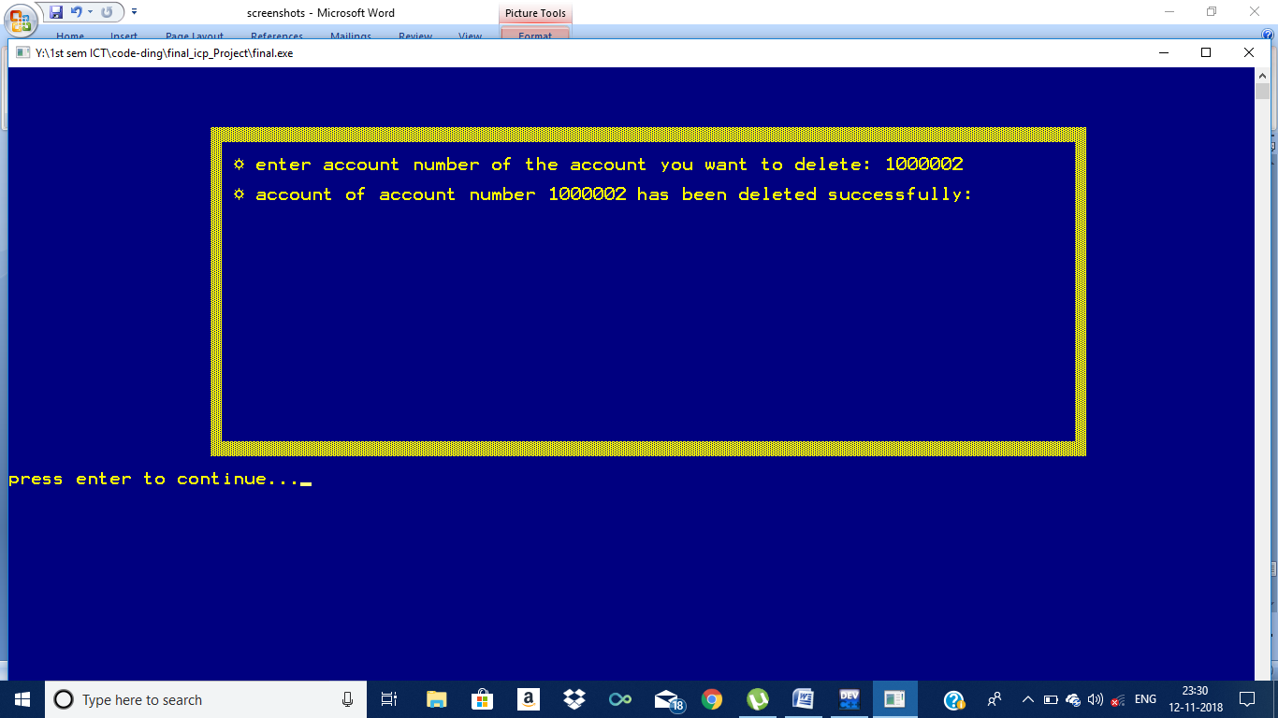

**DATABASE DESIGN :**

|  |  |  |  |
| --- | --- | --- | --- |
| **Sr . no.** | **Name of the field** | **Data type** | **Sample data** |
| **1.** | **User name** | **Char[30]/string** | **Raj Mehta** |
| **2.** | **Address** | **Char[300]/string** | **115/116 zssbfa,navrangpura** |
| **3.** | **Aadhar card** | **Long int** | **1234 5678 8934** |
| **4.** | **Occupation** | **Char[300]/string** | **Working in Ahmedabad uni.** |
| **5.** | **Opening balance** | **Double** | **(cannot be less than 10000Rs)** |
| **6.** | **Loan statistics** | **Double** | **Due amount : 4000Rs** |

**MAIN FUNCTION**

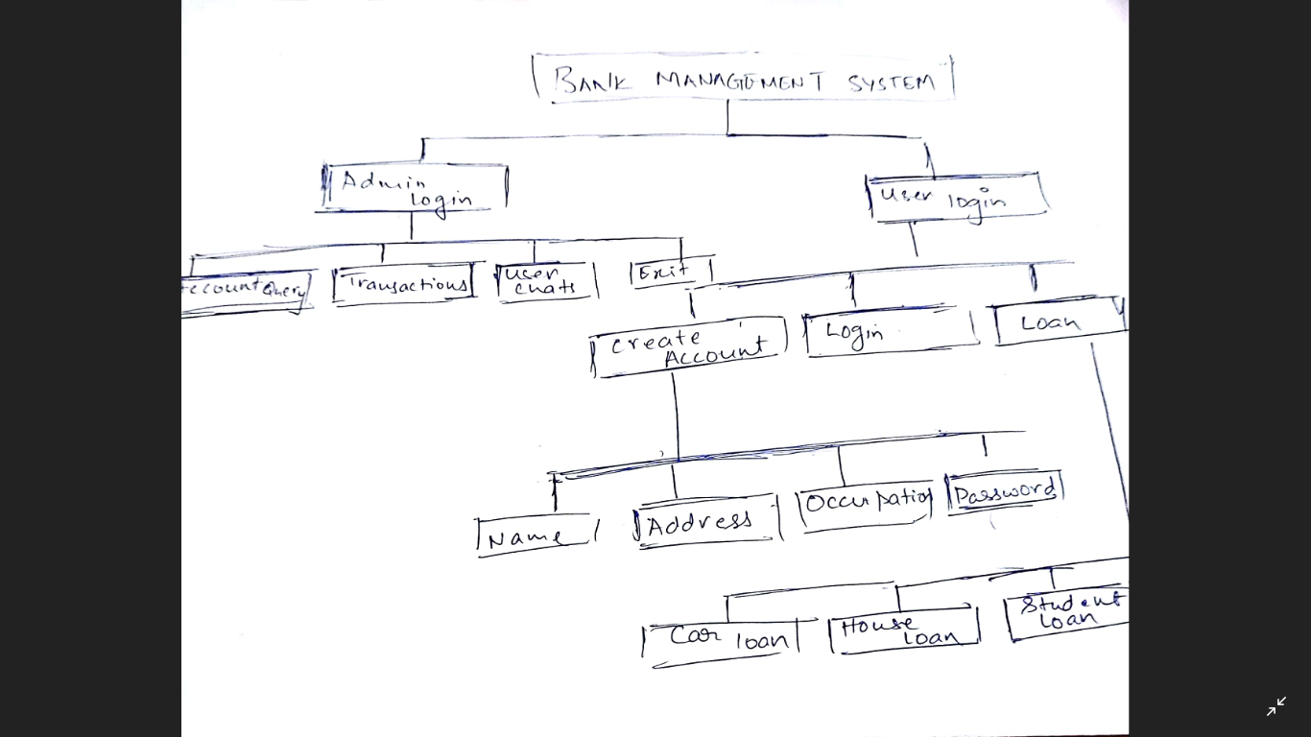

Steps:

It calls predefined starting screen menu.

**STARTING SCREEN FUNCTION**

**Steps:**

1. This function starts with welcome screen showing banking management system and border around it using gotoxy function call.
2. Then it shows the menu as:

* **(choice 1) Login as admin**
* **(Choice 2) Login as user.**

1. Get the choice from the user.
2. So we have defined two functions as admin and user.

**Admin Function**

**Shows menu options as**

* **(choice 1) account query**
* **(choice 2) Transactions**
* **(choice 3) user chats**
* **(choice 4) loan applications**
* **(choice 5) exit**

Get the choice from the user

**Choice 1:**

**Steps:**

1. **Get account number to search from the user.**
2. **Invoke the data file user_accounts.txt and search for the required account number**
3. **Display all the account details**

**Choice 2:**

**Displays all the transactions from a specific account to other accounts.**

**Choice 3:**

**Displays the chat messages by the users and allows the admin to reply to user querries.**

**Choice 4:**

**Gives a listof loan applications with account and income details.**

**The admin can pass or reject the loan.**

**USER FUNCTION**

**Steps:**

1. **Shows menu options as**

* **(choice 1) create an account**
* **(choice 2) login into existing account**
* **(choice 3) help and FAQS**
* **(choice 4) exit**

1. Get the choice from the user.

* **Choice 1 call account function**
* **Choice 2 call user function**
* **Choice 3 call help function’**
* **Choice 4 close app.**

1. This function calls another function account.

**ACCOUNT FUNCTION**

**Steps:**

1. creating a new account for the user.
2. File pointer is created and user_account.txt
3. It asks the following information:

* **-Enter name**
* **Enter address**
* **Enter occupation**
* **Enter adhar-card no.**
* **Enter password and confirm password**

.

1. A structure acc is created with the following parameters as occupation, adharno.address, name
2. The following information is stored in a acc(structure) created using file pointer.
3. File pointer is closed.
4. The programme after necessary validation allots an account no starting from 10,00,000. In chronological order.

**PASSWORD FUNCTION**

**Steps:**

1. This function call under login into existing account is for validation and security login.
2. The user needs to enter his password and user name for login credentials.

YES- goto user function

No- go back for password function( only 3 times)

**USER FUNCTION**

**Steps:**

1. This function call with following menu options:

* **(choice 1) deposit money**
* **(choice 2) withdraw money**
* **(choice 3) transfer money**
* **Choice 4) know current balance with mini-statement**
* **(choice 5) loan.**
* **(choice 6) log-out**

1. The user enters the choice

The information is stored using file pointer.

1. **Choice deposit**

* **Deposit money(saves in file)**

**Choice withdraw**

* **Withdraws money (minimum balance should be 1200.)**

**Choice balance**

* **Graph is printed with mini statement transaction timeline**

**Choice loan**

* **Function call of loan function**

**Choice logout**

* **Closes the app.**

**LOAN FUNCTION**

1. Following choices:

* **(choice 1) apply for loan**
* **(choice 2)Check applied loan status**
* **(Choice 3)Exit to main menu**

**The user enters the choice**

**Choice 1: Sends a loan application to the admin.**

**Choice 2:Gives loan status:**

1. **In Queue**
2. **Loan Passed**
3. **Loan rejected**

**Choice 3:Goes to the user menu**