Normalization of Student Data

# First Normal Form (1NF)

1NF ensures that the data contains only atomic values and that there are no repeating groups.

The primary key is a composite key: (StudentNo, ModuleNo).

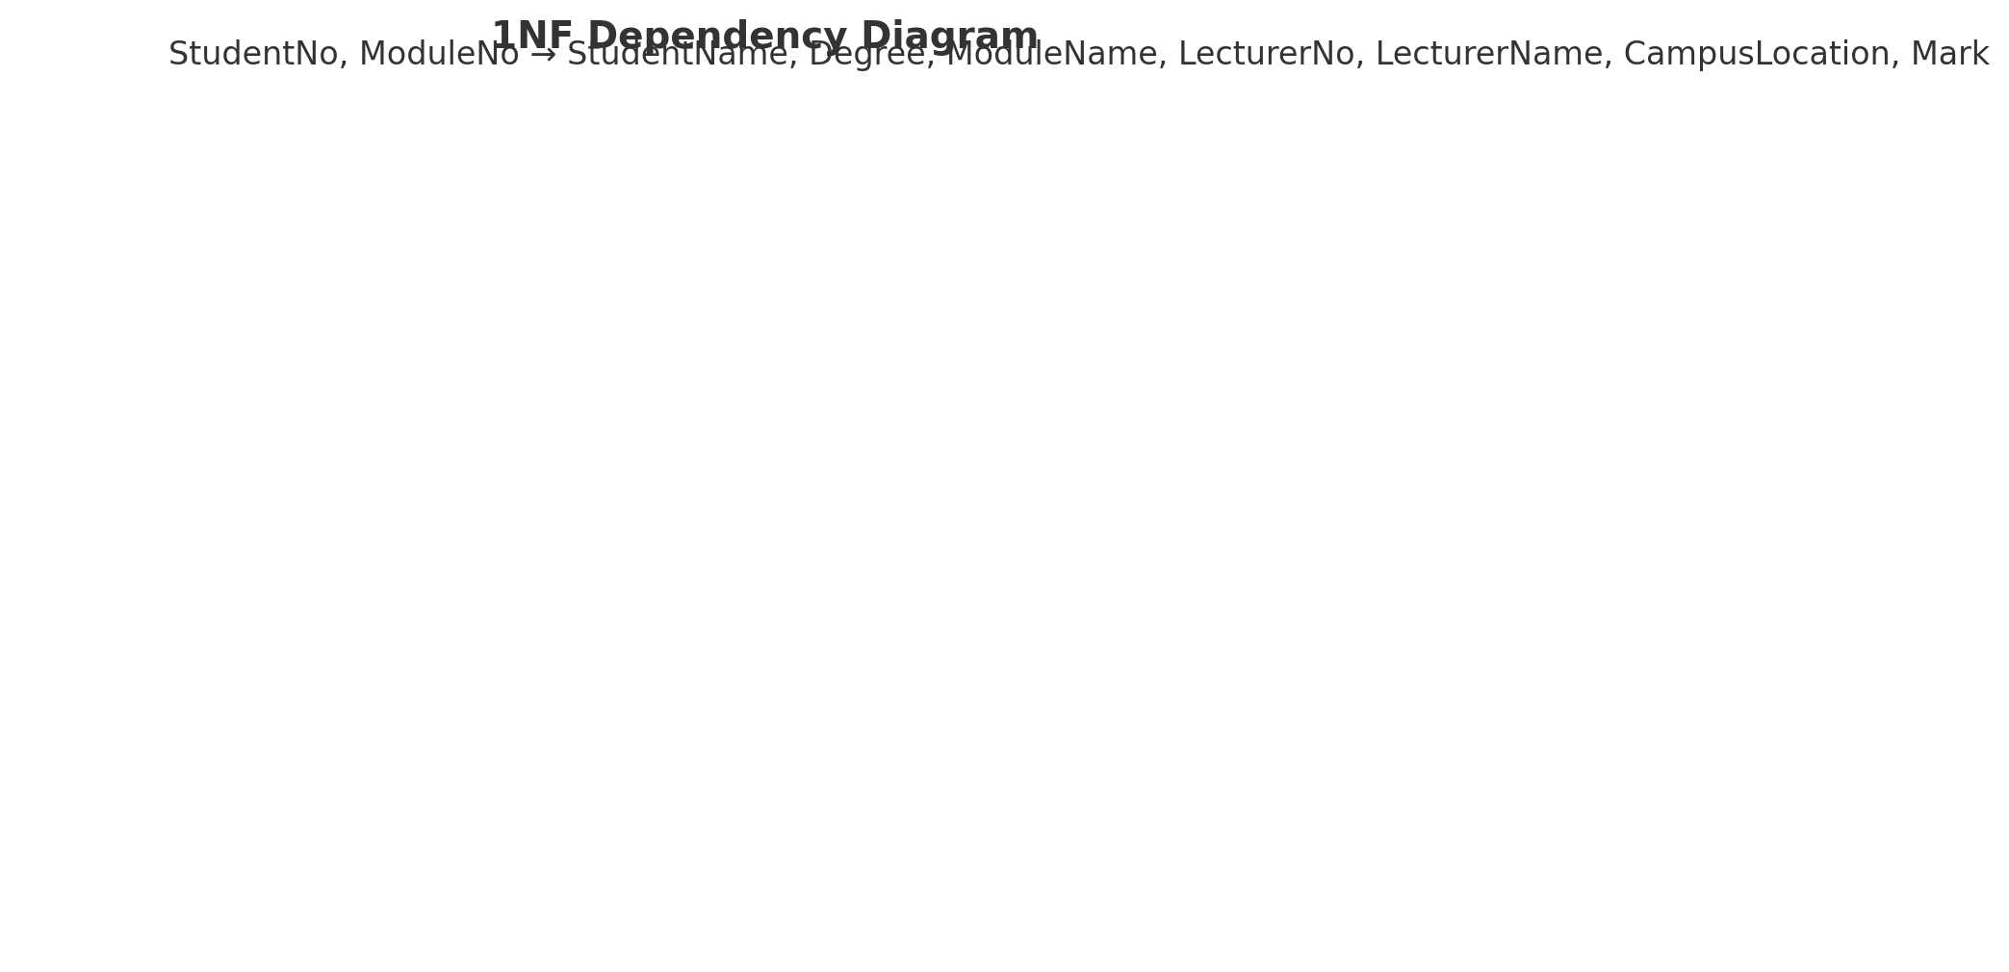

# Second Normal Form (2NF)

2NF removes partial dependencies; non-key attributes must depend on the whole of a composite key.

Student and Module details are separated from the Mark relation.

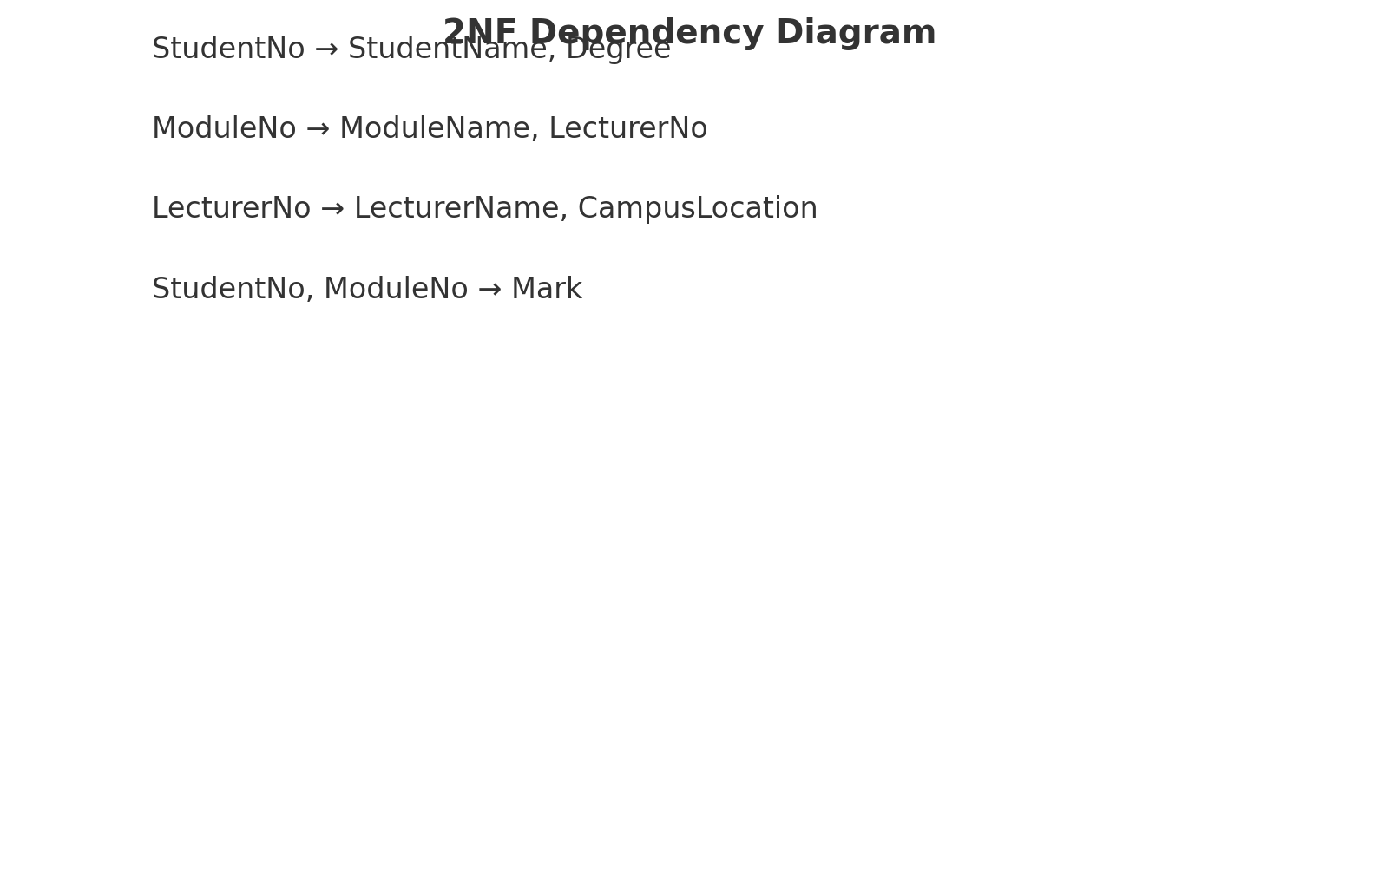

# Third Normal Form (3NF)

3NF removes transitive dependencies. Non-key attributes must depend only on the primary key.

Lecturer and CampusLocation are separated into their own relation.

