Predict the Climate-Induced Geographical Migration of Medicinal Plants for Conservation Planning
Project ID: RP26-IT-20
Project Proposal Report
Student Name: Wickramaarachchi T.M.
Student ID: IT22208958
B.Sc. (Hons) Degree in Information Technology Specialized in Information Technology
Department of Information Technology
Sri Lanka Institute of Information Technology, Sri Lanka
March 2026

DECLARATION
I declare that this is my own work, and this proposal does not knowingly incorporate any material previously submitted for a degree or diploma at any other university or higher education institution, nor does it contain any material that has been previously published or written by another person apart from where proper acknowledgment is given in the text.
Name | Student ID | Signature
Wickramaarachchi T.M. | IT22208958 | 
The above candidate is conducting research for their undergraduate Dissertation under my supervision.
Name | Date | Signature
Ms. Thisara Shyamalee | 2026.03.14

ABSTRACT
Climate change is currently threatening the distribution and survival of medicinal plants in Sri Lanka, which are vital for traditional medicine and biodiversity. Despite this looming threat, there is a distinct lack of predictive tools capable of assessing future habitat suitability under shifting climate conditions. This research proposes a data-driven forecasting system designed to predict the climate-induced geographical migration of these plants up to the year 2030. The solution utilizes Meta's Prophet model for accurate time series forecasting of daily temperature and precipitation, paired with a custom rule-based classifier to predict plant group suitability based on localized habitat types (Dry, Wet, Intermediate, Coastal). Expected outcomes include highly accurate predictive datasets (forecast_temperature_2m_mean.csv, forecast_precipitation_sum.csv, and plant_suitability_2026_2030.csv) and validated accuracy metrics (MAE and RMSE). The social and commercial impact of this system is substantial, as it provides crucial data-driven support for conservation efforts, sustainable harvesting, and policy-making in the environmental sector.
Keywords: Climate Forecasting, Medicinal Plants, Prophet Model, Conservation Planning, Time Series Analysis

ACKNOWLEDGEMENT
I would like to express my deepest appreciation to my supervisor and my co-supervisor for their invaluable guidance, continuous support, and constructive feedback throughout the development of this project proposal. Their expertise and encouragement have been instrumental in shaping this research. I also extend my gratitude to the Department of Information Technology at the Sri Lanka Institute of Information Technology for providing the necessary resources and academic environment to conduct this study. And special thanks to our team and their families for their contribution and providing of the research findings.

TABLE OF CONTENTS
DECLARATION ii
ABSTRACT iii
ACKNOWLEDGEMENT iv
LIST OF TABLES i
LIST OF FIGURES i
LIST OF ABBREVIATIONS i
1. INTRODUCTION 1
1.1 Background and Context 1
1.2 Literature Review 1
1.3 Research Gap 2
2. OBJECTIVE 3
2.1 Main Objective 3
2.2 Specific Objectives 3
3. METHODOLOGY 4
4. HIGH-LEVEL SYSTEM ARCHITECTURE 5
5. USER REQUIREMENTS 6
6. COMMERCIALIZATION PLAN 7
7. BUDGET AND JUSTIFICATION 8
8. WORK BREAKDOWN STRUCTURE (WBS) 9
9. GANTT CHART 10
REFERENCES 11

LIST OF TABLES
Table 1: Research Gap 2
Table 2: Budget Table 8

LIST OF FIGURES
Figure 1: SYSTEM ARCHITECTURE DIAGRAM 5
Figure 2: WBS DIAGRAM 9
Figure 3: GANTT CHART 10

LIST OF ABBREVIATIONS
ML: Machine Learning
MAE: Mean Absolute Error
RMSE: Root Mean Squared Error
SDG: Sustainable Development Goals
WBS: Work Breakdown Structure

1. INTRODUCTION

1.1 Background and Context
Climate change is fundamentally altering ecosystems worldwide, and Sri Lanka, an island nation with rich biodiversity, is particularly vulnerable. Medicinal plants, which form the backbone of Ayurveda and traditional (Sinhala medicine) Sri Lankan medical practices, are facing severe threats due to erratic monsoons, rising ambient temperatures, and unpredictable precipitation patterns. These plants have highly specific growth parameters and are sensitive to even slight climatological shifts.
The primary stakeholders affected by this real-world problem are traditional medicine practitioners, local communities who rely on these natural remedies for primary healthcare, and conservationists attempting to protect Sri Lanka's endemic flora. Statistically, shifts in average daily temperatures have already begun altering plant life cycles across tropical regions, forcing certain species to migrate to higher altitudes or face extinction.
Currently, there is a severe lack of localized predictive tools tailored to assess future habitat suitability under specific, high-frequency climate conditions in Sri Lanka. The proposed solution is a computational forecasting system that leverages the Meta Prophet algorithm to model future climate conditions. By mapping these conditions against predefined plant survival thresholds, the system will forecast the geographical migration and habitat suitability of these plants up to the year 2030. This research strongly aligns with the United Nations Sustainable Development Goals, specifically SDG 13 (Climate Action) and SDG 15 (Life on Land).

1.2 Literature Review
Existing research in botanical conservation predominantly relies on standard ecological niche modeling approaches like MaxEnt. While effective for broad, macro-level climate trends, these models frequently lack the capacity for high-frequency (daily) time series forecasting tailored to localized variables like daily precipitation sums and mean temperatures [1], [2].
Recent advancements in predictive modeling have seen a shift towards Machine Learning (ML) techniques. However, current products or services often utilize heavy ensemble models like ARIMA or LSTM, which require immense computational power and struggle with the missing data common in historical weather datasets [3], [4]. Furthermore, they fail to merge daily historical climate forecasting with distinct habitat classifications (Wet, Dry, Coastal, Intermediate) using rule-based classifiers tailored specifically for Sri Lankan flora [5], [6].
The primary limitation of the existing systems is their failure to accurately forecast daily temperature and precipitation thresholds up to 2030 using computationally efficient models [7], [8]. The integration of the Meta Prophet model—designed specifically for handling time-series data with strong seasonal effects and missing variables—has not been adequately explored in the context of Sri Lankan medicinal plant conservation [9], [10].

1.3 Research Gap
There is a clear missing link between macro-level predictive climate modeling tools and automated, data-driven support for the localized conservation of medicinal plants in Sri Lanka. Current approaches are insufficient because they do not reliably forecast habitat-specific suitability parameters over the next five years. This research ensures novelty by implementing a combined methodology: the Meta Prophet model (configured with reduced complexity, n_changepoints=10 to prevent overfitting) alongside a novel rule-based threshold mapping tailored to Sri Lankan plant groups.
Table 1 illustrates the existing research gaps addressed by the proposed system across various reference methodologies:
Table 1: Research Gap
Features | Ref. [4] | Ref. [5] | Ref. [6] | Ref. [11] | Ref. [12] | Proposed System
Daily Time Series Forecasting | X | X | √ | X | X | √
Habitat-Specific Classification Rules (Sri Lanka) | X | X | X | X | √ | √
Low Computational Complexity | X | X | √ | X | √ | √
Forecast Horizon up to 2030 | √ | √ | X | X | √ | √
High-Frequency Metric Generation (MAE/RMSE) | √ | √ | √ | √ | X | √

2. OBJECTIVE

2.1 Main Objective
The primary objective is to forecast future daily climate conditions and accurately predict the resulting habitat suitability for medicinal plants across Sri Lanka up to the year 2030, thereby supporting proactive conservation planning.

2.2 Specific Objectives
- To collect and accurately preprocess botanical and historical climate datasets for Sri Lanka, separating habitat/region information into distinct relational structures.
- To forecast daily temperature (2m mean) and precipitation sum up to 2030 using the Meta Prophet time series model.
- To categorize medicinal plants into distinct habitat groups (e.g., Dry, Wet, Intermediate, Coastal) for targeted threshold analysis.
- To develop and implement a customized rule-based classifier model to predict the suitability of each habitat group under the forecasted climate scenarios.
- To rigorously evaluate the model's accuracy using statistical metrics including Mean Absolute Error (MAE) and Root Mean Squared Error (RMSE).

3. METHODOLOGY
This project utilizes an Experimental Data Science methodology combining predictive time-series analysis with rule-based classification logic.
Technical Approach: The system relies on Meta's Prophet algorithm for the forecasting engine. Prophet was selected over ARIMA because of its robustness to missing data, outliers, and its ability to handle strong seasonal patterns characteristic of Sri Lankan monsoons. Once the daily forecasts for temperature and precipitation are generated, a custom Python rule-based classifier analyzes these outputs against biological threshold limits established for different Sri Lankan habitat zones.
Tools and Platforms: Development is conducted using Python 3.8+. Key libraries include prophet for time-series modeling, pandas and numpy for data manipulation, scikit-learn for metric evaluation, and matplotlib for generating visual representations of the forecast trajectories.
Data Collection and Ethics: The study utilizes publicly accessible historical daily weather data (spanning decades) for Colombo, Sri Lanka, merged with verified medicinal plant distribution datasets. No human subject data is involved, ensuring complete ethical compliance regarding data privacy.
Validation Strategy: The Prophet model is subjected to a hold-out validation strategy. The model is trained on historical data, reserving the final two years of recorded data as a test set. The predictions for these two years are compared against actual recorded values to generate the Mean Absolute Error (MAE) and Root Mean Squared Error (RMSE), quantifying the model's predictive reliability.

4. HIGH-LEVEL SYSTEM ARCHITECTURE
The system architecture is compartmentalized into three primary execution pipelines: Data Preprocessing, Climate Forecasting, and Suitability Prediction. Raw historical climate datasets and medicinal plant lists enter the preprocessing module (clean_preprocess_dataset.py) where missing values are handled and geographical data is structured. The cleaned data feeds into the Prophet modeling engine (climate_forecast_next5years.py), which outputs projected daily metrics for temperature and precipitation. Finally, these forecasts interact with the rule-based classifier (plant_group_climate_prediction.py) to generate the final suitability groupings mapping out the period from 2026 to 2030.
Scalability and Security: The architecture relies on modular, file-based Python scripts. This ensures that additional climate variables (e.g., relative humidity, soil moisture) can be integrated without overhauling the entire system. Because processing occurs locally or on isolated cloud instances without exposing public APIs, data integrity and security are highly maintained.
Figure 1 represents the system architecture diagram.
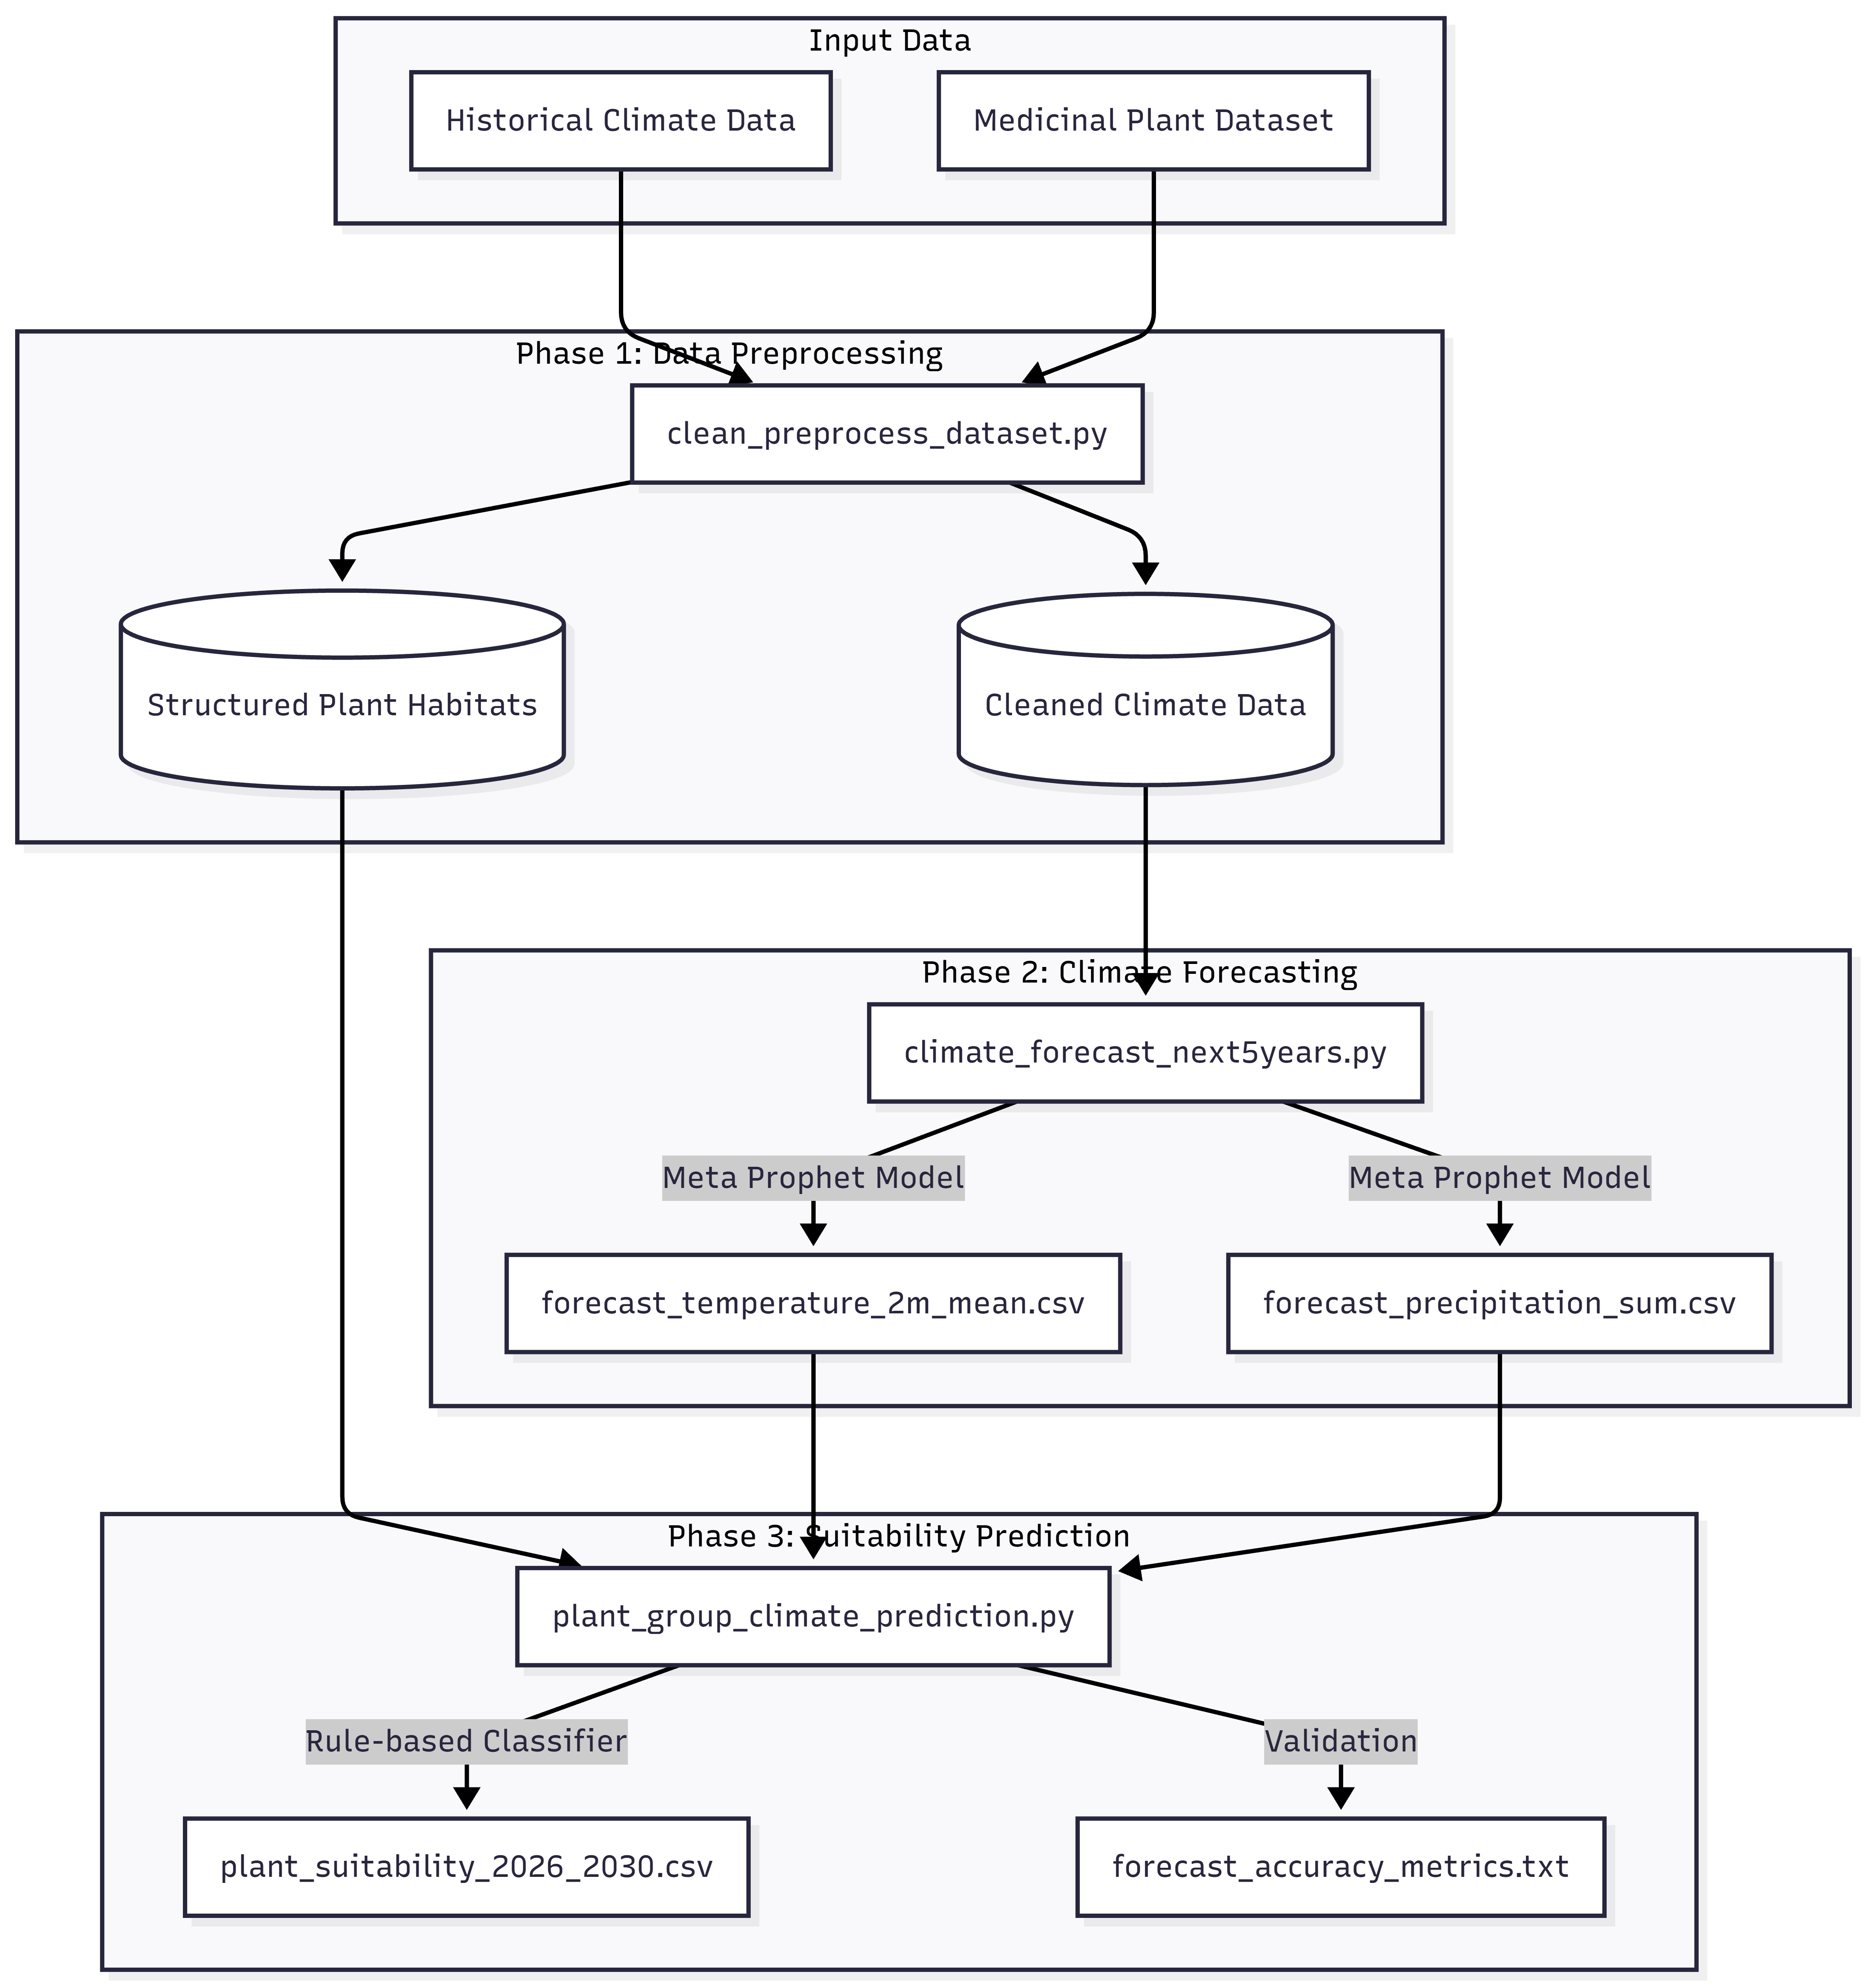
Figure 1: SYSTEM ARCHITECTURE DIAGRAM

5. USER REQUIREMENTS
Stakeholder Identification: The primary users of the system outputs include botanists, environmental policymakers within the Sri Lankan government, and international conservation researchers.
Functional Requirements:
- The system must ingest, clean, and structure raw CSV datasets based on habitat/region.
- The system must successfully forecast daily precipitation and mean temperature metrics up to December 31, 2030.
- The system must execute rule-based conditional logic to classify future habitat suitability into defined groups.
- The system must output the final forecasts as accessible CSV files and generate a text report of MAE and RMSE accuracy metrics.
Non-functional Requirements: The system must process the complete 5-year forecast within standard computational limits (under 10 minutes on a standard local machine). The codebase must maintain high modularity for maintainability, and the outputs must be reproducible across different execution environments.

6. COMMERCIALIZATION PLAN
Target Market: The primary target market consists of Government Environmental Ministries (e.g., Department of Wildlife Conservation), agricultural departments, and international NGOs focused on biodiversity.
Value Proposition: This system offers the only localized, data-driven forecasting tool that explicitly combines predictive daily climate projections with medicinal plant distribution parameters tailored specifically for Sri Lanka's unique topography.
Revenue Model: The commercialization strategy relies on B2B licensing. The core datasets and an upcoming interactive web dashboard will be licensed via subscription models to government bodies and commercial agriculture firms. Academic institutions will be offered free or heavily discounted access to promote further research.
Competitive Advantage: Standard climate modeling tools are too broad and require specialized knowledge to map to botanical survival. This tool automates that mapping process, offering a highly specialized regional focus out-of-the-box.

7. BUDGET AND JUSTIFICATION
Justification:
- Hardware Costs: There is not any hardware planning to use for Initial development and model training. Only based on research findings. So, no hardware cost.
- Software Licenses: The technology stack relies entirely on open-source Python libraries such as Prophet, Pandas, and Scikit-learn. So, no software license cost.
- Hosting Services: Estimated yearly allocation for deploying to host the future interactive dashboard.
- Research Publication Cost: Estimated to Publish the Research Paper.

Table 2: Budget Table
Description | Cost
Electricity | 4000
Internet | 20,000
Communication | 10,000
Hardware | 0
Transportation (Meet stakeholders) | 10,000
Paper Publishing | 30,000
Backend and Frontend Hosting | 5,000
Human Effort | 10,000
Total | 89,000

8. WORK BREAKDOWN STRUCTURE (WBS)
The project is segmented into four distinct execution phases to ensure balanced workload distribution and sequential milestone achievement:
- Phase 1: Dataset Collection & Preprocessing. Involves gathering historical weather data and writing the Python logic to clean and separate habitat classifications.
- Phase 2: Climate Forecasting. Focuses strictly on tuning the Meta Prophet model, running the test data, and generating the CSV files forecasting up to 2030.
- Phase 3: Suitability Prediction. Involves translating botanical survival limits into Python rules and applying them against the forecasted data.
- Phase 4: Output Finalization. Compiling the MAE/RMSE metrics, generating final documentation, and drafting the research paper.
Figure 1 represents the WBS diagram.

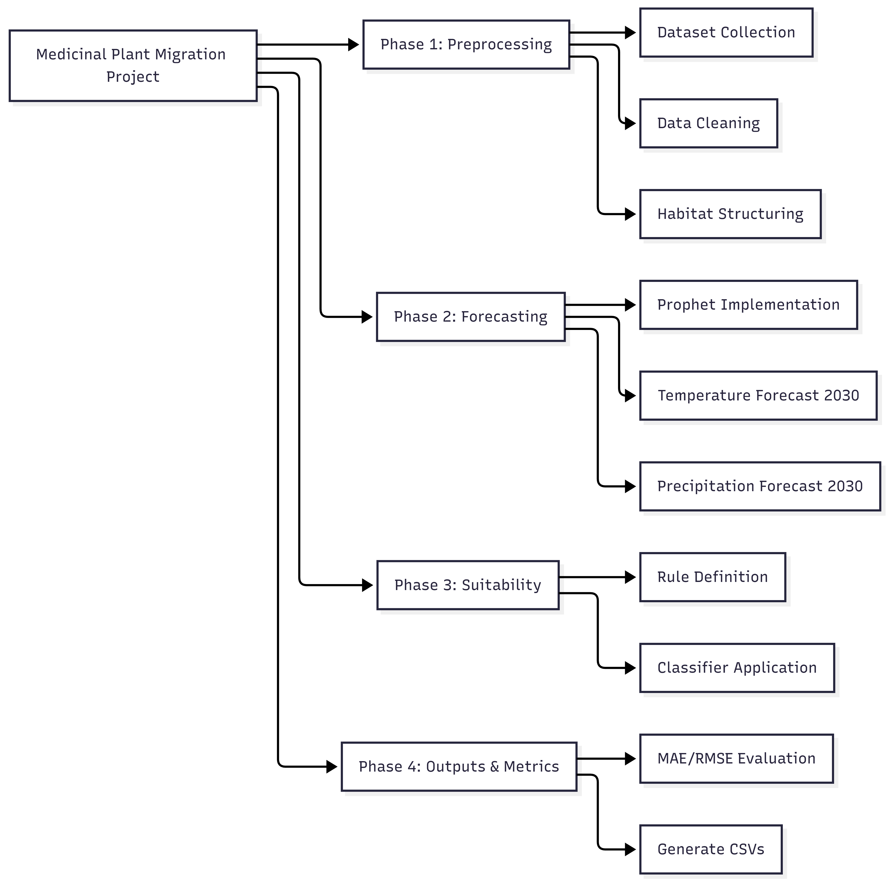
Figure 2: WBS DIAGRAM

9. GANTT CHART
Figure 3 represents the GANTT chart.
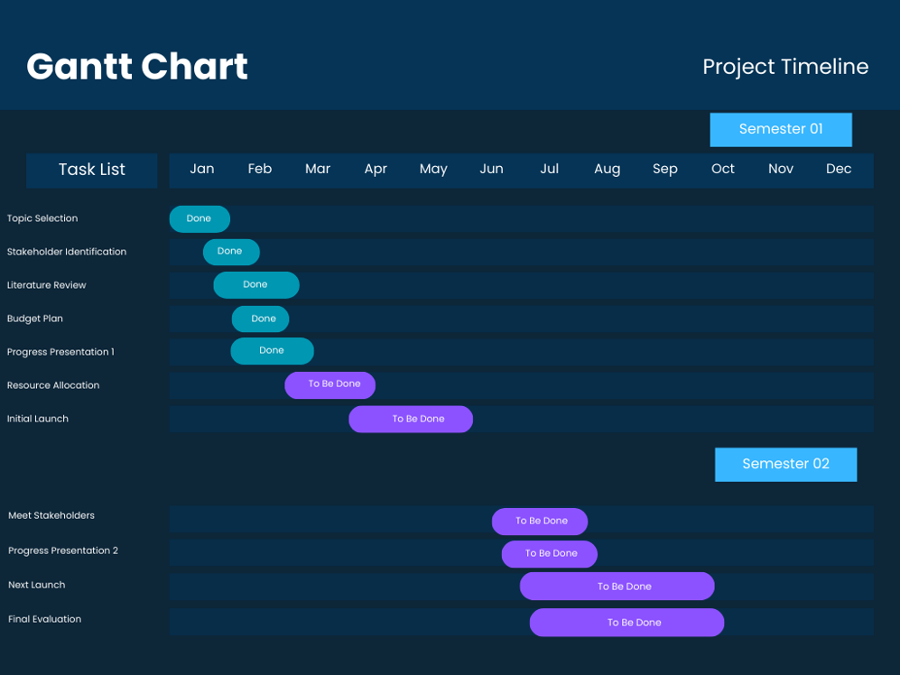
Figure 3: GANTT CHART

REFERENCES

[1] | S. J. T. &. B. Letham, "Forecasting at scale," The American Statistician.
[2] | S. M. B. e. a. Z. A. Shah, "Climate change and the future of medicinal plants research," Bioactive Compounds in Health and Disease.
[3] | B. G. U. e. a. A. S. Nair, "Impact of climate change on the distribution of medicinal plants in the Western Ghats: A predictive modeling approach," Ecological Informatics.
[4] | H. H. e. a. F. Wang, "Assessing the climate change impact on Epimedium brevicornu in China with the MaxEnt model," Frontiers in Plant Science.
[5] | Y. L. &. Y. W. X. Chen, "Predicting the Potential Suitable Distribution of Albizia odoratissima Under Climate Change Based on the Biomod2 Model," Biology (MDPI).
[6] | e. a. W. A. D. C. Maduranga, "Forecasting average temperature and rainfall for Colombo, Sri Lanka using SARIMA and Prophet models," IEEE Xplore (IEEM Conference).
[7] | S. K. &. P. K. Singh, "Time Series Forecasting of Weather Variables using Prophet Model," SpringerLink (IC4S Conference).
[8] | Y. C. &. J. W. J. Li, "Impact of Climate Change on the Habitat Suitability of Endangered Plants: A Case Study in the High-Altitude Zones," Sustainability (MDPI).
[9] | e. a. N. V. S. N. Wijesinghe, "Impact of rainfall anomalies on agricultural patterns in the Wet Zone of Sri Lanka," Journal of Environmental Management.
[10] | S. R. e. a. A. Kumar, "Machine Learning Applications for Predicting Climate-Induced Range Shifts of Flora," Environmental Monitoring and Assessment.
[11] | e. a. M. H. F. Nusrath, "A Comparative Analysis of ARIMA, LSTM, and Prophet for Monthly Rainfall Forecasting in Sri Lanka," Water Resources Management.
[12] | P. L. T. Silva, "Climate change vulnerability assessment of medicinal plant species in the dry zone of Sri Lanka," Int. Journal of Environmental Science and Technology.

