MINIPROJECT LOGBOOK

GROUP MEMBERS

1. Shashank Avhad

2. Nishant Chauhan

3. Yash Kanekar

Supervisor

Prof. Tushar Ghorpade Sir


Department of Computer Engineering
Dr. D. Y. Patil Group’s
Ramrao Adik Institute Of Technology
Dr. D. Y. Patil Vidyanagar, Sector 7, Nerul, Navi Mumbai 400706.
University of Mumbai)
(AY 2021-22)

INSTITUTE VISION & MISSION

VISION:
To foster and permeate higher and quality education with value added engineering, technology programs, providing all facilities in terms of technology and platforms for all round development with societal awareness and nurture the youth with international competencies and exemplary level of employability even under highly competitive environment so that they are innovative, adaptable and capable of handling problems faced by our country and world at large.
RAIT’s firm belief in a new form of engineering education that lays equal stress on academics and leadership building extracurricular skills has been a major contribution to the success of RAIT as one of the most reputed institutions of higher learning. The challenges faced by our country and the world in the 21st century needs a whole new range of thoughts and action leaders, which a conventional educational system in engineering disciplines are ill equipped to produce. Our reputation in providing good engineering education with additional life skills ensures that high grade and highly motivated students join us. Our laboratories and practical sessions reflect the latest that is being followed in the industry. The project works and summer internships make our students adept at handling the real life problems and be industry ready. Our students are well placed in the industry and their performance make reputed companies visit us with renewed demands and vigour.

MISSION:

The Institution is committed to mobilize the resources and equip itself with men and materials of excellence, thereby ensuring that the Institution becomes a pivotal center of service to Industry, academia, and society with the latest technology. RAIT engages different platforms such as technology enhancing Student Technical Societies, Cultural platforms, Sports excellence centers, Entrepreneurial Development Centers and a Societal Interaction Cell. To develop the college to become an autonomous institution & deemed university at the earliest, we provide facilities for advanced research and development programs on par with international standards. We also seek to invite international and reputed national Institutions and Universities to collaborate with our institution on the issues of common interest of teaching and learning sophistication.

RAIT’s Mission is to produce engineering and technology professionals who are innovative and inspiring thought leaders, adept at solving problems faced by our nation and world by providing quality education.

The Institute is working closely with all stake holders like industry, academia to foster knowledge generation, acquisition, dissemination using the best available resources to address the great challenges being faced by our country and World. RAIT is fully dedicated to provide its students skills that make them leaders and solution providers and are industry ready when they graduate from the Institution.

COMPUTER ENGINEERING DEPARTMENT

VISION:

To impart higher and quality education in computer science with value added engineering and technology programs to prepare technically sound, ethically strong engineers with social awareness. To extend the facilities, to meet the fast changing requirements and nurture the youths with international competencies and exemplary level of employability and research under highly competitive environments.

MISSION:
To mobilize the resources and equip the institution with men and materials of excellence to provide knowledge and develop technologies in the thrust areas of computer science and Engineering. To provide the diverse platforms of sports, technical, co curricular and extracurricular activities for the overall development of student with ethical attitude. To prepare the students to sustain the impact of computer education for social needs encompassing industry, educational institutions and public service. To collaborate with IITs, reputed universities and industries for the technical and overall upliftment of students for continuing learning and entrepreneurship.

PROGRAM EDUCATIONAL OBJECTIVES (PEO's)

1. Learn and Integrate
To provide Computer Engineering students with a strong foundation in the mathematical, scientific and engineering fundamentals necessary to formulate, solve and analyze engineering problems and to prepare them for graduate studies.

2. Think and Create
To develop an ability to analyze the requirements of the software and hardware, understand the technical specifications, create a model, design, implement and verify a computing system to meet specified requirements while considering real-world constraints to solve real world problems.

3. Broad Base
To provide broad education necessary to understand the science of computer engineering and the impact of it in a global and social context.

4. Techno-leader
To provide exposure to emerging cutting edge technologies, adequate training & opportunities to work as teams on multidisciplinary projects with effective communication skills and leadership qualities.

5. Practice citizenship
To provide knowledge of professional and ethical responsibility and to contribute to society through active engagement with professional societies, schools, civic organizations or other community activities.

6. Clarify Purpose and Perspective
To provide strong in-depth education through electives and to promote student awareness on the life-long learning to adapt to innovation and change, and to be successful in their professional work or graduate studies.

PROGRAM OUTCOMES (POs)

PO1: Engineering knowledge: Apply the knowledge of mathematics, science, engineering fundamentals, and an engineering specialization to the solution of complex engineering problems.
PO2: Problem analysis: Identify, formulate, review research literature, and analyze complex engineering problems reaching substantiated conclusions using first principles of mathematics, natural sciences, and engineering sciences.

PO3: Design/development of solutions: Design solutions for complex engineering problems and design system components or processes that meet the specified needs with appropriate consideration for the public health and safety, and the cultural, societal, and environmental considerations.

PO4: Conduct investigations of complex problems: Use research-based knowledge and research methods including design of experiments, analysis and interpretation of data, and synthesis of the information to provide valid conclusions.

PO5: Modern tool usage: Create, select, and apply appropriate techniques, resources, and modern engineering and IT tools including prediction and modeling to complex engineering activities with an understanding of the limitations.

PO6: The engineer and society: Apply reasoning informed by the contextual knowledge to assess societal, health, safety, legal and cultural issues and the consequent responsibilities relevant to the professional engineering practice.

PO7: Environment and sustainability: Understand the impact of the professional engineering solutions in societal and environmental contexts, and demonstrate the knowledge of, and need for sustainable development.

PO8: Ethics: Apply ethical principles and commit to professional ethics and responsibilities and norms of the engineering practice.

PO9: Individual and team work: Function effectively as an individual, and as a member or leader in diverse teams, and in multidisciplinary settings.

PO10: Communication: Communicate effectively on complex engineering activities with the engineering community and with society at large, such as, being able to comprehend and write effective reports and design documentation, make effective presentations, and give and receive clear instructions.

PO11: Project management and finance: Demonstrate knowledge and understanding of the engineering and management principles and apply these to one’s own work, as a member and leader in a team, to manage projects and in multidisciplinary environments.

PO12: Life-long learning: Recognize the need for, and have the preparation and ability to engage in independent and life-long learning in the broadest context of technological change.
PROGRAM SPECIFIC OUTCOMES (PSOs)

PSO1 | To build competencies towards problem solving with an ability to understand, identify, analyze and design the problem, implement and validate the solution including both hardware and software.
PSO2 | To build appreciation and knowledge acquiring of current computer techniques with an ability to use skills and tools necessary for computing practice.
PSO3 | To be able to match the industry requirements in the area of computer science and engineering. To equip skills to adopt and imbibe new technologies.

STUDENT INFORMATION

Project Title: Face Recognition System.

 | Student 1 | Student 2 | Student 3
UID/ERP NO
Name | Yash Kanekar | Shashank Avhad | Nishant Chauhan
Class with Division | TE A | TE A | TE A
Contact No. | 9820321285 | 8779713461 | 9811773585
E-mail | kanekaryash.11@gmail.com | shashankavhad03@gmail.com | nishant.nc@gmail.com
Address | Saideep complex,  C-wing/101,rabodi-2,  Shivaji Nagar, Thane(W),  Pin code:400601. | A-1302, Tulsi Sagar CHS,  sec-28, plot-95/98, Nerul(W),  Navi Mumbai, 400706. | 905, platina D, casa Bella gold,  Palava city, dombivali  KALYAN, MAHARASHTRA  421204.

INSTRUCTIONS TO STUDENTS:

- The logbook must be submitted to the Guide or Co-Guide for verification and evaluation of project activities atleast once in a week.

- Log book duly signed by guide must be submitted with project report for evaluation at the end of semester to the department.

DECLARATION

I declare that this project represents my ideas in my own words and wherever others' ideas or words have been included, I have adequately cited and referenced the original sources. I also declare that I have adhered to all principles of academic honesty and integrity and have not misrepresented or fabricated or falsified any idea/data/fact/source in my project work. I promise to maintain minimum 75% attendance, as per the University of Mumbai norms. I understand that any violation of the above will be cause for disciplinary action by the Institute.

Yours Faithfully

1.  -Shashank Avhad

2. -Nishant Chauhan

3. 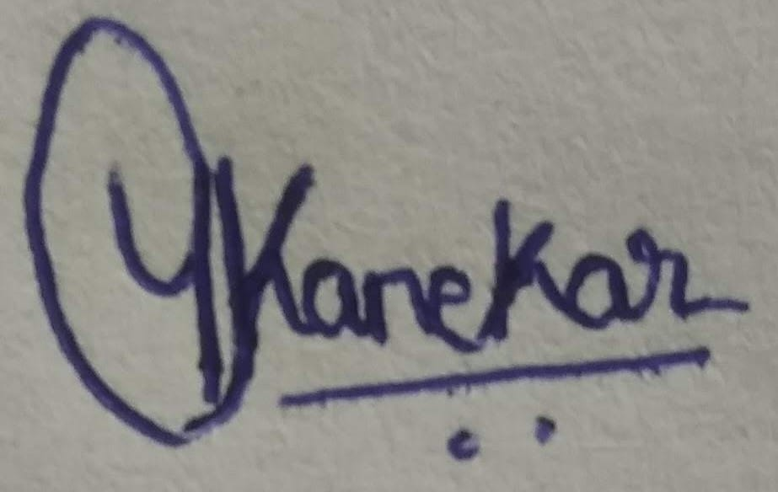-Yash Kanekar

(Signature of Students)

Letter of Acceptance

I undersigned, Prof. Tushar Ghorpade working in Computer Engineering department, willing to guide the project titled Face Recognition Sytem

for the mini project-I Semester V /VI respectively for the academic year 2021-22.
The names of the students are:

1. Shashank Avhad

2. Nishant Chauhan

3. Yash Kanekar

(Project Guide) (Mini Project Coordinator) (HOD Computer)

.

COURSE OUTCOMES

CO  No. | COURSE OUTCOME | POs covered | PSOs  covered
CO1 | Identify problems based on societal /research needs. | PO2, PO6, PO7 | PSO1
CO2 | Apply Knowledge and skill to solve societal problems in a group. | PO1, PO3, PO5, PO6 | PSO1, PSO2
CO3 | Draw the proper inferences from available results through theoretical/ experimental/simulations. | PO3, PO4, PO5 | PSO1
CO4 | Analyze the impact of solutions in societal and environmental context for sustainable development. | PO4, PO5, PO7 | PSO1, PSO2
CO5 | Develop excel in written, oral communication and interpersonal skills and demonstrate capabilities of self-learning in a group or leader, which leads to lifelong learning. | PO1,PO9, PO10, PO12 | PSO2, PSO3
CO6 | Use standard norms of engineering practices and demonstrate project management principles during project work. | PO8, PO11 | PSO2, PSO3

CO-PO-PSO MAPPING

 | PO1 | PO2 | PO3 | PO4 | PO5 | PO6 | PO7 | PO8 | PO9 | PO10 | PO11 | PO12 | PSO1 | PSO2 | PSO3
CO1 |  | 4 |  |  |  | 3 | 3 |  |  |  |  |  | 3
CO2 | 2 |  | 3 |  | 3 | 2 |  |  |  |  |  |  | 2 | 3
CO3 |  |  | 3 | 4 | 3 |  |  |  |  |  |  |  | 3
CO4 |  |  |  | 3 | 2 |  | 5 |  |  |  |  |  | 2 | 3
CO5 | 1 |  |  |  |  |  |  |  | 3 | 3 |  | 3 |  | 3 | 3
CO6 |  |  |  |  |  |  |  | 5 |  |  | 5 |  |  | 3 | 3

SCHEDULE FOR MINI PROJECT

Date | Week | Contents | Remark | Guide Sign
03/08/2020 | 1 | Topic Selection
10/08/2020 | 2 | Abstract Submission
17/08/2020 | 3 | Introduction
24/08/2020 | 4 | Literature Survey
31/08/2020 | 5 | Problem Definition
07/09/2020 | 6 | Proposal
14/09/2020 | 7 | Architecture/ Framework
21/09/2020 | 8 | MOCK-1- Presentation
28/09/2020 | 9 | Algorithm and Process Design
05/10/2020 | 10 | Details of Hardware & Software
12/10/2020 | 11 | Experiment and Results
19/10/2020 | 12 | Conclusion and Future work.  References
26/10/2020 | 13 | MOCK2- Final Presentation + Report
02/11/2020 | 14 | Final Report submission(In LATEX)

PROGRESS/ATTENDANCE REPORT

Title of the Project: Face Recognition System
Group No. 19 | Name of Student 1: Shashank Avhad
Group No. 19 | Name of Student 2: Nishant Chauhan
Group No. 19 | Name of Student 3: Yash Kanekar
Name of the Supervisor:

Sr. No | Date | Attendance |  |  | Progress/Suggestion | Mapping
 |  | 1 | 2 | 3 |  | CO | PO | PSO
1
2
3
4
5

6 |  |  |  |  | Presentation1
7
8
9
10
11
12

Sign of the Supervisor

EXAMINER'S FEEDBACK FORM

Name of External examiner: College of External examiner: Name of Internal examiner:
Date of Examination: / / No. of students in project team: Availability of separate lab for the project: Yes / No

Student Performance Analysis (Put Tick as per your Observation)

Excellent (3) Very Good (2) Good (1)
Sr. No. | Observation | (3) | (2) | (1)
1 | Quality of problem and Clarity
2 | Innovativeness in solutions
3 | Cost effectiveness and Societal impact
4 | Full functioning of working model as per stated requirements
5 | Effective use of skill sets
6 | Effective use of standard engineering norms
7 | Contribution of an individual’s as member or leader
8 | Clarity in written and oral communication
9 | Overall performance

o Can same mini project extend to next semester by adding new objectives/ideas? ( Yes/ No)
o If yes, suggest new Innovative Technique/Idea/ objectives related to this project.

Signature of External Examiner Signature of Internal Examiner

