Cover Sheet for Coursework

Surname (in CAPITALS): KAPURE
First name (in CAPITALS): YASH
Email ID: yvk2@student.le.ac.uk

I understand that this is a piece of coursework. I have completed the Academic integrity training course ADX178 on Blackboard and am fully aware of the University's policy on plagiarism:
https://le.ac.uk/policies/regulations/senate-regulations/senate-regulation-11/academic.
I hereby declare that the work submitted is my own, created solely by me, except where explicitly indicated otherwise in the text.

Date: 13-01-2025 Signature: 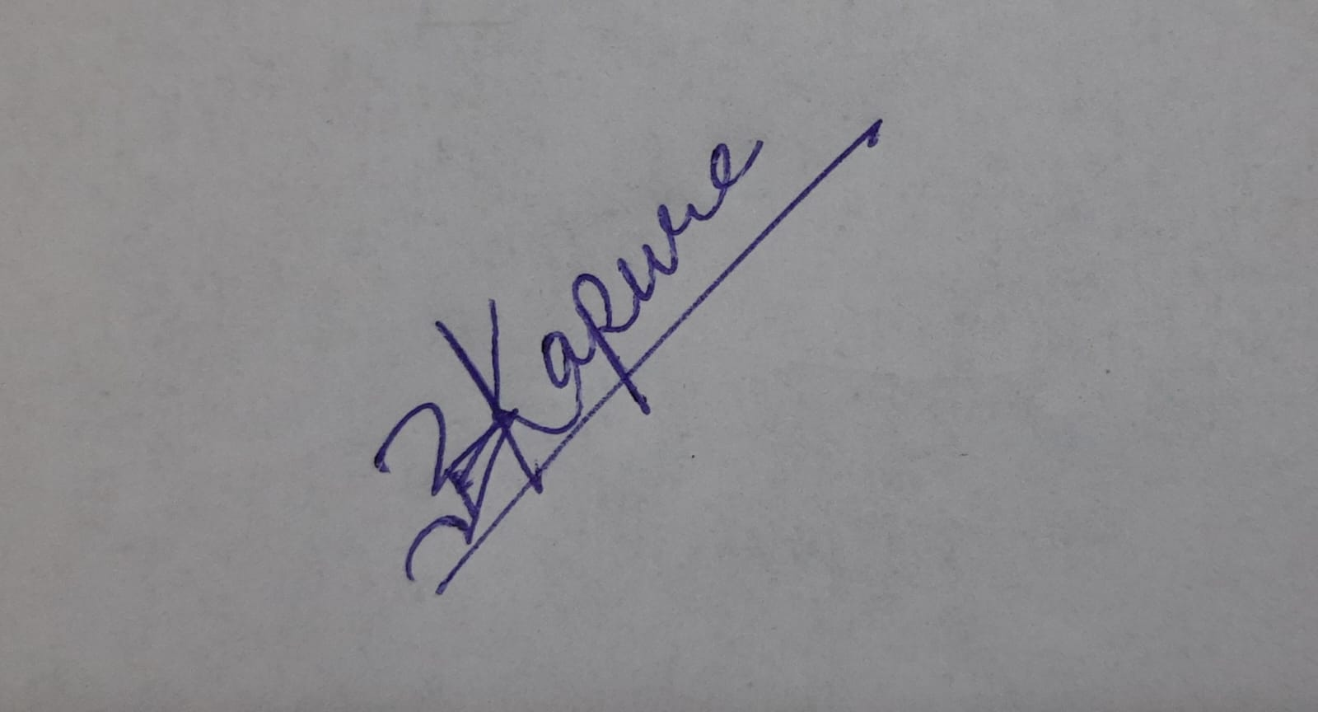

Please give a summary of your submission in the table below:

Category: Web Application

Your choice of language and framework: MERN Stack (MongoDB, Express.js, React.js and Node.js)

Section | Sub-tasks | A: achieved  P: partially implemented  N: not attempt
Task 1  Petitioner | register | A
Task 1  Petitioner | login | A
Task 1  Petitioner | petitioner page | A
Task 1  Petitions Committee | login | A
Task 1  Petitions Committee | set signature threshold | A
Task 1  Petitions Committee | view and response petitions | A
Task 2  REST API | 2.1 | A
Task 2  REST API | 2.2 | A
Bonus |  | - Responsive UI  - Login with QR Code  - Toast Notifications  - Progress Bar for the Signatures  - Profile page for admin and petitioner along with beautiful Pie Chart.

Note: You do not need to implement everything in the functional requirement. But we encourage you to accomplish as much as you can. Your coursework will be evaluated based on factors such as the complexity level, the quality of implemented functions, and the overall effort you invest in the project.
Please attach at least TWO screenshots below:

Petitioner dashboard
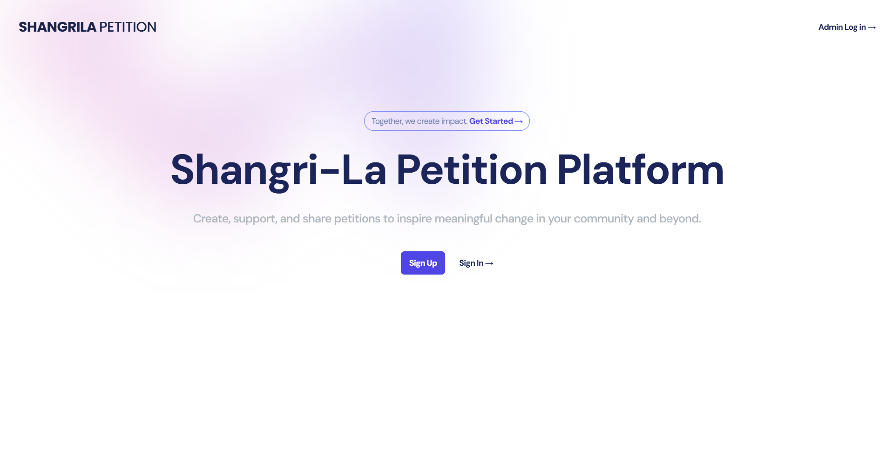

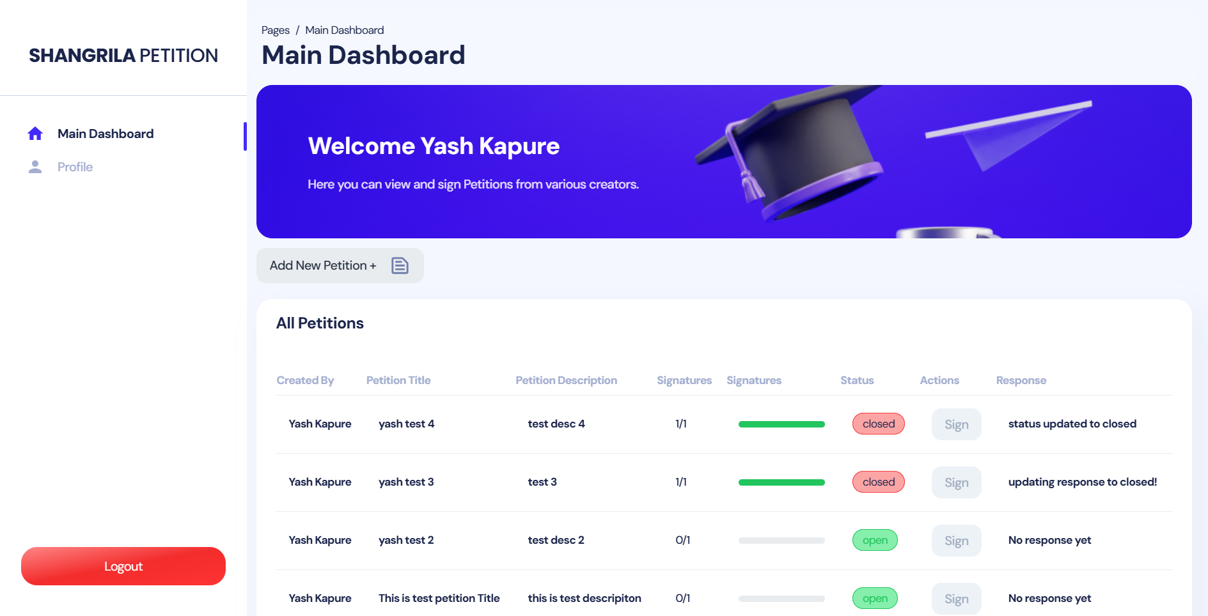

Petitions Committee dashboard

