Worksheet 1

Student Name:Yash Karde UID:25MCI10090
Branch:MCA (AI&ML) Section/Group:1/A
Semester:2nd Date of Performance:13/01/2026
Subject Name:- DBMS LAB Subject Code:

1. Aim of the Session

To design and implement a sample database system using DDL, DML, and DCL commands for managing departments, employees, and projects, and to apply role-based access control for secure data handling.

2. Objective of the Session

After completing this practical, the student will be able to:
- Understand the use of DDL commands to create and modify database structures.
- Perform DML operations such as INSERT, UPDATE, DELETE, and SELECT.
- Implement relationships using primary and foreign keys.
- Apply DCL commands to manage roles and privileges.
- Analyze input and output of SQL queries in a real database environment.

3. Practical / Experiment Steps

Design the database schema for Department, Employee, and Project tables.

Create tables using appropriate constraints.

Insert sample records into tables.

Perform update and delete operations.

Retrieve data using SELECT queries.

Create a role and grant/revoke privileges.

Alter and drop database objects.

4. Procedure of the Practical

(i) Start the system and log in to the computer.

(ii) Open PostgreSQL software.

(iii) create database Experiment1;

(iv) Create tables using DDL commands.

CREATE TABLE Department (

dept_id SERIAL PRIMARY KEY,

dept_name VARCHAR(100) NOT NULL UNIQUE

);

CREATE TABLE Employee (

emp_id SERIAL PRIMARY KEY,

emp_name VARCHAR(100) NOT NULL,

email VARCHAR(150) UNIQUE,

salary NUMERIC(10,2) CHECK (salary > 0),

dept_id INT NOT NULL,

CONSTRAINT fk_department

FOREIGN KEY (dept_id)

REFERENCES Department(dept_id)

);

CREATE TABLE Project (

project_id SERIAL PRIMARY KEY,

project_name VARCHAR(150) NOT NULL UNIQUE,

start_date DATE NOT NULL,

end_date DATE,

CHECK (end_date IS NULL OR end_date >= start_date)

);

(v) Insert records using DML commands.

insert into Department values

INSERT INTO Department (dept_name)

VALUES

('HR'),

('IT'),

('Finance'),

('Marketing'),

('Operations'),

('Research');

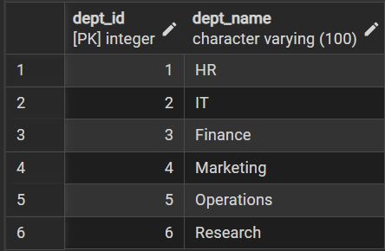

insert into Employee values

INSERT INTO Employee (emp_name, email, salary, dept_id)

VALUES

('Aryan', 'aryan@company.com', 55000, 2),

('Rahul', 'rahul@company.com', 60000, 1),

('Sneha', 'sneha@company.com', 50000, 3),

('Neha', 'neha@company.com', 62000, 2),

('Amit', 'amit@company.com', 45000, 4),

('Pooja', 'pooja@company.com', 70000, 5),

('Karan', 'karan@company.com', 52000, 6),

('Ritika', 'ritika@company.com', 58000, 1);

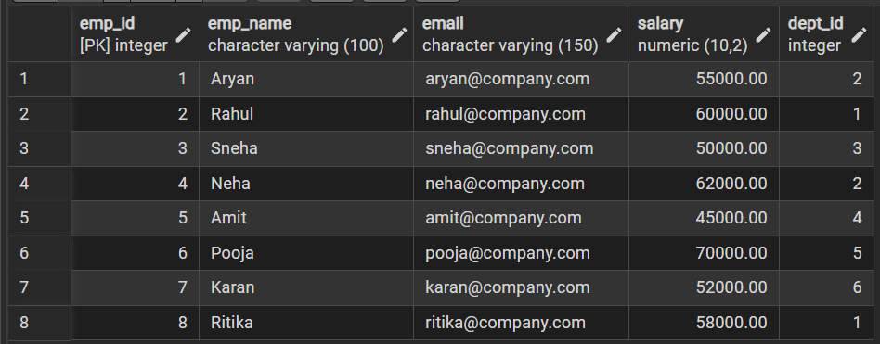

insert into Project values

INSERT INTO Project (project_name, start_date, end_date)

VALUES

('HR Automation', '2024-01-01', '2024-06-30'),

('Website Revamp', '2024-02-15', NULL),

('Marketing Analytics', '2024-03-01', '2024-09-30'),

('ERP Implementation', '2024-04-15', NULL),

('AI Research', '2024-01-10', '2025-01-10'),

('Customer Engagement Platform', '2024-05-01', NULL);

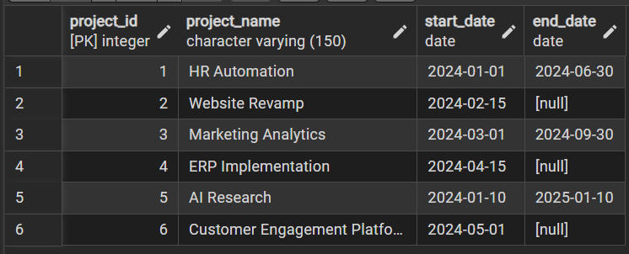

(vi) Update and delete records.

UPDATE Employee

SET salary = 65000

WHERE emp_name = 'Aryan';

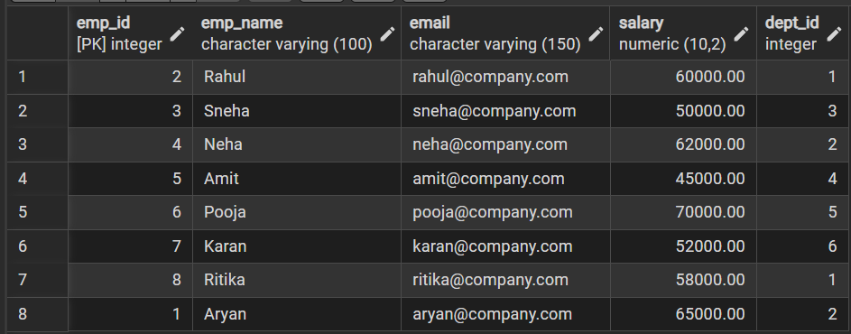

DELETE FROM Department

WHERE dept_id = 1;

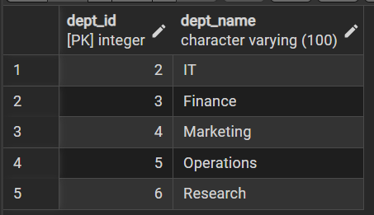

DELETE FROM Employee

WHERE dept_id = 1;

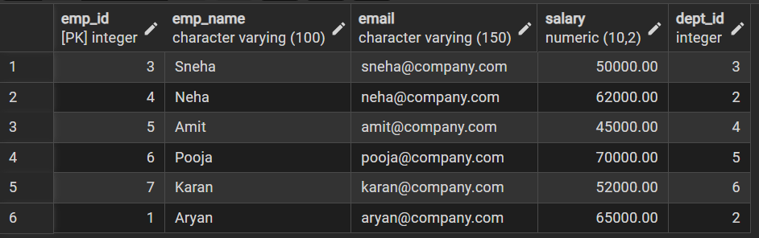

(vii) Create role and assign privileges.

CREATE ROLE reporting_user2

WITH

LOGIN

PASSWORD 'report123';

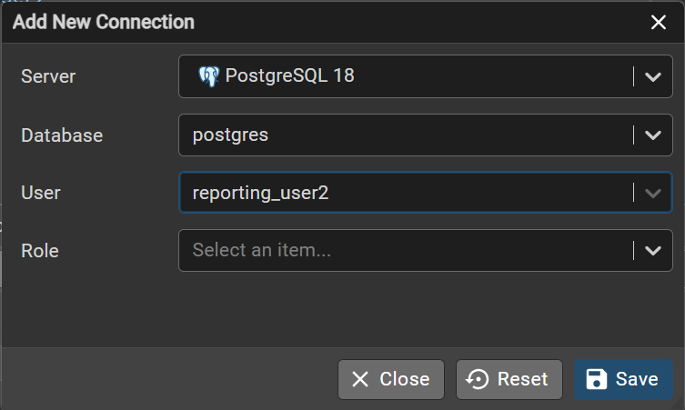

GRANT SELECT ON Department TO reporting_user;

GRANT SELECT ON Employee TO reporting_user;

GRANT SELECT ON Project TO reporting_user;

REVOKE CREATE ON SCHEMA public FROM reporting_user;

REVOKE INSERT, UPDATE, DELETE ON ALL TABLES IN SCHEMA public FROM reporting_user;

(viii) Alter and drop table.

ALTER TABLE Employee

ADD COLUMN phone_number VARCHAR(15);

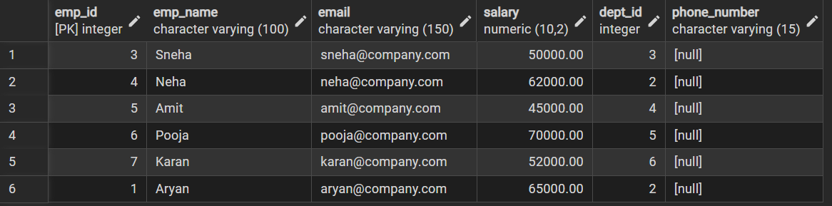

drop table Project;

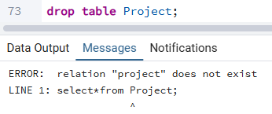

Learning Outcomes
- Understood the basics of relational database design using tables, keys, and relationships.
- Learned to apply primary and foreign key constraints to maintain data integrity.
- Gained hands-on experience with INSERT, UPDATE, and DELETE operations.
- Understood role-based access control using GRANT and REVOKE.
- Learned how to create read-only users for secure data access.
- Practiced ALTER TABLE and DROP TABLE commands for schema management.

