Name – Yash Karde UID – 25MCI10090
Leetcode Problem – 1587
Code-
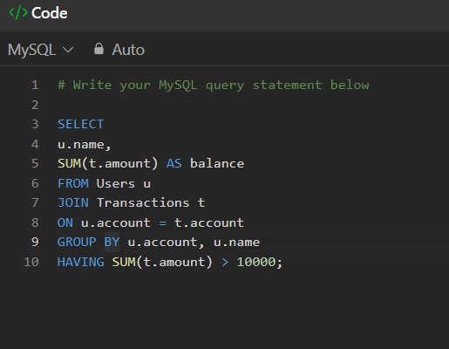

Submission-
