
DEPARTMENT OF

COMPUTER SCIENCE & ENGINEERING

Experiment 6

Student Name: Yash Karde UID: 25MCI10090
Branch: MCA (AI & ML) Section/Group: 25MAM-1
Semester: 2nd Date of Performance:27/02/26
Subject Name: Technical Training Subject Code:25CAP-652

AIM:
Learn how to create, query, and manage views in SQL to simplify database queries and provide a layer of abstraction for end-users.

OBJECTIVE:
- Data Abstraction: To understand how to hide complex table joins and calculations behind a simple virtual table interface.
- Enhanced Security: To learn how to restrict user access to sensitive columns by providing views instead of direct table access.
- Query Simplification: To master the creation of views that pre-join multiple tables, making reporting easier for non-technical users.
- View Management: To understand the syntax for creating, altering, and dropping views, as well as the naming conventions required for efficient data access.

Implementation:

Step 1: Creating a Simple View for Data Filtering
Implementing a view to provide a quick list of active employees without exposing the entire table structure.

CREATE TABLE Employee (
emp_id SERIAL PRIMARY KEY,
emp_name VARCHAR(100),
department VARCHAR(50),
salary NUMERIC(10,2),
is_active BOOLEAN
);

-- Data Insertion

INSERT INTO Employee (emp_name, department, salary, is_active) VALUES
('Rahul', 'IT', 50000, TRUE),
('Sneha', 'HR', 40000, FALSE),
('Amit', 'Finance', 55000, TRUE),
('Priya', 'IT', 60000, TRUE);-- Cursor Commands

Query : -

CREATE OR REPLACE VIEW active_employees AS
SELECT emp_id, emp_name, department, salary
FROM Employee
WHERE is_active = TRUE;

SELECT * FROM active_employees;

Output :-

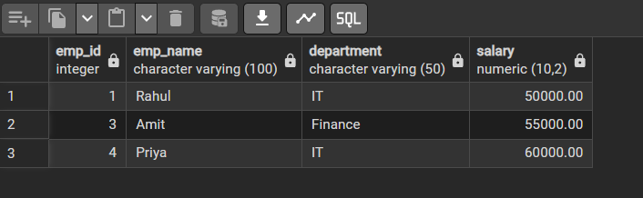

Step 2: Creating a View for Joining Multiple Tables
Simplifying the retrieval of data distributed across Employees and Departments tables.

CREATE TABLE Departments (
dept_id SERIAL PRIMARY KEY,
dept_name VARCHAR(100)
);

INSERT INTO Departments (dept_name) VALUES
('IT'),
('HR'),
('Finance');

CREATE TABLE Employees (
emp_id SERIAL PRIMARY KEY,
emp_name VARCHAR(100),
salary NUMERIC(10,2),
dept_id INT,
FOREIGN KEY (dept_id) REFERENCES Departments(dept_id)
);

INSERT INTO Employees (emp_name, salary, dept_id) VALUES
('Rahul', 50000, 1),
('Sneha', 40000, 2),
('Amit', 55000, 3),
('Priya', 60000, 1);

Query:-

CREATE OR REPLACE VIEW employee_department_view AS
SELECT
e.emp_id,
e.emp_name,
e.salary,
d.dept_name
FROM Employees e
JOIN Departments d
ON e.dept_id = d.dept_id;

SELECT * FROM employee_department_view;

Output :-
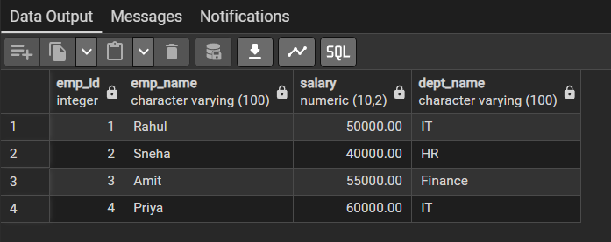

Step 3: Advanced Summarization View
Creating a view to provide department-level statistics automatically

Query:-

CREATE OR REPLACE VIEW department_statistics AS
SELECT
d.dept_name,
COUNT(e.emp_id) AS total_employees,
SUM(e.salary) AS total_salary,
AVG(e.salary) AS average_salary,
MAX(e.salary) AS highest_salary,
MIN(e.salary) AS lowest_salary
FROM Departments d
LEFT JOIN Employees e
ON d.dept_id = e.dept_id
GROUP BY d.dept_name;

Output : -

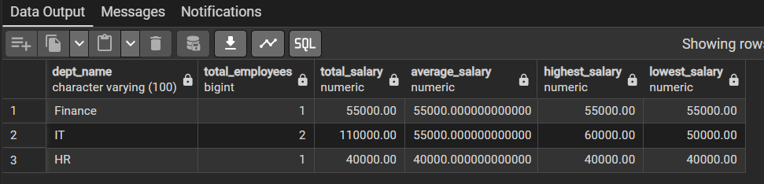

LEARNING OUTCOMES:

- Abstraction Proficiency: Students will be able to create and query views to simplify efficient data access and abstraction.

- Security Implementation: Students will understand how to use views for data masking and providing restricted access to sensitive information.

- Syntactic Accuracy: Students will demonstrate the correct syntax for creating and querying views, ensuring logical clarity in naming conventions.

- Real-world Application: Students will be able to design views for practical domains like Library Management Systems or Payroll Systems to demonstrate functionality.

