Student Name: Yash Karde | UID: 25MCI10090
Branch: MCA(AI/ML) | Section/Group: 25MAM-1 A
Semester: 2nd sem | Date of Performance: 21/04/2026
Subject Name: TECHNICAL SKILLS | Subject Code:

WORKSHEET 10
AIM:
To understand and apply transaction control in PostgreSQL using BEGIN, COMMIT, ROLLBACK, and SAVEPOINT to maintain data integrity during database operations.
S/W Requirement: PostgreSQL and pgAdmin
OBJECTIVES:
Apply transaction control commands for safe and reliable database updates.
Practical / Experiment Steps
Table creation:
DROP TABLE IF EXISTS Payroll;
CREATE TABLE Payroll (
emp_id INT PRIMARY KEY,
emp_name VARCHAR(50),
salary DECIMAL(10,2) CHECK (salary > 0)
);
INSERT INTO Payroll VALUES
(1, 'Amit', 30000),
(2, 'Neha', 40000),
(3, 'Ravi', 50000);
SELECT * FROM Payroll;

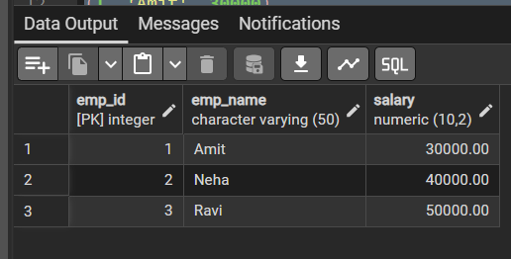
Figure 1: Table created and initial data inserted

Experiment 1: Transaction with ROLLBACK
BEGIN;
UPDATE Payroll
SET salary = -1000
WHERE emp_id = 3;
SELECT * FROM Payroll;
ROLLBACK;
SELECT * FROM Payroll;

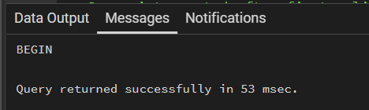
Figure 2: Transaction started with BEGIN

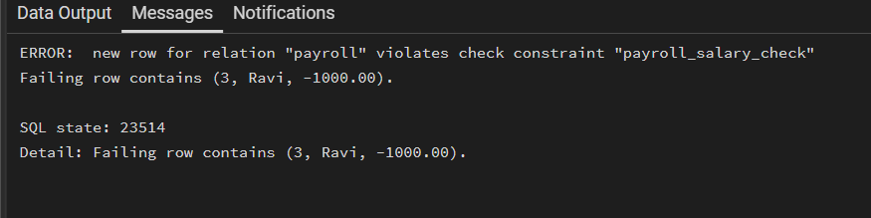
Figure 3: Constraint violation error during update

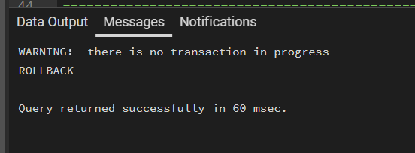
Figure 4: Table state after rollback

Experiment 2: Transaction with SAVEPOINT
BEGIN;
UPDATE Payroll
SET salary = salary + 5000
WHERE emp_id = 1;
SAVEPOINT sp1;
UPDATE Payroll
SET salary = salary + 7000
WHERE emp_id = 2;
UPDATE Payroll
SET salary = -1000
WHERE emp_id = 3;
ROLLBACK TO sp1;
COMMIT;
SELECT * FROM Payroll;

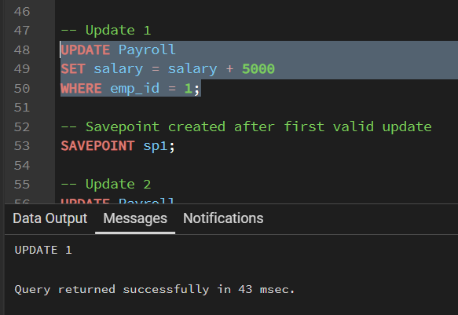
Figure 5: First valid update before savepoint

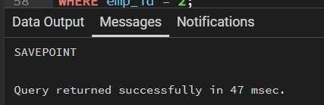
Figure 6: Savepoint created successfully

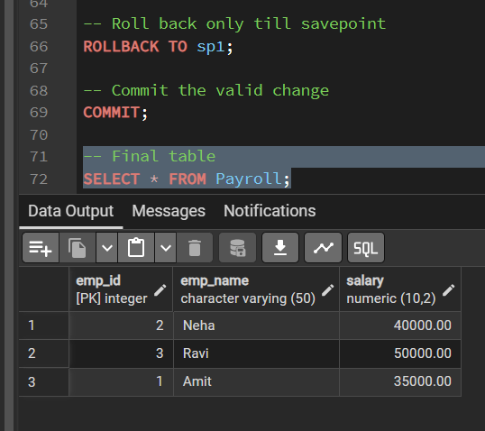
Figure 7: Final result after rollback to savepoint and commit

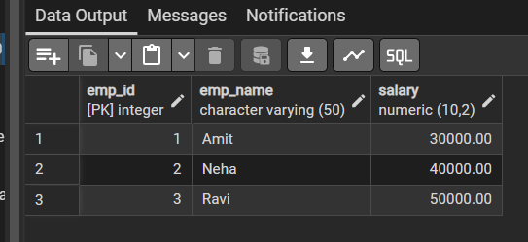
Figure 8: Table data after transaction handling

Outcomes:
1. BEGIN starts a transaction block for grouping multiple SQL commands.
2. ROLLBACK cancels changes made inside the transaction.
3. SAVEPOINT allows partial rollback without losing all valid updates.
4. CHECK constraint ensures salary remains greater than zero.
5. PostgreSQL transaction control helps maintain consistency and data integrity.

