Student Name: Yash Karde UID: 25MCI10090
Branch: MCA(AI/ML) Section/Group: 25MAM-1 A
Semester: 2nd sem Date of Performance: 31/03/2026
Subject Name: TECHINCAL SKILLS Subject Code:

WORKSHEET 7
AIM: Implementation of jOINS in PostgreSQL
S/W Requirement: Oracle Database Express Edition and pgAdmin
OBJECTIVES:
Apply joins to a real-world database schema (e.g., Students, Courses, Enrollments, Departments)
Practical / Experiment Steps

Table creation:
CREATE TABLE Students ( student_id INT PRIMARY KEY, student_name VARCHAR(50), dept_id INT
);

CREATE TABLE Courses ( course_id INT PRIMARY KEY, course_name VARCHAR(50)
);

CREATE TABLE Enrollments ( student_id INT,
course_id INT
);

CREATE TABLE Departments ( dept_id INT PRIMARY KEY, dept_name VARCHAR(50)
);

-- Students (added duplicate dept_id for SELF JOIN) INSERT INTO Students VALUES (1, 'Amit', 101);
INSERT INTO Students VALUES (2, 'Sara', 102); INSERT INTO Students VALUES (3, 'John', 103);
INSERT INTO Students VALUES (4, 'Neha', NULL);
INSERT INTO Students VALUES (5, 'Pankaj', NULL); INSERT INTO Students VALUES (6, 'Rahul', 101);
INSERT INTO Students VALUES (7, 'Simran', 101);

-- Courses
INSERT INTO Courses VALUES (201, 'DBMS'); INSERT INTO Courses VALUES (202, 'Java');
INSERT INTO Courses VALUES (203, 'Python');

-- Enrollments
INSERT INTO Enrollments VALUES (1, 201);
INSERT INTO Enrollments VALUES (1, 202);
INSERT INTO Enrollments VALUES (2, 201);
INSERT INTO Enrollments VALUES (6, 203);

-- Departments
INSERT INTO Departments VALUES (101, 'CS'); INSERT INTO Departments VALUES (102, 'IT');
INSERT INTO Departments VALUES (103, 'ECE');

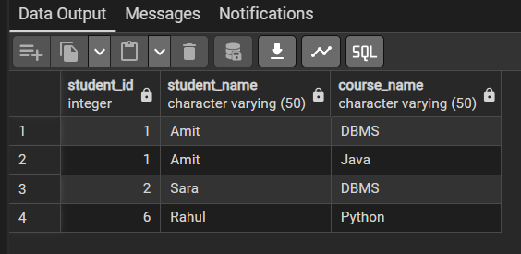
--- inner JOIN
SELECT s.student_id, s.student_name, c.course_name FROM Students s
INNER JOIN Enrollments e
ON s.student_id = e.student_id INNER JOIN Courses c
ON e.course_id = c.course_id;
--- left JOIN
SELECT s.student_name FROM Students s
LEFT JOIN Enrollments e
ON s.student_id = e.student_id WHERE e.course_id IS NULL;

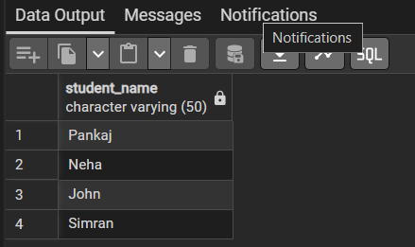
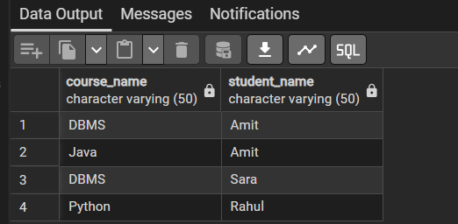
--- RIGHT JOIN
SELECT c.course_name, s.student_name FROM Courses c
LEFT JOIN Enrollments e
ON c.course_id = e.course_id LEFT JOIN Students s
ON e.student_id = s.student_id;

--- multiple join SELECT
s.student_name, d.dept_name, c.course_name
FROM Students s
LEFT JOIN Departments d ON s.dept_id = d.dept_id
LEFT JOIN Enrollments e
ON s.student_id = e.student_id LEFT JOIN Courses c
ON e.course_id = c.course_id;

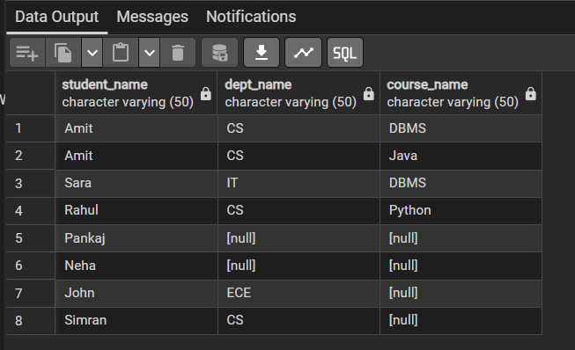

--- self JOIN
SELECT A.student_name AS Student1, B.student_name AS Student2, A.dept_id FROM Students A
JOIN Students B
ON A.dept_id = B.dept_id
WHERE A.student_id < B.student_id;

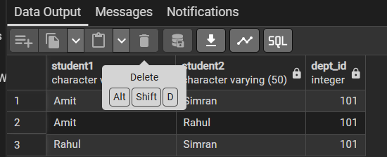

--- cross JOIN
SELECT s.student_name, c.course_name FROM Students s
CROSS JOIN Courses c LIMIT 10;

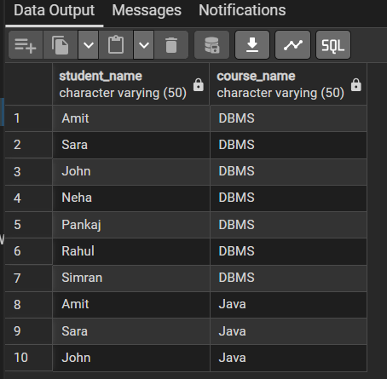

Outcomes:
- INNER JOIN returns only matching records between tables (students who are enrolled in courses).
- LEFT JOIN helps identify unmatched data (students with no course enrollments).
- RIGHT JOIN ensures all records from the right table appear, even without matches.
- SELF JOIN compares rows within the same table (students in the same department).
- CROSS JOIN produces all possible combinations of rows (Cartesian product).

