Name – Yash Karde UID – 25MCI10090
Leetcode Problem – 577

Code-
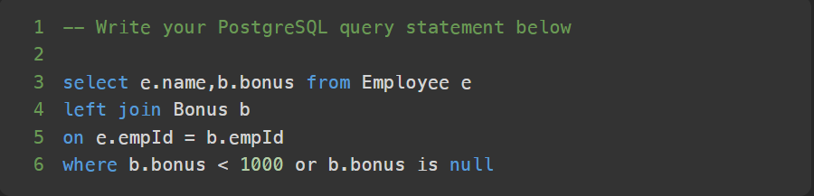

Submission-

