Name – Yash Karde UID – 25MCI10090
Leetcode Problem – 1661

Code-
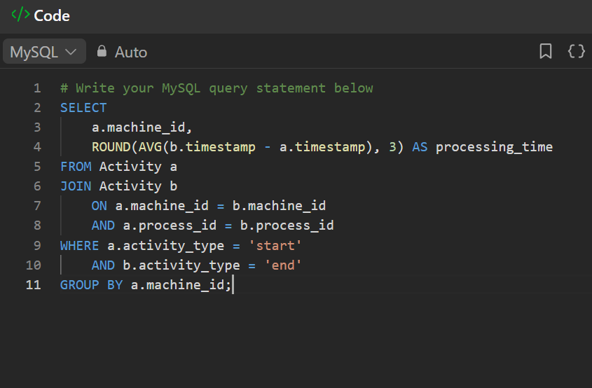
Submission-
