# Introduction

In this project, I am interested in New York City data. First, we will find the most visited commercial shop according to the number of check-ins, then we will try to find the neighborhoods that are lacking the selected type of shop which could be potential business opportunity.

# Target Audience

The target audience of this report is any one that is interested in opening a shop but have no idea what kind of and in which neighborhood.

# Data Section

The data comes from Dingqi Yang from the following link <https://sites.google.com/site/yangdingqi/home/foursquare-dataset>. It contains 227,428 check-ins

in New York city. The data contains two files in tsv format. Each file contains 8 columns, which are:

1. User ID (anonymized)
2. Venue ID (Foursquare)
3. Venue category ID (Foursquare)
4. Venue category name (Foursquare)
5. Latitude
6. Longitude
7. Time zone offset in minutes (The offset in minutes between when this check-in occurred and the same time in UTC)
8. UTC time

After extracting and reading the data, we will translate the above data into a Pandas data frame for processing which would look like this. These are the data elements that are needed when we call Foursquare web service call in order to get the venues available in that neighborhood (Neighborhoods are not included here)

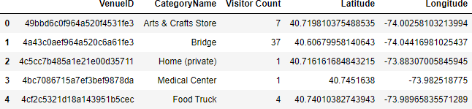

Then we will create a dictionary in order to decide which category is the most popular (commercial type)



After all this, we will check the coordinates within given n number of kilometers and count how many ‘Bar’ are there (venues selected as 2000 as a trial)

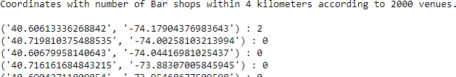

Find the two neighborhoods that are closest to the coordinate which has the most number of the specific shop type but lacking that within 4 kilometers

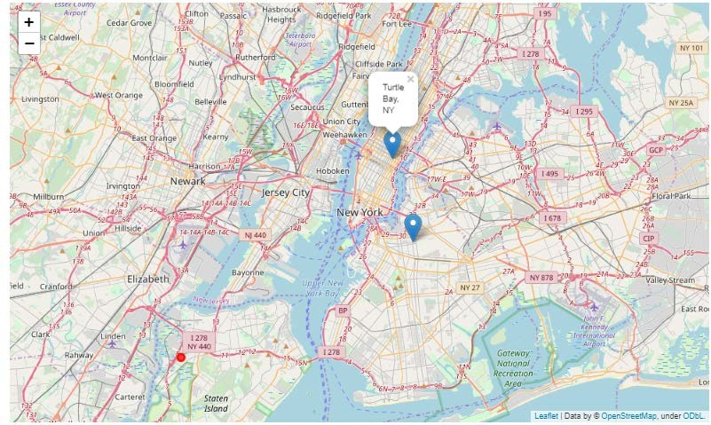

*Red dot is the center*

# - Results & Conclusion

In our sample of 2000 venues, we did find more than 10 coordinates that has no Bar (the most visited shop type according to sample) within four-kilometer sphere. And we did manage to get the neighborhoods’ names from foursquare database and pin down the two closest neighborhoods, ‘Bedford-Stuyvesant’, and ‘Turtle Bay’, into the map. Of course, it should not be forgotten that the data used above is almost 6-year old so further research might be needed.

Anyways, the results according to the data in hand can be checked from the map and analysis above can be of use for future entrepreneurs.