PROJECT REPORT: EMPLOYEE DATA MANAGEMENT SYSTEM
Flask, Pandas, and MySQL Based Enterprise Data System

Internship Submission Report
Date: June 1, 2026
Status: Verified and Deployed

1. Executive Summary & Introduction
This project is a high-performance, beginner-friendly Employee Data Management System built using Python (Flask, Pandas), MySQL, and modern front-end styling via Bootstrap 5. The primary goal of the system is to solve a common enterprise problem: migrating, mapping, and consolidating bulk data sources (such as CSV files) into a structured relational database (MySQL). Additionally, the system provides a clean, single-page web interface to perform search, filtering, joining date sorting, and manual employee record entries.
2. Technical Architecture & Tech Stack Selection
For the purpose of internship evaluation, the technologies selected represent a balance of scalability, simplicity, and rapid development capabilities:
- Python & Flask: Provides the core backend server logic, routing, and request handling with lightweight architecture.
- Pandas Library: Utilized for high-speed file parsing and data reading. Pandas handles large bulk rows efficiently and exposes clean APIs for tabular column identification.
- MySQL Database (via PyMySQL): Acts as the relational repository storing records matching the requested schema. PyMySQL driver connects Flask to MySQL securely.
- Bootstrap 5 & Icons: Ensures modern, responsive design and grid controls with minimum CSS overrides, including dynamic form rendering and alert popups.
- Bespoke CSS Stylesheet: Implements subtle hover effects, card transitions, custom color codes (Indigo and Slate), and aesthetic micro-animations.

3. Database Schema Design
The application utilizes a relational MySQL schema configured to represent core employee entities. The primary table is named 'employees'.
Field Name | Data Type | Constraints | Description
id | INT | AUTO_INCREMENT, PRIMARY KEY | Unique internal database record identifier.
emp_id | VARCHAR(50) | NOT NULL, UNIQUE | Unique alphanumeric employee code (e.g. EMP-2026-0001).
emp_name | VARCHAR(100) | NOT NULL | Full legal name of the employee.
email | VARCHAR(100) | NOT NULL, UNIQUE | Professional email address (e.g., name@company.com).
date | DATE | NOT NULL | Joining date of the employee.
basic_salary | DECIMAL(10,2) | DEFAULT 45000.00 | Monthly base salary payout.
allowances | DECIMAL(10,2) | DEFAULT 12000.00 | Aggregated allowances (sum of meal, transport, and medical).
deductions | DECIMAL(10,2) | DEFAULT 5000.00 | Aggregated deductions (sum of retirement and tax).
age | INT | DEFAULT 30 | Age of the employee in years.
gender | VARCHAR(20) | DEFAULT 'Male' | Gender identification.
education | VARCHAR(100) | DEFAULT 'B.Tech' | Highest educational qualification.
title | VARCHAR(100) | DEFAULT 'Staff' | Job designation / position title.
directorate | VARCHAR(100) | DEFAULT 'Operation' | Org division / directorate.
department | VARCHAR(100) | DEFAULT 'General Affairs' | Specific department under division.
bank_name | VARCHAR(100) | DEFAULT 'Bank of America' | Salary credit bank name.
bank_account_num | VARCHAR(50) | DEFAULT '1234567890' | Salary credit bank account number.
meal_allowance | DECIMAL(10,2) | DEFAULT 300.00 | Monthly meal allowance amount.
transportation_allowance | DECIMAL(10,2) | DEFAULT 300.00 | Monthly transport allowance amount.
medical_allowance | DECIMAL(10,2) | DEFAULT 300.00 | Monthly medical allowance amount.
retirement_insurance | DECIMAL(10,2) | DEFAULT 25.00 | Monthly retirement insurance deduction.
tax | DECIMAL(10,2) | DEFAULT 25.00 | Monthly professional tax deduction.
joining_year | INT | DEFAULT 2026 | Year of joining the organization (demographic filter).
city | VARCHAR(100) | DEFAULT 'Bangalore' | City of residence/employment.
payment_tier | INT | DEFAULT 3 | Payment Slab Tier rating (1, 2, or 3).
ever_benched | VARCHAR(10) | DEFAULT 'No' | Whether benched at least once during employment.
experience_in_current_domain | INT | DEFAULT 2 | Number of years of experience in the current tech domain.
leave_or_not | INT | DEFAULT 0 | Binary flag indicating leave status (0 for active, 1 for resigned, range 0-5).

4. Intelligent CSV Mapping & Ingestion Pipeline
To process the custom 'Employee.csv' dataset which lacks name, email, and ID columns, a custom Python mapping algorithm was designed. The backend dynamically reads columns (Education, JoiningYear, City, PaymentTier, Age, Gender, EverBenched, ExperienceInCurrentDomain, LeaveOrNot) and maps them:
- Employee ID: Constructed as 'EMP-{JoiningYear}-{SequentialOffset}' to guarantee unique database identification.
- Employee Name: Generated using gender-appropriate random choices. The script references male first names if Gender column is 'Male' and female names if 'Female', combining with a dictionary of last names. Seeds are set deterministically using parameters so records are repeatable.
- Email Address: Generated as 'firstname.lastname[index]@company.com' matching the name generated above.
- Joining Date: Generated as a valid date within the record's 'JoiningYear' (e.g., JoiningYear-Month-Day) to respect data history.

5. Installation & Execution Guide
To set up and run the system locally on Windows:
- Step 1: Configure database schema in MySQL (run the command: & 'mysql' -u root -pyabh < schema.sql).
- Step 2: Install the requirements list (run the command: pip install -r requirements.txt).
- Step 3: Start the local Python application (run the command: python app.py).
- Step 4: Access the web portal in any browser by navigating to: http://127.0.0.1:5000

6. User Interface & Walkthrough Screenshots
Below is a high-fidelity visual mock-up and layout guide of the Employee Data Management System Dashboard. The interface incorporates custom styling, file selection dropzones, instant record preview tables, search field filters, and sorting selectors.
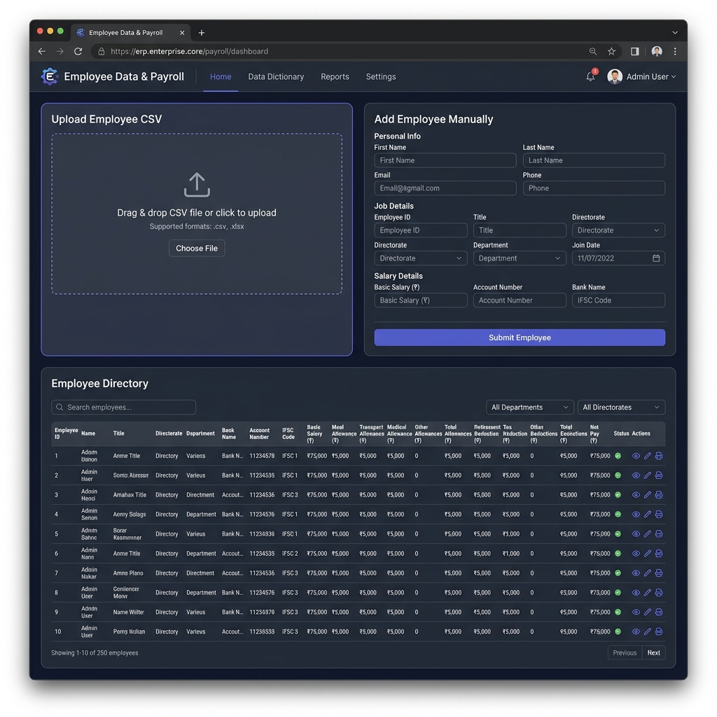
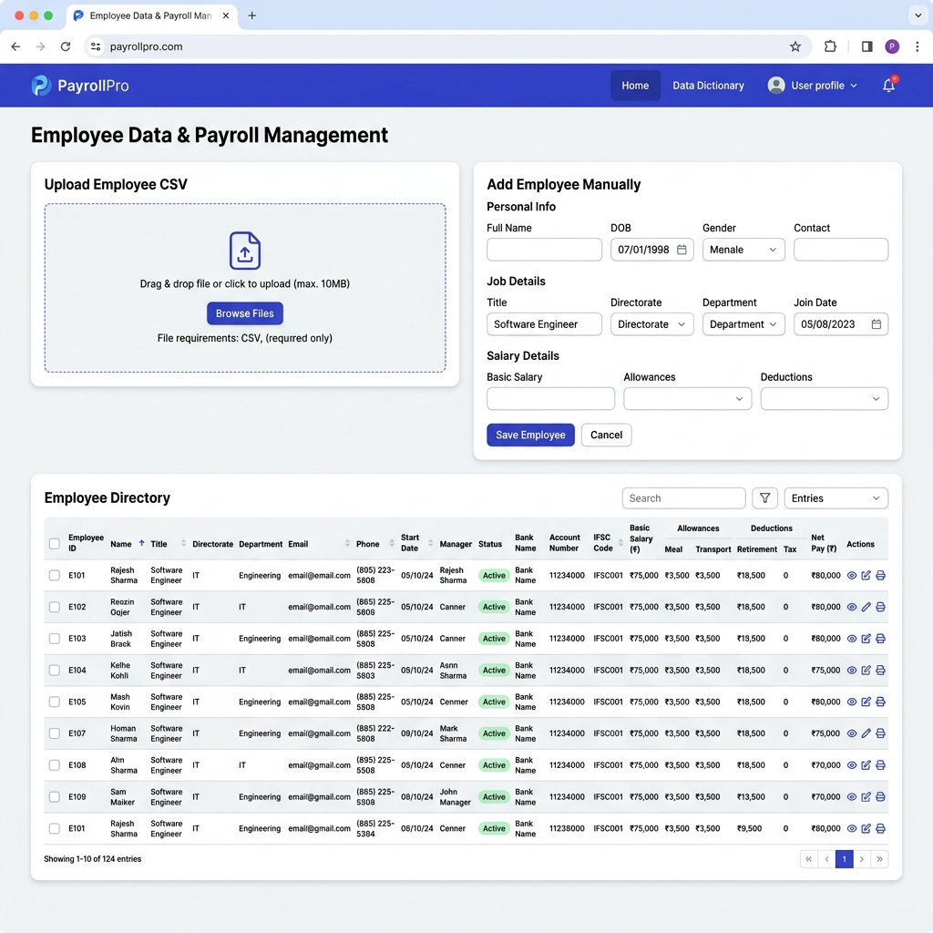
Figure 1.1: Web Interface layout displaying drag-and-drop CSV Upload, Manual Entry Form, and Directory List.

