PROJECT REPORT: EMPLOYEE DATA & PAYROLL SYSTEM
Flask, Pandas, and MySQL Based Enterprise Payroll & Data Management Portal

Internship Submission Report
Date: June 1, 2026
Status: Active and Deployed

1. Executive Summary & Introduction
This project is a high-performance, beginner-friendly Employee Data & Payroll Management System built using Python (Flask, Pandas), MySQL, and modern front-end styling via Bootstrap 5. The primary goal of the system is to solve a common enterprise problem: migrating, mapping, and consolidating bulk data sources (such as CSV files) into a structured relational database (MySQL). Additionally, the system provides a clean, single-page web interface to perform search, filtering, joining date sorting, manual employee record entries, and automatically generating printable digital payslips.
2. Technical Architecture & Tech Stack Selection
For the purpose of internship evaluation, the technologies selected represent a balance of scalability, simplicity, and rapid development capabilities:
- Python & Flask: Provides the core backend server logic, routing, and request handling with lightweight architecture.
- Pandas Library: Utilized for high-speed file parsing and data reading. Pandas handles large bulk rows efficiently and exposes clean APIs for tabular column identification.
- MySQL Database (via PyMySQL): Acts as the relational repository storing records matching the requested schema. PyMySQL driver connects Flask to MySQL securely.
- Bootstrap 5 & Icons: Ensures modern, responsive design and grid controls with minimum CSS overrides, including dynamic form rendering, payslips layouts, and alert popups.
- Bespoke CSS Stylesheet: Implements subtle hover effects, card transitions, custom color codes (Indigo and Slate), and aesthetic micro-animations.

3. Database Schema Design
The application utilizes a relational MySQL schema configured to represent core employee entities and salary metrics. The primary table is named 'employees'.
Field Name | Data Type | Constraints | Description
id | INT | AUTO_INCREMENT, PRIMARY KEY | Unique internal database record identifier.
emp_id | VARCHAR(50) | NOT NULL, UNIQUE | Unique alphanumeric employee code (e.g. EMP-2026-0001).
emp_name | VARCHAR(100) | NOT NULL | Full legal name of the employee.
email | VARCHAR(100) | NOT NULL, UNIQUE | Professional email address (e.g., name@company.com).
date | DATE | NOT NULL | Joining date of the employee.
basic_salary | DECIMAL(10,2) | DEFAULT 45000.00 | Monthly base salary payout.
allowances | DECIMAL(10,2) | DEFAULT 12000.00 | Aggregated allowances (sum of meal, transport, and medical).
deductions | DECIMAL(10,2) | DEFAULT 5000.00 | Aggregated deductions (sum of retirement and tax).
age | INT | DEFAULT 30 | Age of the employee in years.
gender | VARCHAR(20) | DEFAULT 'Male' | Gender identification.
education | VARCHAR(100) | DEFAULT 'B.Tech' | Highest educational qualification.
title | VARCHAR(100) | DEFAULT 'Staff' | Job designation / position title.
directorate | VARCHAR(100) | DEFAULT 'Operation' | Org division / directorate.
department | VARCHAR(100) | DEFAULT 'General Affairs' | Specific department under division.
bank_name | VARCHAR(100) | DEFAULT 'Bank of America' | Salary credit bank name.
bank_account_num | VARCHAR(50) | DEFAULT '1234567890' | Salary credit bank account number.
meal_allowance | DECIMAL(10,2) | DEFAULT 300.00 | Monthly meal allowance amount.
transportation_allowance | DECIMAL(10,2) | DEFAULT 300.00 | Monthly transport allowance amount.
medical_allowance | DECIMAL(10,2) | DEFAULT 300.00 | Monthly medical allowance amount.
retirement_insurance | DECIMAL(10,2) | DEFAULT 25.00 | Monthly retirement insurance deduction.
tax | DECIMAL(10,2) | DEFAULT 25.00 | Monthly professional tax deduction.
joining_year | INT | DEFAULT 2026 | Year of joining the organization (demographic filter).
city | VARCHAR(100) | DEFAULT 'Bangalore' | City of residence/employment.
payment_tier | INT | DEFAULT 3 | Payment Slab Tier rating (1, 2, or 3).
ever_benched | VARCHAR(10) | DEFAULT 'No' | Whether benched at least once during employment.
experience_in_current_domain | INT | DEFAULT 2 | Number of years of experience in the current tech domain.
leave_or_not | INT | DEFAULT 0 | Binary flag indicating leave status (0 for active, 1 for resigned).

4. Intelligent CSV Mapping & Ingestion Pipeline
To process the custom 'Employee.csv' dataset which lacks name, email, ID, and salary columns, a custom Python mapping algorithm was designed. The backend dynamically reads columns (Education, JoiningYear, City, PaymentTier, Age, Gender, EverBenched, ExperienceInCurrentDomain, LeaveOrNot) and maps them:
- Employee ID: Constructed as 'EMP-{JoiningYear}-{SequentialOffset}' to guarantee unique database identification.
- Employee Name: Generated using gender-appropriate random choices. The script references male first names if Gender column is 'Male' and female names if 'Female', combining with a dictionary of last names. Seeds are set deterministically using parameters so records are repeatable.
- Email Address: Generated as 'firstname.lastname[index]@company.com' matching the name generated above.
- Joining Date: Generated as a valid date within the record's 'JoiningYear' (e.g., JoiningYear-Month-Day) to respect data history.
- Employee Age: Extracted directly from the 'Age' column in the dataset if present. If missing or null (or during manual entry without specification), a realistic randomized age between 21 and 58 is generated using an offset-seeded generator.
- Salary Calculations: Determined using a dynamic calculation engine based on demographic features and corporate rules:

5. Interactive Payslip Generation & Calculations
For each employee, the system generates a detailed salary slip that can be downloaded as a PDF or printed. The calculations breakdown is as follows:
- Meal Allowance: Configured at 8% of the employee's Basic Salary.
- Transportation Allowance: Configured at 6% of the employee's Basic Salary.
- Medical Allowance: Configured at 4% of the employee's Basic Salary.
- Retirement Insurance (PF): Mapped at 12% of the employee's Basic Salary.
Net Take-Home Pay: Calculated dynamically as: Basic Salary + Meal + Transportation + Medical - Retirement - Tax.
Spelled Out Net Pay: Translated dynamically into English words (Indian Rupees format) and printed at the bottom of the pay slip.
Signature / Digital Stamp: An automated verification stamp is embedded in the bottom corner of the sheet, positioned lower on the page to prevent overlapping with table borders.
- Dynamic Company Header: Derives the company name dynamically from the employee's email domain (e.g. '@company.com' translates to 'COMPANY ENTERPRISE SOLUTIONS') and displays it on the top-left logo section of the payslip.

6. Advanced Interactive Directory Grid & Layout Features
Interactive Split-Screen Data Dictionary: Renders a live database preview on the left side and metadata definitions on the right. Implements vanilla JavaScript event handlers that track mouse cursor hover on a metadata field and highlight the corresponding data column on the preview table instantly using high-contrast highlight classes.
To provide a premium and user-friendly spreadsheet experience, several client-side and server-side layout features were implemented in the employee directory grid:
- Drag-to-Resize Table Columns: The table header cells are integrated with resizable handles (dashed borders on hover) allowing the user to click-and-drag columns horizontally. A custom lightweight JavaScript handler recalculates column widths in real-time, providing customized viewing bounds.
- Multi-Column Query Sorting: Sort parameters are handled dynamically by the Flask routing layer. Users can sort employees by Employee ID, Name, or Joining Date in ascending or descending order. Sorted columns display visual up/down arrows next to headers.
- Dynamic Salary Slab Filters: An interactive dropdown allows users to filter the list based on employee salary brackets (Executive - Tier 1, Professional - Tier 2, Associate - Tier 3) on the database level, retaining search queries across sessions.
- Horizontal Layout Scrolling: Ensures high responsiveness across screen widths. Setting overflow-x to auto on the table container allows seamless horizontal scrolling of all 21 columns (ID, Name, Email, Basic, Meal, Transport, Medical, Total Allowances, Retirement, Tax, Total Deductions, Net Pay, Slab, Title, Directorate, Department, Bank Details, Joining Date, Actions) on compact screens or when columns are resized extensively.

7. Installation & Execution Guide
To set up and run the system locally on Windows:
- Step 1: Configure database schema in MySQL (run the schema.sql script).
- Step 2: Install the requirements list (run the command: pip install -r requirements.txt).
- Step 3: Start the local Python application (run the command: python app.py).
- Step 4: Access the web portal in any browser by navigating to: http://127.0.0.1:5000

8. User Interface & Walkthrough Screenshots
Below is a high-fidelity visual mock-up and layout guide of the Employee Data & Payroll Management System Dashboard. The interface incorporates custom styling, file selection dropzones, instant record preview tables, search field filters, sorting selectors, and direct payslip PDF generators.
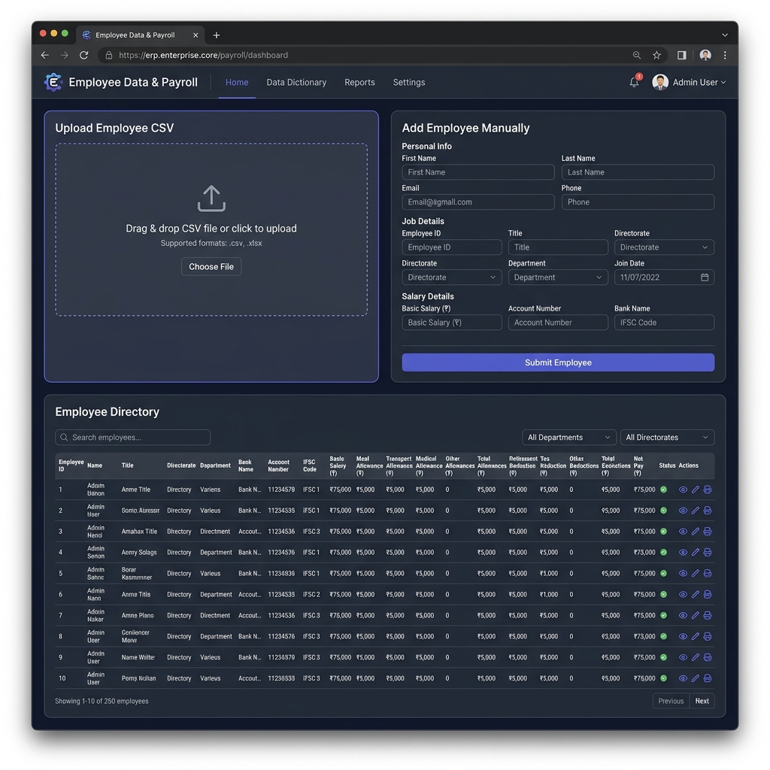
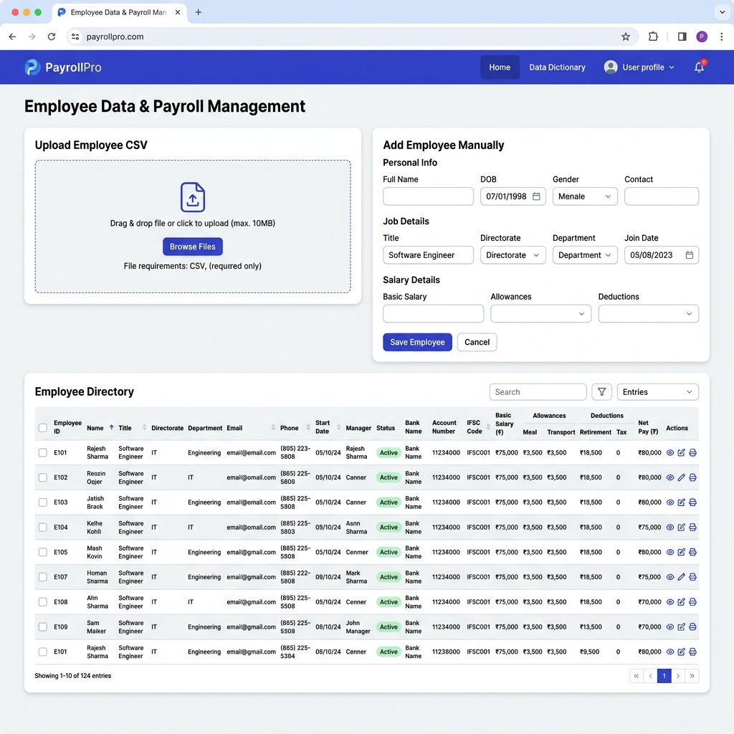
Figure 1.1: Web Interface layout displaying CSV Upload, Manual Entry Form with Salary Details, and Directory List with Payslip Generators.
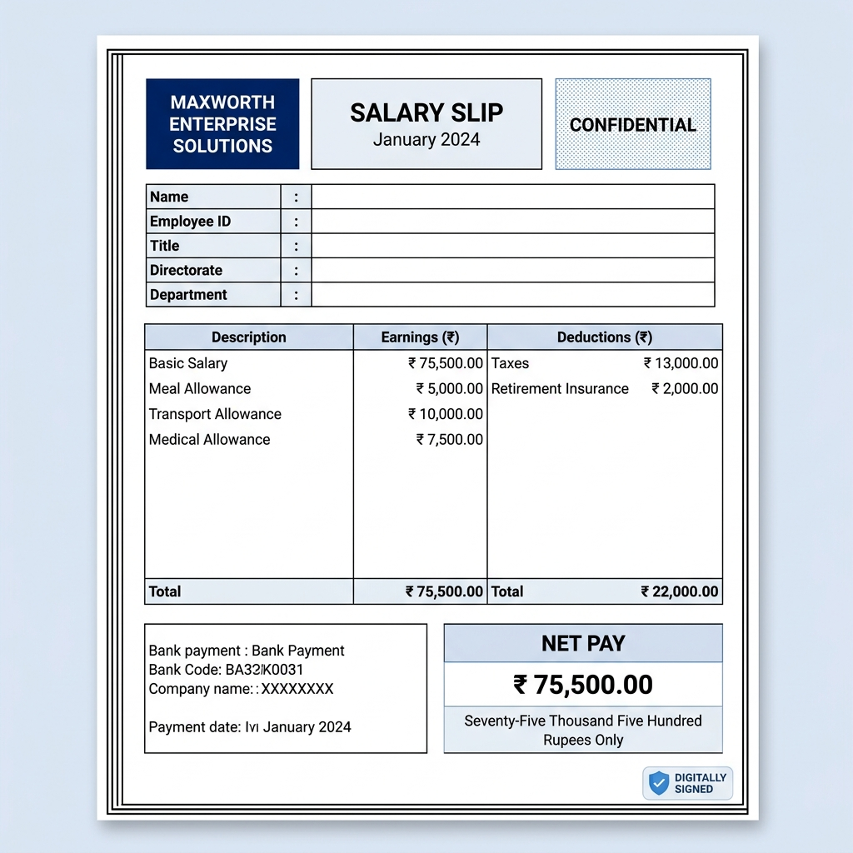
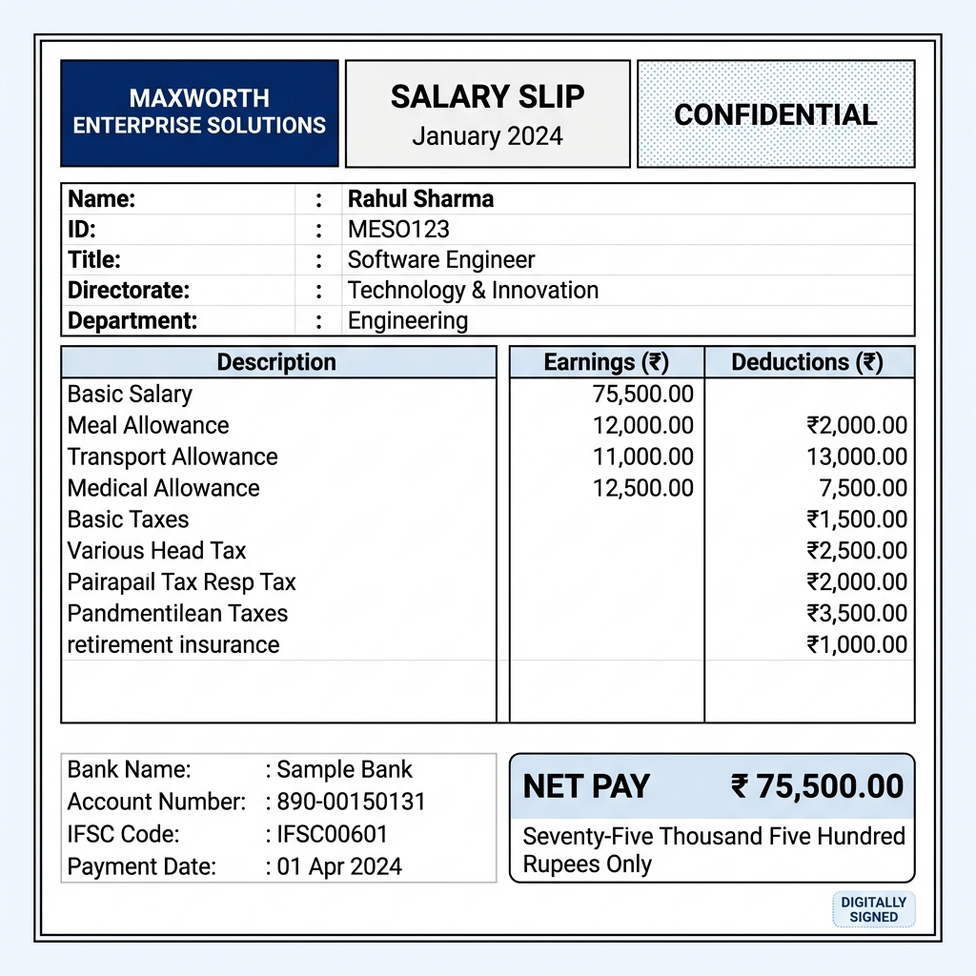
Figure 1.2: Renders a printable salary slip with detailed Meal, Transport, Medical allowances and Retirement Insurance, Tax deductions.

