RAT IN A MAZE PROBLEM

Given a maze, N x N matrix. A rat has to find a path from source to destination. Maze [0][0] (left top corner)is the source and maze[N-1][N-1](right bottom corner) is destination. There are few cells which are blocked, means rat cannot enter into those cells. Rat can move in any direction (left, right, up and down).

**Input**: A 2D-matrix with 0’s and 1’s fill in it. 0 means that cell is blocked and 1 means rat can move to that cell.

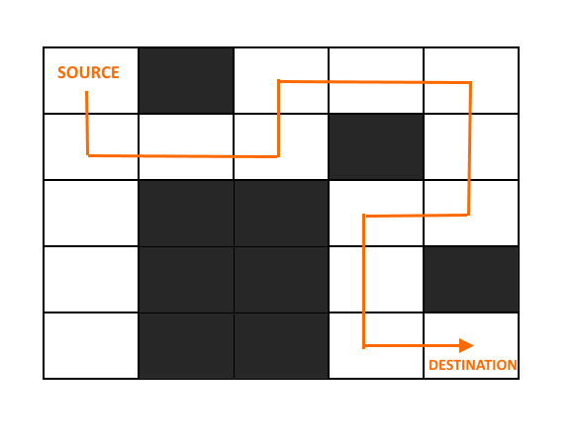

**Approach**:

* Create a solution matrix of the same structure as maze.
* Whenever rat moves to cell in a maze, mark that particular cell in solution matrix.
* At the end print the solution matrix, follow that 1’s from the top left corner, it will be that path for the rat.

**Algorithm**:

1. *If rat reaches the destination*
   * Print the solution matrix.
   * *Else*
     + Mark the current cell in solution matrix as 1
     + If previous step is not in vertical direction (upwards) then move forward in the vertical direction (downwards) and recursively check if this movement leads to solution.
     + If movement in above step doesn’t lead to the solution and if previous step is not in horizontal direction (towards left) then move forward in the horizontal direction (towards right) and recursively check if this movement leads to solution.
2. If movement in above step doesn’t lead to the solution and if previous step is not in vertical direction (downwards) then move forward in the horizontal direction (upwards) and recursively check if this movement leads to solution.
3. If movement in above step doesn’t lead to the solution and if previous step is not in horizontal direction (towards right) then move forward in the horizontal direction (towards left) and recursively check if this movement leads to solution.
4. If none of the above solution works then BACKTRACK and mark the current cell as 0.

**NOTE**: It is important to check the previous direction in which the rat has moved because if rat will move in the opposite direction w.r.t its previous direction then rat might end up in infinite loop. Example: if rat has moved to its left in the previous direction then if in next moves to right then moving left option will be available again then rat will move to left again , then again right and so on