|  |  |  |  |
| --- | --- | --- | --- |
| [www.caddcentre.lk](http://www.caddcentre.lk/) |  | | |
| certificate title  In: {in} Awarded to: {first_name} {last_name} At: {at} During: {during} | | | |
|  | Student ID: {id}    **Ajith Ameresekera** Signature  Managing Director 12 -06-2022 | | |
| Certificate Title |
| **CADD Centre Lanka (Pvt) Ltd** | **CADD**  **CENTRE**  Driving Digital Designs! | **Master Franchise Holder for Sri Lanka** | TVEC Reg No. P01/0781 |

### ID:

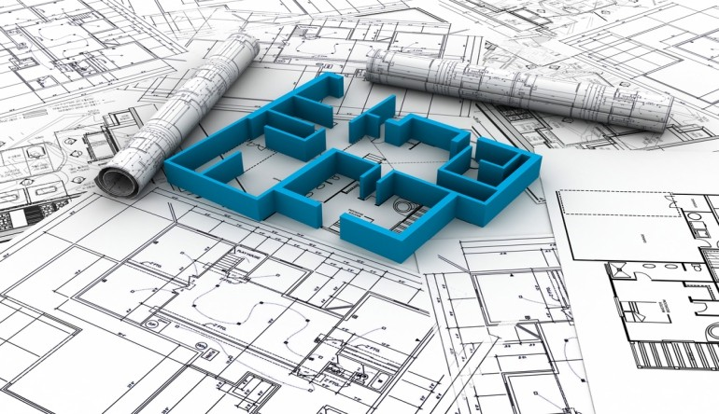

**Transcript**

# Program : Certificate Title

**Student Name : Student ID :**

**Ml364**

**Training content**

To understand and work on AutoCAD To work on GUI of AutoCAD

To understand co-ordinate systems in AutoCAD To create Lines and Polylines

To create Arcs and Circles

To select entities for modiﬁcation To edit and Modify Entities Created To set the Drafting Parameters To manage the drawing Files

To add text information to the drawing To set properties of objects

To understand Hatch Patterns To create Hatch Patterns

To understand Entity Grips To edit entities using Grips To Inquire objects

To understand Computer Aided Dimensioning

To understand Dimensioning methods in AutoCAD To create Dimension styles in AutoCAD

To understand the productivity tools in AutoCAD To create and use blocks

To create and use dynamic blocks To understand attributes

To create and manager attributes

To understand and use the measuring tools in AutoCAD

To create slide

To make presentations using slides To make and run Scripts

To create documents with OLE

To understand the external references To use external reference for productivity To understand AutoCAD Design Center To understand and use tool palettes

To explode the drawing

To Understand Plotting the drawings To use AutoDesk DWF viewer

To publish drawing Web Format To publish drawing and designs

To understand 3D Modeling concepts in AutoCAD To understand and use 3D Viewpoint

To understand View ports To understand UCS

To understand and use 3D Coordinate System To understand create Wire Frame models

To create Surface Models To create Solid Models

To create and use 3D Surface Primitive To Shade the Model

To make slice the 3D model To create sectional 3D model To make Union of 3D model

To Subtract the models

To identify Interference and intersection To edit Solid Model

To use 3D Solid primitives

To understand Rendering Techniques To understand rendering engine

To know about Anti-Aliasing To render models in View port

To render a ﬁle containing a 3D Model

## Name of Software/s :



Course Duration ( in hours ) :

## Final Grade :

Grading : 35 - 49 marks - S - Ordinary Pass I 50 - 64 marks - C - Credit Pass I 65 - 74 marks - B - Merit Pass I 75 and above - A - Distinction Pass

TVEC Reg No. P01/0781

### ID: