PIZZA SALES SQL QUERIES
A. KPI’s
1. Total Revenue:
SELECT SUM(total_price) AS Total_Revenue FROM pizza_sales;
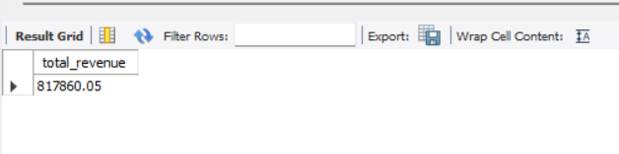
2. Average Order Value
SELECT (SUM(total_price) / COUNT(DISTINCT order_id)) AS Avg_order_Value FROM pizza_sales
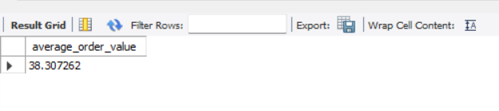
3. Total Pizzas Sold
SELECT SUM(quantity) AS Total_pizza_sold FROM pizza_sales
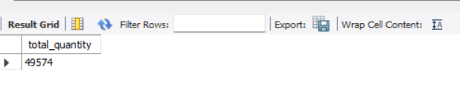
4. Total Orders
SELECT COUNT(DISTINCT order_id) AS Total_Orders FROM pizza_sales
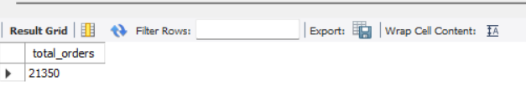

5. Average Pizzas Per Order
SELECT
ROUND(
SUM(quantity) / COUNT(DISTINCT order_id),2) AS average_pizza_per_order
FROM pizza_sales;
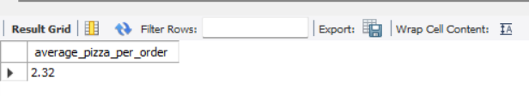

B. Daily Trend for Total Orders
SELECT
DAYNAME(order_date) AS day_name,
COUNT(DISTINCT order_id) AS total_orders
FROM pizza_sales
GROUP BY DAYNAME(order_date)
ORDER BY total_orders DESC;
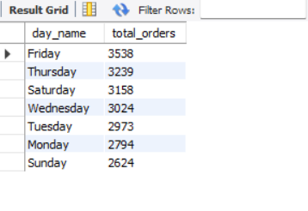
C. Hourly Trend for Orders
SELECT
HOUR(order_time) AS order_hour,
COUNT(DISTINCT order_id) AS total_orders
FROM pizza_sales GROUP BY order_hour order by order_hour;
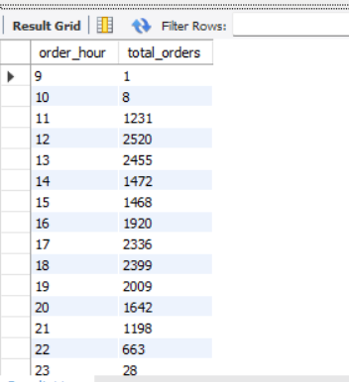

D. % of Sales by Pizza Category
SELECT
pizza_category,
SUM(total_price) TOTAL_SALES,
ROUND(
SUM(total_price) * 100.0 /
(SELECT SUM(total_price)
FROM pizza_sales
),2 ) AS percentage_of_sales
FROM pizza_sales GROUP BY pizza_category;
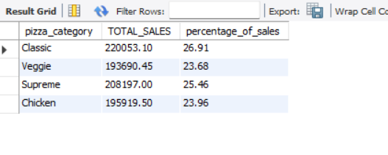
E. % of Sales by Pizza Size
SELECT
pizza_size,
SUM(total_price) TOTAL_SALES,
ROUND(
SUM(total_price) * 100.0 /
(SELECT SUM(total_price)
FROM pizza_sales
),
2
) AS percentage_of_sales
FROM pizza_sales
GROUP BY pizza_size order by percentage_of_sales desc;
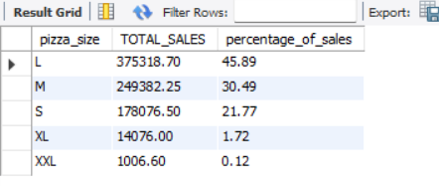

F. Total Pizzas Sold by Pizza Category
select pizza_Category,sum(quantity) total_quantity from pizza_sales group by pizza_category;
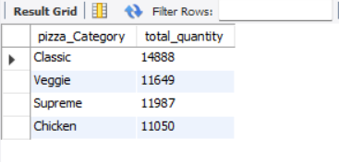
G. Top 5 Best Sellers by Total Pizzas Sold
select pizza_name,sum(quantity) total_quantity_sales from pizza_sales group by pizza_name order by total_quantity_sales desc limit 5;
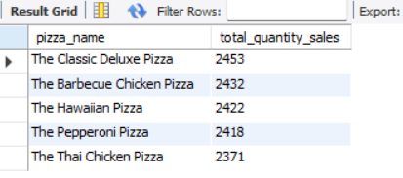
H. Bottom 5 Best Sellers by Total Pizzas Sold
select pizza_name,sum(quantity) total_quantity_sales from pizza_sales group by pizza_name order by total_quantity_sales limit 5;
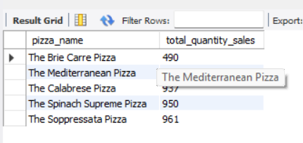

NOTE
If you want to apply the Month, Quarter, Week filters to the above queries you can use the WHERE clause. Follow some of the below examples:
SELECT DAYNAME(order_date) AS order_day,
COUNT(DISTINCT order_id) AS total_orders
FROM pizza_sales
WHERE MONTH(order_date) = 1
GROUP BY DAYNAME(order_date);
Here MONTH(order_date) = 1 indicates that the output is for the month of January. MONTH(order_date) = 4 indicates output for the month of April.

SELECT DAYNAME(order_date) AS order_day,
COUNT(DISTINCT order_id) AS total_orders
FROM pizza_sales
WHERE QUARTER(order_date) = 1
GROUP BY DAYNAME(order_date);
Here QUARTER(order_date) = 1 indicates that the output is for Quarter 1. QUARTER(order_date) = 3 indicates output for Quarter 3.

