Shell and Tube Heat Exchanger
SolidWorks Flow Simulation and Heat Transfer Optimization Study
Final Engineering Report
Prepared for portfolio documentation
Prepared by: Yash Morbia
Date: May 2026

Study Type | Solver | Final Physics | Primary Metric
Steady-state internal CHT | SolidWorks Flow Simulation | Forced water-water flow, gravity off | Bulk outlet temperature and heat duty
Final recommendation: Case 4 gives the highest heat transfer, while Case 3 gives the best balanced low-pressure design.

Executive Summary
A shell and tube heat exchanger was evaluated using SolidWorks Flow Simulation with conjugate heat transfer enabled. The objective was to validate baseline thermal behavior, compare flow arrangement sensitivity, and identify practical changes that reduce hot-side outlet temperature or pressure loss.
All final cases were rerun with gravity disabled. This was appropriate because the model represents a forced-convection, pump-driven water-water heat exchanger. Disabling gravity removed hydrostatic pressure effects from the pressure-drop calculation and produced excellent hot-side/cold-side energy balance.
Four cases were retained for the final study: a baseline counterflow configuration, a parallel-flow comparison, an inline tube-side inlet optimization, and an increased shell-side velocity parameter case. Bulk-average temperature goals were used for the final calculations so that heat transfer could be checked using energy balance.
Case | Configuration | Hot outlet (degC) | Cold outlet (degC) | Heat transfer (kW) | Tube dP (Pa) | Shell dP (Pa)
Case 1 | Baseline Counterflow HX | 86.71 | 24.80 | 26.3 | 10.69 | 21.06
Case 2 | Parallel Flow Comparison | 87.15 | 24.57 | 25.2 | 10.70 | 20.52
Case 3 | Inline Tube-Side Inlet Optimization | 86.22 | 24.96 | 27.2 | 9.82 | 21.11
Case 4 | Increased Shell-Side Velocity | 84.75 | 22.72 | 30.0 | 9.82 | 83.58
Table 1. Final case comparison using bulk-average outlet temperatures.

Key Findings
- Case 1 established a stable baseline with approximately 26.2 kW of heat transfer and excellent energy balance.
- Case 2 showed that reversing the shell-side flow direction produced only a small performance change because the baffle-driven shell side behaves more like mixed cross-flow than ideal textbook counterflow or parallel flow.
- Case 3 improved the tube-side inlet path, slightly increasing heat transfer and reducing tube-side pressure drop relative to the baseline.
- Case 4 doubled shell-side velocity from 0.1 m/s to 0.2 m/s. This increased heat transfer by about 15 percent versus the baseline, but increased shell-side pressure drop by about 4 times.
- For minimum hot outlet temperature, Case 4 is the best. For a balanced design with low pressure drop, Case 3 is preferred.

Simulation Methodology

Model and Materials
The model is a shell and tube heat exchanger with copper tubes and stainless steel shell, baffles, headers, and tube sheets. The simulation used internal flow with heat conduction in solids enabled so that heat transfer through the tube walls was captured.

Final Physics Settings
Setting | Final report value
Analysis type | Internal flow
Thermal model | Conjugate heat transfer, heat conduction in solids enabled
Fluids | Water on tube side and shell side
Solid materials | Copper tubes; stainless steel shell, headers, baffles, tube sheets
Wall condition | Adiabatic external wall
Gravity | Off
Radiation | Off
Solver type | Steady-state
Temperature goals | Bulk-average fluid temperature

Boundary Conditions
Boundary | Case 1 to 3 | Case 4 | Temperature | Notes
Hot tube-side inlet | 0.1 m/s equivalent inlet flow | Same as Case 3 | 100 degC | Velocity inlet or equivalent final mass flow used consistently by case
Hot tube-side outlet | Environmental pressure | Same | 101325 Pa reference | Outlet temperature calculated by solver
Cold shell-side inlet | 0.1 m/s | 0.2 m/s | 20 degC | Case 4 doubles shell-side velocity
Cold shell-side outlet | Environmental pressure | Same | 101325 Pa reference | Outlet temperature calculated by solver

Mesh Strategy
A local mesh strategy was used for the final cases. Refinement was focused around the tube bundle, baffles, tube sheets, and shell-side passages where velocity and thermal gradients are highest. This avoided over-refining the entire computational domain while improving resolution in the heat-transfer core.
The local mesh strategy was retained across the final cases so that design comparisons were based on geometry and boundary-condition changes rather than mesh changes.

Post-processing Metrics
The main validation and comparison metrics were bulk-average inlet and outlet temperatures, mass flow rate balance, tube-side pressure drop, shell-side pressure drop, and heat transfer rate.
Heat transfer was calculated from both the hot and cold sides using:
- Q_hot = m_hot x Cp x (T_hot,in - T_hot,out)
- Q_cold = m_cold x Cp x (T_cold,out - T_cold,in)
- Cp for water = 4180 J/kg-K
The clean tables in this report are the controlling numerical results. The included images are used as visual evidence of temperature field, velocity distribution, and flow trajectory behavior.

Final Results and Case Comparison
Case | Configuration | m hot (kg/s) | m cold (kg/s) | Hot out (degC) | Cold out (degC) | Hot drop (degC) | Cold rise (degC) | Q hot (kW) | Q cold (kW) | Energy error (%) | Notes
Case 1 | Baseline Counterflow HX | 0.4716 | 1.3118 | 86.71 | 24.80 | 13.29 | 4.80 | 26.2 | 26.3 | 0.46 | Validated baseline
Case 2 | Parallel Flow Comparison | 0.4716 | 1.3125 | 87.15 | 24.57 | 12.85 | 4.57 | 25.3 | 25.1 | 1.03 | Slightly lower performance than baseline
Case 3 | Inline Tube-Side Inlet Optimization | 0.4725 | 1.3126 | 86.22 | 24.96 | 13.78 | 4.96 | 27.2 | 27.2 | 0.01 | Best balanced design
Case 4 | Increased Shell-Side Velocity | 0.4725 | 2.6252 | 84.75 | 22.72 | 15.25 | 2.72 | 30.1 | 29.8 | 0.91 | Highest heat transfer, higher shell dP
Table 2. Detailed final results with heat-transfer and energy-balance checks.

Engineering Interpretation
Case 1 provided the validated baseline. The hot outlet temperature was 86.71 degC and the cold outlet temperature was 24.80 degC. The hot-side and cold-side heat-transfer estimates matched within 0.5 percent, which indicates a reliable thermal setup.
Case 2, the parallel-flow comparison, reduced heat transfer by about 3.3 percent compared with Case 1. The change was small because the shell side is not a pure one-dimensional flow path. The baffles generate cross-flow and mixing, so ideal textbook counterflow and parallel-flow trends are muted.
Case 3, the inline tube-side inlet optimization, provided the best balanced improvement. It increased heat transfer relative to baseline and reduced tube-side pressure drop from 10.69 Pa to 9.82 Pa. This makes it the best low-pressure-drop design.
Case 4 increased shell-side velocity and achieved the highest heat transfer, approximately 30.0 kW. The tradeoff was a shell-side pressure-drop increase from about 21 Pa to 84 Pa. This case is recommended only when the additional pumping penalty is acceptable.

Case 1 - Baseline Counterflow HX
Validated baseline with local mesh, counterflow arrangement, copper tubes, stainless steel shell, and bulk-average temperature goals.
Metric | Value | Metric | Value
Hot outlet bulk temp | 86.71 degC | Cold outlet bulk temp | 24.80 degC
Heat transfer, average | 26.3 kW | Energy balance error | 0.46 %
Tube-side pressure drop | 10.69 Pa | Shell-side pressure drop | 21.06 Pa
Result: This case is used as the baseline for all comparisons. The energy balance is excellent, and the temperature field shows expected hot-side cooling and cold-side heating.

Result Images
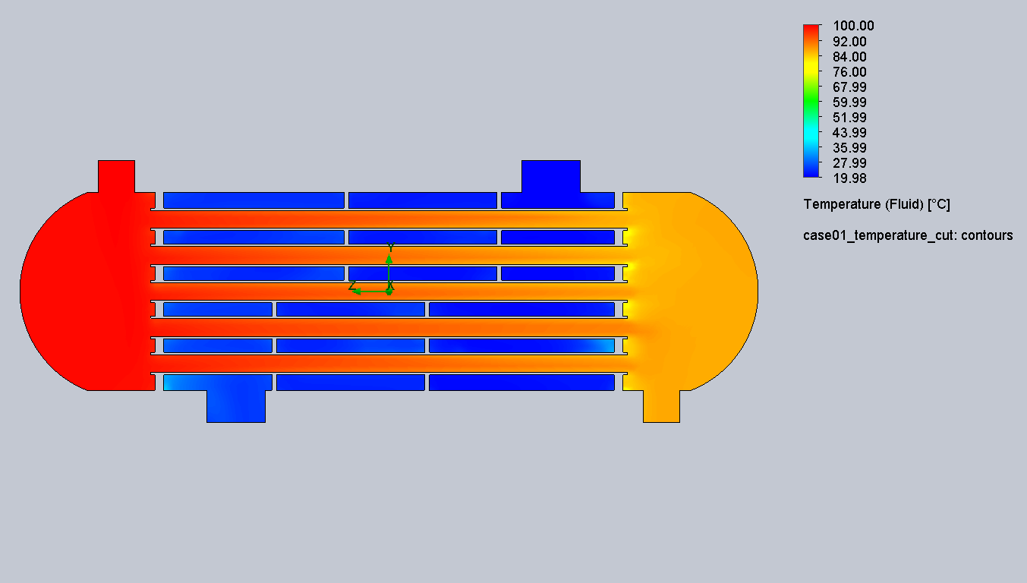
Figure 1.1. Temperature cut plot for Baseline Counterflow HX.
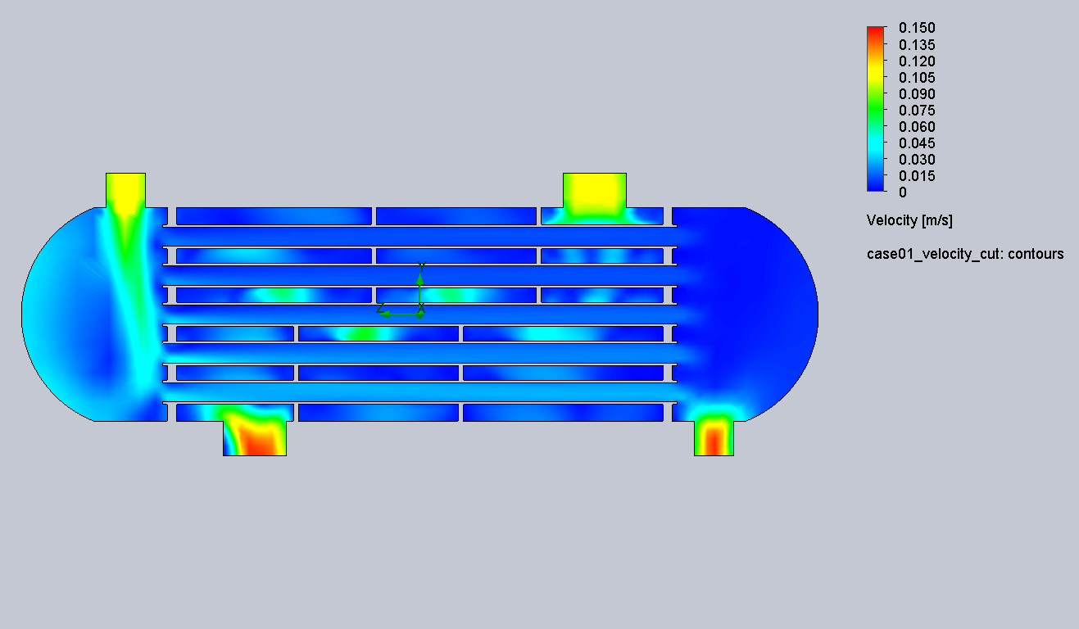
Figure 1.2. Velocity cut plot for Baseline Counterflow HX.
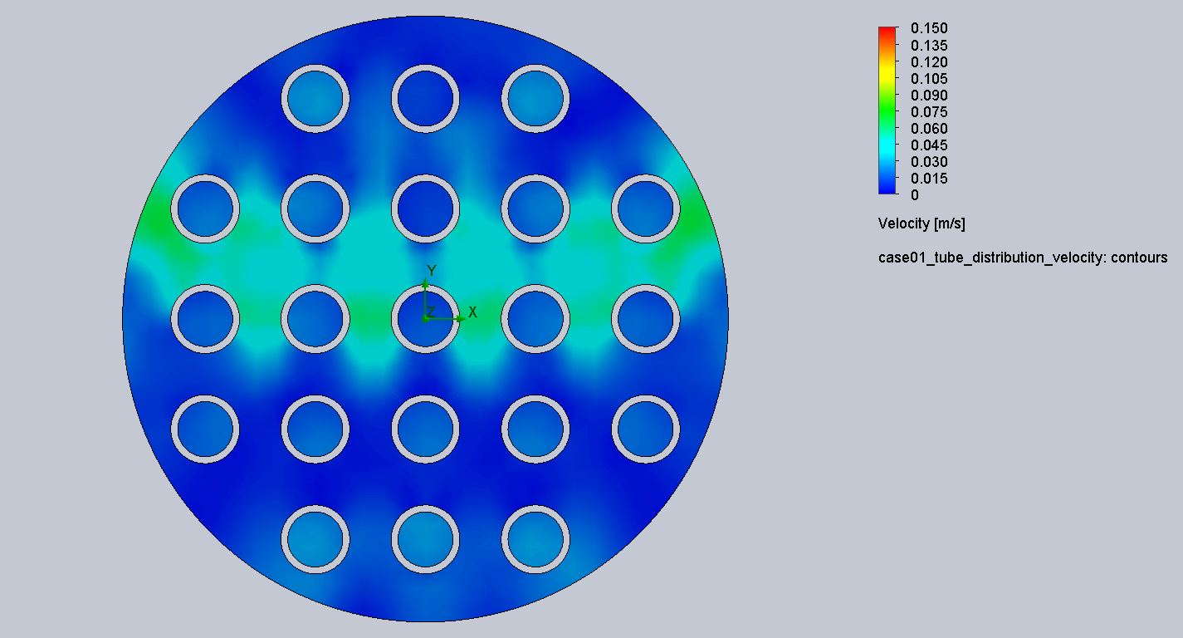
Figure 1.3. Tube-side distribution velocity for Baseline Counterflow HX.
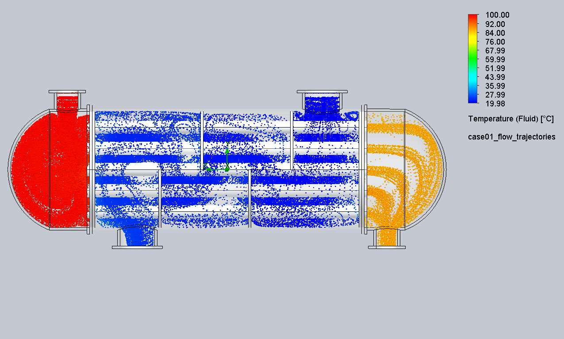
Figure 1.4. Flow trajectories for Baseline Counterflow HX.

Case 2 - Parallel Flow Comparison
Shell-side flow direction reversed to compare the baseline counterflow arrangement against a parallel-flow arrangement.
Metric | Value | Metric | Value
Hot outlet bulk temp | 87.15 degC | Cold outlet bulk temp | 24.57 degC
Heat transfer, average | 25.2 kW | Energy balance error | 1.03 %
Tube-side pressure drop | 10.70 Pa | Shell-side pressure drop | 20.52 Pa
Result: Parallel flow performed slightly worse than the baseline. The small difference indicates that the baffled shell-side flow field dominates the heat-transfer pattern.

Result Images
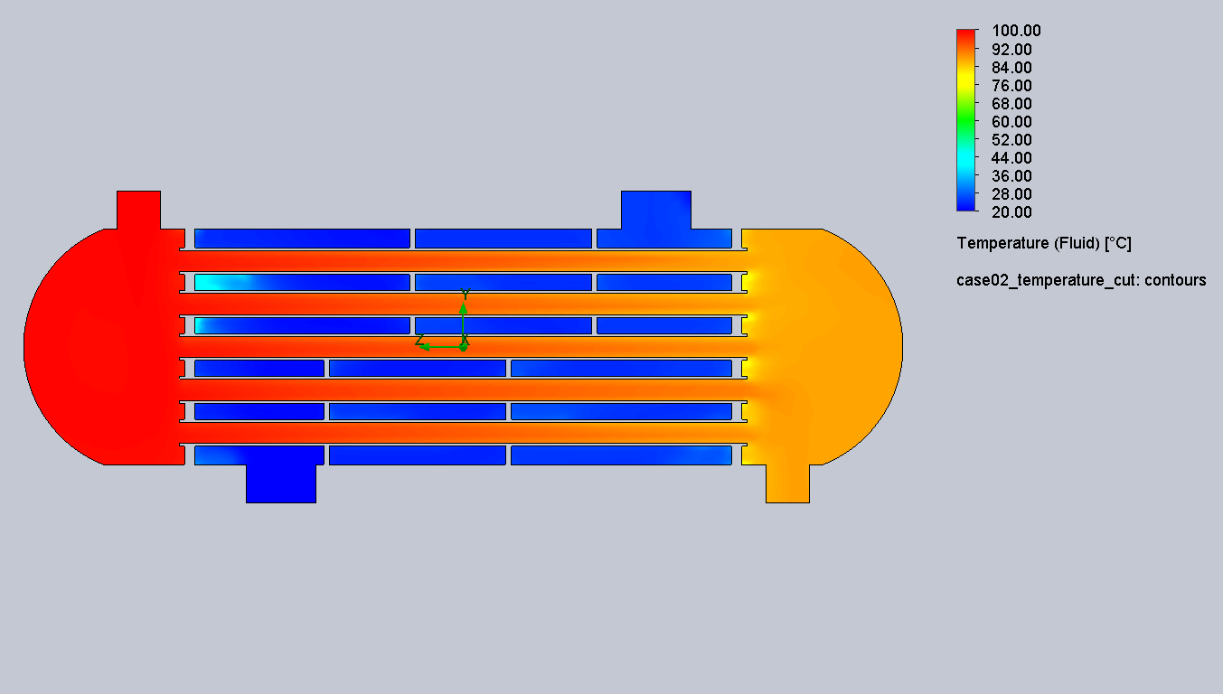
Figure 2.1. Temperature cut plot for Parallel Flow Comparison.
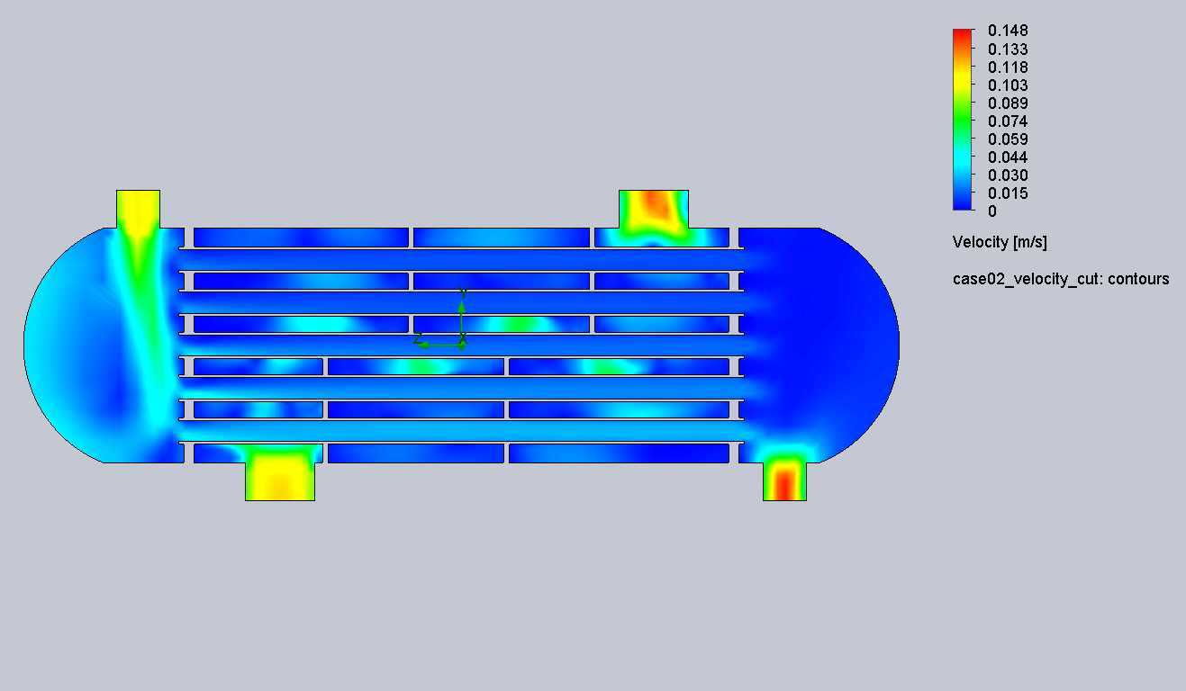
Figure 2.2. Velocity cut plot for Parallel Flow Comparison.
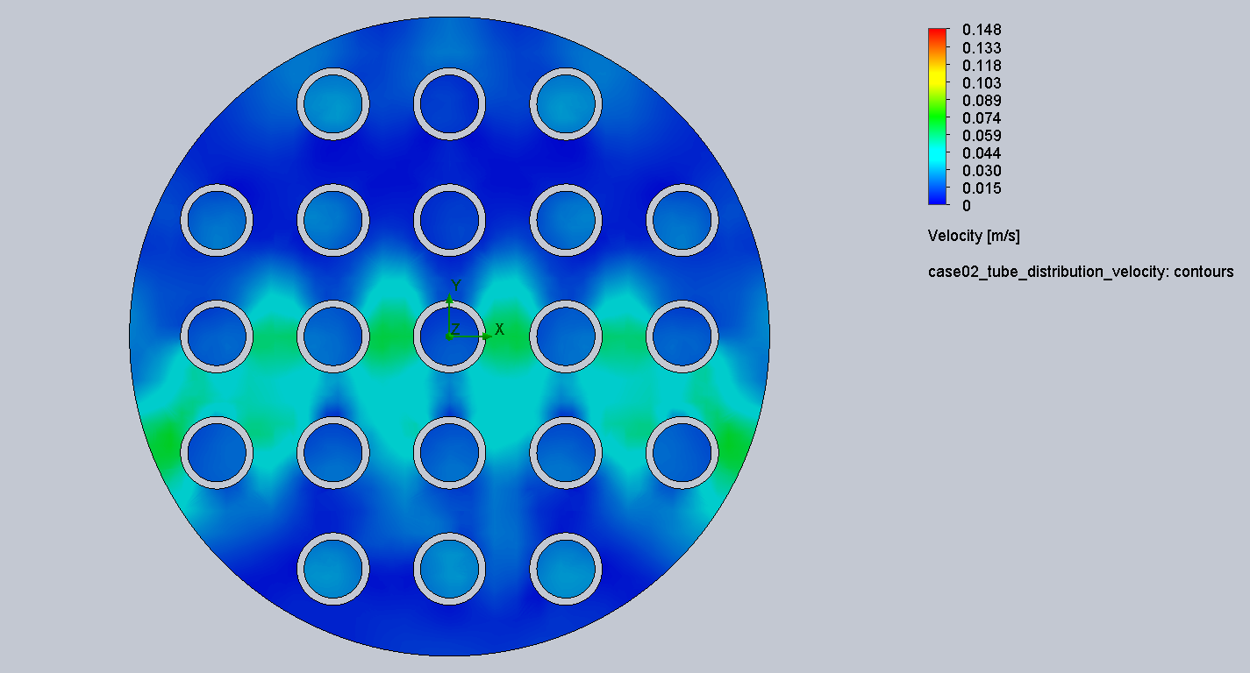
Figure 2.3. Tube-side distribution velocity for Parallel Flow Comparison.
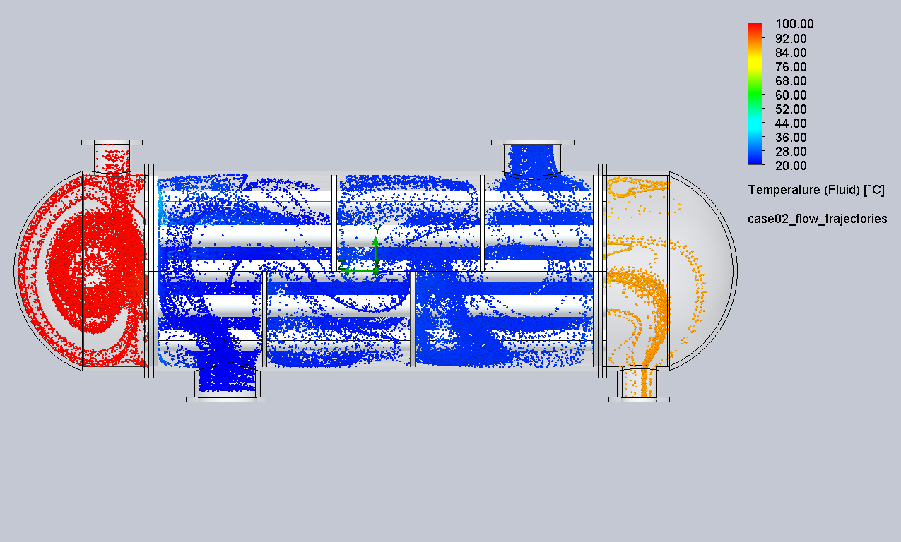
Figure 2.4. Flow trajectories for Parallel Flow Comparison.

Case 3 - Inline Tube-Side Inlet Optimization
Tube-side inlet was reoriented to a more inline configuration to reduce inlet losses and improve the tube-side flow path.
Metric | Value | Metric | Value
Hot outlet bulk temp | 86.22 degC | Cold outlet bulk temp | 24.96 degC
Heat transfer, average | 27.2 kW | Energy balance error | 0.01 %
Tube-side pressure drop | 9.82 Pa | Shell-side pressure drop | 21.11 Pa
Result: This is the preferred balanced design. It reduces tube-side pressure drop while improving heat transfer relative to the baseline.

Result Images
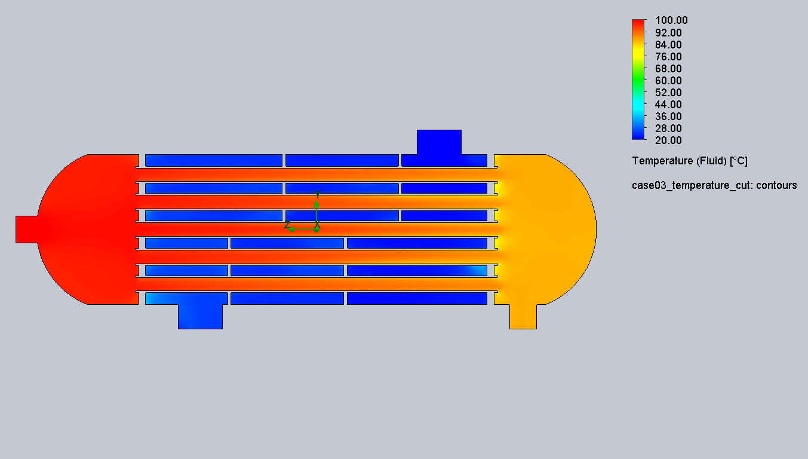
Figure 3.1. Temperature cut plot for Inline Tube-Side Inlet Optimization.
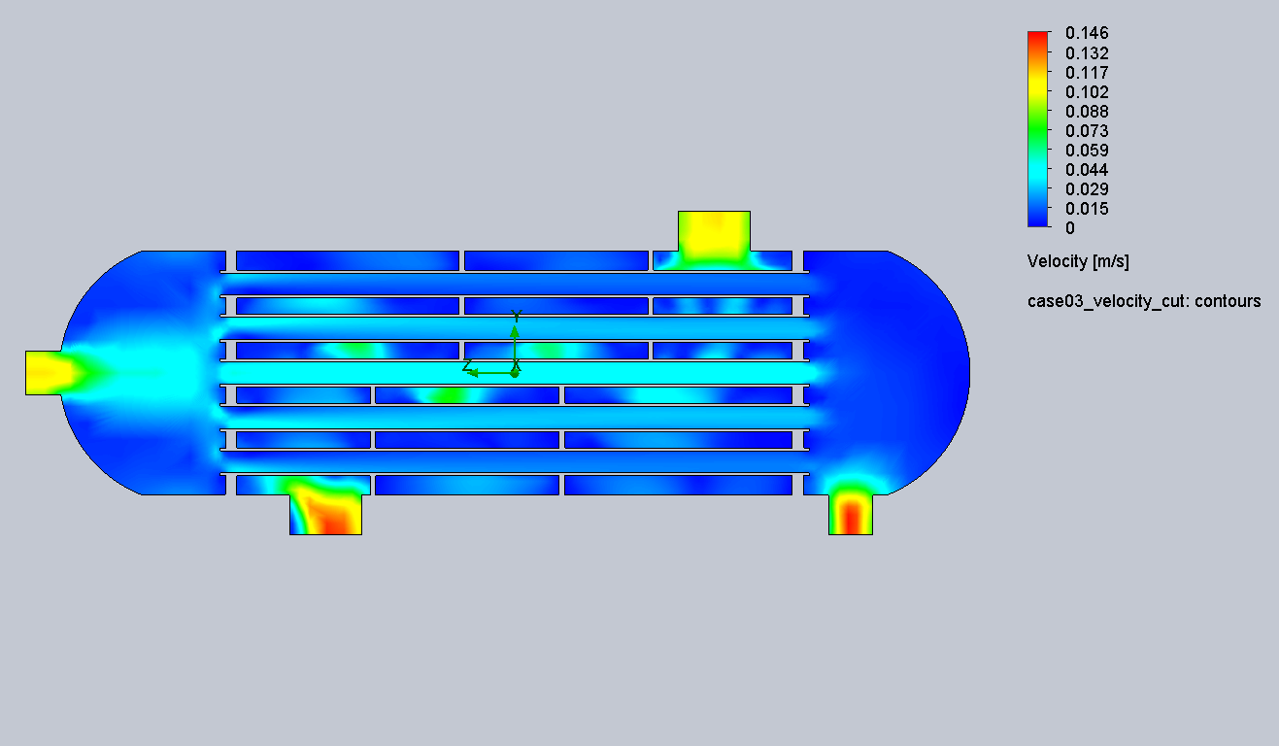
Figure 3.2. Velocity cut plot for Inline Tube-Side Inlet Optimization.
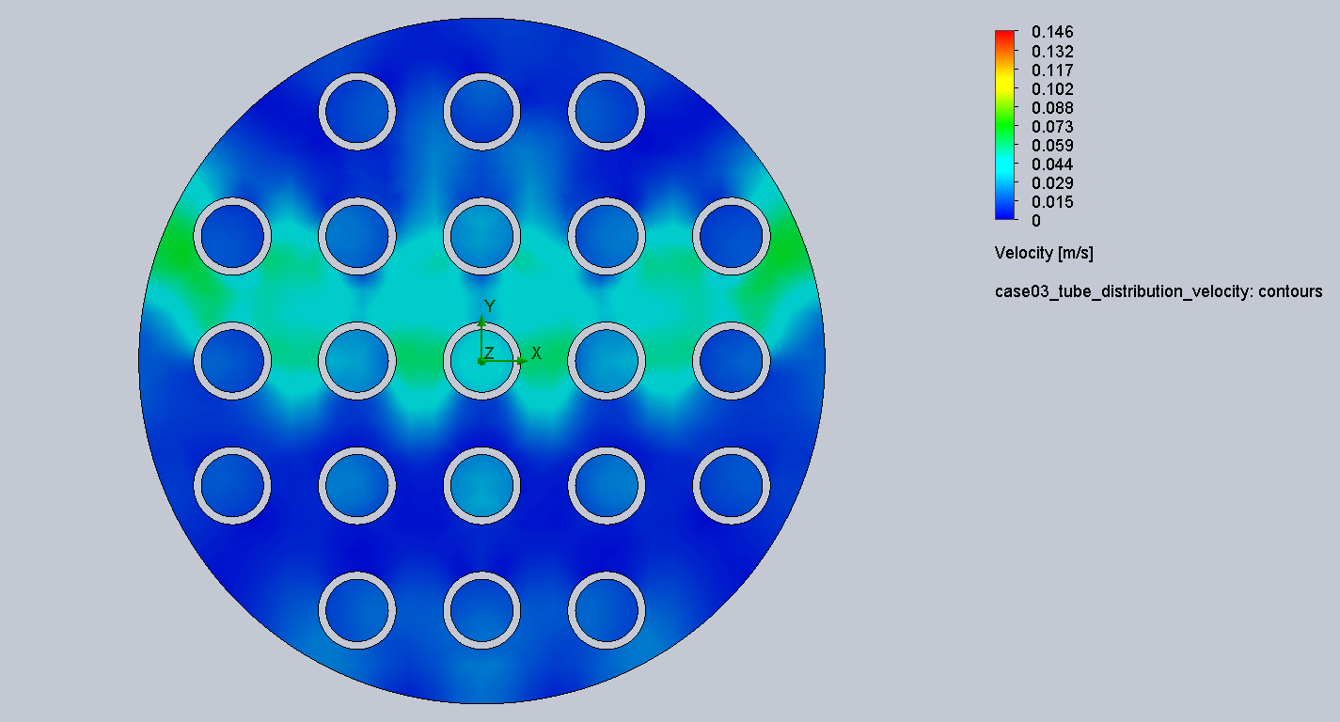
Figure 3.3. Tube-side distribution velocity for Inline Tube-Side Inlet Optimization.
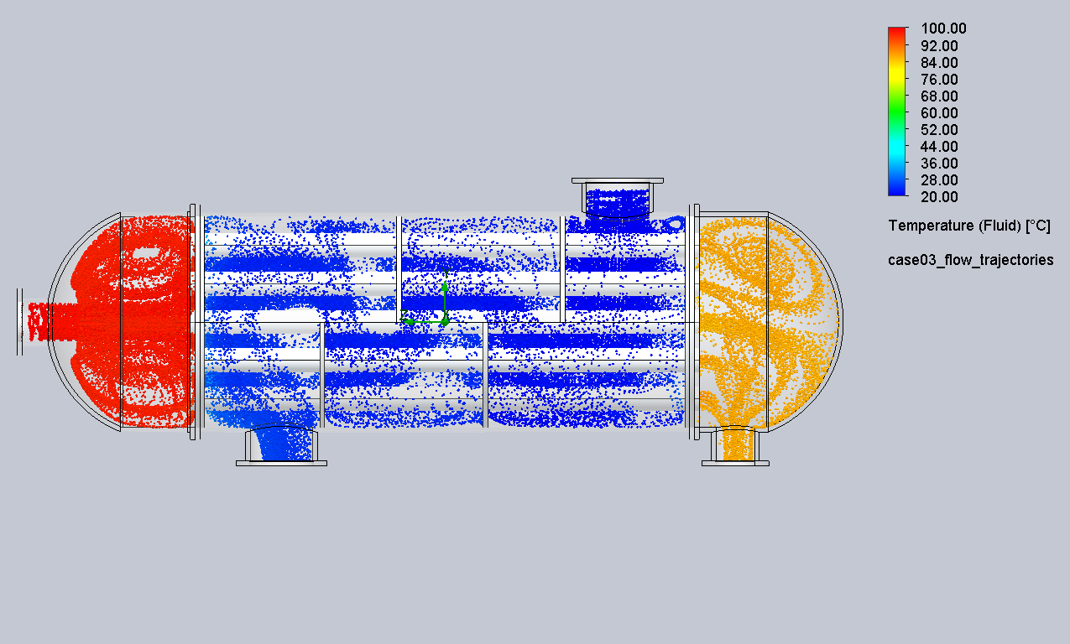
Figure 3.4. Flow trajectories for Inline Tube-Side Inlet Optimization.

Case 4 - Increased Shell-Side Velocity
Parameter sensitivity based on Case 3. Shell-side inlet velocity was increased from 0.1 m/s to 0.2 m/s to improve convective heat removal.
Metric | Value | Metric | Value
Hot outlet bulk temp | 84.75 degC | Cold outlet bulk temp | 22.72 degC
Heat transfer, average | 30.0 kW | Energy balance error | 0.91 %
Tube-side pressure drop | 9.82 Pa | Shell-side pressure drop | 83.58 Pa
Result: This case gives the maximum heat transfer, but it requires a significantly higher shell-side pressure drop. It is the best option when thermal performance is prioritized over pumping loss.

Result Images
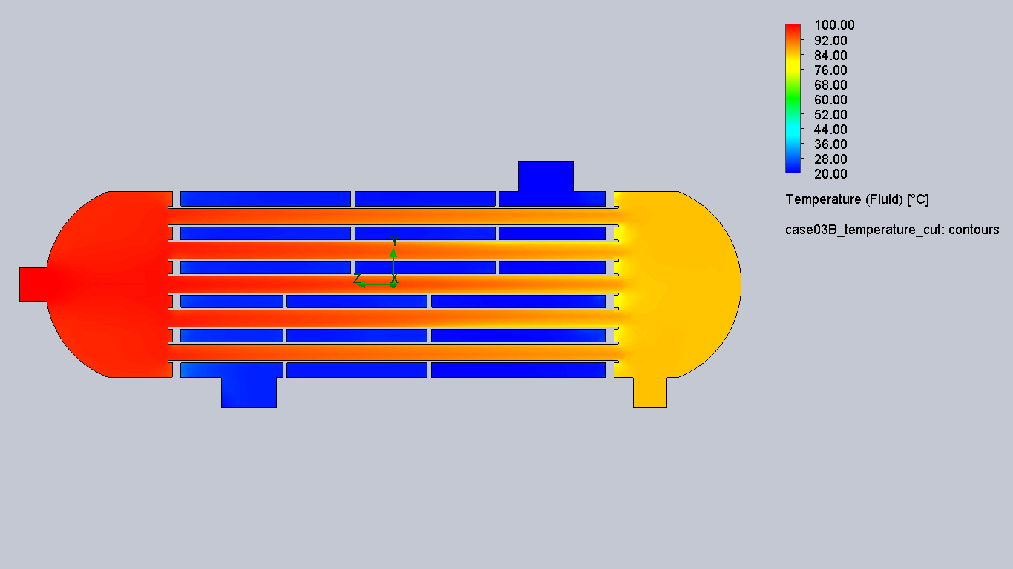
Figure 4.1. Temperature cut plot for Increased Shell-Side Velocity.
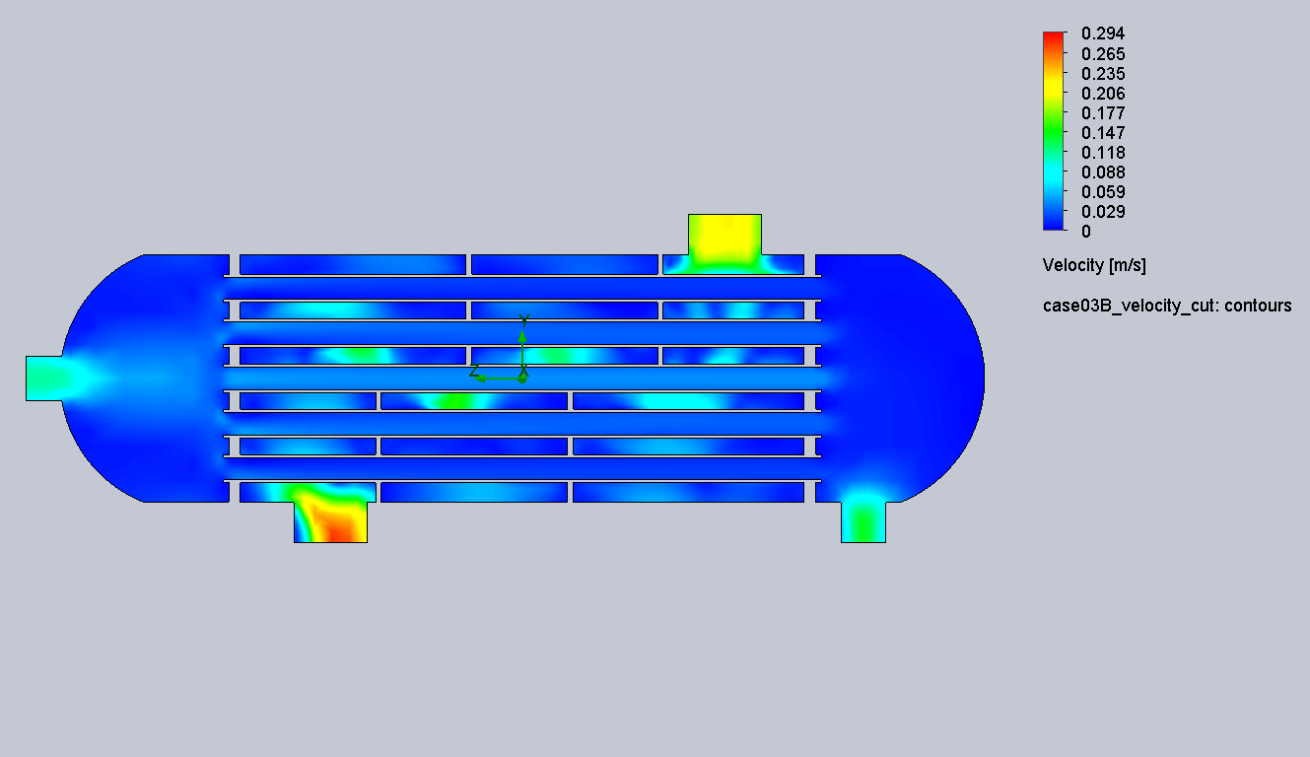
Figure 4.2. Velocity cut plot for Increased Shell-Side Velocity.
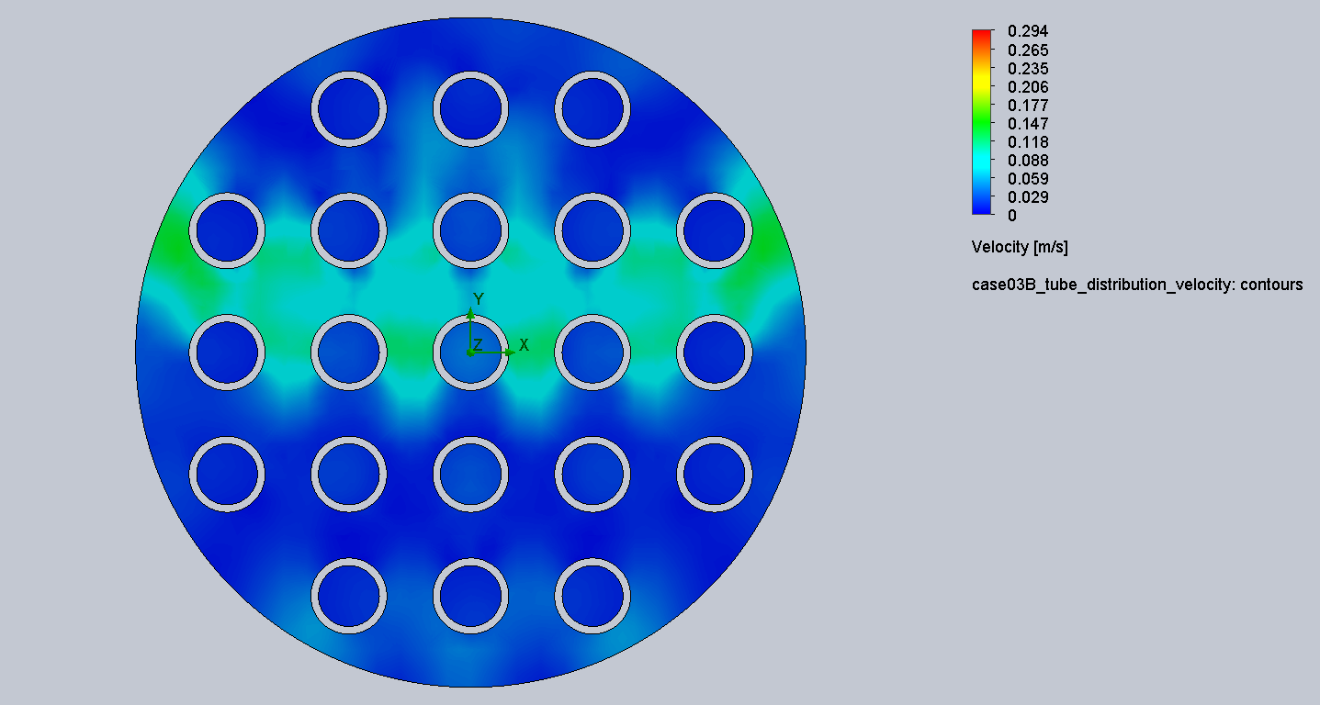
Figure 4.3. Tube-side distribution velocity for Increased Shell-Side Velocity.
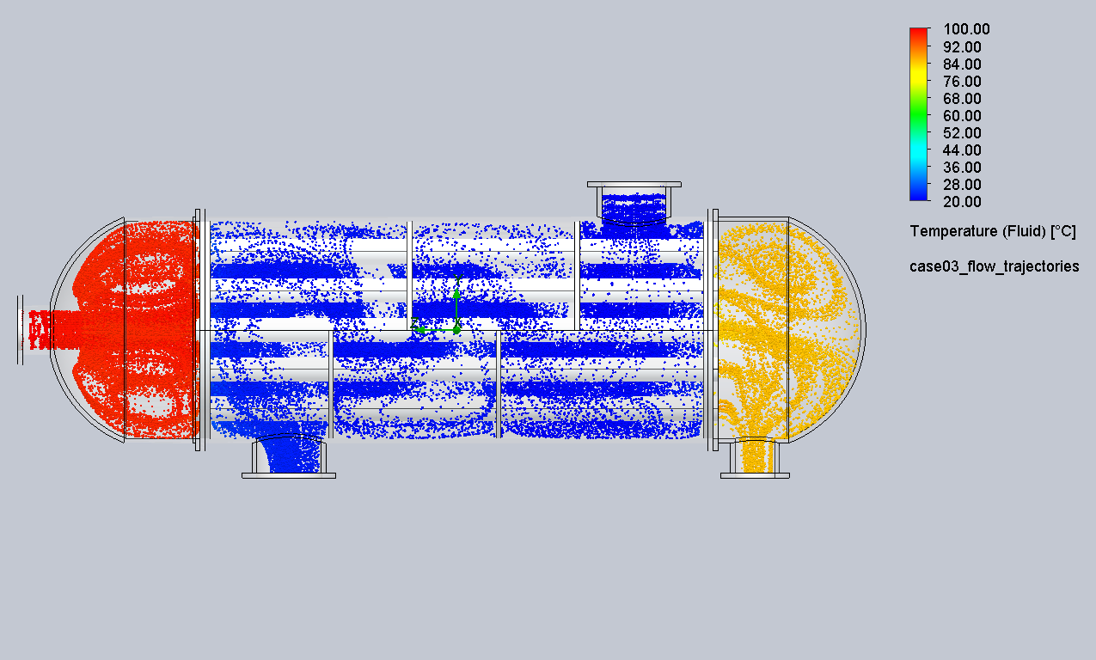
Figure 4.4. Flow trajectories for Increased Shell-Side Velocity.

Final Design Recommendation
The recommended design depends on the engineering objective:
Design priority | Recommended case | Reason
Highest heat transfer | Case 4 - Increased Shell-Side Velocity | Lowest hot outlet temperature and highest heat duty, approximately 30.0 kW
Best balanced design | Case 3 - Inline Tube-Side Inlet Optimization | Improves heat transfer while keeping pressure drops low
Baseline reference | Case 1 - Baseline Counterflow HX | Validated reference case with excellent energy balance
For a practical design recommendation, Case 3 is the preferred balanced configuration because it improves heat transfer compared with the baseline and reduces tube-side pressure drop. Case 4 is recommended only if the system can tolerate higher shell-side pumping requirements.

Recommended Future Work
- Run a mesh independence check on the selected final design using a slightly finer local mesh.
- Evaluate intermediate shell-side velocities such as 0.15 m/s to find a better tradeoff between heat transfer and pressure drop.
- Evaluate baffle spacing and baffle cut ratio to improve shell-side mixing without excessive pressure drop.
- Quantify individual tube mass flow rates if tube-side maldistribution remains a critical design concern.
- Validate the CFD trend against a hand calculation using LMTD or epsilon-NTU methods.

Limitations
- The study is comparative and uses steady-state CFD assumptions.
- External heat loss is neglected using an adiabatic wall boundary condition.
- Gravity was disabled for final results because the system is modeled as forced convection with pump-driven flow.
- The results are appropriate for portfolio and design-screening purposes, but final product design would require experimental validation and more detailed mesh independence testing.

